WELCOME

Thanks for using FOF Draft/Roster Utility. This tool will create CSV (comma-separated value) files for use in Front Office Football version 7 or 8. The files contain information for a custom-made Roster or Draft Class which you can import and use within the game.

INSTALLATION

First you need Java version 8 or later installed. You may already have it, so check the Windows Control Panel. If not, you can get it here:

https://java.com/en/download/

The next step is optional but recommended for convenience when saving/loading roster and draft CSV files. See below for details on why it's recommended.

From the Windows Control Panel, go to Appearance and Personalization -> Folder Options and select the View tab. Select "Show hidden files, folders, and drives" .

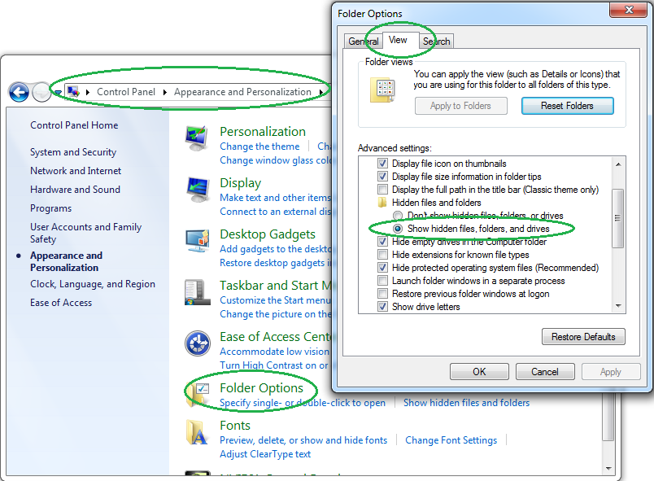

The reason this is recommended is because Front Office Football and its roster/draft utilities prefer the files to be in a subdirectory of the user's AppData folder, which is hidden by default:

C:\Users\<UserName>\AppData\Roaming\ Solecismic Software\Front Office Football Seven

or:

C:\Users\<UserName>\AppData\Local\Solecismic Software\Front Office Football Eight

In the rest of this document, I will refer to this folder as the "**Save/Load Folder**". This utility is written in Java, which doesn't give programs access to hidden files. So if they are not un-hidden in the Control Panel, you'll have to save the CSV files somewhere else and then navigate through the file pickers whenever you use the game's converter tools. If you don't mind doing that, you leave the hidden files setting where it's at.

Next, be aware that Windows has a dubious setting called "Hide extensions for known file types," and by default this setting is turned on. That means your program file may be called "FOFDraftRosterUtil" or "FOFDraftRosterUtil.jar" depending on your particular setting. You can see in the above screenshot, just below the hidden files setting, I have mine turned off to make it show file extensions. I recommend doing the same so you can easily tell the difference between files like "MyDraftFile.csv" and "MyDraftFile.fdt" (same names, different extensions). So I'm going to refer to the program file as "FOFDraftRosterUtil.jar."

If Java 8 is properly installed, double-click FOFDraftRosterUtil.jar to launch the program. If nothing happens after a few seconds, right-click FOFDraftRosterUtil.jar, select Properties, and make sure it's set to open with Java:

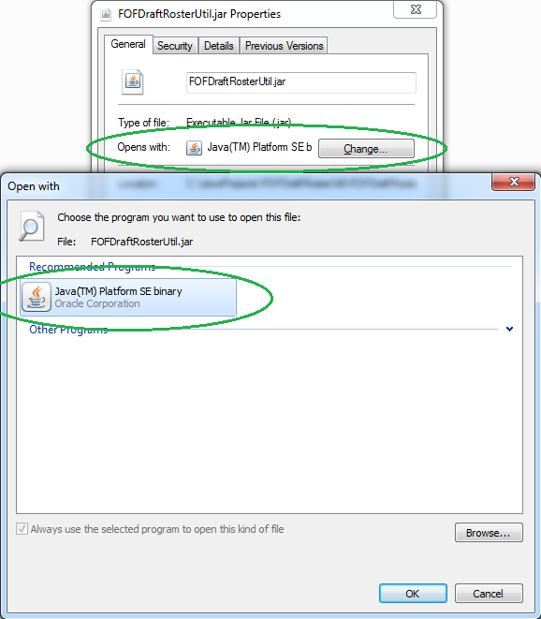

FIRST RUN

The first time this utility is ran, it will try to find where Front Office Football is installed on your system. It looks in the default install locations, and prefers version eight over seven if you have both. If it can't find where Front Office Football is installed, it will ask you to navigate to the game's exe file:

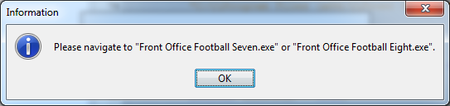

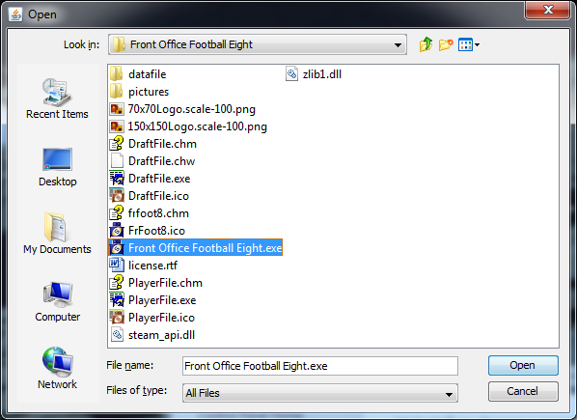

After that it will save the install location so it won't have to ask again next time. This utility needs to know where FOF is installed so it can parse the teams, colleges, and cities from the files inside the "datafile" folder.

CREATING A NEW ROSTER

A new Roster is used when creating a new game in Front Office Football. The Roster consists of all the players in the league and which teams they play for, if any.

Select File -> New -> Roster from the main menu bar. The Create Roster screen will appear and ask for a few parameters:

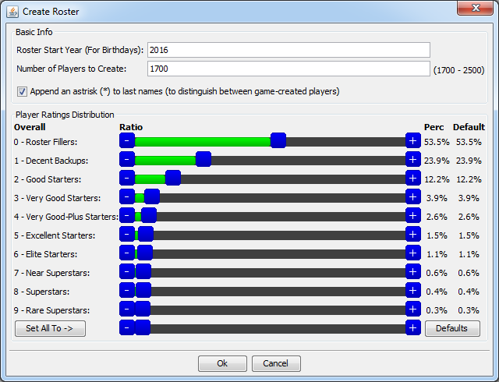

**Roster Start Year**: Enter the same year the game starts at. As-of this writing (April, 2017), FOF 7 starts at 2013 and FOF 8 starts at 2016.

**Number of Players to Create**: More players means more Free Agents.

**Append an astrisk to last names**: The game will create some of its own players when you import the roster. Adding astrisks next to player names helps identify which ones were created by this utility.

**Player Ratings Distribution**: Drag the sliders (or click the "+" and "-" buttons) to adjust the percentage of the roster that will be made up of players at that skill level.

Click Ok to create the Roster. Here's how it gets created:

1. Teams are randomly assigned to have either a 4-3 or 3-4 defensive scheme.

2. The specified number of players are created. It will create roughly the same number of players at each position, while ensuring there are enough LBs and DLs for the defensive schemes of all the teams.

3. Random players are given Overall ratings according to the distribution percentages. Roster Fillers are given individual skills (random between 0 - 5) for their position. Any player who is better than Roster Filler will be given 0 for all skills because the game will calculate them based on the Overall rating when the roster is imported. (You are free to edit the player and set his position-specific skills if you want.) If you load the game's default roster (default.csv under the AppData save/load folder location), that's how those players are set up, so this utility does it the same way.

4. Teams draft players in a "snake" order according to BPA (best player available) and position of need until all teams meet the Roster Distribution minimums. Teams will try to draft at least two of every position except K, P, and LS.

5. All players, regardless of skill level, are given a 1-year, $500,000 contract with no bonus. I figured this is the most flexible, so that once you're in-game you can freely cut or trade players without any dead money penalties. You'll want to extend your studs though, and they'll want market value if you do it in-game.

6. At least 1696 players will be on teams (53 * 32). All others will become Free Agents.

After clicking Ok, the roster is created and this screen will appear:

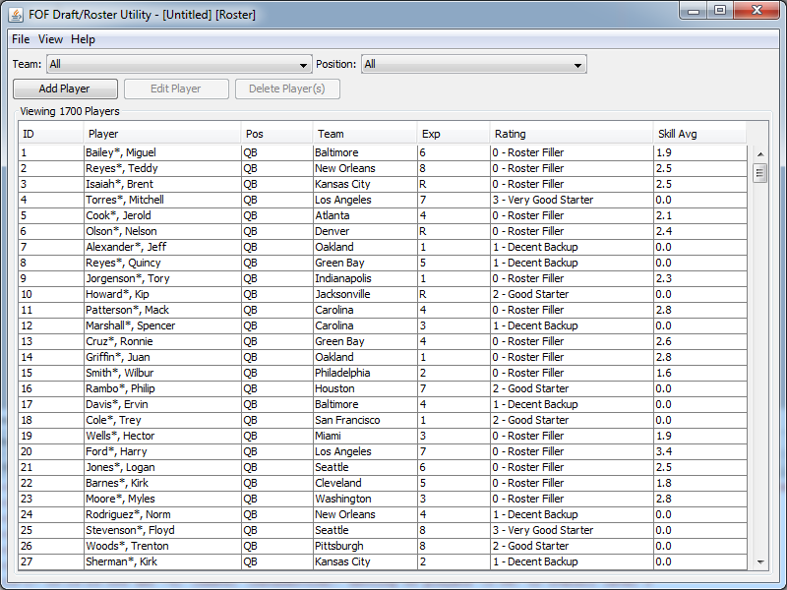

Use the Team and Position dropdowns to filter the players in the table.

Sort ascending/descending by clicking on the column headers.

The Skill Avg column is the average of the player's skills specific to his position. This is only applicable for Roster Fillers and players who'se skills you've changed. (Recall that this utility doesn't give skills to anyone better than Roster Filler, letting the game decide instead.)

To Add or Edit a player, click the Add Player button or select a player in the table and click the Edit Player button. You can also right-click players for a popup menu. This screen will appear:

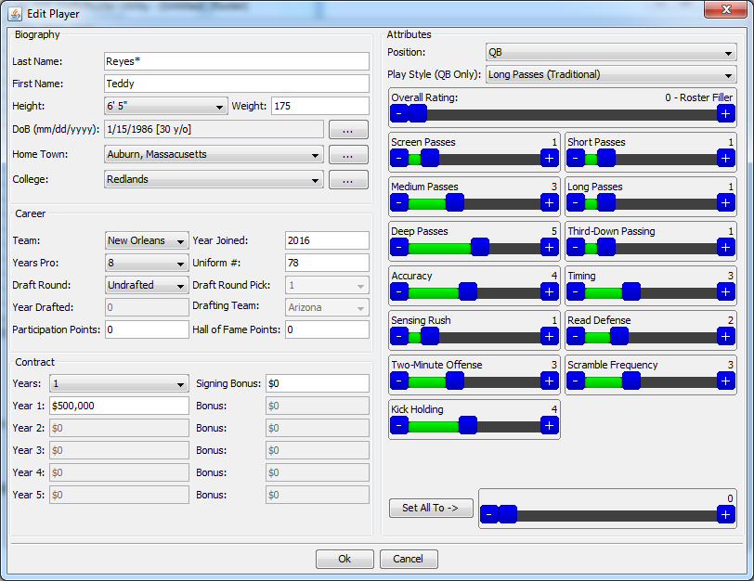

The ellipsis (...) buttons will show a popup window to change the respective field.

You can change the player's skills by dragging the slider's middle blue button, or clicking its +/- buttons.

Annual salary should be in increments of $10,000. The Signing Bonus, if any, should be in increments of $10,000 for each year of the contract.

Click Ok to apply your changes (add or edit player), or Cancel to change your mind.

Add/edit/delete any other players you want. Once you're satisfied with the roster, choose File -> Save from the main menu bar. You'll be asked to choose a location and name for the CSV file:

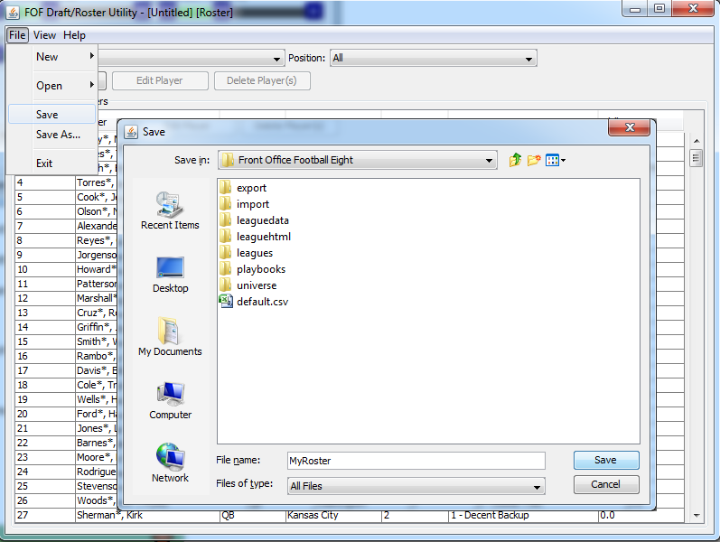

Choosing the Save/Load Folder is recommended. Enter a name for the roster ("MyRoster" in this case) and click Save. Including ".csv" extension in the file name is optional, as this utility will add it if needed. A file called "MyRoster.csv" will be created and the game's Player File Generator tool should appear:

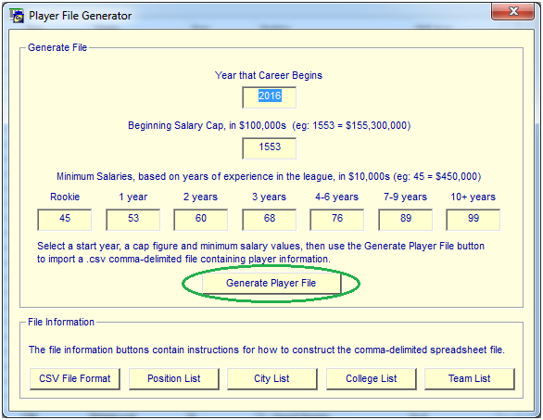

Click the Generate Player File button and navigate to your roster CSV file:

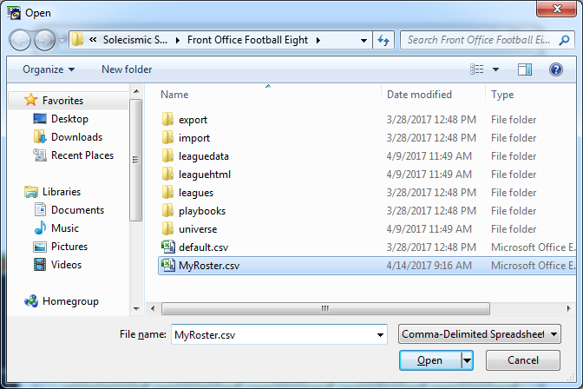

After selecting your roster file and clicking Open, you will then be prompted for the location of the converted (.fdt) roster file:

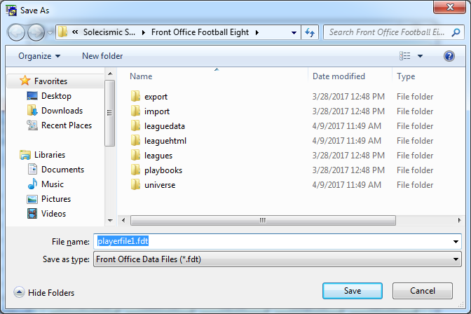

Choosing the Save/Load Folder is recommended. Click Save and you should get a "Conversion Completed" message indicating success. Close the Player File Generator tool and start a new FOF game. Critical settings for the new game are circled in the image below:

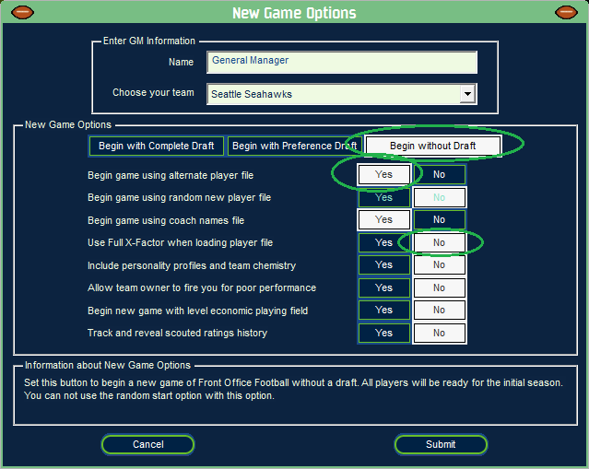

**Begin without Draft**: The roster already has the team/player assignments we want, so no need to go through a draft.

**Begin game using alternate player file**: The most important setting, this tells the game that we have a custom roster we want to use. It will ask for the location of the .fdt roster file.

**Use Full X-Factor when loading player file**: This can be Yes or No, but if you enable it then the players' skills in-game may deviate significantly from what you actually specified in the roster. Set this to No to tell the game not to do that. There will still be some variation but not nearly as much.

After clicking Submit, you'll be prompted for the custom roster file. Navigate to and open the converted .fdt file that we created with the game's Player File Generator tool:

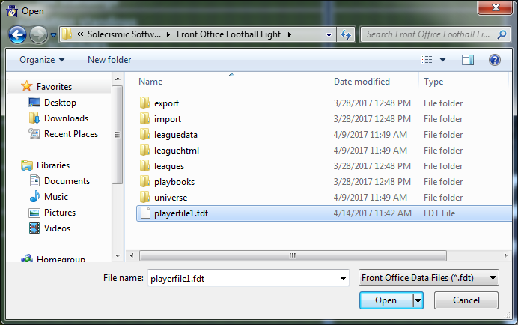

That's it! The game should load the roster and start you at the Training Camp phase.

CREATING A NEW DRAFT CLASS

Select File -> New -> Draft Class from the main menu. The Create Draft Class screen will appear and ask for a few parameters:

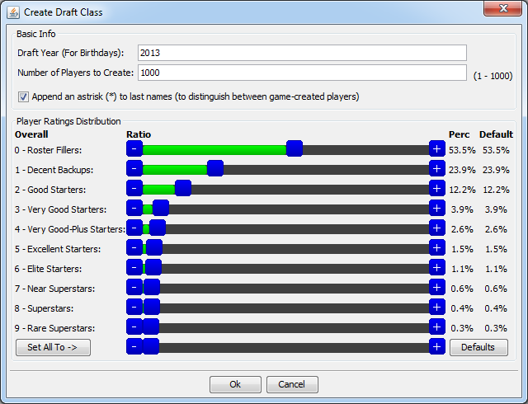

**Draft Year**: Enter the current year of the roster to which you're going to import the draft class.

**Number of Players to Create**: If you create fewer than 1000, the game will create mediocre players to fill the gap up to 1000.

**Append an astrisk to last names**: The game may create some of its own players when you import the draft. Adding astrisks next to player names helps identify which ones were created by this utility.

**Player Ratings Distribution**: Drag the sliders (or click the "+" and "-" buttons) to adjust the percentage of the roster that will be made up of players at that skill level.

Click Ok to create the Draft Class. Here's how it gets created:

1. The specified number of players are created. Roughly the same number of players for each "Position Group" will be created. (Draft Classes have "Position Groups" instead of "Positions", meaning WRs instead of FLs and SEs, CBs instead of LCB/RCB, things like that).

2. Random players are given Overall ratings according to the distribution percentages, then given random values for skills in their Position Group according to their Overall rating (Rating - Min, Max):

Roster Filler - 375, 399

Replacement-Level Starter - 400, 424

Good Starter - 425, 449

Very Good Starter - 450, 474

Very Good-Plus Starter - 475, 499

Excellent Starter - 500, 524

Elite Starter - 525, 549

Near Superstar - 550, 574

Superstar - 575, 599

Rare Superstar - 600, 625

(Note the Overall rating is not actually supported or included in the draft class file; it's only used internally by this tool to pick the min/max range of position group skills. Those skill numbers are the only ones that matter for players in a draft class.)

After clicking Ok, the Draft Class is created and the following screen will appear:

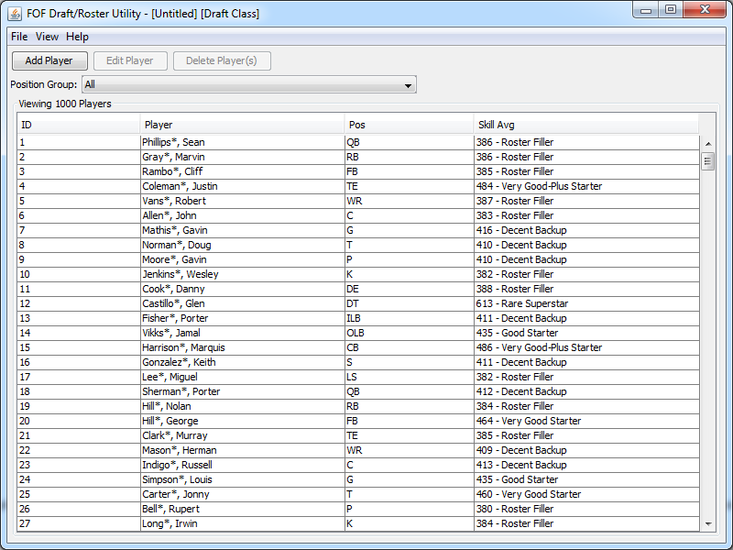

Use the Position Group dropdown to filter the players in the table.

Sort ascending/descending by clicking on the column headers.

The Skill Avg column is the average of the player's skills specific to his Position Group.

To Add or Edit a player, click the Add Player button or select a player in the table and click the Edit Player button. You can also right-click players for a popup menu. The Edit Player screen will appear:

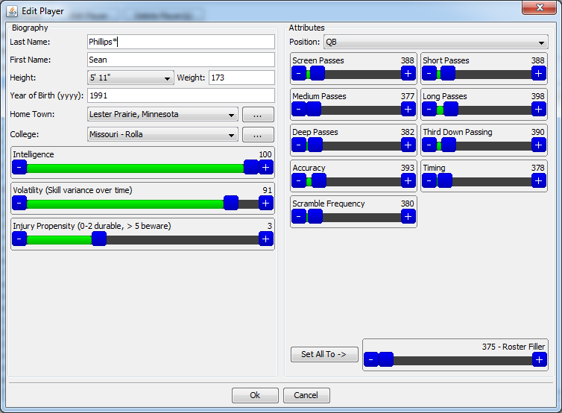

The ellipsis (...) buttons will show a popup window to change the respective field.

You can change the player's skills by dragging the slider's middle blue button, or clicking its +/- buttons.

You might notice that some attributes are "missing" from this screen. That's because the following skills are not supported as CSV fields by the game and/or converter tool, even though the player's info screen has blue bars for them:

Sense Rush

Read Defense

Two-Minute Offense

Kick Holding

Speed to Outside

Blitz Pickup

Blocking Strength

Adjust to Ball

Bump-and-Run

Pass Rush Strength

Punishing Hitter

Play Diagnosis

However, offensive ball carriers (RB, FB, WR, TE) have an "Avoid Fumbles" skill which I believe doesn't appear anywhere in the game.

Click Ok to apply your changes (add or edit player), or Cancel to change your mind.

Add/edit/delete any other players you want. Once you're satisfied with the draft class, choose File -> Save from the main menu bar. You'll be asked to choose a location and name for the CSV file:

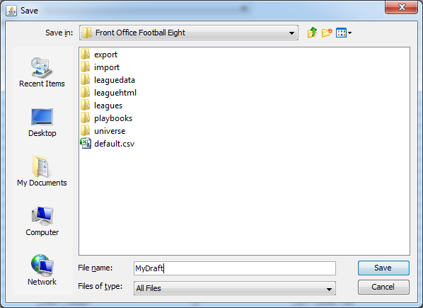

Choosing the Save/Load Folder is recommended. Enter a name for the draft file ("MyDraft" in this case) and click Save. Including ".csv" extension in the file name is optional, as this utility will add it if needed. A file called "MyDraft.csv" will be created and the game's Draft File Generator tool should appear:

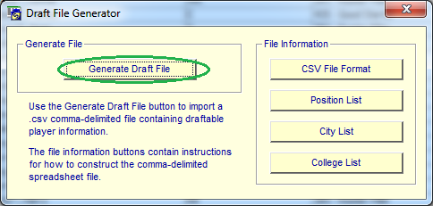

Click the Generate Draft File button and navigate to your Draft CSV file:

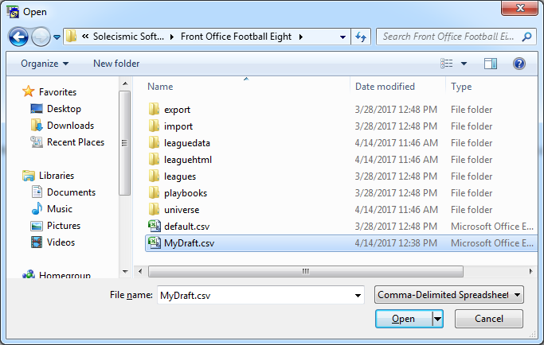

After selecting your draft file and clicking Open, you will then be prompted for the location of the converted (.faf) draft file:

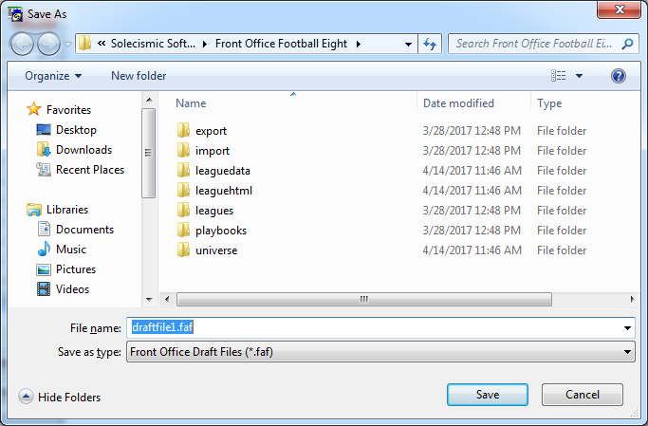

Choosing the Save/Load Folder is recommended. Click Save and you should get a "Conversion Completed" message indicating success. Close the Draft File Generator tool and switch to the game. Get your roster to the Pre-Free Agency phase and then click the Import Draft button:

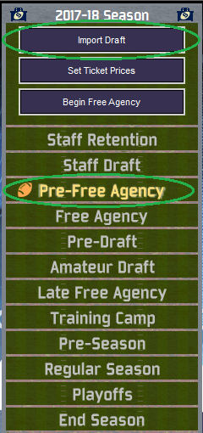

You'll be prompted for the custom draft file. Navigate to and open the converted .faf file that we created with the game's Draft File Generator tool:

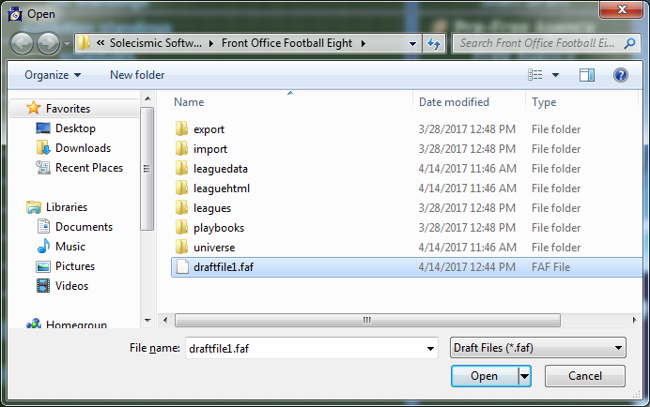

That's it! You should get a "Draft imported successfully" message from the game. Now you can begin Free Agency (don't forget ticket prices and franchise tags first) and view the Draft Preview to see your custom rookies:

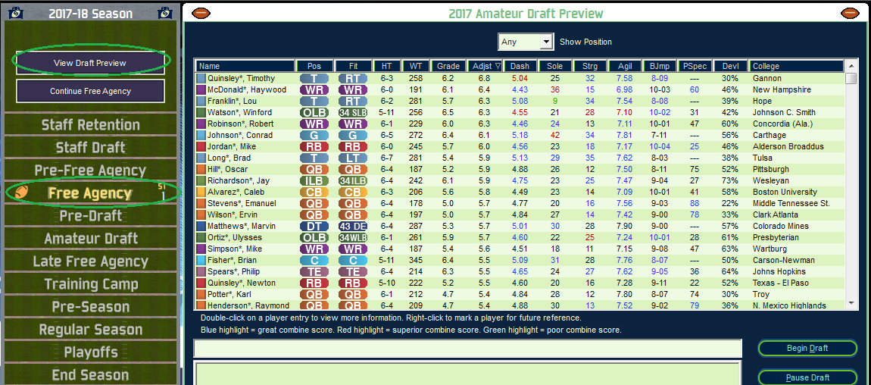

OPTIONS

Navigate to View -> Options from the main menu bar. The following screen will appear:

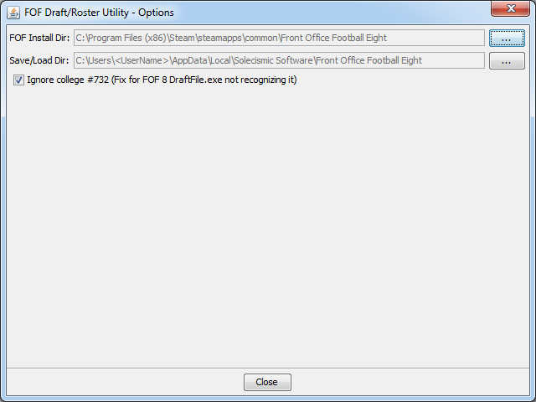

**FOF Install Dir**: The folder where "Front Office Football Seven.exe" or "Front Office Football Eight.exe" exists. The utility needs to know this location so it can parse the teams, colleges, and cities from the game's files. Click the Elipsis (...) button to change the game's install folder, in case you upgraded from 7 to 8 or re-installed the game into a different folder.

**Save/Load Dir**: The folder where all save and load prompts from this utility will default to. This is for convenience so you don't have to re-navigate through the file picker every time. Click the Elipsis (...) button to select a different folder.

**Ignore College #732**: As of this writing (April, 2017), the DraftFile.exe tool that shipped with FOF 8 does not support the new "Colo. St. - Pueblo" college (ID 732). This setting makes the utility to ignore that college so the game's tool doesn't refuse the CSV file for invalid entries. This setting has no effect if you're using FOF 7.