Artificial Neural Network (SL2)
Roll No. 32501
Name: Anil Babasaheb Abhange

Problem Statement :
Write a Python program to plot a few activation functions that are being used in neural networks.
Group_A1.py

import numpy as np
import matplotlib.pyplot as plt

# Define activation functions
def sigmoid(x):
return 1 / (1 + np.exp(-x))

def relu(x):
return np.maximum(0, x)

def tanh(x):
return np.tanh(x)

def leaky_relu(x, alpha=0.01):
return np.where(x > 0, x, alpha * x)

# Function to plot the activation functions
def plot_af(function, function_name):
x = np.linspace(-10, 10, 200)
y = function(x)
plt.plot(x, y, label=function_name)

# Plot all activation functions
plot_af(sigmoid, 'Sigmoid')
plot_af(relu, 'ReLU')
plot_af(tanh, 'Tanh')
plot_af(leaky_relu, 'Leaky ReLU')

# Labels and title
plt.xlabel('x')
plt.ylabel('f(x)')
plt.title('Activation Functions')
plt.legend()
plt.show()

# Output
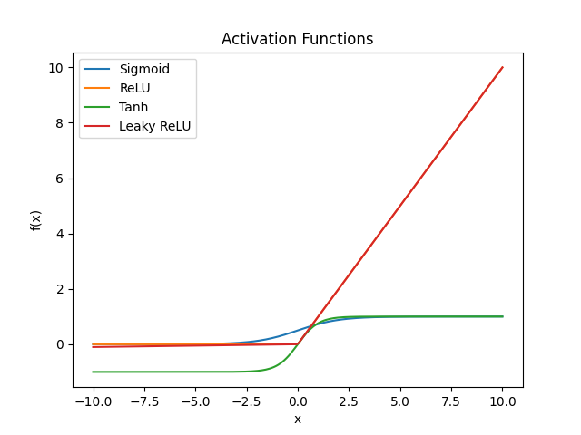

Explanation :-
This code is used to visualize different activation functions used in deep learning and neural networks. Let's break it down step by step in a simple way.

1️⃣ Importing Necessary Libraries
import numpy as np
import matplotlib.pyplot as plt
- numpy (imported as np): A powerful Python library for mathematical operations.
- matplotlib.pyplot (imported as plt): A library used to create graphs and plots.

2️⃣ Defining Activation Functions
Activation functions decide how neurons in a neural network process input values. Each function takes an input x and transforms it.
🔹 Sigmoid Function
def sigmoid(x):
return 1 / (1 + np.exp(-x))
- Converts any value into a range between 0 and 1.
- Used in probability-based models and older neural networks.
- Example: If x = 0, sigmoid(0) = 1 / (1 + e^0) = 0.5.
Graph Behavior
- Small x → Near 0
- Large x → Near 1
- Symmetric around x=0.

🔹 ReLU (Rectified Linear Unit) Function
def relu(x):
return np.maximum(0, x)
- If x is positive, it stays the same.
- If x is negative, it becomes 0.
- Helps neural networks learn faster.
Graph Behavior
- x < 0 → Output is 0
- x >= 0 → Output is x

🔹 Tanh (Hyperbolic Tangent) Function
def tanh(x):
return np.tanh(x)
- Similar to sigmoid, but outputs values between -1 and 1.
- Used in hidden layers of neural networks.
Graph Behavior
- x < 0 → Output is between -1 and 0
- x > 0 → Output is between 0 and 1
- Better than sigmoid because it centers around zero.

🔹 Leaky ReLU Function
def leaky_relu(x, alpha=0.01):
return np.where(x > 0, x, alpha * x)
- Similar to ReLU, but allows small negative values.
- Uses alpha * x (default: 0.01 * x) for negative inputs to prevent neurons from "dying" (always being 0).
- Used in deep learning models.
Graph Behavior
- x > 0 → Output is x
- x < 0 → Output is 0.01 * x (small negative value)

3️⃣ Function to Plot the Activation Functions
def plot_af(function, function_name):
x = np.linspace(-10, 10, 200)
y = function(x)
plt.plot(x, y, label=function_name)
- np.linspace(-10, 10, 200)
  - Creates 200 points between -10 and 10 for a smooth graph.
- function(x)
  - Calls the activation function (sigmoid, relu, tanh, etc.).
- plt.plot(x, y, label=function_name)
  - Draws the function curve with a label.

4️⃣ Plotting All Activation Functions
plot_af(sigmoid, 'Sigmoid')
plot_af(relu, 'ReLU')
plot_af(tanh, 'Tanh')
plot_af(leaky_relu, 'Leaky ReLU')
- Calls plot_af for each activation function, so all functions appear in one graph.

5️⃣ Adding Labels and Showing the Plot
plt.xlabel('x') # Label for x-axis
plt.ylabel('f(x)') # Label for y-axis
plt.title('Activation Functions') # Graph title
plt.legend() # Displays the function names
plt.show() # Shows the final graph
- plt.xlabel('x') → Names the x-axis.
- plt.ylabel('f(x)') → Names the y-axis.
- plt.title('Activation Functions') → Adds a title.
- plt.legend() → Adds a legend to show function names.
- plt.show() → Displays the graph.

📌 Summary
- The code defines four activation functions used in deep learning.
- It plots all functions using matplotlib.pyplot.
- It labels the axes and adds a legend.
- Finally, it displays the activation function curves.

📊 What the Graph Will Show
- Sigmoid → S-shaped curve (output: 0 to 1).
- ReLU → Straight line for positive x, zero for negatives.
- Tanh → S-shaped curve (output: -1 to 1).
- Leaky ReLU → Like ReLU but allows small negative values.
This graph helps visualize how each function behaves in a neural network.

🚀 Why This Code is Useful
- Helps understand activation functions visually.
- Used in deep learning to decide how neurons fire.
- Different functions are better for different tasks.
Hope this helps! 😊

