# **A Plus Holidays & Travels**

## **Dataset – Booking Data**

### Cleaning Process

* Converted the entire dataset to a table for faster processing of formulas.
* After careful consideration there are 6 columns that needed cleaning they are **“Booking ID”, “Agent”, “Country”,** **“Payment Date”, “Payment Status”, “Total Amount”.**

### Cleaning Process for “Total Amount”

* **Used TRIM to clean any white spaces**Step 1: “TRIM([@[Total Amount]])”
* **Used to “SUBSTITUTE” to remove “INR” and Comma**

Step 2: “SUBSTITUTE([@TRIM],"INR","")”

Step 3: “SUBSTITUTE([@[Removing "INR"]],",","")

* **Used VALUE to covert the col from string to “Numeric”**

Step 4: “VALUE([@[Removing Comma]])”

### Cleaning Process for “Payment Status”

* “Payment Status” is a Categorical column
* It has 3 values “Paid”, “Pending”, “Cancelled”
* The column had “PAID” which was converted to “Paid”

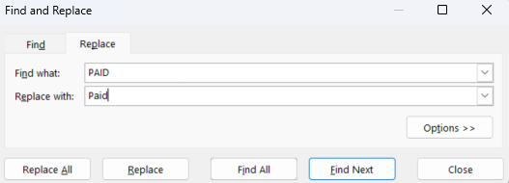

* 557 replacements are made

### Cleaning Process for “Payment Status”

* First I removed all the “None” to BLANK
* 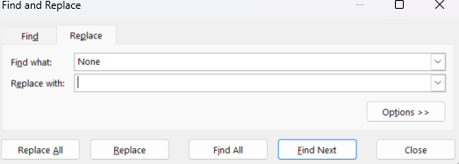
* I have used custom formatting to standardize the “Payment Date” col.

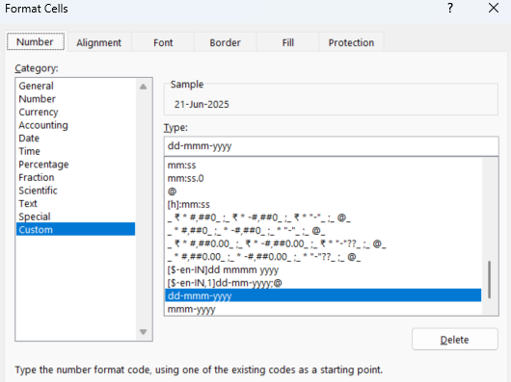

### Cleaning Process for “Country”

* In order to standardize the Country col I have converted “United Arab Emirates” to “UAE”

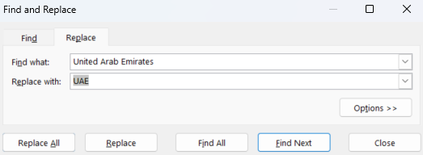

* 143 replacements are made

### Cleaning Process for “Booking ID”

* There were duplicate rows in the “Booking ID” col which was then removed
* 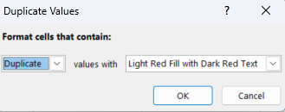

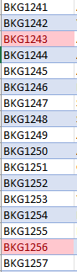

* Removed all the duplicates value using “Remove Duplicates” from the data tab
* 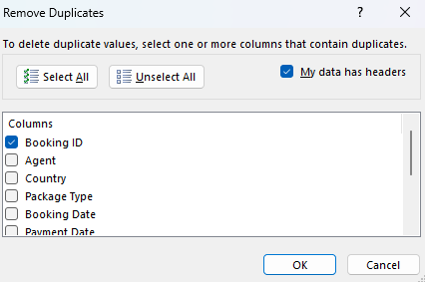
* 

### Cleaning Process for “Country”

* Agent col had some inconsistency with names. I have cleaned them and removed the white spaces.

“**Agent_Cleaned**” col – “=TRIM([@Agent])”

## **Data Modelling:**

* After cleaning the data I added the “**Bookings_data**” to the data model to calculate measures.

### These are the queries I have used to create these measures

* **Average Revenue**  
  “AVERAGE(Booking_Data[Total_Amount_Clean])”
* **Paid_Perct%**

“DIVIDE(COUNTROWS(FILTER(Booking_Data, Booking_Data[Payment Status] = "Paid")), COUNTROWS(Booking_Data))”

* **Cancellation%**

**“**DIVIDE(  
 COUNTROWS(  
 FILTER(Booking_Data, Booking_Data[Payment Status] = "Cancelled")) ,

COUNTROWS(Booking_Data))”

* **Commission_Perct  
  “**AVERAGE([Commission_Perct])”
* **Total Commission Earned**

**“**SUM(Booking_Data[Commission_Earned])”

* **MoM_Growth%**
* **Total Revenue** = “SUM(Booking_Data[Total_Amount_Clean])”
* **Previous_Month_Revenue** = “CALCULATE(SUM(Booking_Data[Total_Amount_Clean]), PARALLELPERIOD('Calendar'[Date], -1, MONTH))”
* MoM_Growth% = “DIVIDE([Total_Revenue] - [Previous_Month_Revenue], [Previous_Month_Revenue])”
* **AR_Days**
* Created a calculated col for “Booking Lead Time”

“IF(  
 AND(

NOT(ISBLANK([Payment Date])), [Payment Date] >= [Booking Date]),

DATEDIFF([Booking Date], [Payment Date], DAY), BLANK())”

## **Dashboard Insights – Performance Table**

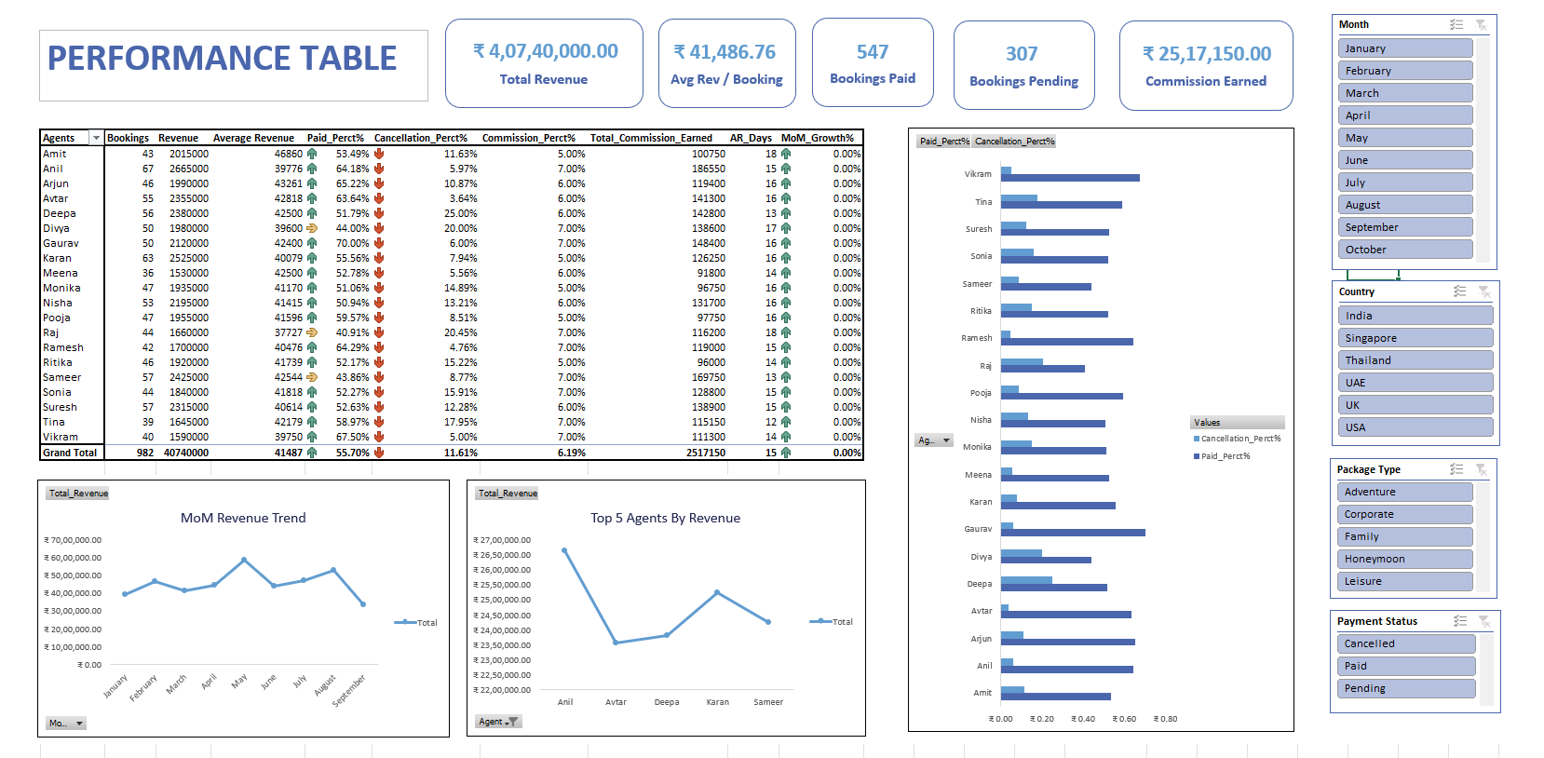

## **Insights:**

**This dashboard presents a clear summary of booking performance, agent effectiveness and Revenue metrics for the year 2025.**

**Key Performance Insights:**

* **Total Revenue generated** is ₹ 4,07,40,000.00, spread across 982 bookings.
* **Average Revenue per Booking** stands at ₹ 41,486.76, highlighting revenue efficiency per transaction.
* **Bookings Paid** are 547, and Bookings Pending total 307, indicating a substantial portion of bookings are yet to be finalized.
* **Commission Earned**so far is ₹ 25,17,150.00, with an average commission percentage of about 6.19% across agents.

**Agent and Booking Analysis:**

* **Top performing agent by revenue** is **Anil**, with revenue exceeding **₹ 26,65,000**.
* **Highest Paid Percentage** for an agent is **Vikram**, at **58.76%**, showing better payment reliability.
* **Highest Cancellation Percentage** is with **Divya**, at **20.00%**, suggesting a need for follow-up or process improvement.

**Trends:**

* **Revenue saw a peak in May**, hitting the highest point of the year, and declined in September, indicating possible seasonality in bookings