

TRIBHUVAN UNIVERSITY
INSTITUTE OF ENGINEERING
PASCHIMANCHAL CAMPUS

A project on
‘Movie Ticket Booking System’

Submitted By:
Name: Bianyek Banstola
Roll no: PAS080BCT011

Submitted To:
Name: Hari Prasad Baral
Department of computer and electronic engineering

TABLE OF CONTENT

 | Page no.
- Introduction | 2
- Objectives | 2
- Key Features | 2
- Scope | 2
- Algorithm | 3
- Flowchart | 5
- Source Code | 7
- Output | 23
- Further Development | 26
- Conclusion | 26
- Reference | 26

- Introduction
In this tech world, being in a line, booking a small handwritten sheet as a ticket, and watching a movie is so boring. Especially when there are so many over-the-top (OTT) platforms through which you can watch movies anywhere, it's time to revolutionize the booking system. To make the process more managed and user-friendly, there is a need for a digital platform through which a business vendor can add his or her movie details, edit them if needed, and a customer can remotely book their ticket. That's why I present this project, which will meet today's need for movie ticket booking.

- Objectives
The main objective of this project is to provide movie hall managers with a convenient and effective way to enlist their daily business, like movies available, to store data digitally, and to offer customers a user-friendly interface and a seamless booking experience.

- Key features
- Interface: This project has two separate interfaces for business managers and customers.
- Movie Listings: Movie Hall employees are able to add and edit a wide selection of movies, including the latest releases, schedule upcoming movies, etc.
- Showtimes: The system provides detailed information on showtimes for each movie, allowing users to choose the most suitable timing for their moviegoing experience.
- Login: Users can register their account and login to book seats. This increases security and prevents spam bookings.
- Seat Reservation: The system enables users to select their desired seats in the theater, subject to availability.

- Scope
This project is for movie halls. With the help of the web, a front end, and an efficient database, we can use this project in an online system as well as at the counter of a movie hall. The scope isn't limited to this. Little changes can allow this project to manage the bus system, events, and other ticket booking systems.

- Algorithm
System Algorithm
- User Interaction:
  - The system presents options for both business owners and customers.
- Business Side:
  - Business owners can add new movies and edit existing movie details, such as available seats.
- Customer Side:
  - Customers can view available movies and book tickets.
- User Authentication (Customer Side):
  - Customers are required to log in or register before booking tickets.
- Data Persistence:
  - Movie details, user credentials, and booking records are stored persistently in files or a database.
- Error Handling:
  - The system provides appropriate error messages to users.
  - Common errors include invalid inputs, unavailable seats, and authentication failures.
- Integration:
  - The business and customer sides interact with shared data files or a database to ensure consistency.
- Feedback and confirmation:
  - Users are notified of successful bookings and provided with booking details for reference.
Code Algorithm
Business interface
- Main Function:
  - Display a welcome message for the Movie Ticket Booking System.
  - Ask the user to choose an action: add a movie, edit movie seats, or exit.
  - If the user chooses to add a movie, call the add() function.
  - If the user chooses to edit movie seats, call the edit() function.
  - Repeat the process until the user chooses to exit.
- Add Function (add()):
  - Clear the screen.
  - Prompt the user to enter the date (month and day).
  - Generate a filename based on the entered date.
  - Open the file for writing.
  - Prompt the user to enter the number of movies to add.
  - For each movie:
    - Prompt the user to enter movie details: name, time, and available seats.
    - Write movie details to the file.
  - Close the file.
  - Display a success message.
- Edit Function (edit()):
  - Clear the screen.
  - Prompt the user to enter the date (month and day) to edit movie seats.
  - Generate the filename based on the entered date.
  - Open the file for reading and writing.
  - Display the movie schedule for the chosen date.
  - Ask the user to choose the movie they want to edit.
  - Move the file pointer to the chosen movie's position.
  - Display the current available seats for the chosen movie.
  - Ask the user to manipulate seats (edit available seats).
  - Provide an option to edit more seats.
  - Create a temporary file.
  - Copy all lines until the edit section to the temporary file.
  - Write updated seats to the temporary file.
  - Copy the remaining lines to the temporary file.
  - Close both files.
  - Delete the original file.
  - Rename the temporary file to the original filename.
  - Clear the screen.
  - Display a success message.
Customer interface
- Main Function:
  - Display a menu for the customer to choose an action: View available movies and seats. Book movies, or Exit.
  - If the user chooses to View movies, call the view() function.
  - If the user chooses to Book movies, call the book() function.
  - Repeat the process until the user chooses to exit.
- View Function (view()):
  - Clear the screen.
  - Prompt the user to enter the date (month and day) to view movie schedules.
  - Generate the filename based on the entered date.
  - Open the file for reading.
  - Display the movie schedule for the chosen date.
  - Close the file.
- Book Function (book()):
  - Clear the screen.
  - Prompt the user to log in.
    - If the user chooses to Register:
      - Prompt the user to enter a username and password.
      - Save the username and password to the "login.txt" file.
    - If the user chooses to Login:
      - Prompt the user to enter a username and password.
      - Check if the entered credentials match any in the "login.txt" file.
        - If matched, proceed with booking.
        - If not matched, display an error message.
    - If the user chooses to Exit, return to the main menu.
  - Prompt the user to enter the date (month and day) to book a movie.
  - Generate the filename based on the entered date.
  - Open the file for reading and writing.
  - Display the movie schedule for the chosen date.
  - Ask the user to choose the movie they want to book.
  - Display the current available seats for the chosen movie.
  - Ask the user to book seats.
  - Update the seat status in the array and display a success message.
  - Provide an option to book more seats.
  - Create a temporary file.
  - Copy all lines until the edit section to the temporary file.
  - Write updated seats to the temporary file.
  - Copy the remaining lines to the temporary file.
  - Close both files.
  - Delete the original file.
  - Rename the temporary file to the original filename.
- Login Function (login()):
  - Display a menu for the user to choose: Register, Login, or Exit.
  - If the user chooses to Register:
    - Prompt the user to enter a username and password.
    - Save the username and password to the "login.txt" file.
    - Display a success message.
  - If the user chooses to Login:
    - Prompt the user to enter a username and password.
    - Check if the entered credentials match any in the "login.txt" file.
      - If matched, return 1 (Login successful).
      - If not matched, display an error message and return 0 (Login failed).
  - If the user chooses to Exit, return 0 (Exit program).
  - If the user chooses an invalid option, display an error message and return 0 (Invalid choice).

- Flowchart
Code flowchart (Business Part)
Start Movie ticket Booking system Entry point of the program

Display Menu options
- Add movies
- Edit movies seats
- exit

Terminate program
Edit
Add
1 or 2 or 3

Validate Seats
Ensure that the entered seat values are either 0 available or 1 booked .

Close File
Close the file after the seat are added.

Write Movie Details to File
Write the movie information name, time, and available seats to the opened file.
Get Movie Details
Prompt the user to enter the movie name, time, and available seats.

Add Movie Loop
Iterate through the number of movies to be added.
Get Number of Movies
Prompt the user to enter the number of movies to be added
Open File for Reading and Writing
Open the file with the generated name for both reading and writing.
Generate File Name
Create a file name based on the entered date in the format 'MM_DD.txt'.
Get Date
Prompt the user to enter the month and day for the movie.
Close File
Close the file after the seat updates are complete.
Update File
Rewrite the updated seat information to the file.
Edit Seats
Prompt the user to update the availability of specific seats.
Display Seats
Print the current availability of seats for the selected movie.

Read Movie Details
Read the details of the selected movie from the file.
Get Movie Choice
Prompt the user to select the movie they want to edit.
Display Movies
Print the list of movies available for the given date
Open File for Reading and Writing
Open the file with the generated name for both reading and writing.

Get Date
Prompt the user to enter the month and day for the movie.
Generate File Name
Create a file name based on the entered date in the format 'MM_DD.txt'.
Start edit Movie
Entry point for adding a new movie
Start Add Movie
Entry point for adding a new movie

- Source code
//business side interface for movie ticket booking system

//declaration section
#include<stdio.h>
#include <stdlib.h>
#include<conio.h>
#include<string.h>

//for generating file name
struct date {
int m, day;
};

//for reading details of movie
struct movie {
char name[20];
struct time {
int ho, min;
} t1;
int seat[5][3];
};

//function declaration
void add();
void edit();

int main(){
char d=' ';
printf("\n\n%49cMovie Ticket Booking System\n",d);

int ch;
top:
printf("\nwhat do you want to do? press respective number\n");
printf("1. add movie \n2. edit movie seats \n3. press anything to exit");
scanf("%d",&ch);
switch(ch){
case 1:
add();
break;
case 2:
edit();
break;
default:
printf("invalid choice");
}
char n;
printf("if you want to continue press Y or type anything else\n");
n=getch();
if(n=='y'||n=='Y'){
goto top;
}
return 0;
}
void add() {
system("cls");
printf("Enter date (month and day): ");
struct date d;
scanf("%d %d", &d.m, &d.day);

// Generate filename
char filename[20];
sprintf(filename, "%02d_%02d.txt", d.m, d.day);

// Open file for writing
FILE *file = fopen(filename, "w");
if (file == NULL) {
printf("Error opening file.\n");
return;
}
int num_movies;
printf("Enter the number of movies you want to add: ");
scanf("%d", &num_movies);

for (int i = 0; i < num_movies; i++) {
struct movie m;
//input section for movie details
printf("Enter movie name: ");
scanf("%s", m.name);
printf("Enter movie time (hour and minute): ");
scanf("%d %d", &m.t1.ho, &m.t1.min);
printf("Enter available seats (5x2 matrix) press 0 for available 1 for booked :\n");
for (int j = 0; j < 5; j++) {
for (int k = 0; k < 3; k++) {
b:
printf("[%d][%d]",j+1,k+1);
scanf("%d", &m.seat[j][k]);

// checking garbage value
if (!(m.seat[j][k]==0 || m.seat[j][k]==1)){
printf("invalid value");
goto b;
}
}
}

// Write movie details to file
fprintf(file, "Name: %s\nTime: %02d:%02d\nAvailable Seats:\n", m.name, m.t1.ho, m.t1.min);
for (int j = 0; j < 5; j++) {
for (int k = 0; k < 3; k++) {
fprintf(file, "%d ", m.seat[j][k]);
}
fprintf(file, "\n");
}
fprintf(file, "\n");
}
system("cls");
fclose(file); // Close file
printf("\n \n Movies added successfully.\n\n");
}
void edit(){
system("cls");
printf("Enter date (month and day) to edit movie: ");
struct date d;
scanf("%d %d", &d.m, &d.day);

char filename[20];
sprintf(filename, "%02d_%02d.txt", d.m, d.day); // Generate filename

FILE *file = fopen(filename, "r+"); // Open file for reading and writing
if (file == NULL) {
printf("No movies for this day.\n");
return;
}

int line_number,i;
printf("Movie schedule for %02d/%02d:\n", d.m, d.day);
printf("--------------------------------\n");
char line[100];
while (fgets(line, sizeof(line), file) != NULL) {
printf("%s", line);
line_number++;
}
printf("--------------------------------\n");

// Ask which movie to edit
int movie_choice;
printf("Enter the movie number you want to edit: press 1 for first movie; 2 for second and so on");
scanf("%d", &movie_choice);

rewind(file); //fseek(file, 0, SEEK_SET); // Move file pointer to the beginning

system("cls");

// Skip lines until the chosen movie
for (i = 1; i <=((movie_choice-1) * 9); i++) { // Each movie entry is 8 lines (including empty lines)
fgets(line, sizeof(line), file);
}

fgets(line, sizeof(line), file); // Skip movie name line
fgets(line, sizeof(line), file); // Skip movie time line
fgets(line, sizeof(line), file); // Skip Available Seats header or could have done +3 above

// Display current available seats for the chosen movie
int seats[5][3]={0,0,0,0,0,0,0,0,0,0,0,0,0,0,0};
printf("Current available seats for the chosen movie:\n");
for (i = 0; i < 5; i++) {
fscanf(file, "%d %d %d", &seats[i][0], &seats[i][1], &seats[i][2]);
printf("%d %d %d\n", seats[i][0], seats[i][1], seats[i][2]);
}

// Ask user to manipulate seats
int row, col, value;
char n;
edit1:
b:
printf("Enter row and column numbers (1-5, 1-3) and value (0 for available, 1 for booked): ");
scanf("%d %d %d", &row, &col, &value);
if (!(value==0 || value==1)){
printf("invalid value");
goto b;
}

// Update the seat in the array
seats[row - 1][col - 1] = value;

//giving option to manipulate more
printf("if you want to continue press Y or type anything else\n");
n=getch();
if(n=='y'||n=='Y'){
goto edit1;
}

// Create a temporary file
FILE *temp_file = fopen("temp.txt", "w");
if (temp_file == NULL) {
printf("Error creating temporary file");
fclose(file);
return;
}

// copying all line till edit section to temp file
rewind(file);
for (i = 1; i <=((movie_choice-1) * 9+3); i++) {
fgets(line, sizeof(line), file);
fputs(line, temp_file);
}

int c=i+6;
// Write updated seats to the temp file
for (i = 0; i < 5; i++) {
fgets(line, sizeof(line), file);
fprintf(temp_file, "%d %d %d\n", seats[i][0], seats[i][1], seats[i][2]);
}

//to move through blank line in original file
fgets(line, sizeof(line), file);

//copying remaining line to the temp file
for(c;c<=line_number;c++){
fgets(line, sizeof(line), file);
fputs(line, temp_file);

}

// Close both files
fclose(file);
fclose(temp_file);
// Delete the original file
remove(filename);

// Rename the temporary file to the original filename
rename("temp.txt", filename);

system("cls");

printf("\n\nMovie seats edited successfully.\n \n");
}

//Customer side interface for movie booking system

//declaration section
#include<stdio.h>
#include <stdlib.h>
#include<conio.h>
#include<string.h>
#include <stdbool.h>

void view();
void book();
int login();

//for generating file name
struct date {
int m, day;
};

int main(){
char n;
char d=' ';
printf("\n\n%49cMovie Ticket Booking System\n",d);

top:

printf("\nwhat do you want to do? press respective number\n");
printf("1. view available movies and seats \n2. book movies \n3. press any number to exit");
scanf("%d",&n);
switch(n){
case 1:
view();
break;
case 2:
book();
break;
default:
printf("invalid choice");
}
system("cls");
printf("Want to continue press Y else press anything\n");
n=getch();
if(n=='y'||n=='Y'){
goto top;
}
return 0;
}

void view() {
system("cls");
printf("Enter date (month and day) to view movie: ");
struct date d;
scanf("%d %d", &d.m, &d.day);

char filename[20];
sprintf(filename, "%02d_%02d.txt", d.m, d.day); // Generate filename

FILE *file = fopen(filename, "r"); // Open file for reading and writing
if (file == NULL) {
printf("No movies for this day.\n");
return;
}

int line_number,i;
printf("Movie schedule for %02d/%02d:\n", d.m, d.day);
printf("--------------------------------\n");
char line[100];
while (fgets(line, sizeof(line), file) != NULL) {
printf("%s", line);
line_number++;
}
printf("--------------------------------\n");
fclose(file);
}

void book(){
system("cls");
printf("\n\nyou need to login first\n\n");
b:
int a=login();
if(a==0){
printf("you have to login first");
goto b;
}
Printf("Enter date (month and day) to edit movie: ");
struct date d;
scanf("%d %d", &d.m, &d.day);

char filename[20];
sprintf(filename, "%02d_%02d.txt", d.m, d.day); // Generate filename

FILE *file = fopen(filename, "r+"); // Open file for reading and writing
if (file == NULL) {
printf("No movies for this day.\n");
return;
}

int line_number,i;
printf("Movie schedule for %02d/%02d:\n", d.m, d.day);
printf("--------------------------------\n");
char line[100];
while (fgets(line, sizeof(line), file) != NULL) {
printf("%s", line);
line_number++;
}
printf("--------------------------------\n");

// Ask which movie to bool
int movie_choice;
printf("Enter the movie number you want to book: press 1 for first movie; 2 for second and so on");
scanf("%d", &movie_choice);

rewind(file); //fseek(file, 0, SEEK_SET); // Move file pointer to the beginning

system("cls");

// Skip lines until the chosen movie
for (i = 1; i <=((movie_choice-1) * 9); i++) { // Each movie entry is 8 lines (including empty lines)
fgets(line, sizeof(line), file);
}

fgets(line, sizeof(line), file); // Skip movie name line
fgets(line, sizeof(line), file); // Skip movie time line
fgets(line, sizeof(line), file); // Skip Available Seats header or could have done +3 above

// Display current available seats for the chosen movie
int seats[5][3]={0,0,0,0,0,0,0,0,0,0,0,0,0,0,0};
printf("Current available seats for the chosen movie:\n");
for (i = 0; i < 5; i++) {
fscanf(file, "%d %d %d", &seats[i][0], &seats[i][1], &seats[i][2]);
printf("%d %d %d\n", seats[i][0], seats[i][1], seats[i][2]);
}

// Ask user to book seats
int row, col,e=0;
char n;
edit1:
e++;
ef:
printf("Enter row and column numbers (1-5, 1-3) you want to book: ");
scanf("%d %d", &row, &col);
if (seats[row - 1][col - 1]==1){
printf("that seat is already booked\n\n");
goto ef;
}
else{
printf("\n \n seat booked successfully\n \n");

// Update the seat in the array
seats[row - 1][col - 1] = 1;

//giving option to book more
printf("if you want to book more please type Y or type anything else\n");
n=getch();
if(n=='y'||n=='Y'){
goto edit1;
}
}

system("cls");
printf("\nthank you for booking with us\n");
printf("\nPlease bring %d money when coming to the hall\n",e*150);

// Create a temporary file
FILE *temp_file = fopen("temp.txt", "w");
if (temp_file == NULL) {
printf("Error creating temporary file");
fclose(file);
return;
}

//update in file section
// copying all line till edit section to temp file
rewind(file);
for (i = 1; i <=((movie_choice-1) * 9+3); i++) {
fgets(line, sizeof(line), file);
fputs(line, temp_file);

}

int c=i+6;

// Write updated seats to the temp file
for (i = 0; i < 5; i++) {
fprintf(temp_file, "%d %d %d\n", seats[i][0], seats[i][1], seats[i][2]);
}

//copying remaining line to the temp file
for(c;c<=line_number;c++){
fgets(line, sizeof(line), file);
fputs(line, temp_file);
}

// Close both files
fclose(file);
fclose(temp_file);

// Delete the original file
remove(filename);
// Rename the temporary file to the original filename
rename("temp.txt", filename);
}

int login() {
int choice;
char us[20], pa[20],a[20], b[20];

printf("\nMenu:\n");
printf("1. Register\n");
printf("2. Login\n");
printf("3. Exit\n");
printf("Enter your choice: ");
scanf("%d", &choice);
FILE *fp = fopen("login.txt", "r+");
if (fp == NULL) {
printf("Error opening file.\n");
return 0;
}
switch (choice) {
case 1:
printf("Enter username: ");
scanf("%s", us);
printf("Enter password: ");
scanf("%s", pa);
fseek(fp,0,SEEK_END);
fprintf(fp, "%s %s\n", us, pa);
fclose(fp);
system("cls");
printf("\n\n User registered successfully. You can now book a ticket.\n\n");
return 1; // Registration successful
case 2:
printf("Enter username: ");
scanf("%s", us);
printf("Enter password: ");
scanf("%s", pa);
system("cls");
while (fscanf(fp, "%s %s", a, b) != EOF) {
if (strcmp(a, us) == 0 && strcmp(b, pa) == 0) {
printf("Login successful.\n");
fclose(fp);
return 1; // Login successful
}
}
fclose(fp);
printf("Invalid username or password.\n");
return 0; // Login failed
case 3:
printf("Exiting program.\n");
return 0; // Exit program
default:
printf("Invalid choice.\n");
return 0; // Invalid choice
}
}

- Output

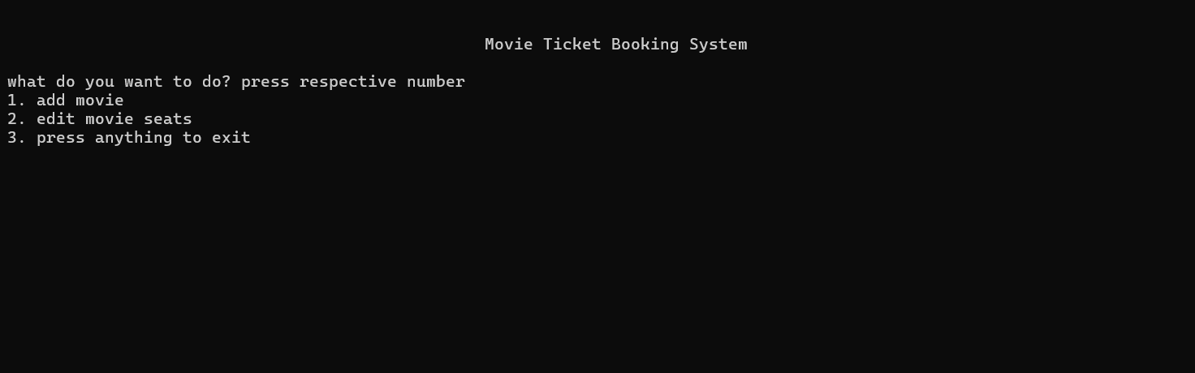
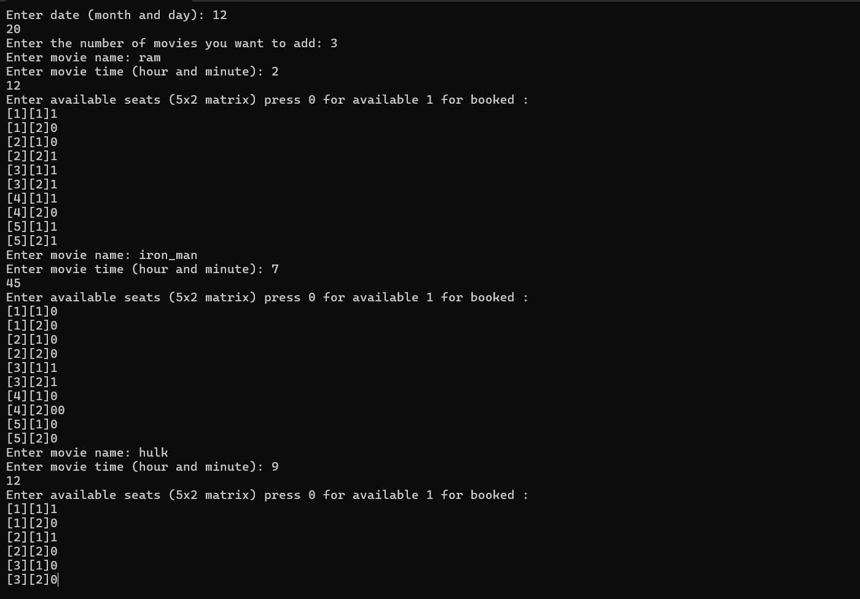

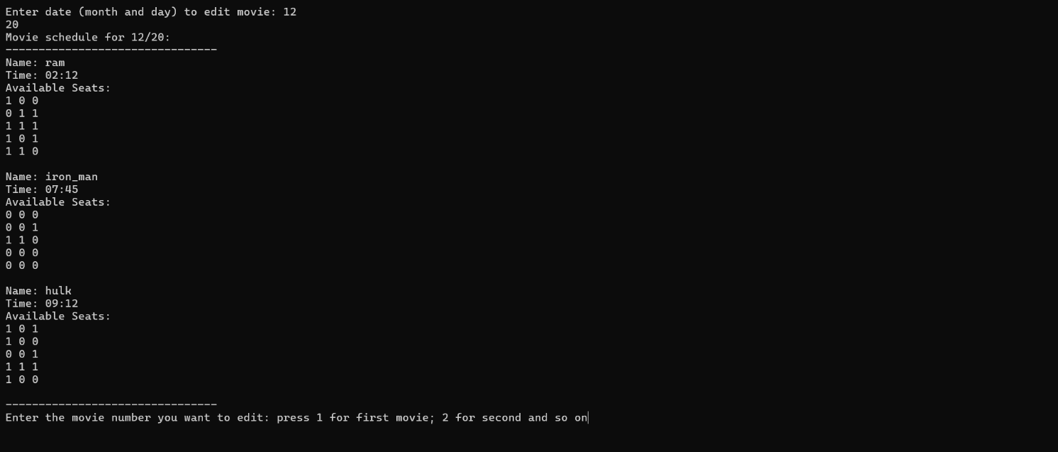

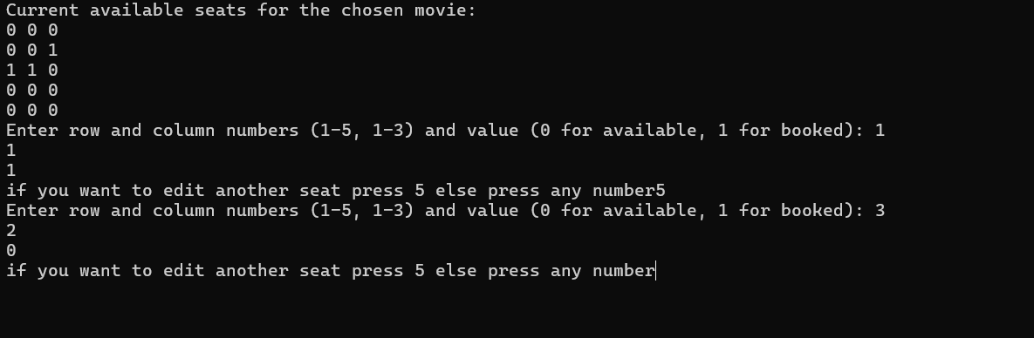
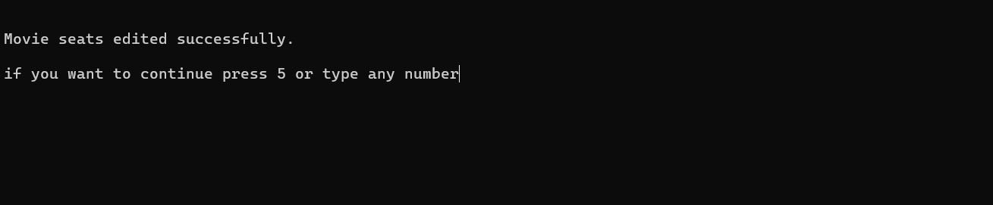
Customer Interface
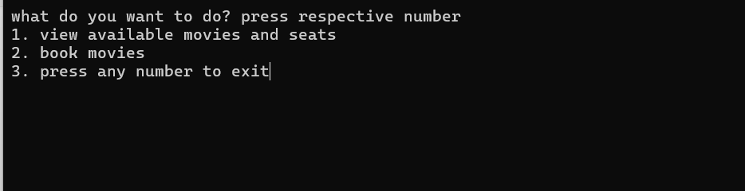
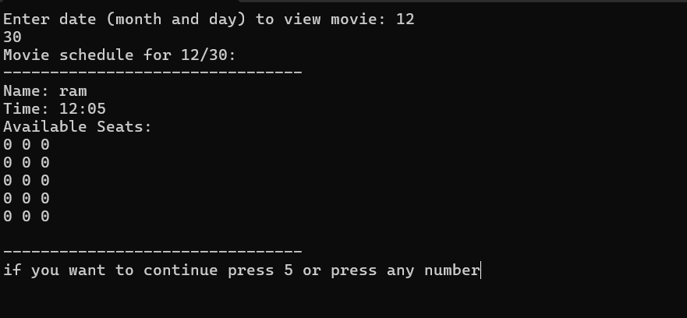

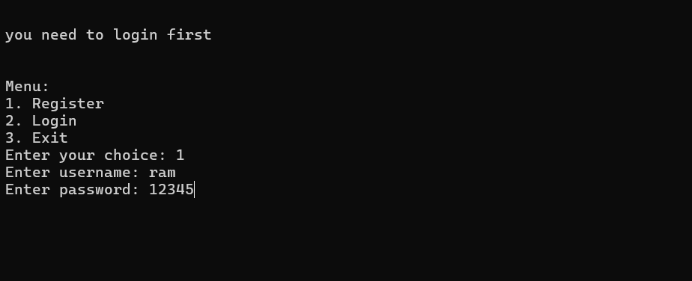
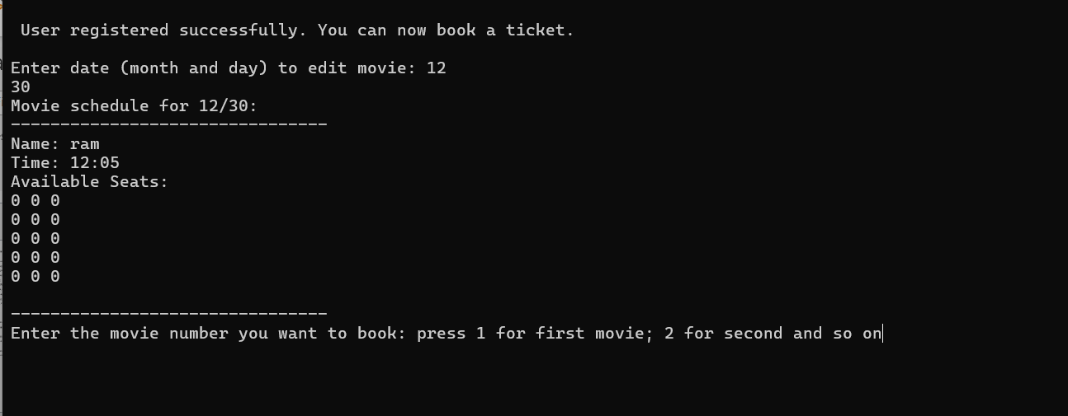
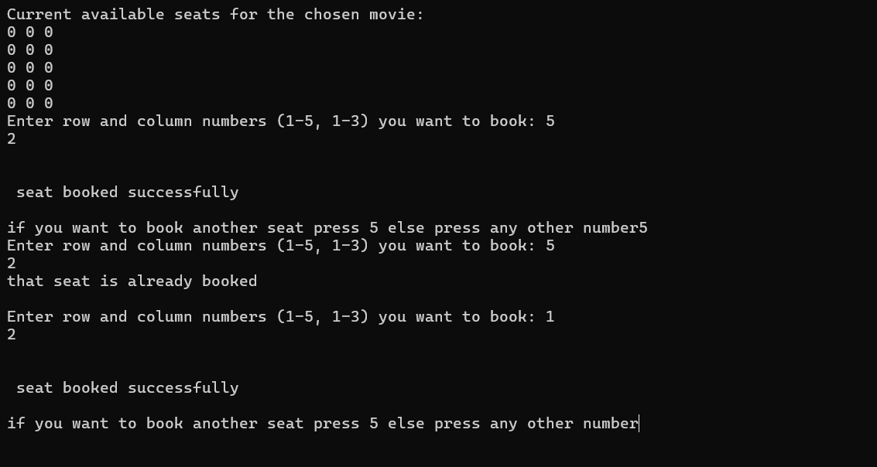
- Future Projection
- Develop a more user-friendly graphical user interface (GUI) using libraries like Tkinter (for Python) or Qt (for C++)
- Integrate a database system (e.g., MySQL, SQLite) to store movie details, user information, and booking records
- Enhance the user authentication system to include features such as password hashing for security
- Integrate payment processing, advanced booking features, etc.

- Conclusion
Project
To sum up, the initial code of the movie ticket booking system offers a fundamental structure for users and business owners to interact with the system. It has regular functions like adding new films, changing movie details, seeing the movies that are currently available, and making ticket reservations. While the current implementation serves as a starting point, there are several areas for further development and improvement.

I was able to utilize most of my knowledge about the C language in this project. While I drafted the framework and how it should be, I did look up through Google about syntax and more effective lines of code. I realize there are other prospects, like graphic, of which, if I have prior knowledge, the project will be even better. I am looking forward to working on similar projects because it has boosted my knowledge and encouraged me to do more research.

- References
Codetoflow; https://codetoflow.com/
Google;

