BINCOM ACADEMY - CLASS ASSIGNMENT 1
TECHNICAL CODE DOCUMENTATION & PROJECT REPORT
Student Name: | Shuraihu Usman
Program Track: | PHP / Backend Web Development Intern
Academy: | Bincom Academy
Organization: | Bincom-Academy-PHP-Assignments
Project Title: | PHP Class Assignment 1 - HTML & CSS Overview
GitHub Repository: | https://github.com/Bincom-Academy-PHP-Assignments/PHP-Class-Assignment-1

1. Executive Summary & Project Overview
This document serves as the official technical documentation for PHP Class Assignment 1 at Bincom Academy. The assignment demonstrates the practical implementation of foundational web concepts: setting up the local development environment (XAMPP / WAMP), configuring code editors, structuring pages with semantic HTML5, and applying modern CSS styling governed strictly by the CSS Box Model (margins, padding, content) with clean flat aesthetics (zero borders and zero shadows).

2. Lesson 1 Syllabus Topics Covered
- Setup Local Server (XAMPP/WAMP): Understanding the role of local servers like Apache, MySQL, and PHP runtime environments. Familiarity with local directory mapping: C:\xampp\htdocs\ for XAMPP and C:\wamp64\www\ for WAMP.
- Setup Environment (Text Editor / Tools): Configuring industry-standard text editors (Sublime Text, VS Code) with syntax highlighting, clean folder structures, and browser developer tools for DOM inspection and debugging.
- Introduction to HTML and CSS: Mastering the division of responsibilities: HTML provides semantic document structure and content landmarks, while CSS controls presentation, colors, typography, and spacing.
- The CSS Box Model: Understanding the relationship between Content, Padding, and Margin. Enforcing flat designs without borders or drop shadows to emphasize clean spatial structure.
- Running & Testing First Code: Executing HTML/CSS files directly in web browsers via the file:// protocol and verifying behavior through HTTP localhost web servers.

3. Assignment Implementation: Personal Developer Profile
Rather than displaying lecture notes on the web page, this assignment applies the acquired concepts to create a genuine, functional Personal Student Profile & Portfolio page for Shuraihu Usman. The page incorporates semantic landmarks, structured lists, a quote highlight, and an interactive contact form.

4. Code Snippets & Technical Walkthrough

4.1 HTML5 Semantic Markup (index.html)
Header and navigation landmarks providing clear hierarchical structure and anchor link navigation:
<header>
<div class="container">
<h1>Shuraihu Usman</h1>
<p>PHP / Backend Intern • Bincom Academy Trainee</p>
<nav>
<ul>
<li><a href="#about">About Me</a></li>
<li><a href="#learning">What I'm Learning</a></li>
<li><a href="#hobbies">Hobbies &amp; Interests</a></li>
<li><a href="#contact">Contact Me</a></li>
</ul>
</nav>
</div>
</header>

Accessible Form Elements with dedicated label associations:
<section id="contact">
<h2>Get In Touch</h2>
<form action="#" method="get">
<div class="form-group">
<label for="fullname">Your Name:</label>
<input type="text" id="fullname" name="fullname" placeholder="Enter your full name" required>
</div>
<div class="form-group">
<label for="email">Your Email:</label>
<input type="email" id="email" name="email" placeholder="Enter your email address" required>
</div>
<div class="form-group">
<label for="message">Message:</label>
<textarea id="message" name="message" placeholder="Type your message here..." required></textarea>
</div>
<button type="submit">Send Message</button>
</form>
</section>

4.2 CSS Box Model & Spacing Rules (style.css)
Universal reset and layout container with explicit box-sizing:
* {
margin: 0;
padding: 0;
box-sizing: border-box;
}
.container {
width: 85%;
max-width: 900px;
margin: 0 auto;
padding: 20px 0;
}

Section separation and interior padding (demonstrating Margin and Padding):
section {
background-color: #ffffff;
margin-bottom: 25px;
padding: 30px;
}

Flat form styling without borders or box-shadows:
input[type="text"],
input[type="email"],
select,
textarea {
width: 100%;
padding: 12px;
background-color: #f9fafb;
font-family: inherit;
font-size: 14px;
border: none;
outline: none;
}
button {
background-color: #1e3a8a;
color: #ffffff;
padding: 12px 28px;
font-size: 15px;
font-weight: bold;
border: none;
cursor: pointer;
}

5. Rendered UI Output Screenshot
The screenshot below exhibits the complete rendered web page output in a browser, illustrating the flat design aesthetic, color contrast, and balanced box-model spacing:
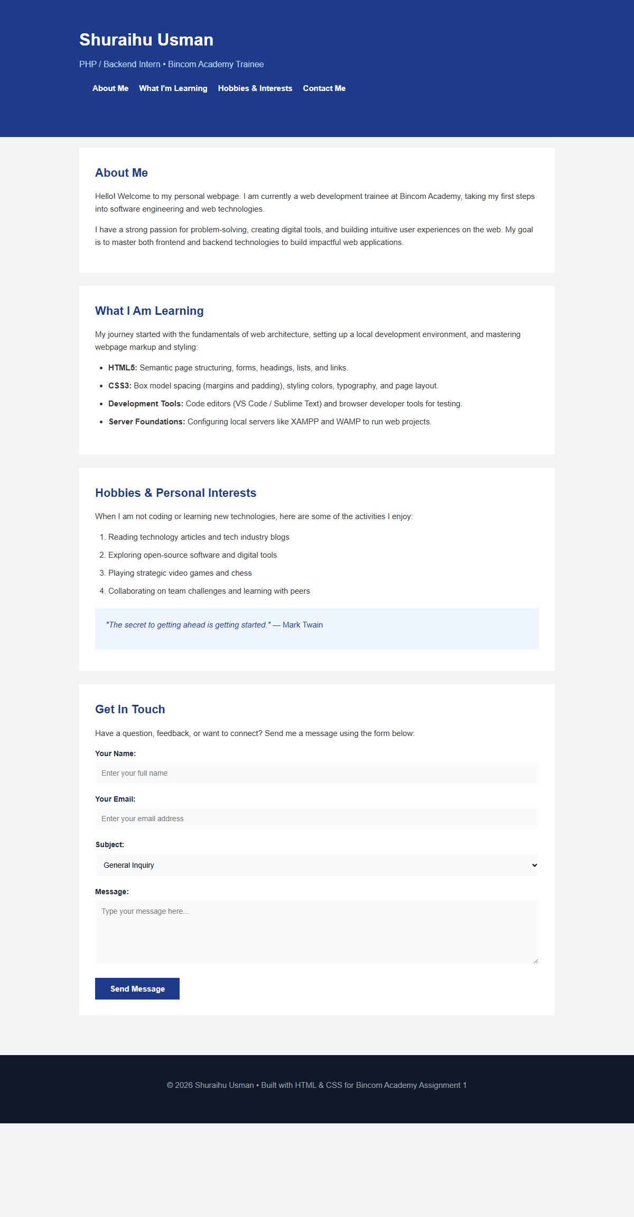
Figure 1: Full-Page Rendered UI Output of PHP Class Assignment 1

6. How to Run and Verify the Project
- Direct Browser Preview: Open the project folder and double-click index.html to render in any modern browser (Chrome, Edge, Firefox).
- Local Server Testing (XAMPP/WAMP): Copy the folder to C:\xampp\htdocs\PHP-Class-Assignment-1\ or C:\wamp64\www\PHP-Class-Assignment-1\ and navigate to http://localhost/PHP-Class-Assignment-1/index.html.
- Developer Tools Inspection: Press F12 in your browser to inspect elements and view the CSS Box Model layout diagram verifying margin and padding values.

7. Project Repository & Submission Links
Organization URL: https://github.com/Bincom-Academy-PHP-Assignments
Official Assignment Repository: https://github.com/Bincom-Academy-PHP-Assignments/PHP-Class-Assignment-1

