1. **Create a new django project**

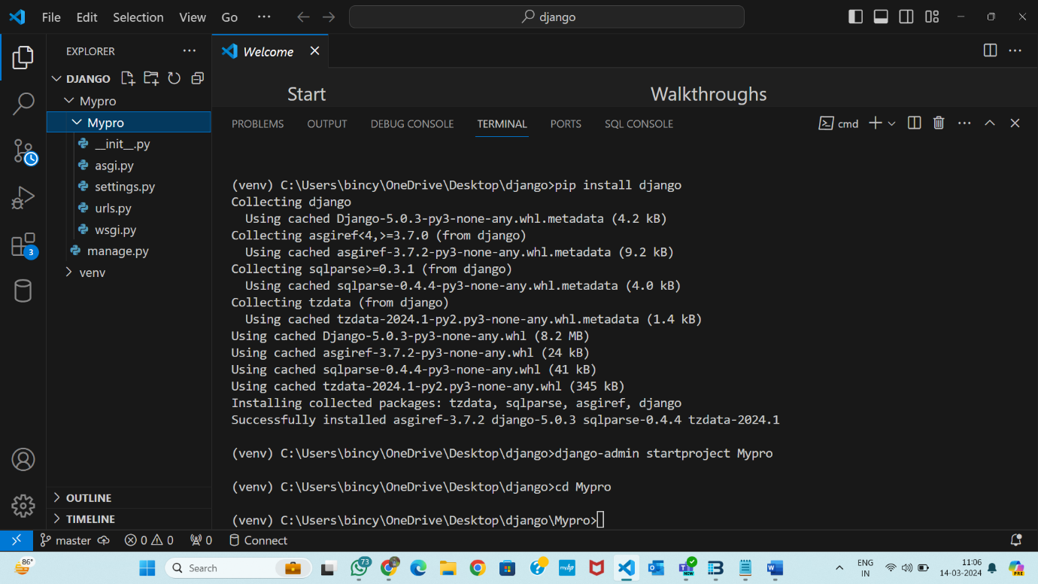

1. **Create an app**

1. **Create two models and then add items (using admin panel or shell)**

**Using Admin panel**

**Using shell**

**Admin panel**

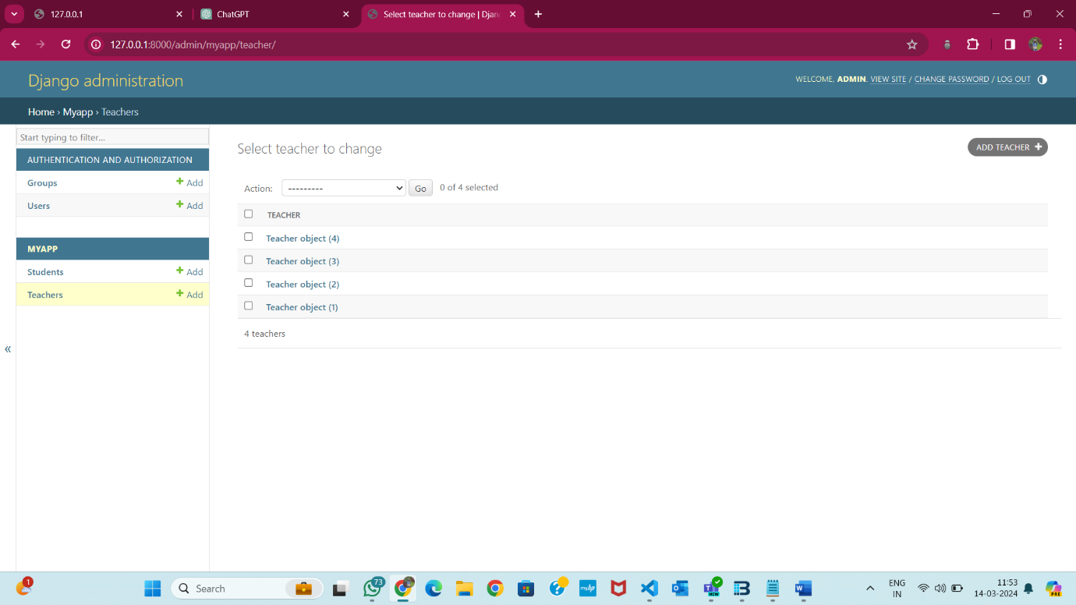

1. **Create list view using function based view to show list of items from the first model**

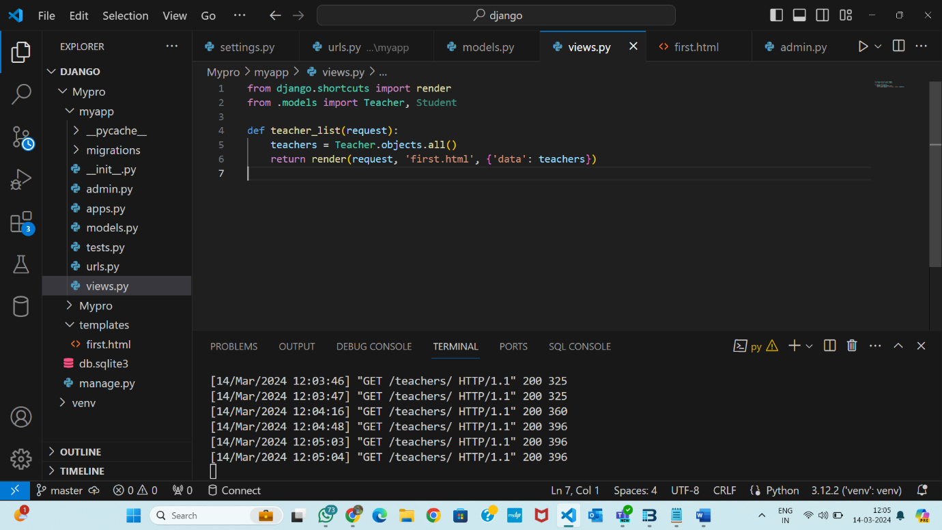

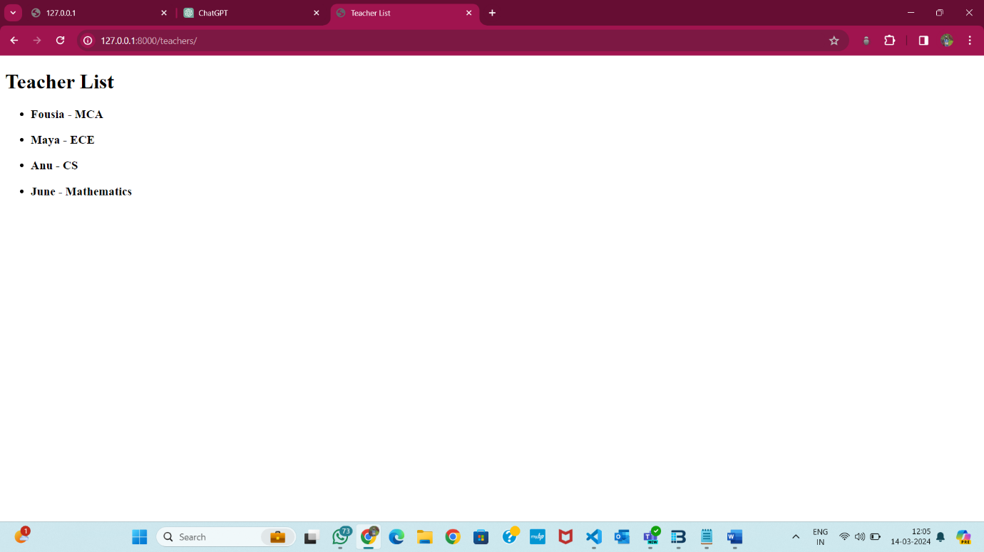

1. **Create list view using class based view to show list of items from the second model**

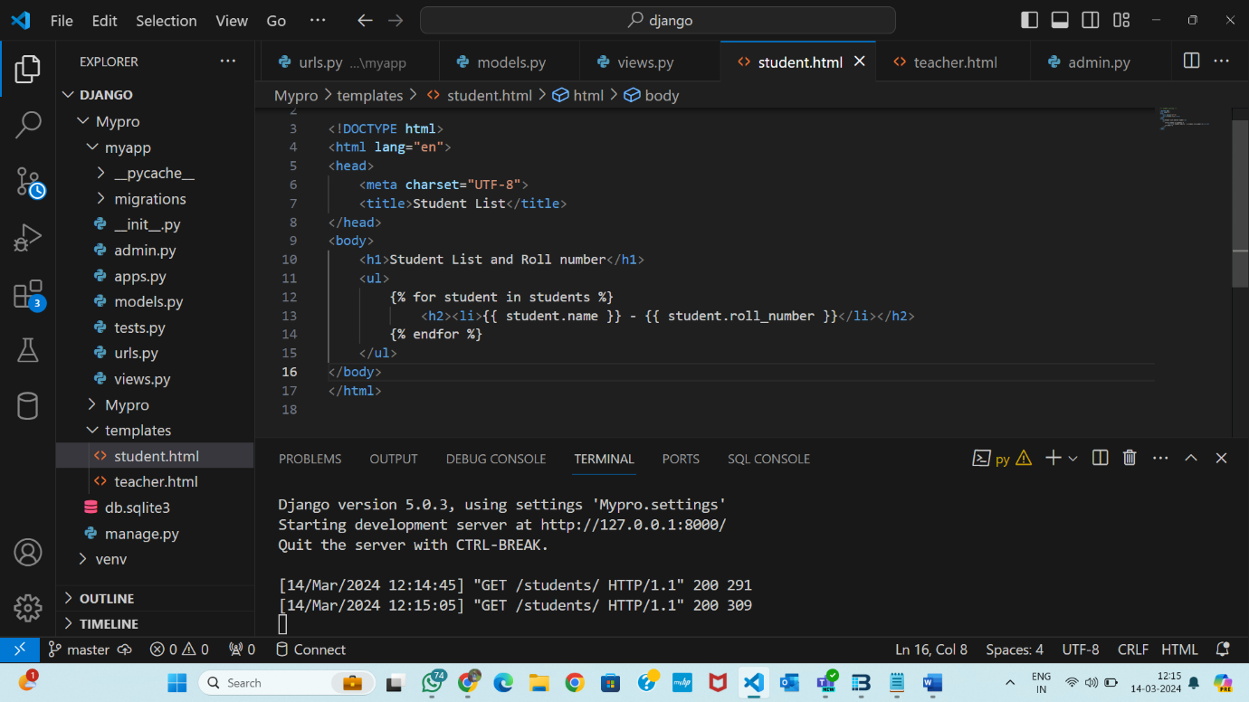

1. **Create detail view using function based view to show detail view of an item**

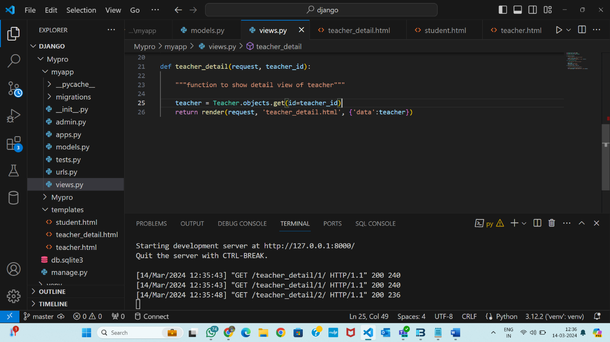

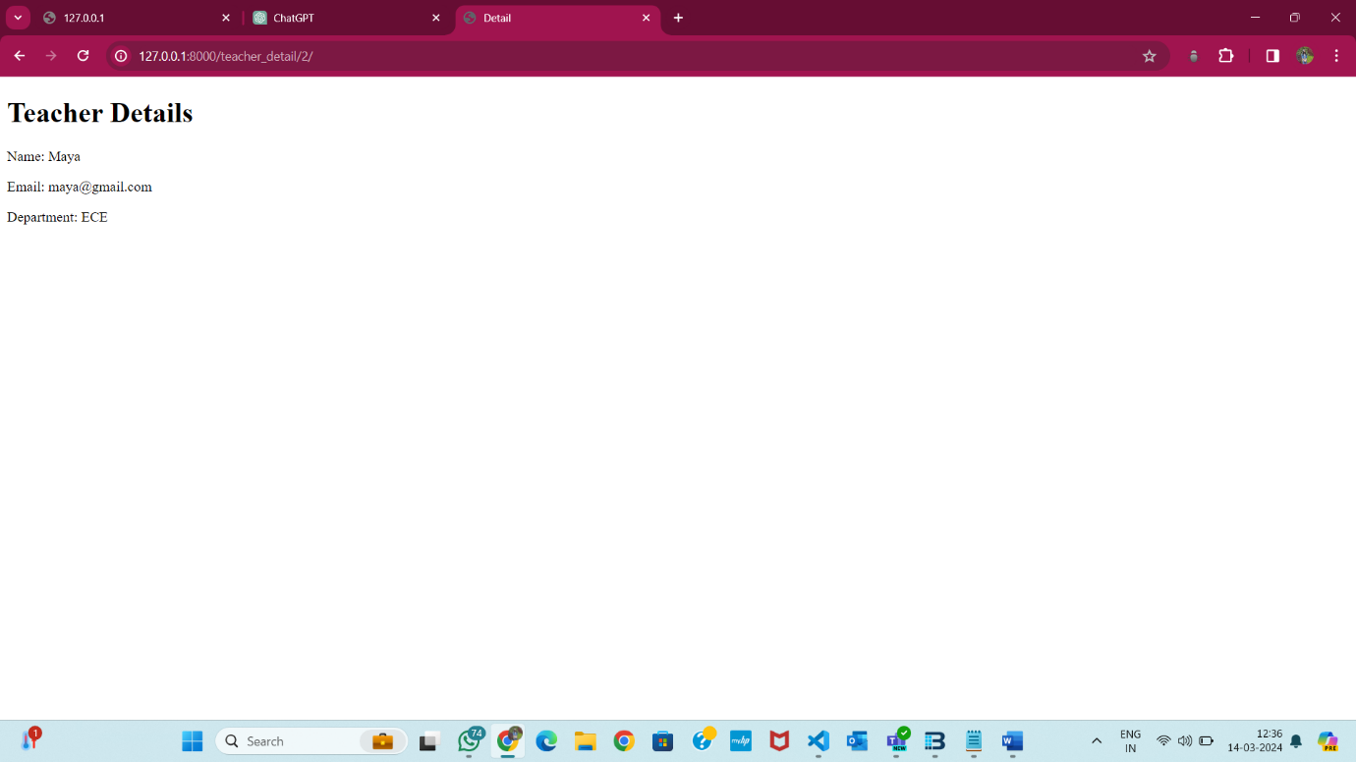

1. **Create detail view using class based view to show detail view of an item**

