**1.Create a new django project**

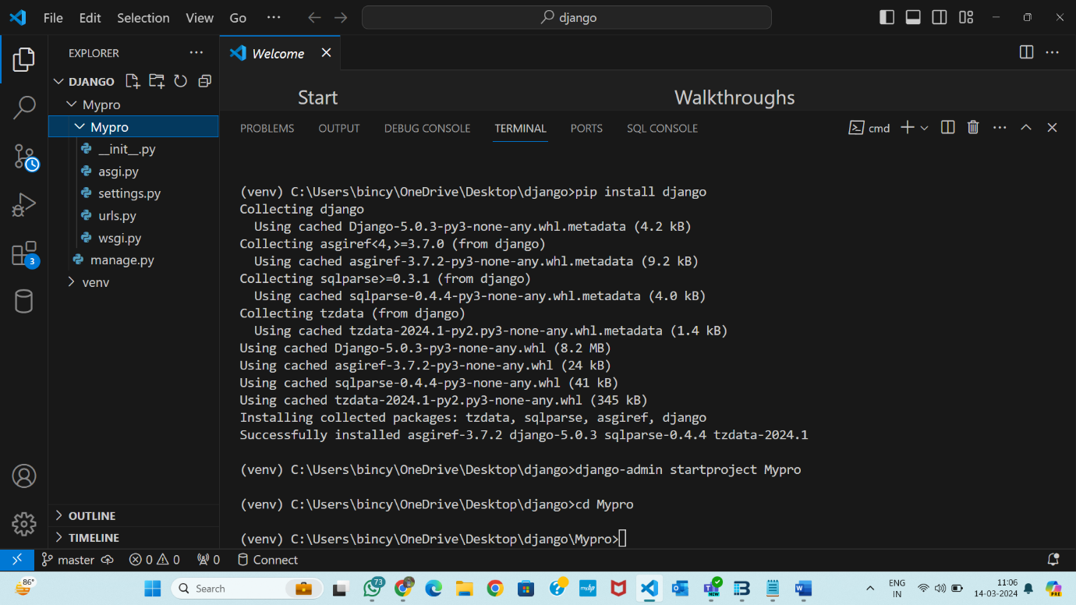

**2.Create required apps and models**

**3.Create views for login, logout and listing items from a model which can be accessed only by logged in users**

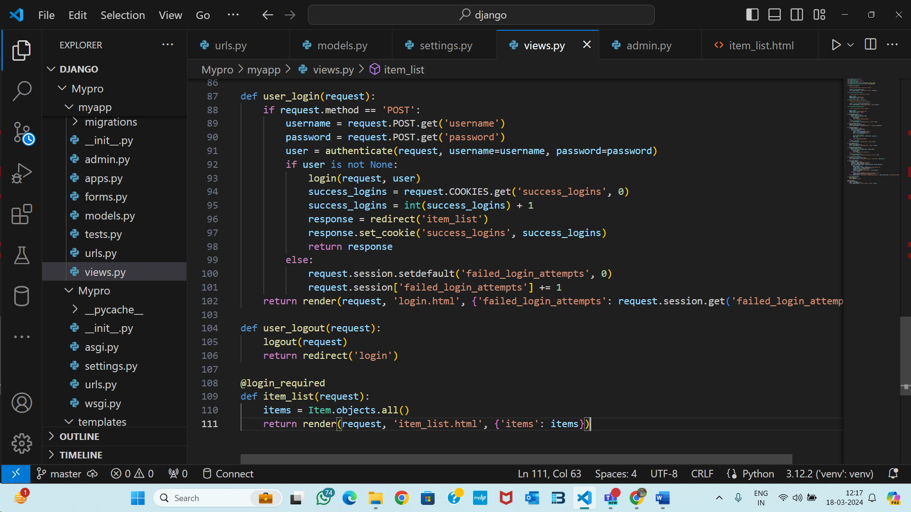

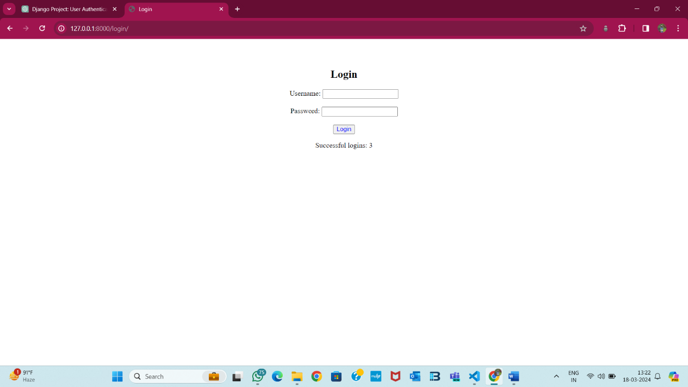

**4.Show the number of failed login attempts in session**

**5.Show the number of successful login in cookies**

