Listing Page Interactions
- For basic search, if user should enter the complete search value and press on a button or icon to display the results in the table.
Component to be used is search field with trailing button for clarity.
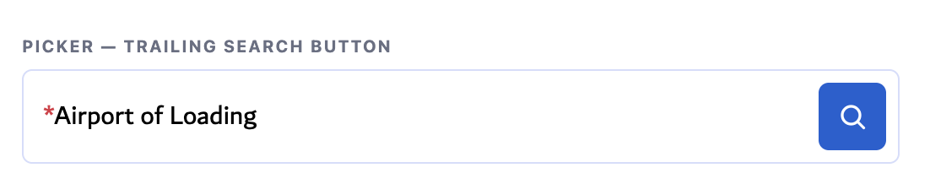
- Dropdown fields should support single-select or multi-select based on the business requirement.
For multi-select dropdowns, use checkboxes along with the available values. A separate “Search” or “Save” button is not required. Selections should be applied automatically upon selection.
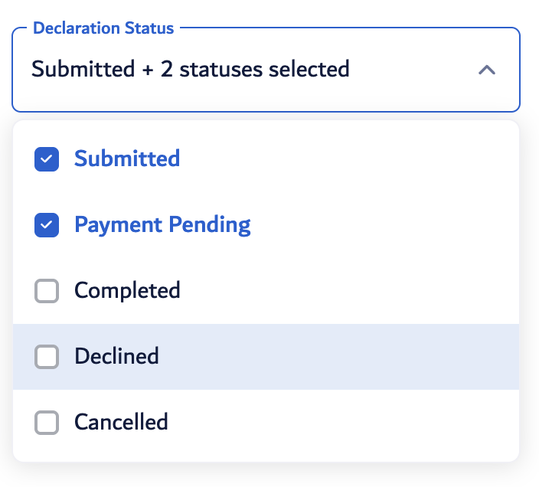
- The Status dropdown placed alongside the Basic Search may directly populate the relevant records based on the default date range defined under the “Status As On” section, subject to system performance and technical feasibility.

- For modules where drafts are applicable, provide a Drafts toggle to allow users to switch between draft and regular records.
When Drafts is enabled, display the relevant table, search, and filters, where applicable. The Status filter should be disabled/greyed out when viewing drafts.
When the user switches back from Drafts to the regular records view, any filters previously applied should be reset to avoid carrying over potentially irrelevant filter criteria.
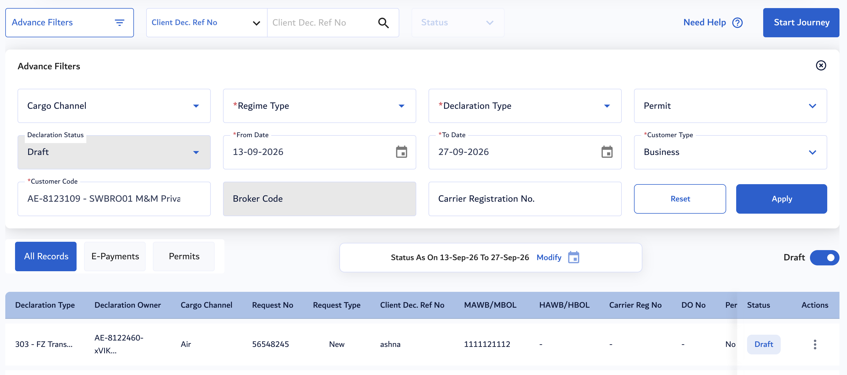
- For advance filters:
a) When the Advanced Filters card is expanded, the basic search, status dropdown, and status-related controls should be hidden or greyed out to reduce user confusion.
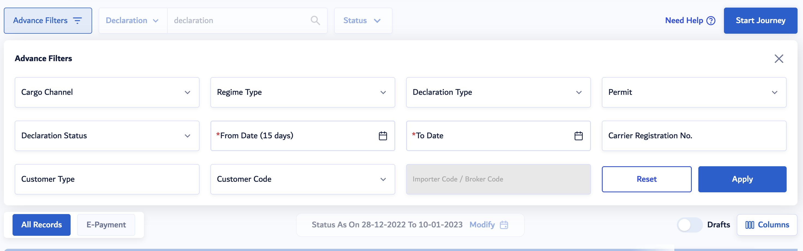
b) Once filters are applied, display the selected filter criteria as tags below the Advanced Filters card. So that, users can easily identify which filters are currently active, even when the filter card is collapsed or accidentally closed.
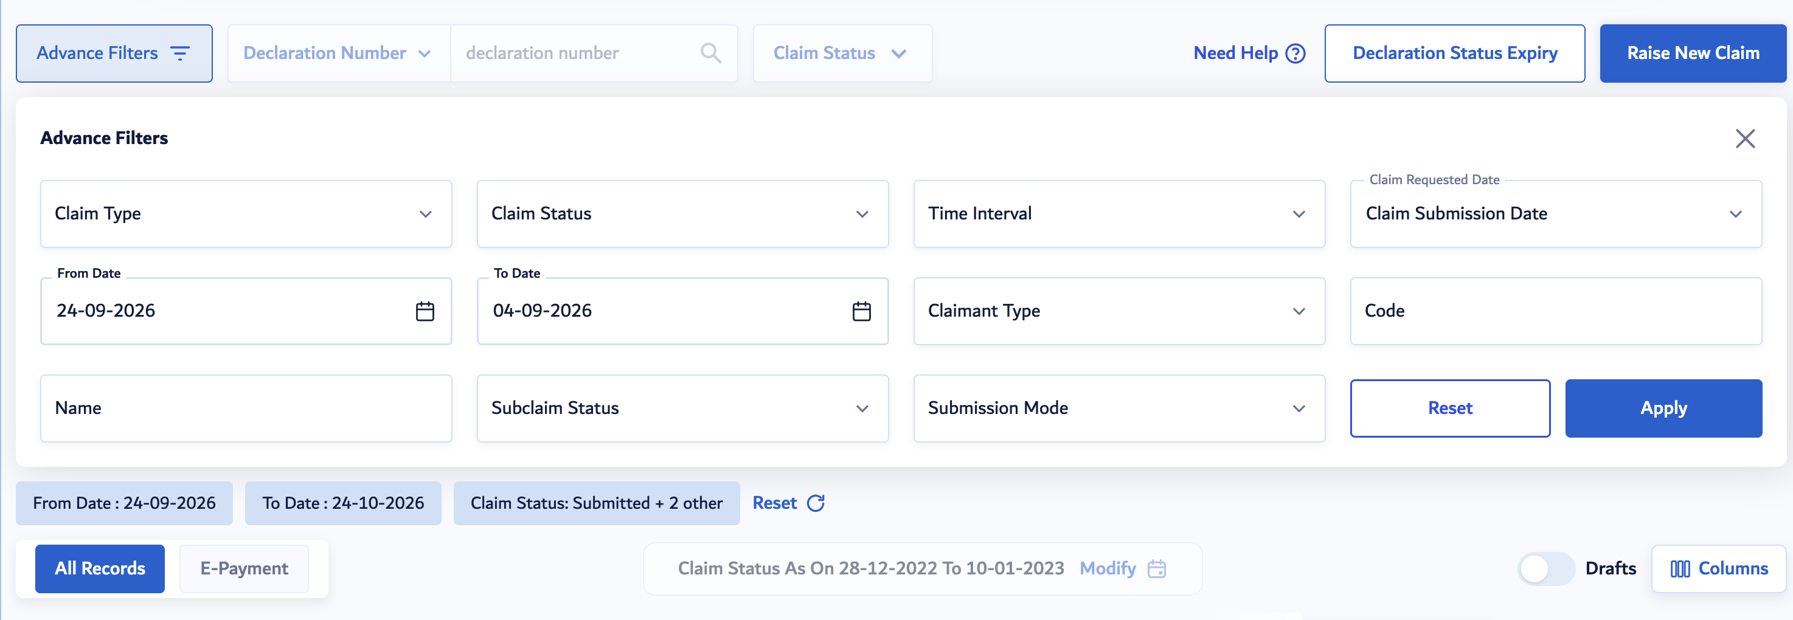
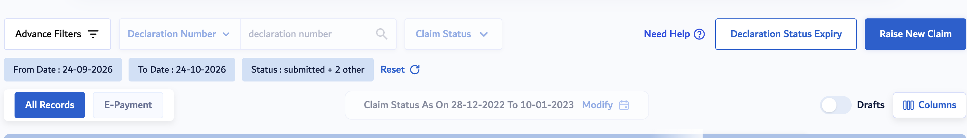

c) Each tab, such as All Records, ePayment, Drafts, etc., should maintain its own set of advanced filters.
Filters applied within one tab should not carry over to another tab when the user switches between tabs. Each tab should retain or manage its filters independently based on the records displayed in that tab.

- Need help, will open the relevant knowledge hub page in new window. URL will be shared by Dubai Trade team.
- Where technically feasible, the user's column rearrangement preferences should be saved against their user login/profile.
This will allow users to retain their preferred table configuration and access the same column arrangement when they log in again, including from a different browser or device.
Reference: Similar behaviour on the column customisation experience available in JIRA

