Bindhu Kumar Reddy Pulyala
0029054149
Objective:This algorithms aims at classifying the given data X2 in to Y2 with training data given as X1 and y1.

knn classification with n=1 1
knn with n=3 3

knn classification with n=1
written by :bindhu Kumar reddy 0029054149
clc
close all
clear all
load('dataP1c.mat');
X1=X1';X2=X2';
x1_training=X1(:,1);
x2_training=X1(:,2);
x1_test=X2(:,1);
x2_test=X2(:,2);
y1=y1';
figure
pos=find(y1==1);
neg=find(y1==-1);
plot(x1_training(pos,1),x2_training(pos,1),'+');
hold on
plot(x1_training(neg,1),x2_training(neg,1),'.');
hold off
% nearest neigbhour with n=1 algorithm begins
for i=1:length(x1_training)
for j=1:length(x1_training)
dis(j)=sqrt((x1_training(j,1)-x1_test(i,1))^2+(x2_training(j,1)-x2_test(i,1))^2);
end
[val,ind]=min(dis);
y2(i,1)=y1(ind,1);
end
pos=find(y2==1);
neg=find(y2==-1);
figure
plot(x1_test(pos,1),x2_test(pos,1),'+');
hold on
plot(x1_test(neg,1),x2_test(neg,1),'.');
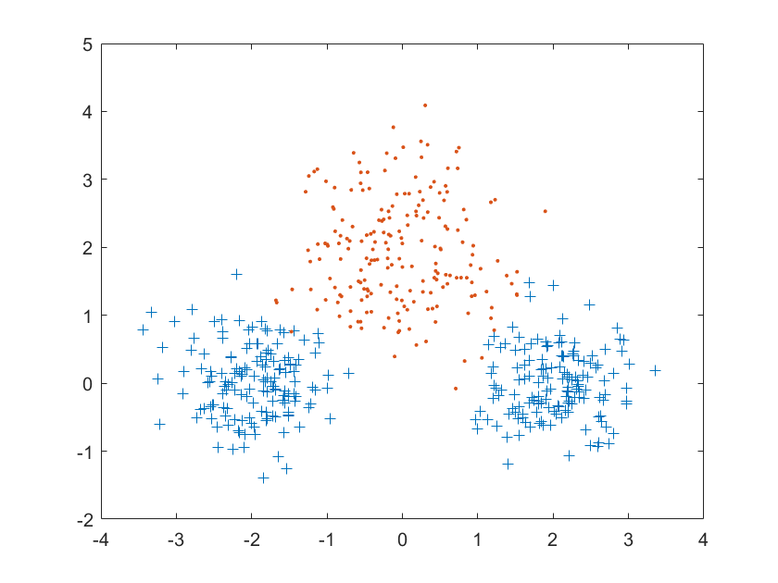
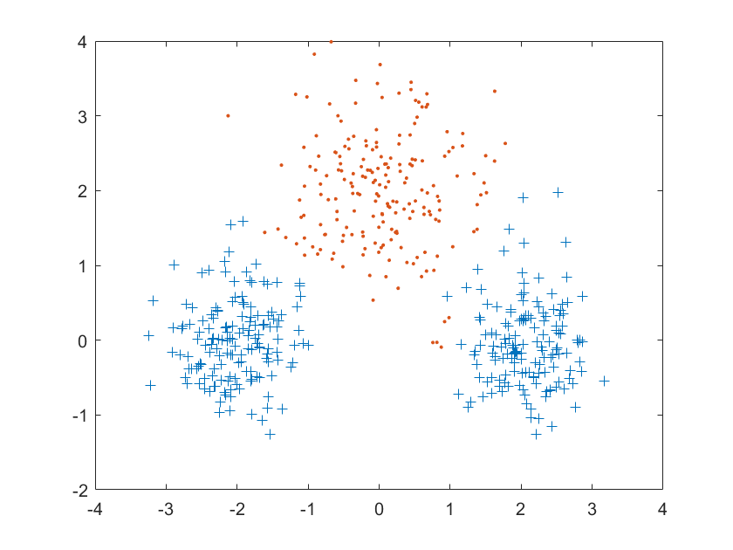

knn with n=3
clc
close all
clear all
load('dataP1c.mat');
X1=X1';X2=X2';
x1_training=X1(:,1);
x2_training=X1(:,2);
x1_test=X2(:,1);
x2_test=X2(:,2);
y1=y1';
figure
pos=find(y1==1);
neg=find(y1==-1);
plot(x1_training(pos,1),x2_training(pos,1),'+');
hold on
plot(x1_training(neg,1),x2_training(neg,1),'.');
hold off
xlabel('x1_training');
ylabel('x2_training');
title('scatter plot of training data')
for i=1:500
for j=1:500
dis(j)=sqrt((x1_training(j,1)-x1_test(i,1))^2+(x2_training(j,1)-x2_test(i,1))^2);
end
[a,b]=sort(dis);
if (y1(b(1))+y1(b(2))+y1(b(3))>=1);
y2(i,1)=1;
else
y2(i,1)=-1;
end
end
pos=find(y2==1);
neg=find(y2==-1);
figure
plot(x1_test(pos,1),x2_test(pos,1),'+');
hold on
plot(x1_test(neg,1),x2_test(neg,1),'.');
hold off
xlabel('x1_test');
ylabel('x2_test');
title('knn with n=3');
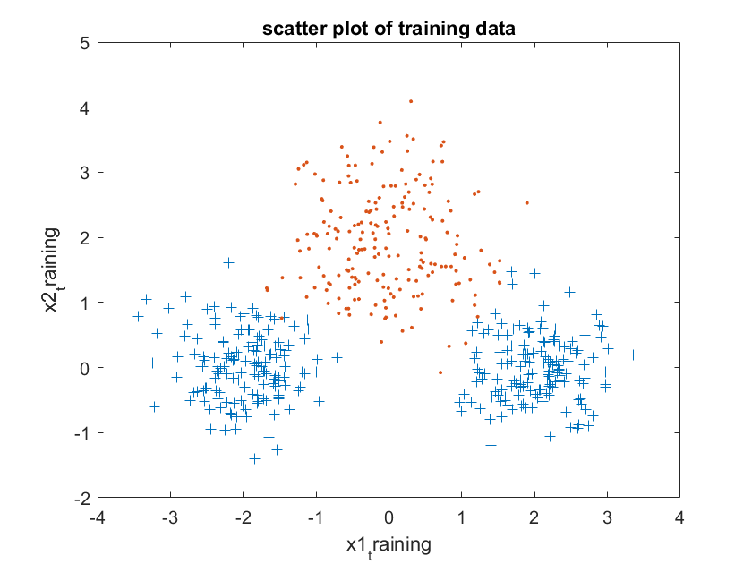
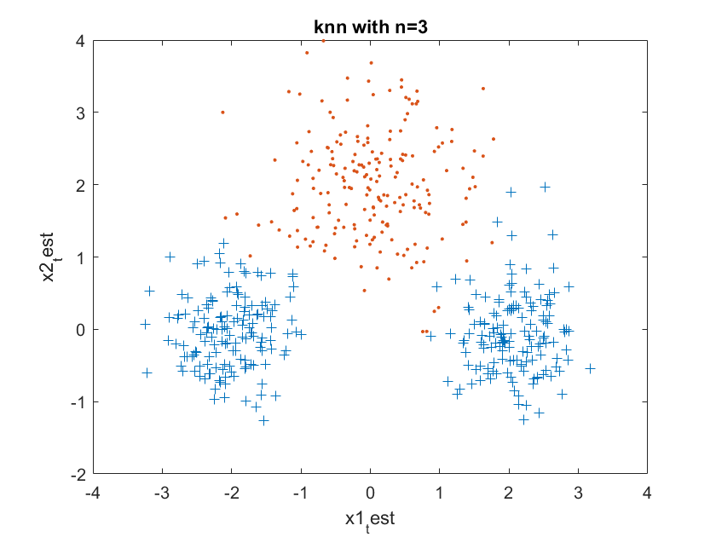
Published with MATLAB® R2016a

