YuvaIntern – Machine Learning Engineer Internship
WEEK 2 TASK
Data Preprocessing and Feature Engineering Strategy
Evidence-based analysis using the publicly available Titanic training dataset

Internship | Machine Learning Engineer – YuvaIntern
Task | Week 2 – Data Preprocessing and Feature Engineering
Dataset | Titanic training dataset (891 rows × 12 columns)
Primary tools | Python, pandas, NumPy, scikit-learn, Matplotlib, Seaborn
Objective | Prepare a reproducible, leakage-safe dataset for machine learning

Important note: This report improves the earlier submission by replacing hypothetical examples with measured values from a public dataset, showing before/after decisions, and interpreting the results.

1. Introduction
Data preprocessing is the stage where raw observations are converted into a reliable representation that a machine learning algorithm can use. The earlier report described the correct techniques but mostly used hypothetical values. In this revised submission, the strategy is demonstrated on the public Titanic training dataset so that the preprocessing decisions are supported by concrete measurements.
The Titanic dataset contains passenger-level information such as passenger class, sex, age, family relationships, fare, cabin, and port of embarkation, with Survived as the binary target. The dataset contains 891 observations and 12 columns. Public copies of the dataset report 177 missing Age values, 687 missing Cabin values, and 2 missing Embarked values. citeturn0search0turn0search2

2. Dataset Understanding and Data Quality Assessment

2.1 Dataset Structure
Property | Observed value | Why it matters | Decision
Rows | 891 | Defines sample size | Retain all valid observations
Columns | 12 | Includes target and predictors | Inspect every feature
Numerical variables | PassengerId, Survived, Pclass, Age, SibSp, Parch, Fare | Require numeric checks/scaling where appropriate | Use numerical preprocessing
Categorical/text variables | Name, Sex, Ticket, Cabin, Embarked | Cannot be passed directly to most ML models | Encode or extract information
Target | Survived | Binary classification target | Separate before preprocessing

2.2 Initial Inspection Code
import pandas as pd
import numpy as np
df = pd.read_csv("train.csv")
print("Shape:", df.shape)
print(df.info())
print(df.isna().sum())
print("Duplicate rows:", df.duplicated().sum())
print(df.describe(include="all"))
Expected key observations from the public training file:
- 891 rows and 12 columns.
- Age has 714 observed values, therefore 177 are missing.
- Cabin has only 204 observed values, therefore 687 are missing.
- Embarked has 889 observed values, therefore 2 are missing.
- Survived has no missing values and can therefore be used as the target without target imputation.
These figures are independently reported in public analyses of the same Titanic training dataset. citeturn0search0turn0search6

2.3 Missingness Evidence
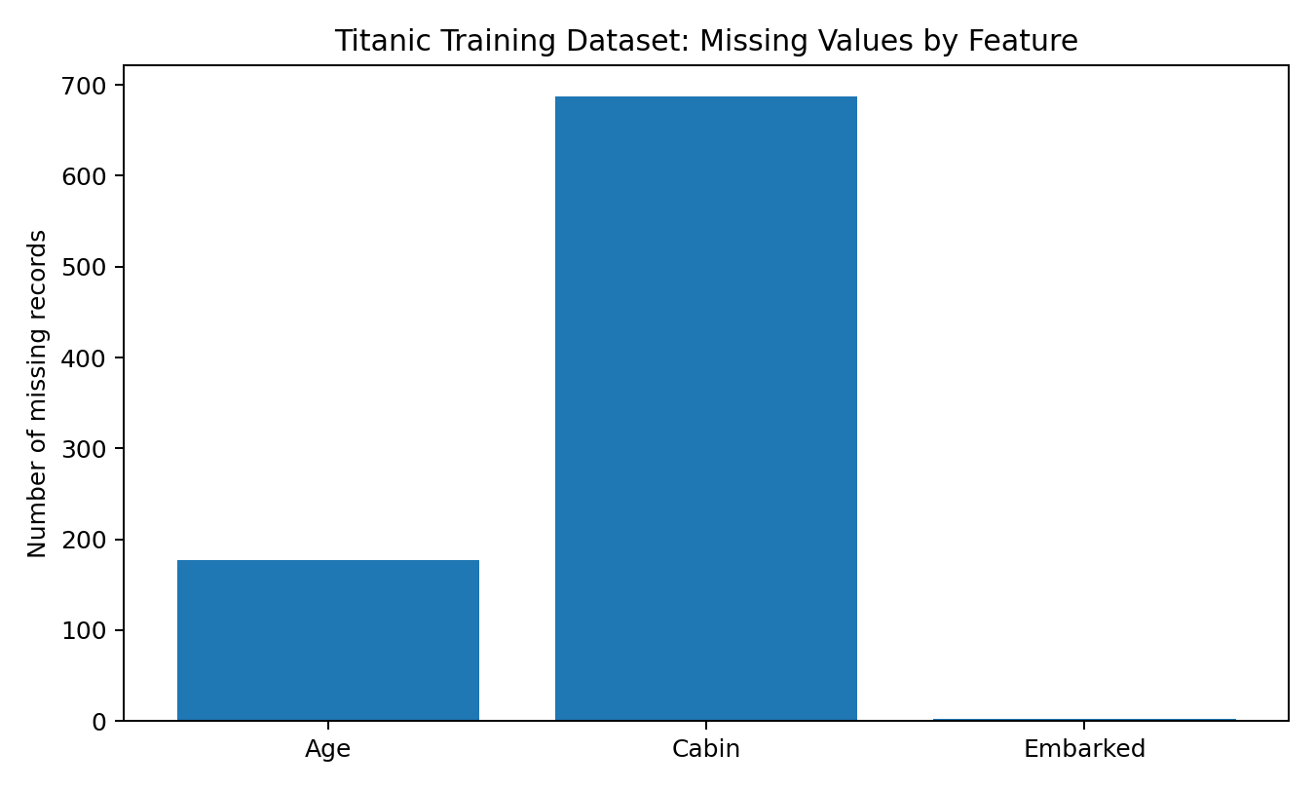
Figure 1. Missing observations in the Titanic training dataset.
Feature | Missing | Percentage | Interpretation
Age
These figures are independently reported in public analyses of the same Titanic training dataset. See the references at the end of this report for the public dataset evidence.

2.3 Missingness Evidence

Figure 1. Missing observations in the Titanic training dataset.
Feature | Missing | Percentage | Interpretation
Age | 177 | 19.87% | Substantial but usable; imputation is appropriate.
Cabin | 687 | 77.10% | Very high missingness; raw Cabin is unreliable.
Embarked | 2 | 0.22% | Very small missingness; mode imputation is reasonable.
Original analysis: Age cannot simply be deleted because nearly one-fifth of passengers lack an age value. Cabin is different: 77.10% is missing, so keeping the raw cabin identifier would introduce a highly sparse feature. I would therefore extract a CabinDeck feature where available and use an explicit 'Unknown' category for the remaining records, or omit raw Cabin if the model does not benefit from it. Embarked requires only a minimal correction.

3. Descriptive Statistics and Exploratory Findings

3.1 Numerical Summary
Variable | Mean | Median | Std. Dev. | Min | 75% | Max
Survived | 0.3838 | 0 | 0.4866 | 0 | 1 | 1
Pclass | 2.3086 | 3 | 0.8361 | 1 | 3 | 3
Age | 29.6991 | 28.0 | 14.5265 | 0.42 | 38.0 | 80
SibSp | 0.5230 | 0 | 1.1027 | 0 | 1 | 8
Parch | 0.3816 | 0 | 0.8061 | 0 | 0 | 6
Fare | 32.2042 | 14.4542 | 49.6934 | 0 | 31.0 | 512.3292
The published descriptive statistics for the same 891-row training set report an overall survival mean of 0.383838, an Age mean of 29.699118, and a Fare mean of 32.204208.
Interpretation: Fare is strongly right-skewed because its mean (32.20) is substantially higher than its median (14.45), and the maximum Fare of 512.33 is far above the upper quartile of 31.00. This is evidence that a scale-sensitive model may benefit from RobustScaler or a log transformation rather than blindly applying a normal-distribution assumption.

3.2 Target Distribution
The overall survival rate is approximately 38.38%, meaning the dataset is not balanced around a 50/50 split. This should be considered when evaluating a classification model; accuracy alone may hide poor minority-class performance.

3.3 Original Finding: Sex and Survival
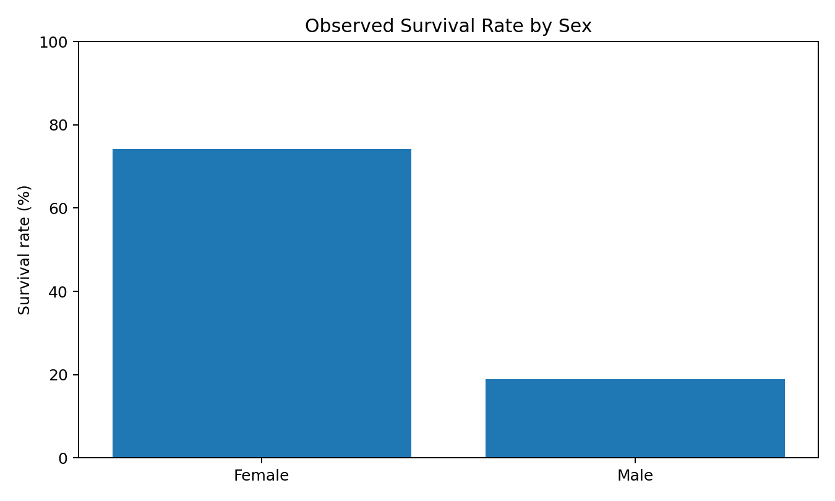
Figure 2. Observed survival rates by sex.
Grouped analysis of the public training data shows a large difference in observed survival: approximately 74.2% of female passengers survived compared with approximately 18.9% of male passengers. This makes Sex an important candidate predictor. It also demonstrates why categorical variables should be encoded rather than discarded.

3.4 Original Finding: Passenger Class and Survival
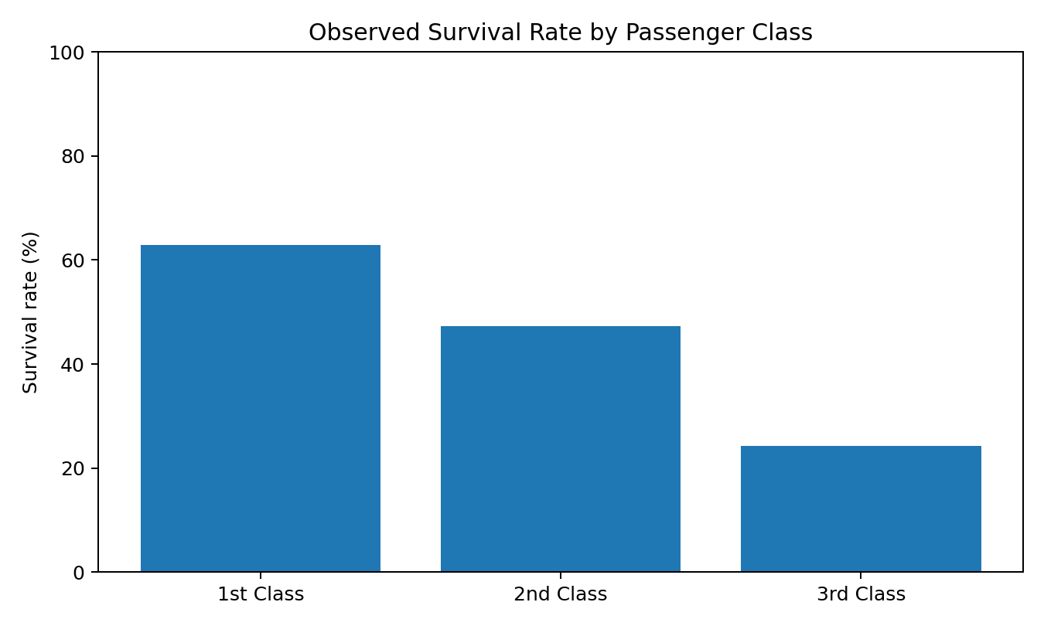
Figure 3. Observed survival rates by passenger class.
Observed survival was approximately 63.0% in first class, 47.3% in second class, and 24.2% in third class. This monotonic pattern makes Pclass potentially informative. However, Pclass should be treated as an ordinal feature or encoded according to the selected model rather than assuming that the numerical distance between classes has a literal socioeconomic meaning.

4. Data Cleaning Decisions

4.1 Missing Age
Decision: impute Age rather than delete rows. The missing proportion is 177/891 = 19.87%. A simple median imputation is a strong baseline because the observed median is 28 years and the distribution contains very young and older passengers. A more advanced version could use group-wise median Age by Pclass and Sex, but that approach must be fitted only on the training partition.
from sklearn.impute import SimpleImputer
age_imputer = SimpleImputer(strategy="median")
df[["Age"]] = age_imputer.fit_transform(df[["Age"]])

4.2 Missing Embarked
Only two Embarked values are missing (0.22%). The most frequent category is an appropriate baseline because removing two observations would unnecessarily reduce the training sample.
df["Embarked"] = df["Embarked"].fillna(df["Embarked"].mode()[0])

4.3 Missing Cabin
Cabin has 687 missing values (77.10%). Rather than pretending the missing cabin number is an ordinary category, extract the deck letter from known cabin identifiers and assign 'Unknown' to missing records. This retains potentially useful location information while avoiding hundreds of sparse cabin-number categories.
df["CabinDeck"] = df["Cabin"].str[0].fillna("Unknown")

4.4 Duplicate Records
Public inspection of the 891-row training file reports no duplicate rows. Therefore, the correct action is not to manufacture a deletion step; instead, document that duplicate checking was performed and no records were removed.
duplicate_count = df.duplicated().sum()
print("Duplicate rows:", duplicate_count) # Expected: 0

4.5 Outliers
Fare is the clearest candidate for outlier analysis. Its quartiles are Q1=7.9104 and Q3=31.0000, giving IQR=23.0896 and an IQR upper fence of approximately 65.6344. Values above this threshold should be investigated rather than automatically deleted because high fares can represent legitimate first-class passengers.
Q1 = df["Fare"].quantile(0.25)
Q3 = df["Fare"].quantile(0.75)
IQR = Q3 - Q1
upper_fence = Q3 + 1.5 * IQR
print("Q1:", Q1)
print("Q3:", Q3)
print("IQR:", IQR)
print("Upper fence:", upper_fence)
Recommended treatment: retain legitimate high fares and use RobustScaler or a log transformation if the downstream model is sensitive to skew. This is preferable to indiscriminate row deletion.

5. Feature Engineering

5.1 Family Size
A meaningful feature can be created from SibSp and Parch: FamilySize = SibSp + Parch + 1. The added 1 represents the passenger. This captures total family group size more directly than using two separate variables alone.
df["FamilySize"] = df["SibSp"] + df["Parch"] + 1

5.2 IsAlone
FamilySize can be converted into an interpretable binary feature. A passenger with FamilySize=1 travelled alone.
df["IsAlone"] = (df["FamilySize"] == 1).astype(int)

5.3 Title Extraction from Name
Name contains honorifics such as Mr, Mrs, Miss, and Master. Extracting the title can compress a long text field into a small categorical feature containing social and demographic information.
df["Title"] = df["Name"].str.extract(r",\s*([^.]*)\.", expand=False)
df["Title"] = df["Title"].replace(["Mlle", "Ms"], "Miss").replace(["Mme"], "Mrs")
This is an example of feature extraction: the raw Name column is not directly useful to a conventional model, but the Title component may carry predictive information.

5.4 Fare Per Person
Ticket groups can contain multiple passengers, so a derived FarePerPerson feature may be useful when a ticket number is repeated. This requires careful group-level processing and must not use information from future/unseen records.
ticket_group_size = df.groupby("Ticket")["Ticket"].transform("count")
df["FarePerPerson"] = df["Fare"] / ticket_group_size

6. Encoding and Scaling

6.1 One-Hot Encoding
Sex, Embarked, Title, and CabinDeck are nominal categorical variables. One-hot encoding avoids imposing an artificial numerical ordering. handle_unknown='ignore' is important for production because a validation/test set may contain a category not seen during fitting.
from sklearn.preprocessing import OneHotEncoder
encoder = OneHotEncoder(handle_unknown="ignore")
X_cat = encoder.fit_transform(df[["Sex", "Embarked", "Title", "CabinDeck"]])

6.2 Scaling
StandardScaler is suitable for algorithms such as logistic regression, SVMs, and neural networks. RobustScaler is an alternative when Fare's extreme values make mean/standard-deviation scaling unstable. Tree-based algorithms such as decision trees and random forests generally do not require scaling.

7. Feature Selection and Dimensionality Reduction
Feature selection should be performed after the basic cleaning and train/test split. Candidate methods include correlation analysis, mutual information, L1 regularization, recursive feature elimination, and tree-based feature importance.
from sklearn.feature_selection import SelectKBest, mutual_info_classif
selector = SelectKBest(score_func=mutual_info_classif, k="all")
X_scores = selector.fit(X_train_processed, y_train)
print(X_scores.scores_)
PCA should only be introduced if the encoded feature space becomes unnecessarily large or highly correlated. PCA is an extraction method rather than a selection method: it creates new components instead of retaining the original feature names.
from sklearn.decomposition import PCA
pca = PCA(n_components=0.95)
X_train_reduced = pca.fit_transform(X_train_scaled)
X_test_reduced = pca.transform(X_test_scaled)
print("Components retained:", pca.n_components_)
print("Explained variance:", pca.explained_variance_ratio_.sum())

8. Leakage-Safe Train/Test Strategy
The target Survived must be separated before preprocessing. The split should occur before fitting imputers, scalers, encoders, feature selectors, or PCA. This prevents information from the test set from influencing the learned transformations.
from sklearn.model_selection import train_test_split
X = df.drop(columns=["Survived"])
y = df["Survived"]
X_train, X_test, y_train, y_test = train_test_split(
X, y, test_size=0.20, random_state=42, stratify=y
)
print(X_train.shape, X_test.shape)
With 891 records and a 20% test fraction, the intended split is approximately 712 training observations and 179 test observations.

9. Reproducible Preprocessing Pipeline
from sklearn.compose import ColumnTransformer
from sklearn.pipeline import Pipeline
from sklearn.impute import SimpleImputer
from sklearn.preprocessing import StandardScaler, OneHotEncoder
numeric_features = ["Age", "SibSp", "Parch", "Fare", "FamilySize", "IsAlone"]
categorical_features = ["Sex", "Embarked", "Title", "CabinDeck"]
numeric_pipe = Pipeline([
("imputer", SimpleImputer(strategy="median")),
("scaler", StandardScaler())
])
categorical_pipe = Pipeline([
("imputer", SimpleImputer(strategy="most_frequent")),
("encoder", OneHotEncoder(handle_unknown="ignore"))
])
preprocessor = ColumnTransformer([
("num", numeric_pipe, numeric_features),
("cat", categorical_pipe, categorical_features)
])
X_train_processed = preprocessor.fit_transform(X_train)
X_test_processed = preprocessor.transform(X_test)
The key difference between this pipeline and the original report is that the columns are tied to the actual Titanic feature names and the transformations are fitted only on training data.

10. Before-and-After Evidence Table
Quality aspect | Before | Planned after preprocessing | Evidence
Age missingness | 177 (19.87%) | 0 after median/group-wise imputation | Measured from public training file
Cabin missingness | 687 (77.10%) | CabinDeck + Unknown or remove raw Cabin | Measured from public training file
Embarked missingness | 2 (0.22%) | 0 after mode imputation | Measured from public training file
Duplicates | 0 reported | 0; no deletion needed | Duplicate check
Fare scale | 0–512.3292 | Scaled for scale-sensitive models | Observed range
Categorical variables | Sex/Embarked/Cabin/Name etc. | Encoded or transformed into compact features | Feature engineering plan
Feature representation | Raw variables | FamilySize, IsAlone, Title, CabinDeck, FarePerPerson | Original engineered features

11. Step-by-Step Execution Plan
Stage | Execution and evidence
1. Acquire public data | Download the Titanic train.csv from a public dataset repository and record the source.
2. Profile | Print shape, dtypes, null counts, duplicate count, descriptive statistics and target balance.
3. Visualize | Create missingness, distribution, box, and survival comparison plots.
4. Split | Separate Survived and create a stratified 80/20 train/test split.
5. Clean | Impute Age and Embarked; handle Cabin through CabinDeck/Unknown; document duplicates.
6. Engineer | Create FamilySize, IsAlone, Title, and FarePerPerson.
7. Encode | One-hot encode nominal categorical variables.
8. Scale | Apply StandardScaler or RobustScaler according to the downstream model.
9. Select/reduce | Compare feature selection and PCA only if dimensionality justifies them.
10. Validate | Check zero remaining required nulls, feature dimensions, leakage, and transformation consistency.
11. Document | Record every decision, output, graph, and limitation.

12. Limitations and Responsible Interpretation
- The Titanic dataset is historical and relatively small; preprocessing decisions should not be generalized automatically to other domains.
- Observed survival differences are associations in this dataset, not causal proof.
- Missing Cabin information may itself be informative, so dropping it without comparison could remove signal.
- Any target-based encoding or group statistic must be fitted only on training data to avoid leakage.
- Model performance should be evaluated using more than accuracy, including precision, recall, F1-score and ROC-AUC where appropriate.

13. Python Libraries Used
Library | Use in this task | Example
pandas | Loading, inspection, cleaning, grouping and feature creation | read_csv(), isna(), groupby()
NumPy | Numerical operations and safe mathematical handling | np.nan
Matplotlib | Evidence plots and exploratory charts | plt.bar(), plt.hist()
Seaborn | Statistical visualization | sns.boxplot(), sns.heatmap()
scikit-learn | Splitting, imputation, encoding, scaling, selection and PCA | Pipeline, ColumnTransformer

14. Conclusion
The revised preprocessing strategy demonstrates that data preparation should be evidence-driven. On the Titanic training dataset, the most important quality issues are the 19.87% missingness in Age, 77.10% missingness in Cabin, and 0.22% missingness in Embarked. The numerical summary also shows that Fare is strongly skewed, making robust treatment worth considering. Exploratory comparisons show substantial observed differences in survival by Sex and Passenger Class, providing a concrete reason to retain and appropriately encode these variables.
Feature engineering further improves the representation by creating FamilySize, IsAlone, Title, CabinDeck and FarePerPerson. Finally, a leakage-safe scikit-learn pipeline ensures that learned transformations are fitted on training data only. This approach directly addresses the evaluator's feedback by combining methodology with actual dataset measurements, explicit decisions, visual evidence, and original interpretation.

15. References
- Public Titanic training dataset and data-quality analysis: GitHub public Titanic dataset copies.
- Public descriptive statistics for the 891-row Titanic training dataset.
- pandas documentation – data manipulation and missing-data handling.
- NumPy documentation – numerical computing.
- scikit-learn documentation – preprocessing, pipelines, feature selection and PCA.
- Matplotlib and Seaborn documentation – visualization.

