**Logistic Regression Model**

**Step1:** Dataset Ingested: diabetes-data

**Step2:** Created Pipeline

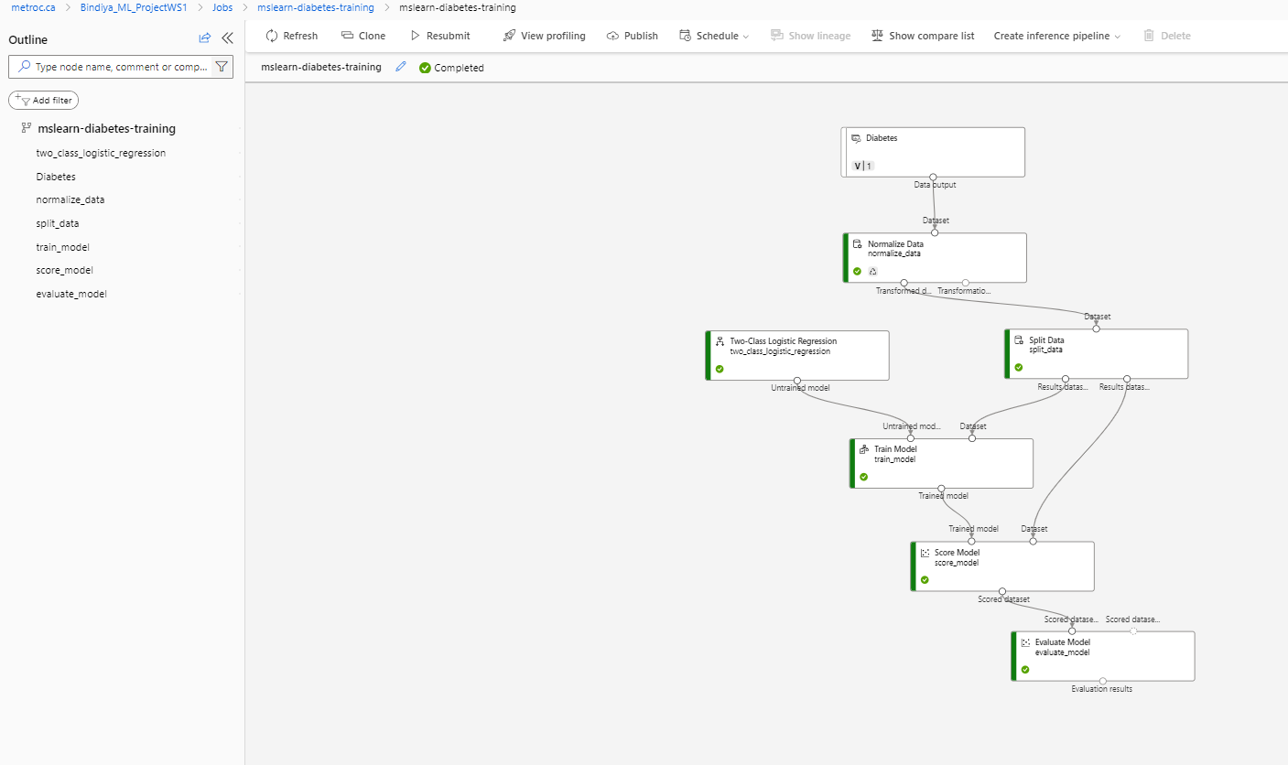

**Step3:** Evaluated results

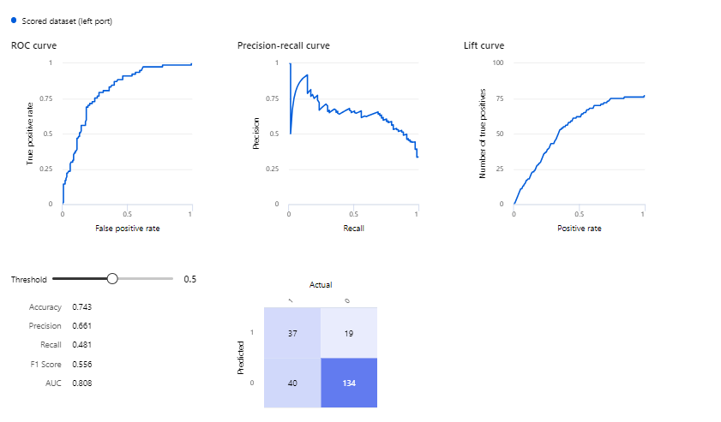**Step4:** Created an Inference Pipeline based on manual data

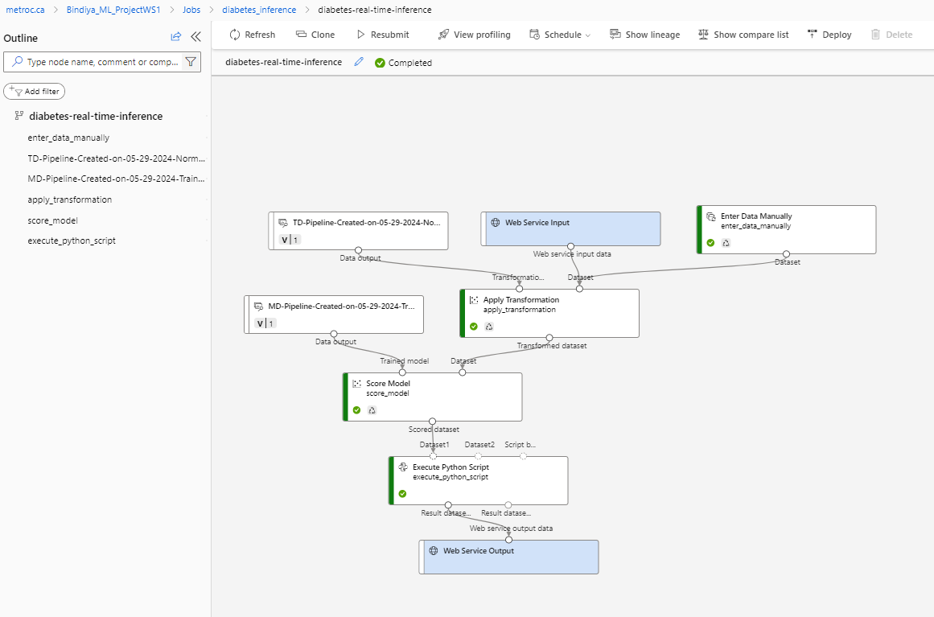

**Step 5:** Deploy a service

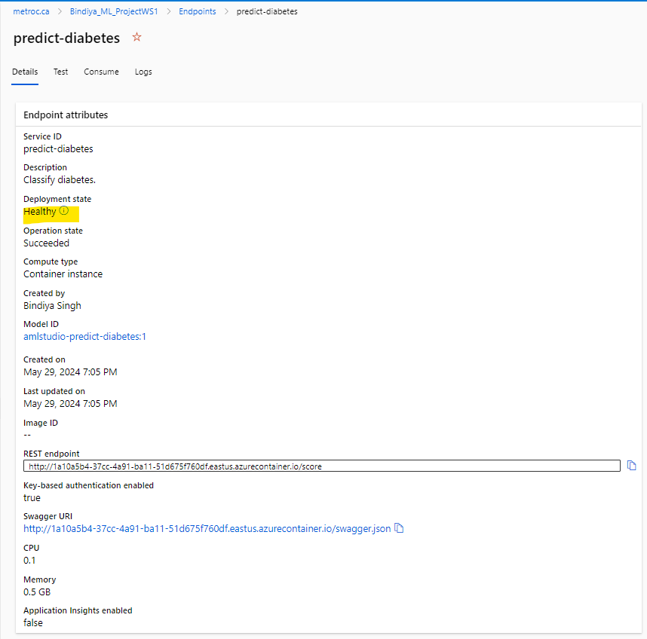

Step 6: Service has been tested and it is ready to be connected to a client application using the credentials in the Consume tab.

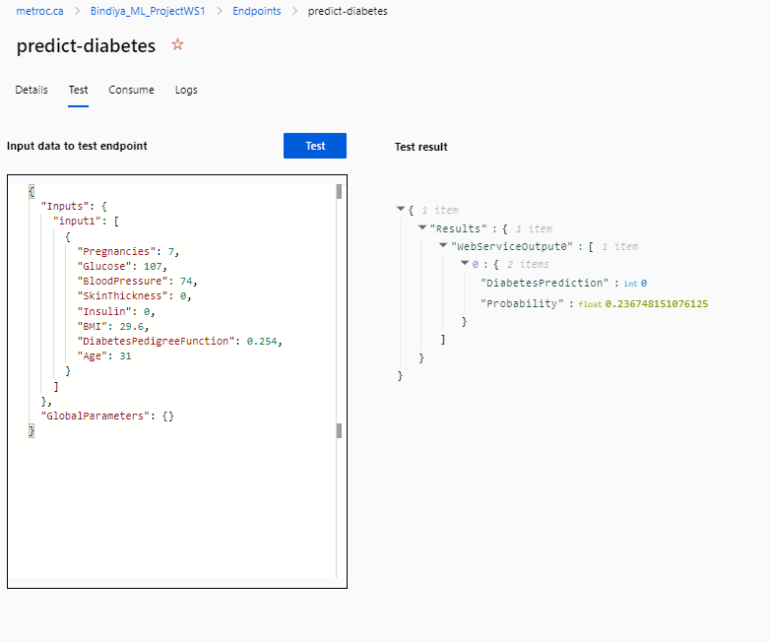

Steps involved in creating and deploy pipeline:

Creating a pipeline in Azure involves several steps to automate data workflows and model deployments. Here's a simplified outline:

1. **Define Requirements:** Clearly outline the data sources, processing steps, and outputs needed for your pipeline.
2. **Azure Resources Setup:**
   * **Azure Storage:** Store raw data and outputs.
   * **Azure Databricks:** For data processing and transformation.
   * **Azure Machine Learning:** For model training and deployment.
3. **Data Ingestion:** Import data from various sources (e.g., databases, files) into Azure Storage or Azure Databricks.
4. **Data Preparation:** Cleanse, transform, and preprocess data using tools like Databricks notebooks or Azure Data Factory.
5. **Model Training:** Use Azure Machine Learning to build and train predictive models using frameworks like TensorFlow or Scikit-learn.
6. **Model Evaluation:** Assess model performance using metrics like accuracy, precision, recall, etc., to ensure quality.
7. **Model Deployment:** Deploy the trained model as a web service on Azure using Azure ML Service or Azure Kubernetes Service (AKS).
8. **Monitoring and Logging:** Implement logging and monitoring to track pipeline performance, data quality, and model inference.
9. **Automation:** Schedule and automate pipeline execution using Azure Data Factory or Azure DevOps for continuous integration and deployment (CI/CD).
10. **Testing and Validation:** Conduct thorough testing and validation of the entire pipeline to ensure reliability and accuracy.
11. **Documentation and Maintenance:** Document pipeline components, dependencies, and configurations. Regularly update and maintain the pipeline to adapt to changing data and business requirements.

These steps provide a structured approach to creating and maintaining a data pipeline in Azure, enabling efficient data processing and model deployment for predictive analytics and business intelligence.