Project of Automate CI / CD pipeline script in Jenkins (Step by Step process)
- Continues integrate to GitHub
- Continues delivery to SonarQube
- Continues deploy to nexus repository
- Continues deploy to Tomcat

Step1: Setup all environment and configuration
NOTE: before installing anything in instance first udate
sudo apt update

Before start create 4 instance in AWS (or any cloud which you prefer)
  - 1 instance for –Jenkin (Edit security group allow port 8080)
|___connect to instance
|___Install java and maven

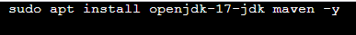

|___Install Jenkin (browse Jenkins for Linux)
https://www.jenkins.io/doc/book/installing/linux/
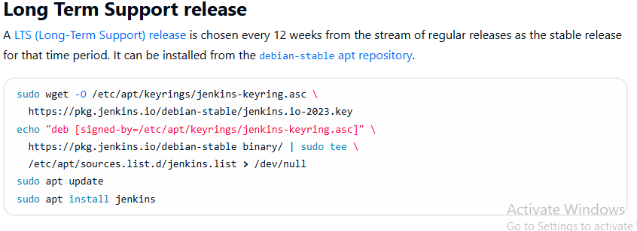

|___Copy those commands’ and paste it in instance run to download Jenkins
|___after check whether Jenkin is running or not

|___browse (http://public_ip:8080) Jenkin window will come start install and set up

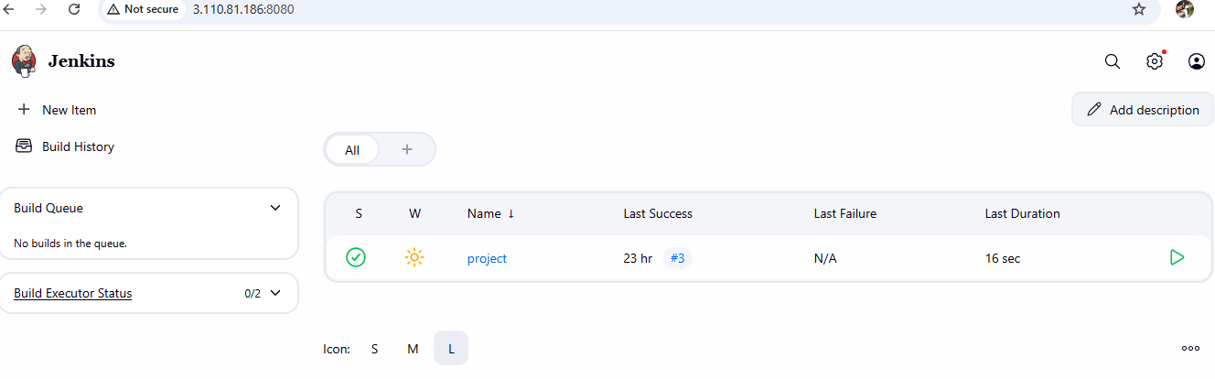

  - 2 instance for –sonarqube (Edit security group allow port 9000)
|___connect to instance
|___Install java and zip

|___browse sonarqube for Ubuntu
|___select first link
|___community build
|___download for free -right click -copy link address
https://www.sonarsource.com/products/sonarqube/downloads/success-download-community-edition/

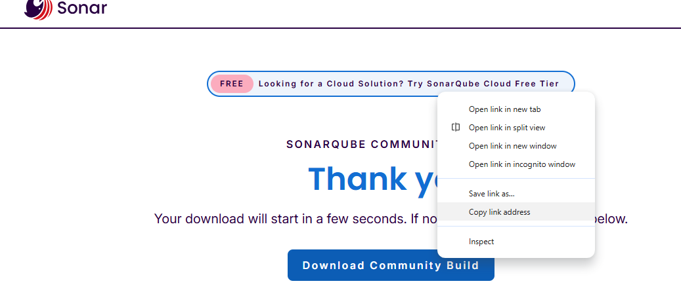
|___Paste it and download it refer below cmd

|___then unzip and get into the folder refer blow and start sonarqube
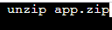

|___browse (http://public_ip:9000) sonarqube window will come start set up by login and all

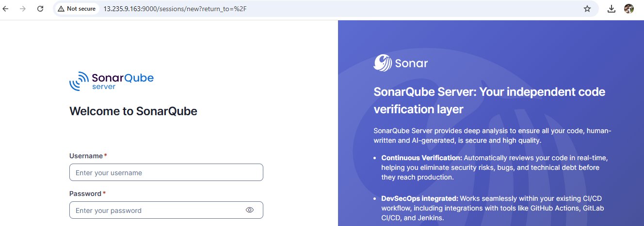

  - 3 instance for –nexus (Edit security group allow port 8081)
|___connect to instance
|___browse nexus for Linux
https://help.sonatype.com/en/download.html
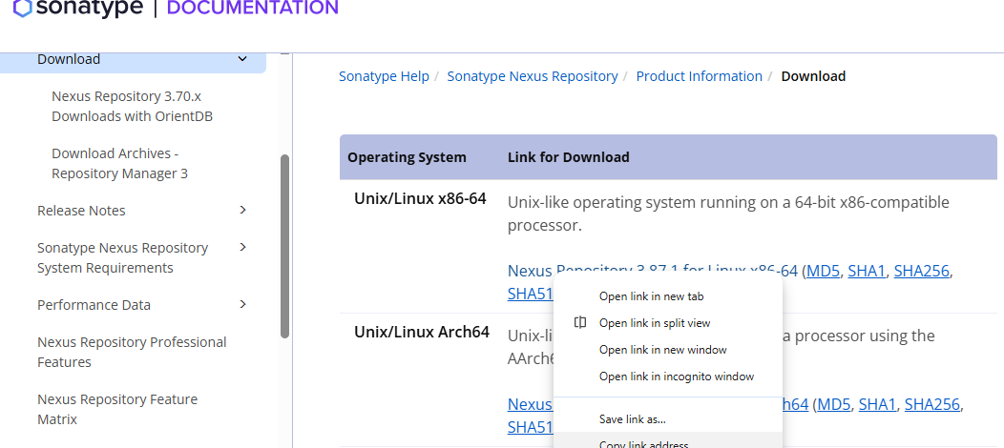

|___ right click -copy link address

|___browse (http://public_ip:8081) nexus window will come start set up by login and all

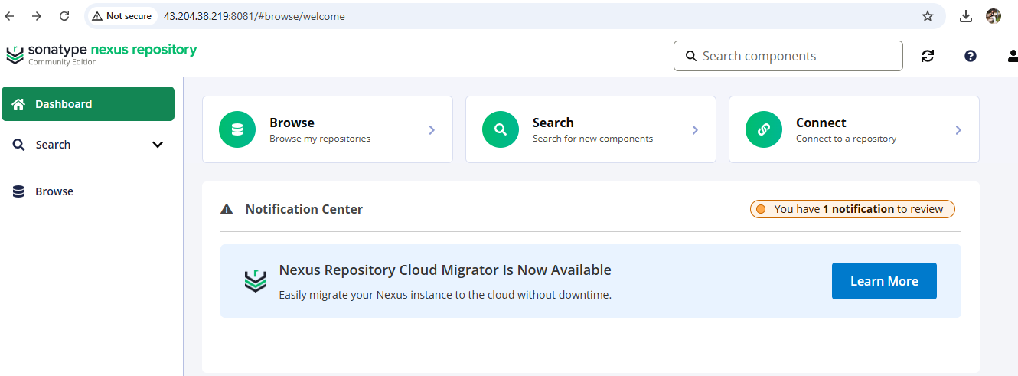

  - 4 instance for –tomcat (Edit security group allow port 8080)
|____Browse tomcat for ubuntu select first link
|___tomcat 10 right click copy link address

|___ Browse http://public_ip:8080 you will get tomcat page

Step2: Writing script in Jenkins
|___ login to Jenkin
|___ New item
|___ name = cicd project
|___ pipeline okay
Write below secrete in pipeline section
pipeline {
agent any

stages {
stage('git') {
steps {
git branch: 'main', url: 'https://github.com/Preran-48/spring-framework-petclinic.git'
}
}
stage('test') {
steps {
sh 'mvn clean test'
}
}
stage('sonar-test') {
steps {
withSonarQubeEnv(installationName:'SonarQube',credentialsId: 'sonarqube') {
sh 'mvn sonar:sonar'
}
}
}
stage('build') {
steps {
sh 'mvn package'
}
}
stage('nexus-deploy') {
steps {
nexusArtifactUploader artifacts: [[artifactId: 'spring-framework-petclinic', classifier: '', file: 'target/petclinic.war', type: 'war']], credentialsId: 'nexus-e1', groupId: 'org.springframework.samples', nexusUrl: '35.154.211.49:8081', nexusVersion: 'nexus3', protocol: 'http', repository: 'petclinic', version: '6.2.8'
}
}
stage('tomcat-deploy') {
steps {
sh 'scp target/petclinic.war ubuntu@172.31.44.244:/home/ubuntu/apache-tomcat-10.1.50/webapps'
}
}
}
}
You don’t know script use Pipeline syntax
For Git refer below screenshot
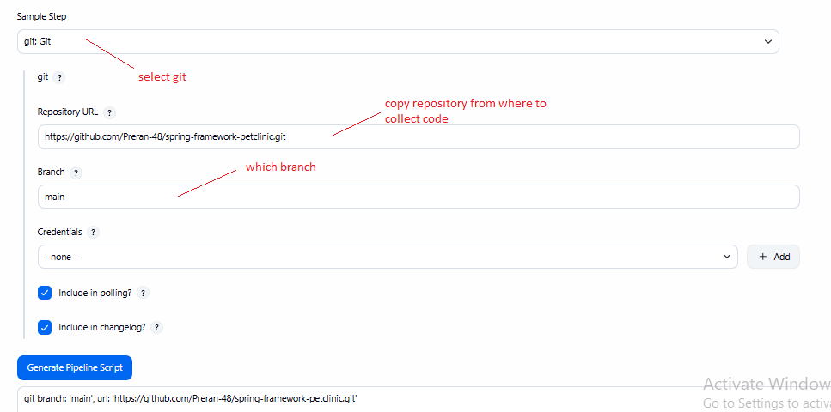

|___generate copy and paste code

stage('git') {
steps {
//paste here
}
}

For sonarqube refer below screenshot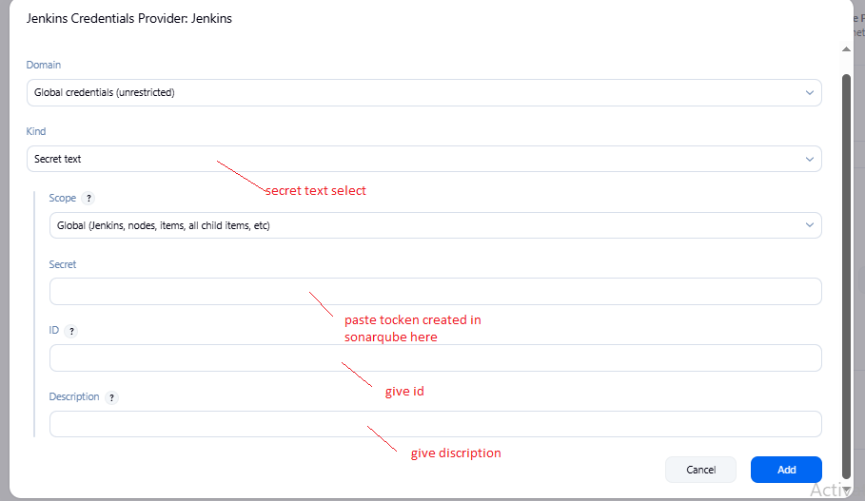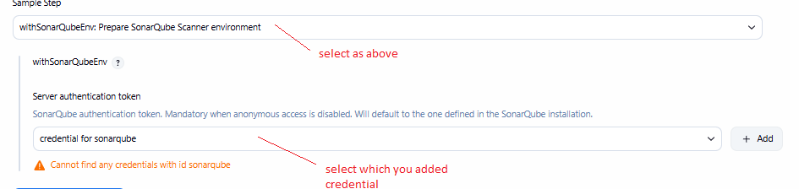
|___paste here add some other part which in blue color are additional refer below code
stage('sonar-test') {
steps {
withSonarQubeEnv(installationName:'SonarQube',credentialsId: 'sonarqube') {
sh 'mvn sonar:sonar'
}
}
}

For Nexus refer below screenshot
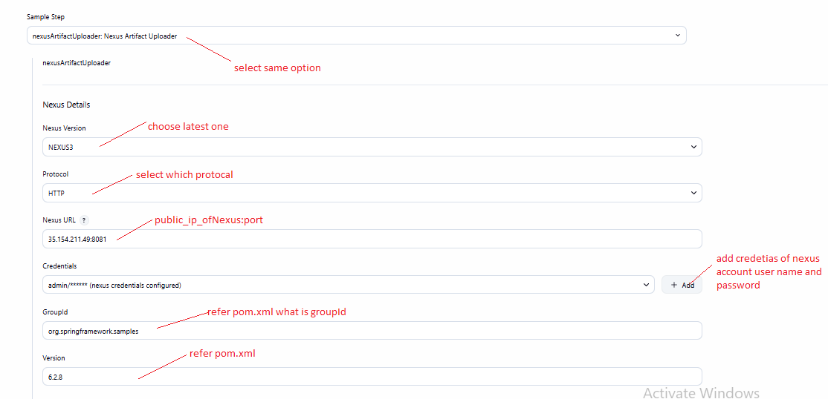
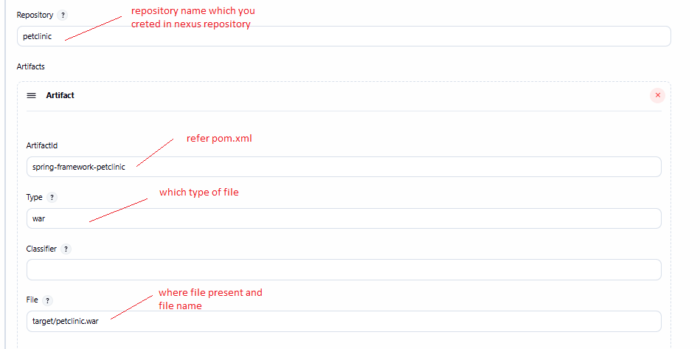
|___generate copy and paste code
stage('nexus') {
steps {
//paste here
}
}

For tomcat refer below screenshot
|__ connect tomcat and Jenkin instance by key
Jenkin ins
|___ su – jenkin
|___ ssh-keygen(create .pub key)
|___ enter cd .ssh
|___ cat id_ed25519.pub
|___ copy content

Tomcat
|___ cd .ssh
|___ nano authorized_keys
|___ paste here save and exit

|___ copy and paste below one edit value as per yours

stage('tomcat-deploy') {
steps {
sh 'scp target/petclinic.war ubuntu@172.31.44.244:/home/ubuntu/apache-tomcat-10.1.50/webapps'
}
}

|____ private_ip of tomcat running instance
|____file name which generated .war you can edit

