NIFTY100 FINANCIAL INTELLIGENCE PLATFORM
Sprint 1 – Data Foundation Report
Prepared By
Bindu Madhavi Manthi
Internship
Data Analyst Internship
Project
Nifty100 Financial Intelligence Platform
Submission Date
June 2026

TABLE OF CONTENTS
1. Executive Summary
2. Project Objectives
3. Data Sources
4. Technology Stack
5. ETL Pipeline Design
6. Database Design
7. Data Validation Framework
8. Data Loading Results
9. Testing Results
10. Deliverables Generated
11. Project Folder Structure
12. Key Achievements
13. Future Scope
14. Challenges Encountered
15. Appendix
16. Project Evidence
17. Conclusion

1.Executive Summary
The objective of Sprint 1 was to establish a reliable data foundation for the Nifty100 Financial Intelligence Platform. This sprint focused on data ingestion, validation, normalization, database design, and data quality assurance.
The project involved processing multiple financial datasets containing information related to company fundamentals, profit and loss statements, balance sheets, cash flows, financial ratios, sectors, peer groups, stock prices, annual reports, and company insights.
A complete ETL (Extract, Transform, Load) pipeline was developed using Python and SQLite. Data quality validation rules were implemented to ensure data consistency, uniqueness, referential integrity, and completeness. The final outcome of Sprint 1 is a fully populated SQLite database that serves as the foundation for subsequent analytical modules.

2.Project Objectives
The primary objectives of Sprint 1 were:
• Create a structured project environment for data engineering activities.
• Design and implement an ETL pipeline for processing raw Excel datasets.
• Normalize and validate source data.
• Build a relational SQLite database.
• Implement data quality validation rules.
• Generate validation reports and audit files.
• Prepare the project foundation for advanced analytics and dashboard development.

3.Data Sources
Dataset | Description
companies | Company profile information, website links, ROE and ROCE
profitandloss | Revenue, expenses, operating profit, net profit, EPS, and dividend payout details
balancesheet | Assets, liabilities, reserves, borrowings, and equity information
cash Flow | Operating, investing, financing, and net cash flow activities
Analysis | Growth metrics, CAGR calculations, and historical performance indicators
documents | Annual report links and company document references
prosandcons | Qualitative strengths and weaknesses of companies
Financial_ratios | Profitability, leverage, liquidity, and efficiency ratios
Peer_groups | Industry peer comparison groups and benchmark companies
sectors | Sector classification, market-cap category, and index weight information
Stock_prices | Historical stock price data including OHLC, volume, and adjusted close values

These datasets were collected and integrated to provide a comprehensive view of Nifty100 companies. Together, they support financial analysis, data validation, company screening, sector comparison, and future analytical modules of the Financial Intelligence Platform.

4.Technology Stack
The Nifty100 Financial Intelligence Platform was developed using the following technologies and tools:
Category | Technology
Programming Language | Python
Data Processing | Pandas
Database | SQLite
Testing Framework | Pytest
Version Control | Git
Repository Hosting | GitHub
Development Environment | Visual Studio Code

These technologies were selected to support efficient data ingestion, validation, transformation, testing, and database management throughout Sprint 1 of the project.

5.ETL Pipeline Design
The ETL pipeline was designed to automate the movement of data from raw Excel files into the SQLite database.
The workflow consisted of:
Step 1: Data Extraction
Raw Excel datasets were loaded into Pandas DataFrames.
Step 2: Data Normalization
Company identifiers and year formats were standardized to ensure consistency.
Step 3: Data Validation
Primary key, foreign key, and uniqueness checks were performed.
Step 4: Database Loading
Validated datasets were loaded into SQLite tables.
Step 5: Quality Verification
Row counts and validation reports were generated.
The ETL architecture ensured repeatable and scalable data processing.

6.Database Design
A relational SQLite database named "nifty100.db" was created.
The database contains the following tables:
• companies
• profit and loss
• balance sheet
• cashflow
• analysis
• documents
• pros and cons
• financial_ratios
• peer_groups
• sectors
• stock_prices
The schema was designed to support future analytical modules including screening, scoring, peer comparison, and dashboard visualization.

7.Data Validation Framework
Several validation rules were implemented to ensure data quality.
DQ-01 Primary Key Validation
Verified uniqueness of primary key values.
DQ-02 Company-Year Uniqueness
Validated that each company-year combination appears only once.
DQ-03 Foreign Key Validation
Ensured valid company references across datasets.
DQ-04 Null Value Analysis
Measured missing values across all tables.
DQ-05 Negative Value Analysis
Evaluated negative financial values and assessed business validity.
DQ-06 Data Type Validation
Verified numeric, text, and date fields.
DQ-07 Range Validation
Confirmed stock prices remained within valid ranges.
DQ-08 Date Validation
Validated stock market date records.
Validation reports were generated and stored for auditing purposes.

8.Data Loading Results
The final database contains the following records:
Table | Records
companies | 92
profitandloss | 1276
Balance sheet | 1312
cashflow | 1187
analysis | 20
documents | 1585
Pros and cons | 16
financial_ratios | 1184
peer_groups | 56
sectors | 92
stock_prices | 5520

All datasets were successfully loaded into the SQLite database.

9.Testing Results
Unit tests were executed for normalization and validation modules.
All implemented tests passed successfully with zero failures.
The successful execution of all tests confirms the reliability of the ETL pipeline, validation framework, and data processing logic.

10.Deliverables Generated
The following project deliverables were created:
• nifty100.db
• schema. sql
• validation_failures.csv
• load_audit.csv
• dq_report.csv
• final_validation_report.txt
• README.md
These files collectively document the project implementation and validation outcomes.

11.Project Folder Structure
The project was organized using a structured folder hierarchy to improve maintainability and scalability.
nifty100_capstone/
├── data/
│ └── raw/
├── db/
│ ├── nifty100.db
│ ├── schema.sql
│ └── create_database.py
├── src/
│ └── etl/
├── tests/
├── notebooks/
├── output/
├── README.md
└── requirements.txt

This structure ensured clear separation between source data, database assets, ETL scripts, testing modules, reports, and project documentation.

12.Key Achievements
The following milestones were successfully achieved during Sprint 1:
• Developed an end-to-end ETL pipeline using Python.
• Created a normalized SQLite database containing financial information for Nifty100 companies.
• Implemented multiple data quality validation rules.
• Generated audit and validation reports.
• Successfully loaded more than 11,000 records across multiple datasets.
• Achieved 100% pass rate in implemented unit tests.
• Maintained version control using Git and GitHub.
• Prepared the project foundation for future analytical modules.

13.Future Scope
The data foundation created during Sprint 1 will support future development phases of the Nifty100 Financial Intelligence Platform.
Planned future enhancements include:
• Financial Ratio Engine
• Investment Screening Module
• Financial Health Scoring System
• Peer Comparison Engine
• Sector Analytics
• Interactive Dashboards
• Report Generation
• Portfolio Tracking and Alerts
These modules will transform the project from a data repository into a comprehensive financial analytics platform.
14.Challenges Encountered
Several challenges were encountered during development:
• Duplicate company-year records in source datasets.
• Foreign key inconsistencies across datasets.
• Excel header variations requiring custom loading logic.
• Database schema mismatches during data loading.
These issues were identified and resolved through iterative validation and testing.

15.Appendix
The following supporting artifacts were generated as part of Sprint 1:
• SQLite Database (nifty100.db)
• Data Quality Report (dq_report.csv)
• Validation Failures Report (validation_failures.csv)
• Load Audit Report (load_audit.csv)
• Final Validation Report (final_validation_report.txt)
• SQL Schema Definition (schema.sql)
• Unit Test Suite
• GitHub Repository
These artifacts provide evidence of successful completion of Sprint 1 objectives and support future development activities.

16.Project Evidence

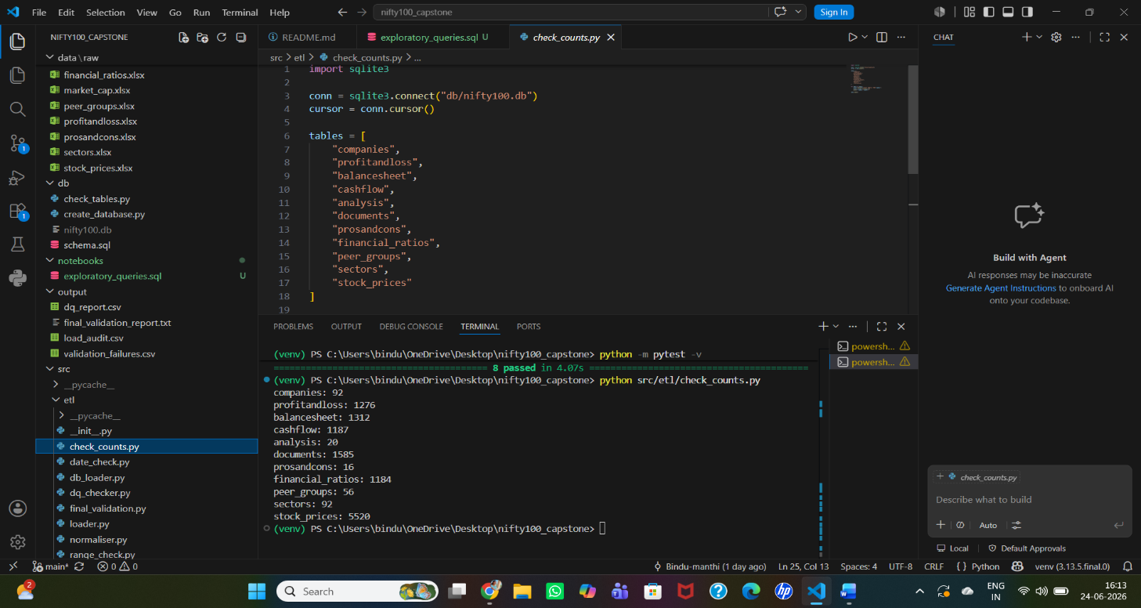
Figure 1: Final database row counts for all tables.

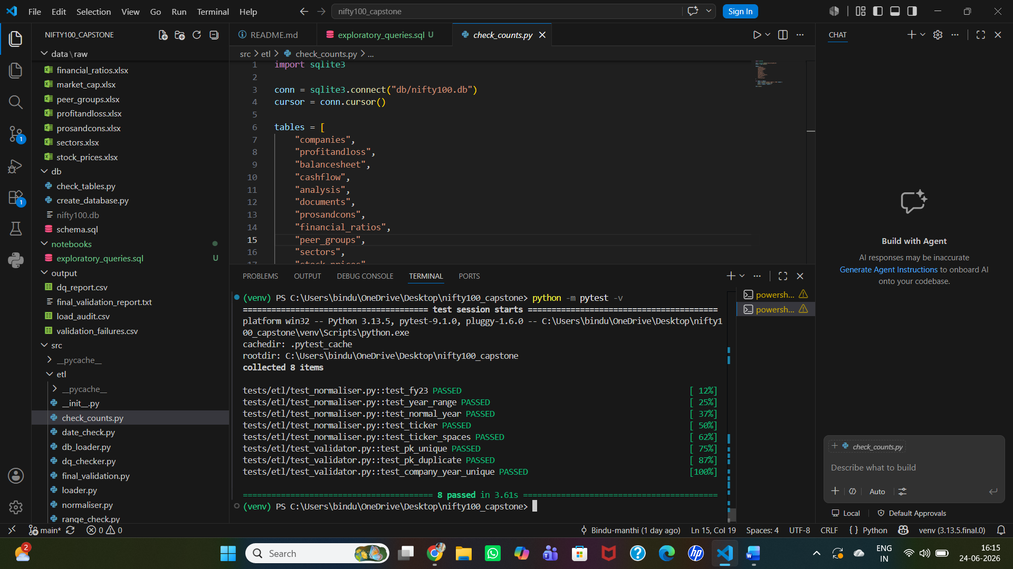
Figure 2: Successful execution of unit tests.

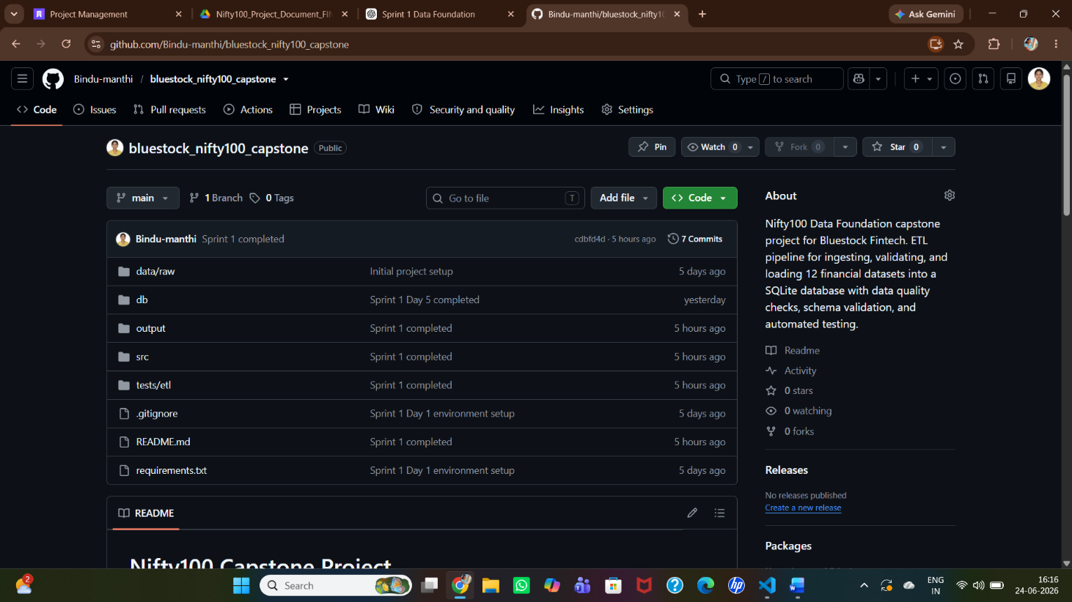
Figure 3: GitHub repository containing ETL scripts, database assets, validation reports, test cases, and project documentation for the Nifty100 Financial Intelligence Platform.

17.Conclusion
Sprint 1 successfully established the foundational data infrastructure for the Nifty100 Financial Intelligence Platform.
A robust ETL pipeline was developed, data quality checks were implemented, and a fully validated SQLite database was created. The project now provides a reliable foundation for future modules involving financial ratio analysis, stock screening, scoring systems, peer comparison, and dashboard reporting.
The objectives defined for Sprint 1 were achieved successfully, and the project is prepared for subsequent development phases.

