**UML DIAGRAMS**

Unified Modeling Language (UML) is a modelling language. The main purpose of UML is to visualize the way a system has been designed. It is a visual language to sketch the behavior and structure of the system. This was adopted by Object Management Group (OMG) as a standard in 1997.

The Unified Modelling Language (UML) is a standard language for writing software blue prints. The UML is a language for

* Visualizing
* Specifying
* Constructing
* Documenting the artefacts of a software intensive system.

The UML is a language which provides vocabulary and the rules for combining words in that vocabulary for the purpose of communication. A modelling language is a language whose vocabulary and the rules focus on the conceptual and physical representation of a system. Modelling yields an understanding of a system.

**Use Case Diagram:**

* The purpose of use case diagram is to capture the dynamic aspect of a system. This is used to gather the requirements of a system including internal and external influences.
* The main purpose of a use case diagram is to show what system functions are performed for which actor. Roles of the actors in the system can be depicted.

The UML is a very important part of developing objects oriented software and the software development process. The UML uses mostly graphical notations to express the design of software projects.

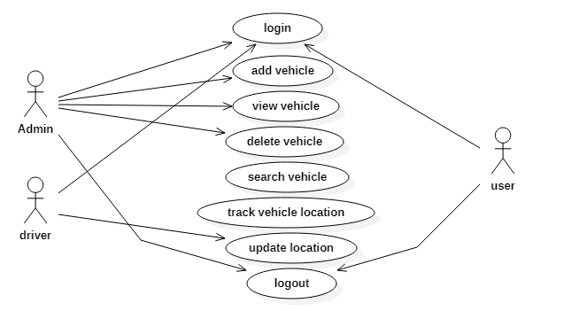

**Class Diagram:**

* The class diagram describes the structure of a system by showing the system's classes, their attributes, operations, and the relationships among the classes.
* It explains which class contains information and also describes responsibilities of the system. This is also known as structural diagram.

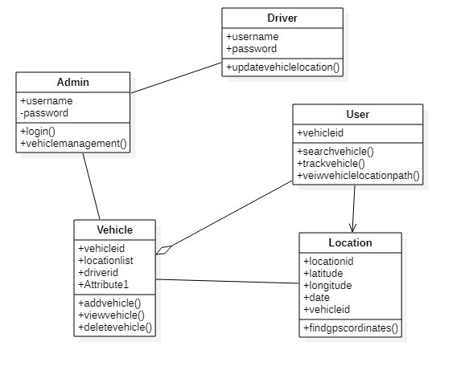

**Sequence Diagram:**

* A sequence diagram details the interaction between objects in a sequential order i.e. the order in which these interactions take place.
* This diagrams sometimes known as event diagrams or event scenarios. This helps in understanding how the objects and component interacts to execute the process.
* This has two dimensions which represents time (Vertical) and different objects (Horizontal)

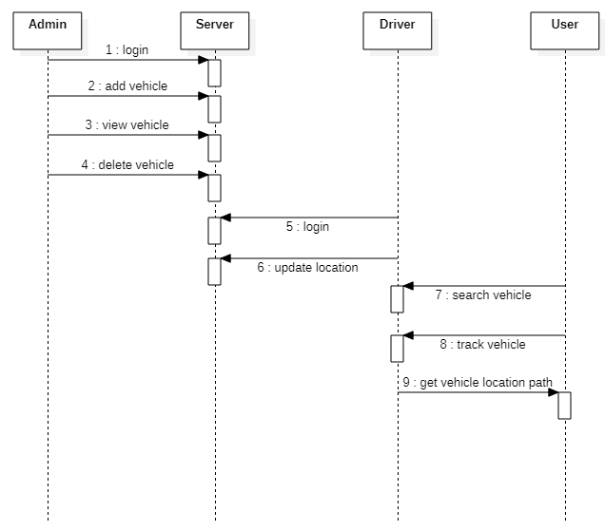

**Activity Diagram:**

* It is behavioural diagram which reveals the behaviour of a system.it sketches the control flow from initiation point to a finish point showing the several decision paths that exist while the activity is being executed.
* This doesn’t show any message flow from one activity to another, it is sometimes treated as the flowchart. Despite they look like a flowchart, they are not.
* In the Unified Modeling Language, activity diagrams can be used to describe the business and operational step-by-step workflows of components in a system..

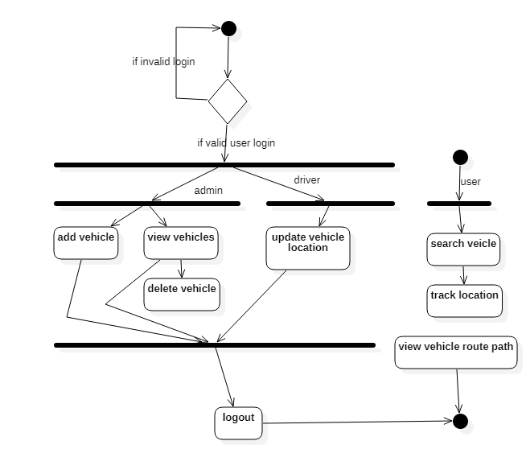

**Software and Hardware Requirements:**

**Software Requirements for Mobile App (Driver):**

* Platform : Java
* Framework : Android
* IDE : Android Studio
* Database : Google firebase
* Uml Design : Start UML
* Testing : Junit

**SOFTWARE REQUIREMENTS for Web Application (User and Admin):**

* Programming Language : Python
* IDE : PyCharm
* Tools : PIP
* WebServer : Tomcat
* Framework : DJango, Google Maps API

**Hardware Requirements:**

* Processor : i3
* Hard Disk : 500 GB
* RAM : 8 GB

Screen Shots:

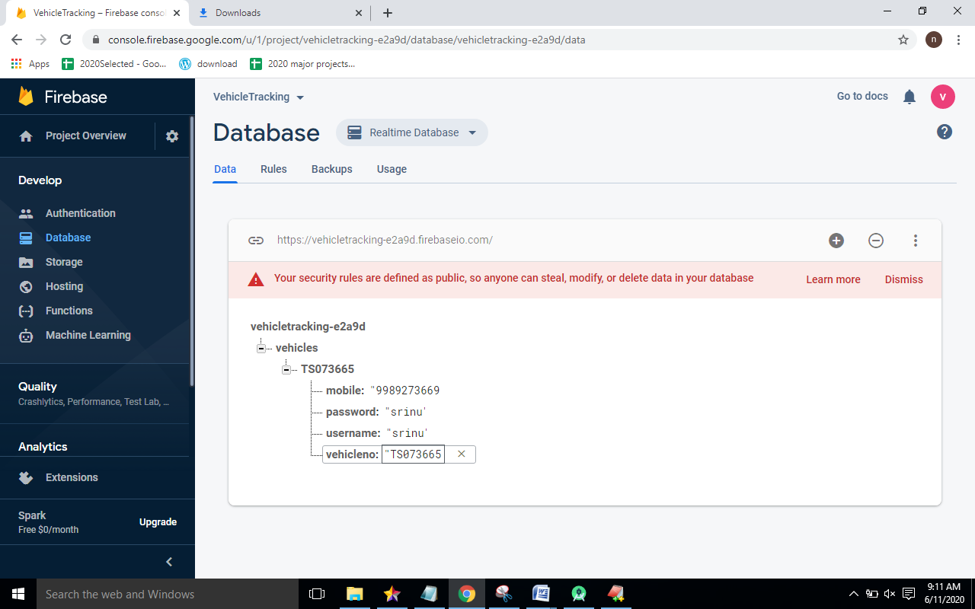

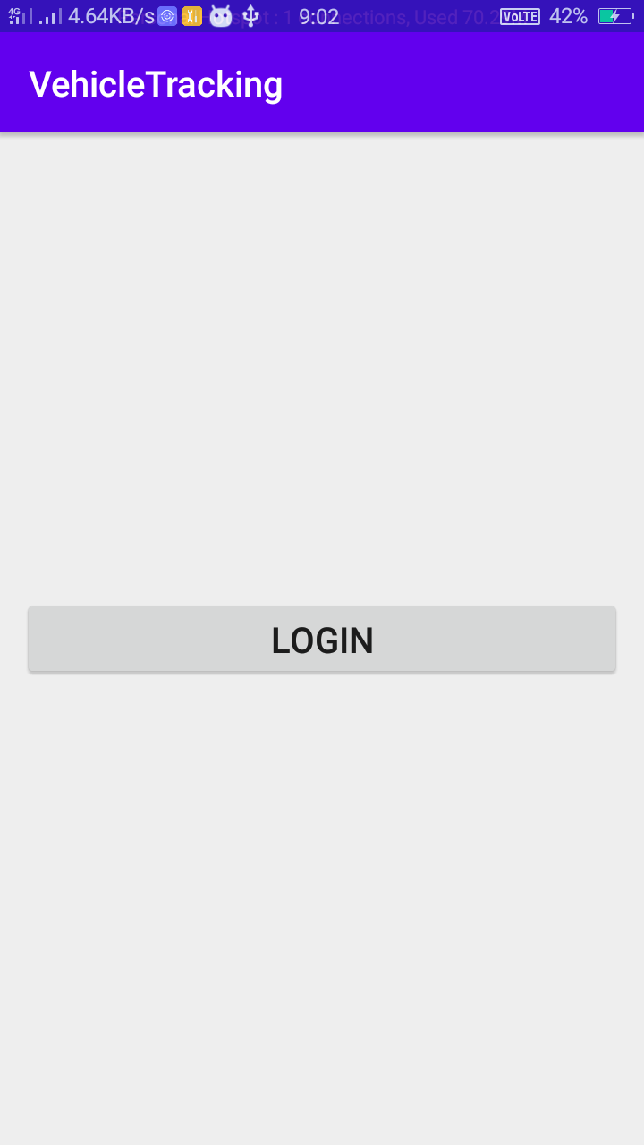

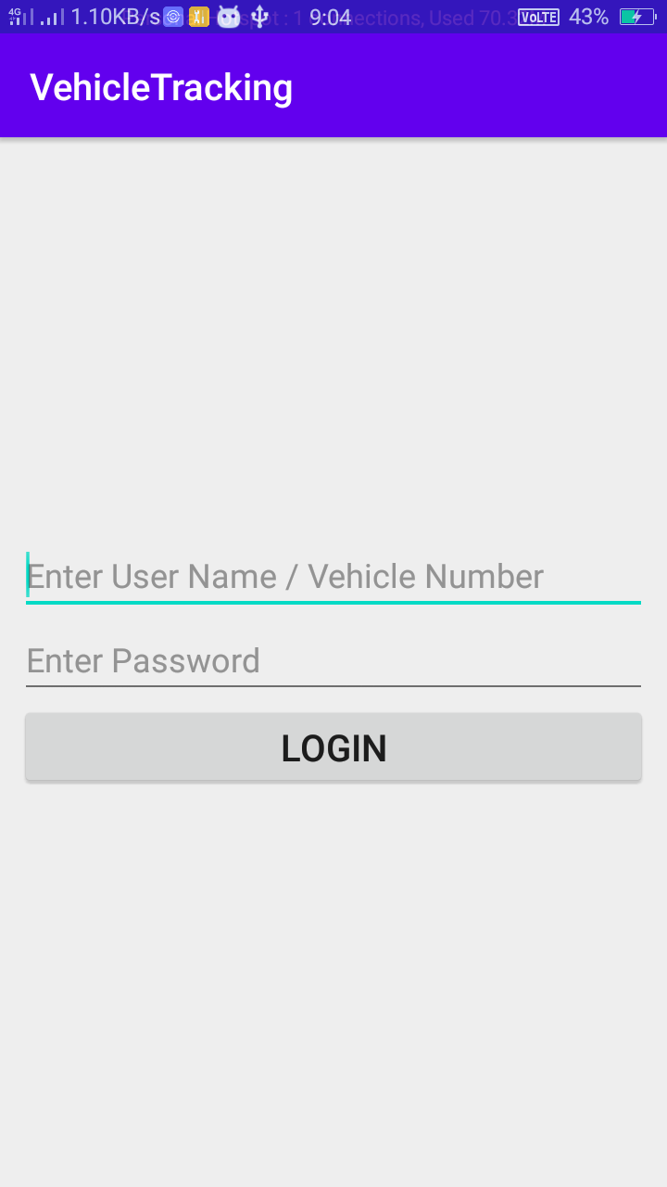

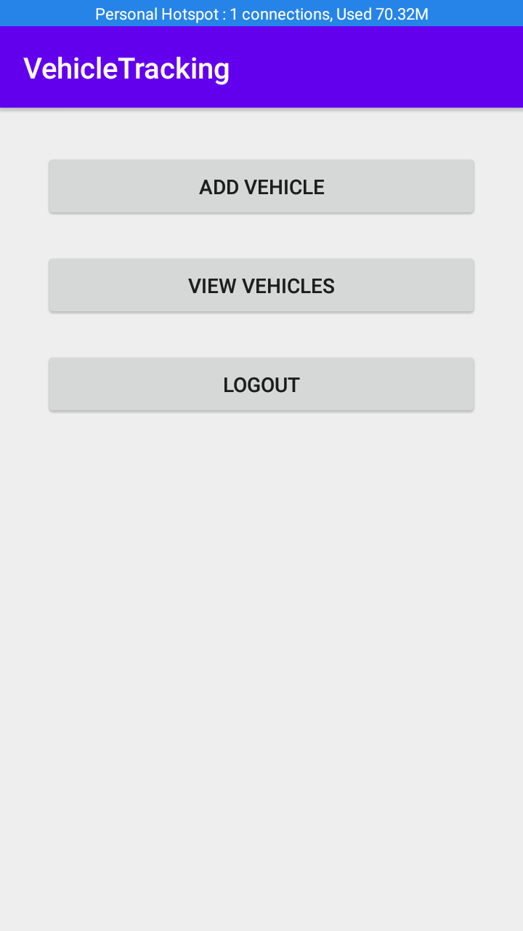

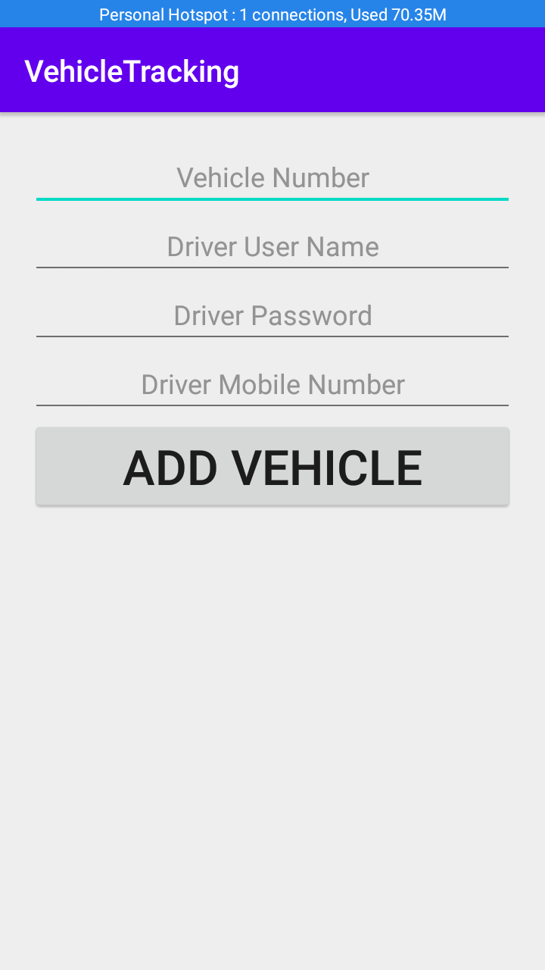

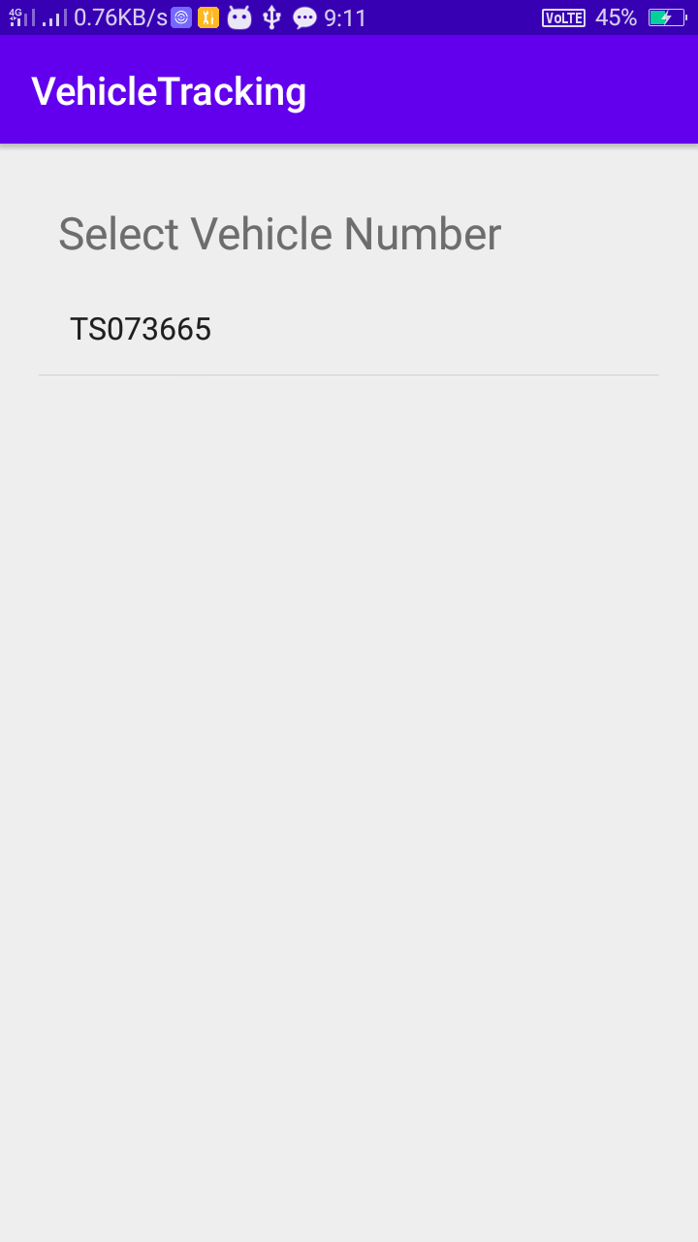

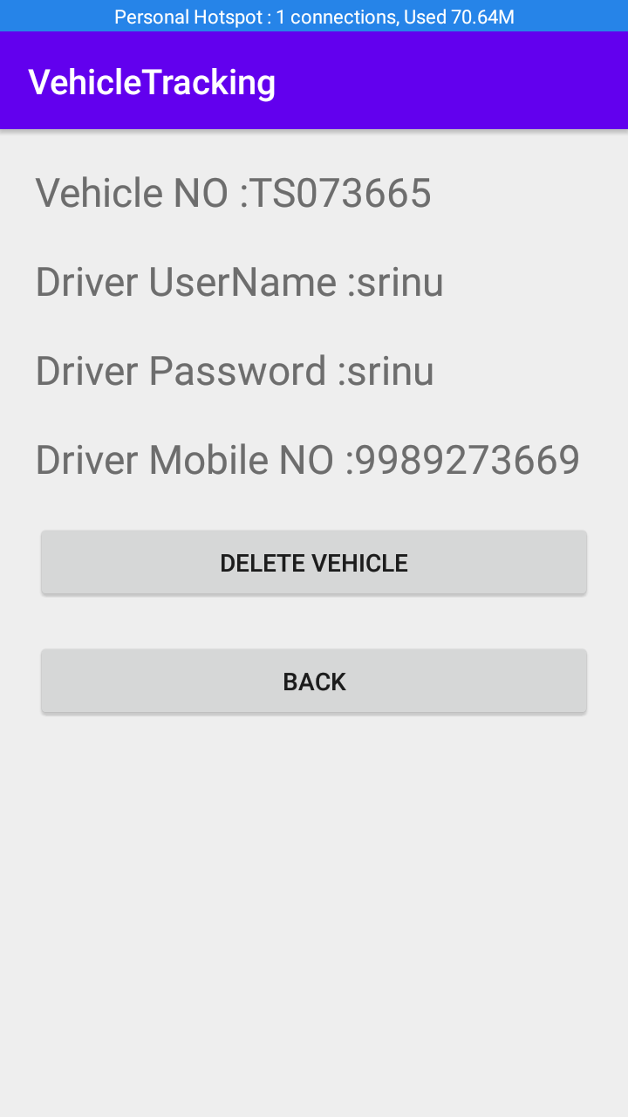

User:

