**Output**

This webpage is a clean and friendly landing page for a web developer internship. It starts with a clear headline welcoming you to the internship opportunities. Below that, you'll find a brief overview explaining what the internship is all about.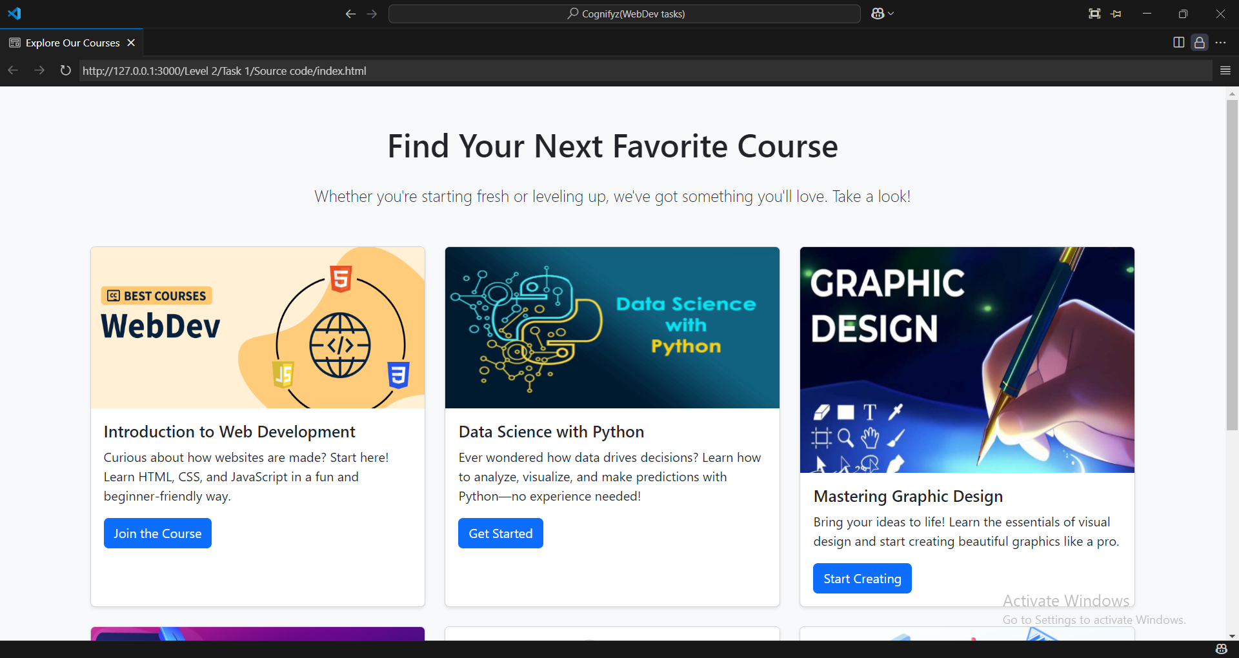

It also lists the skills and qualifications they're looking for in applicants. There's a prominent "start course" button to easily guide you to t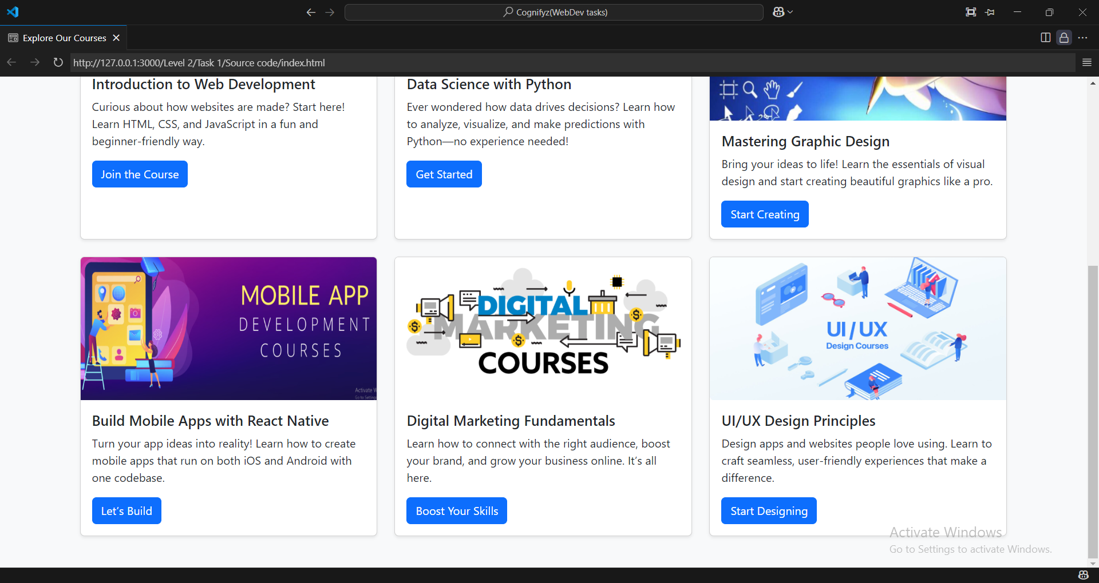he application.