**Outputs**

The output of this project will be a webpage with a button that changes its background color every time you click it.

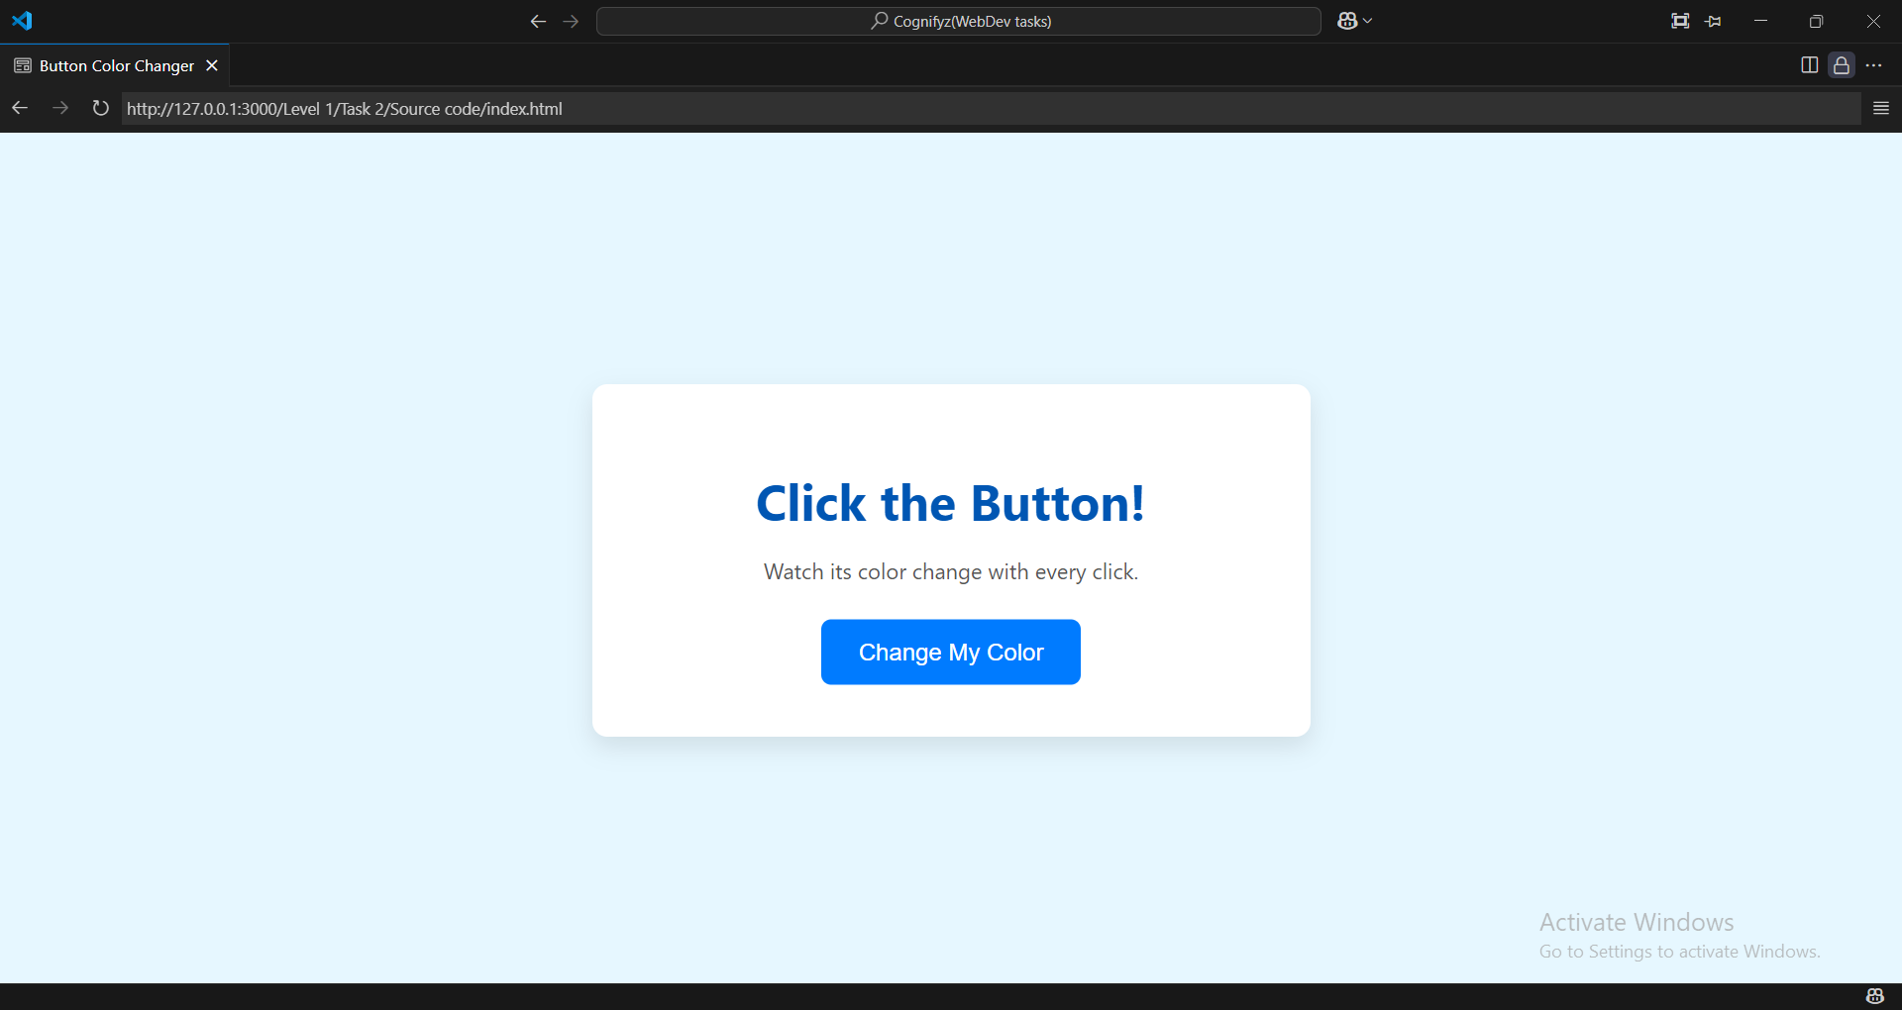

Button is in blue when you click on if it change.

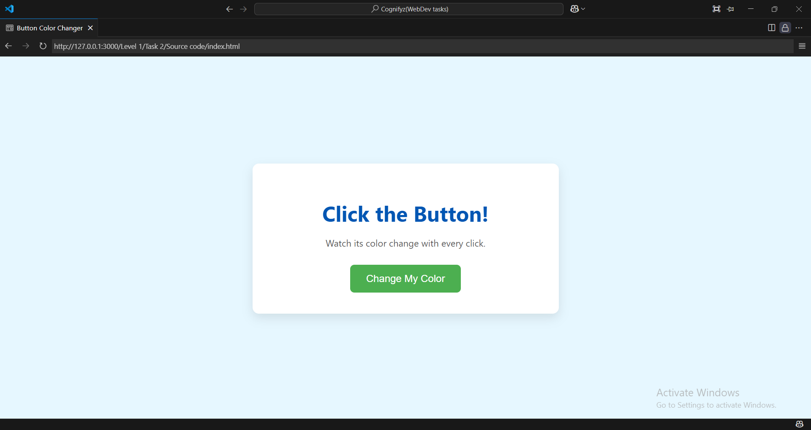Here the button color changes to green.

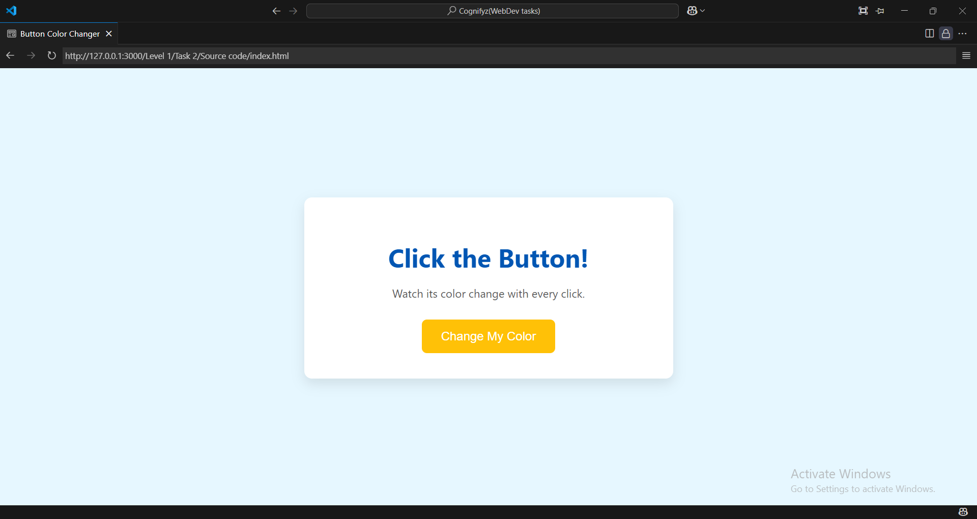

Here the button color changes to yellow.

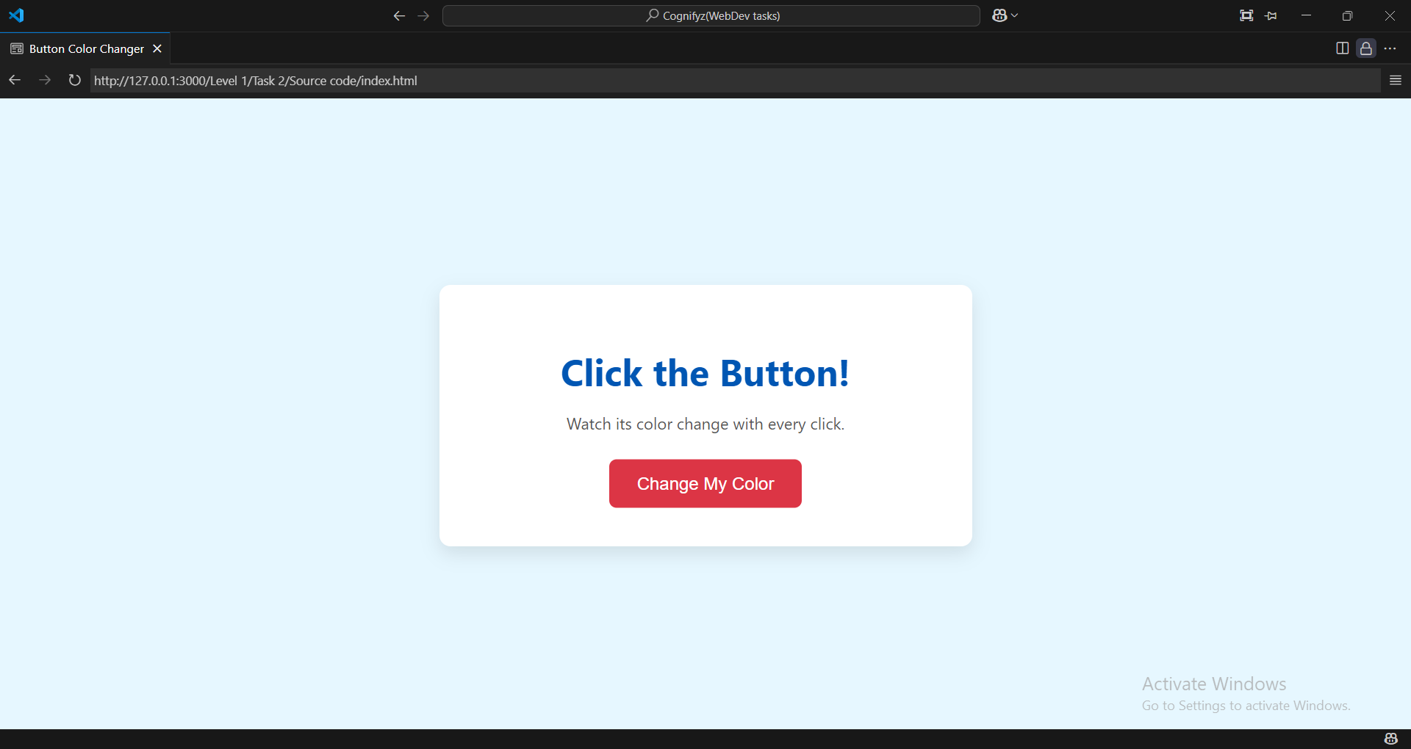

Here the button color changes to pink.

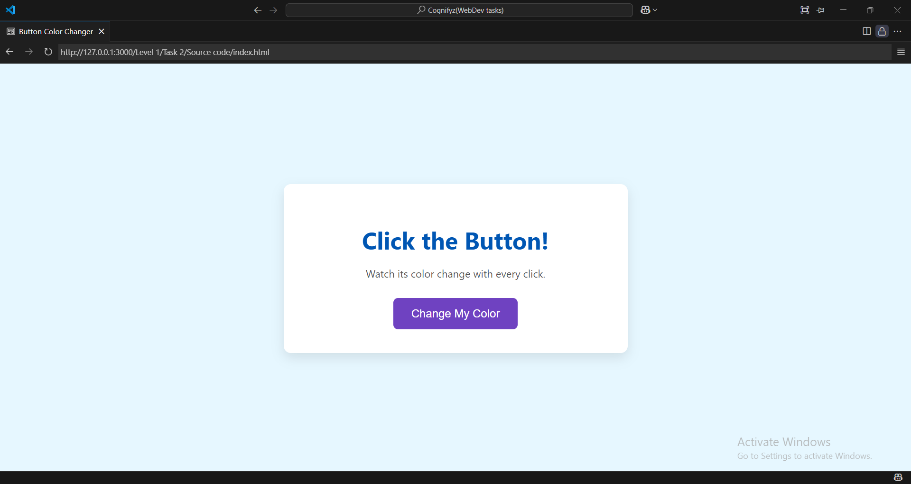

Here the button color changes to purple.