**Output**

This webpage displays an image slideshow. You'll see a series of pictures appear one after another. The images will automatically change on their own. They smoothly fade from one picture to the next. It creates a continuous, rotating display of different scenes.

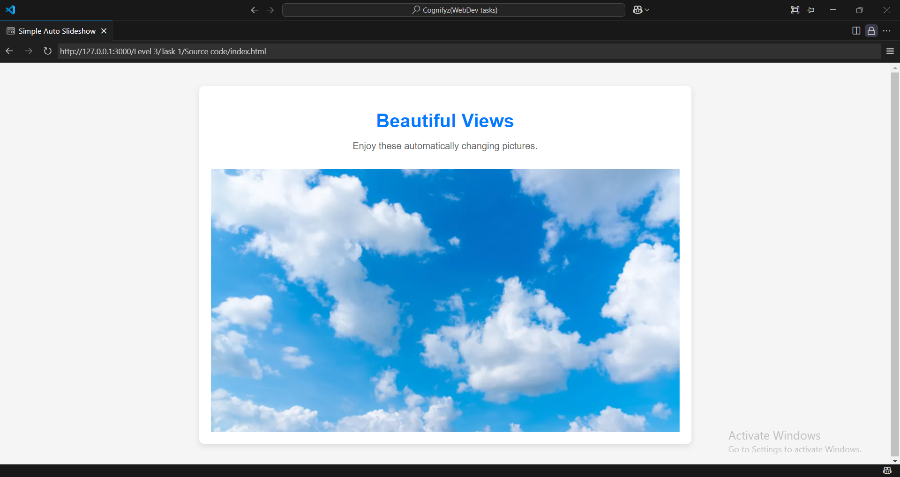

It shows a blue sky and then automatically changes into another image.

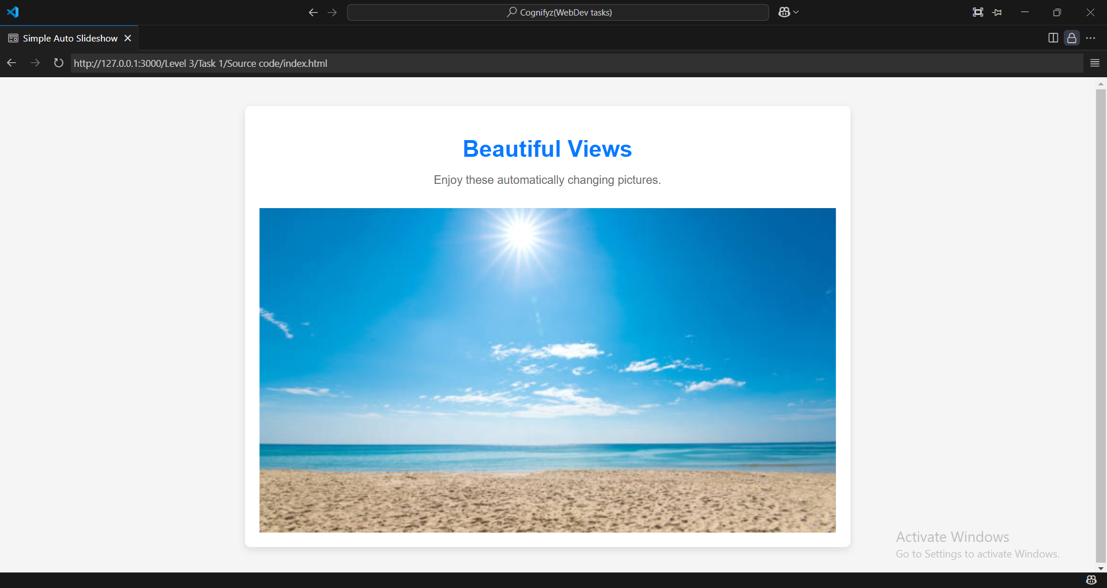

Here we have a image of a beach.

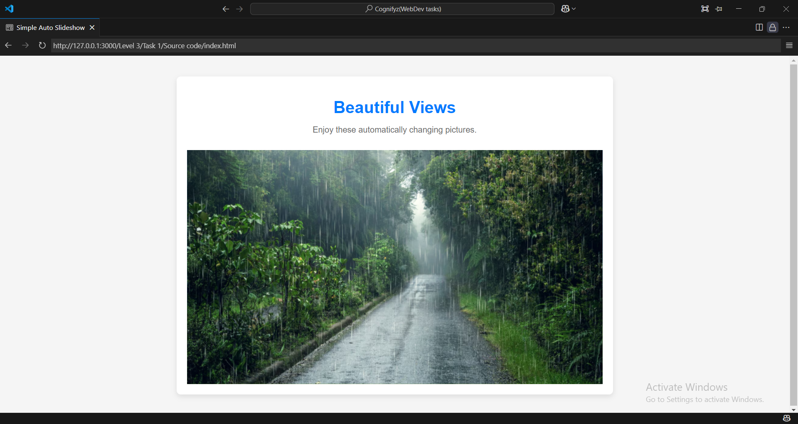

Here we have image of rainy road.