**Output**

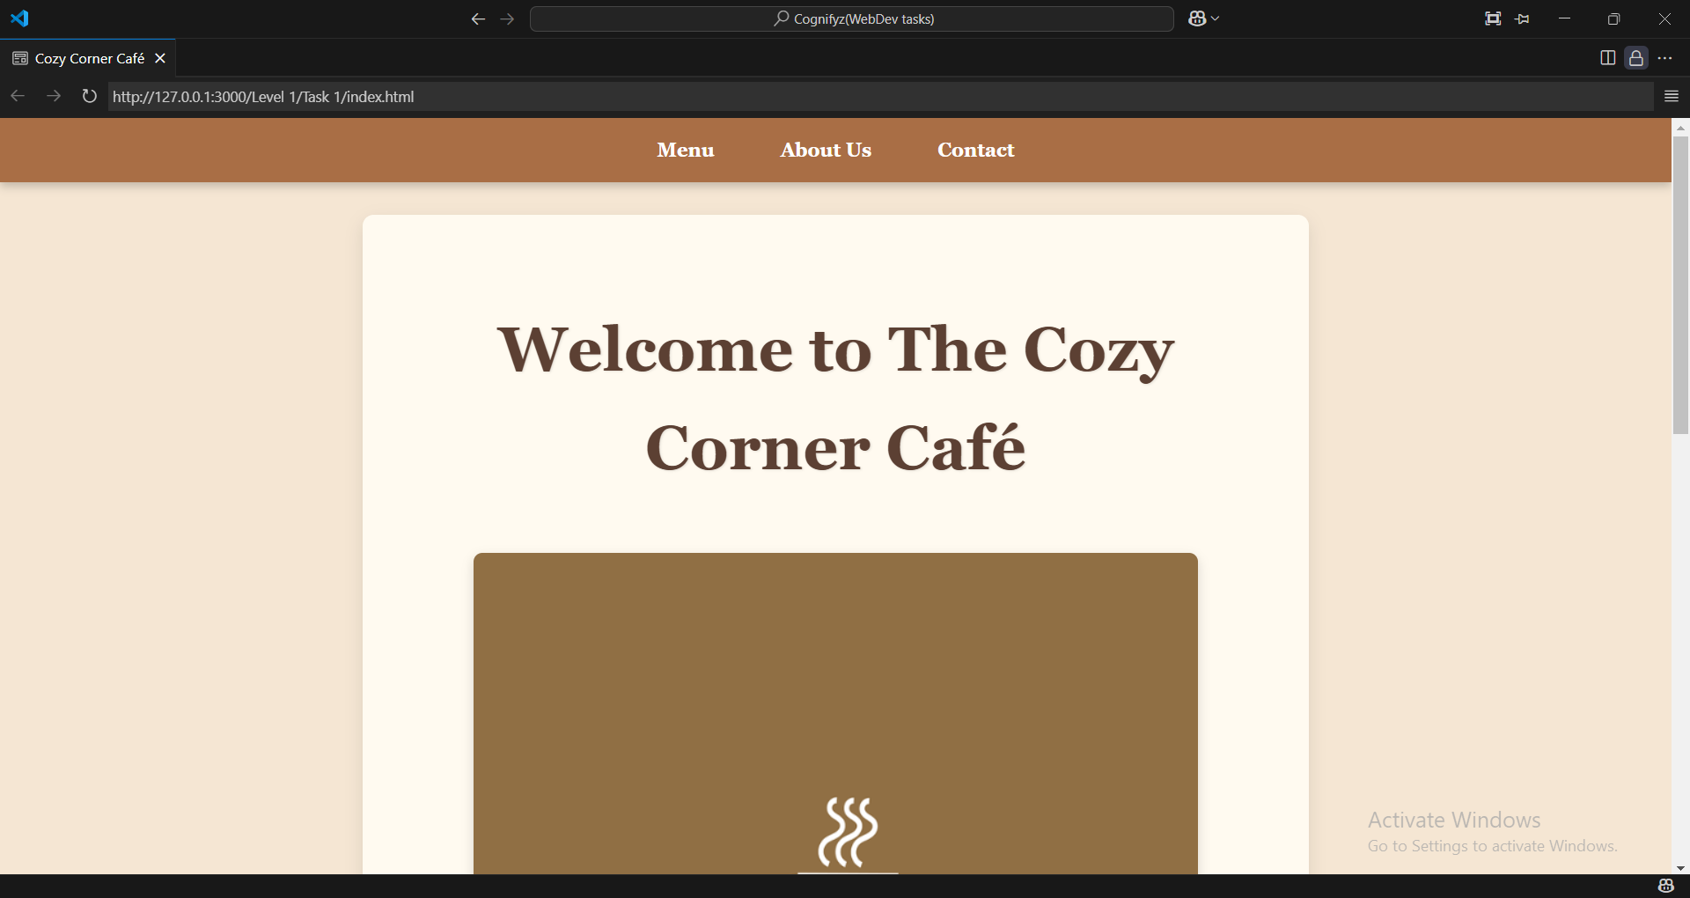

As we open the page we see a menu bar on the top of the page which guide us to other information.

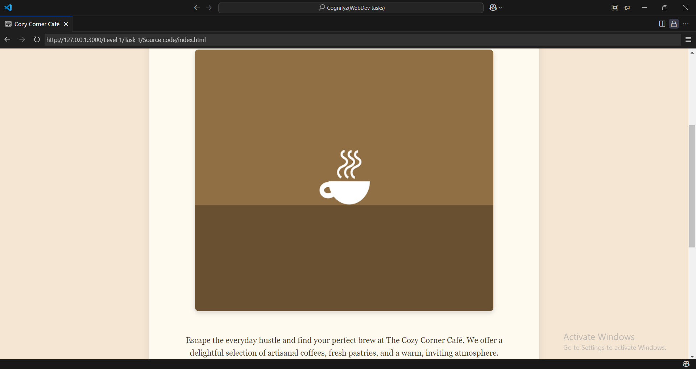

It includes a image which refers to a coffe cup as my my theme in this task.

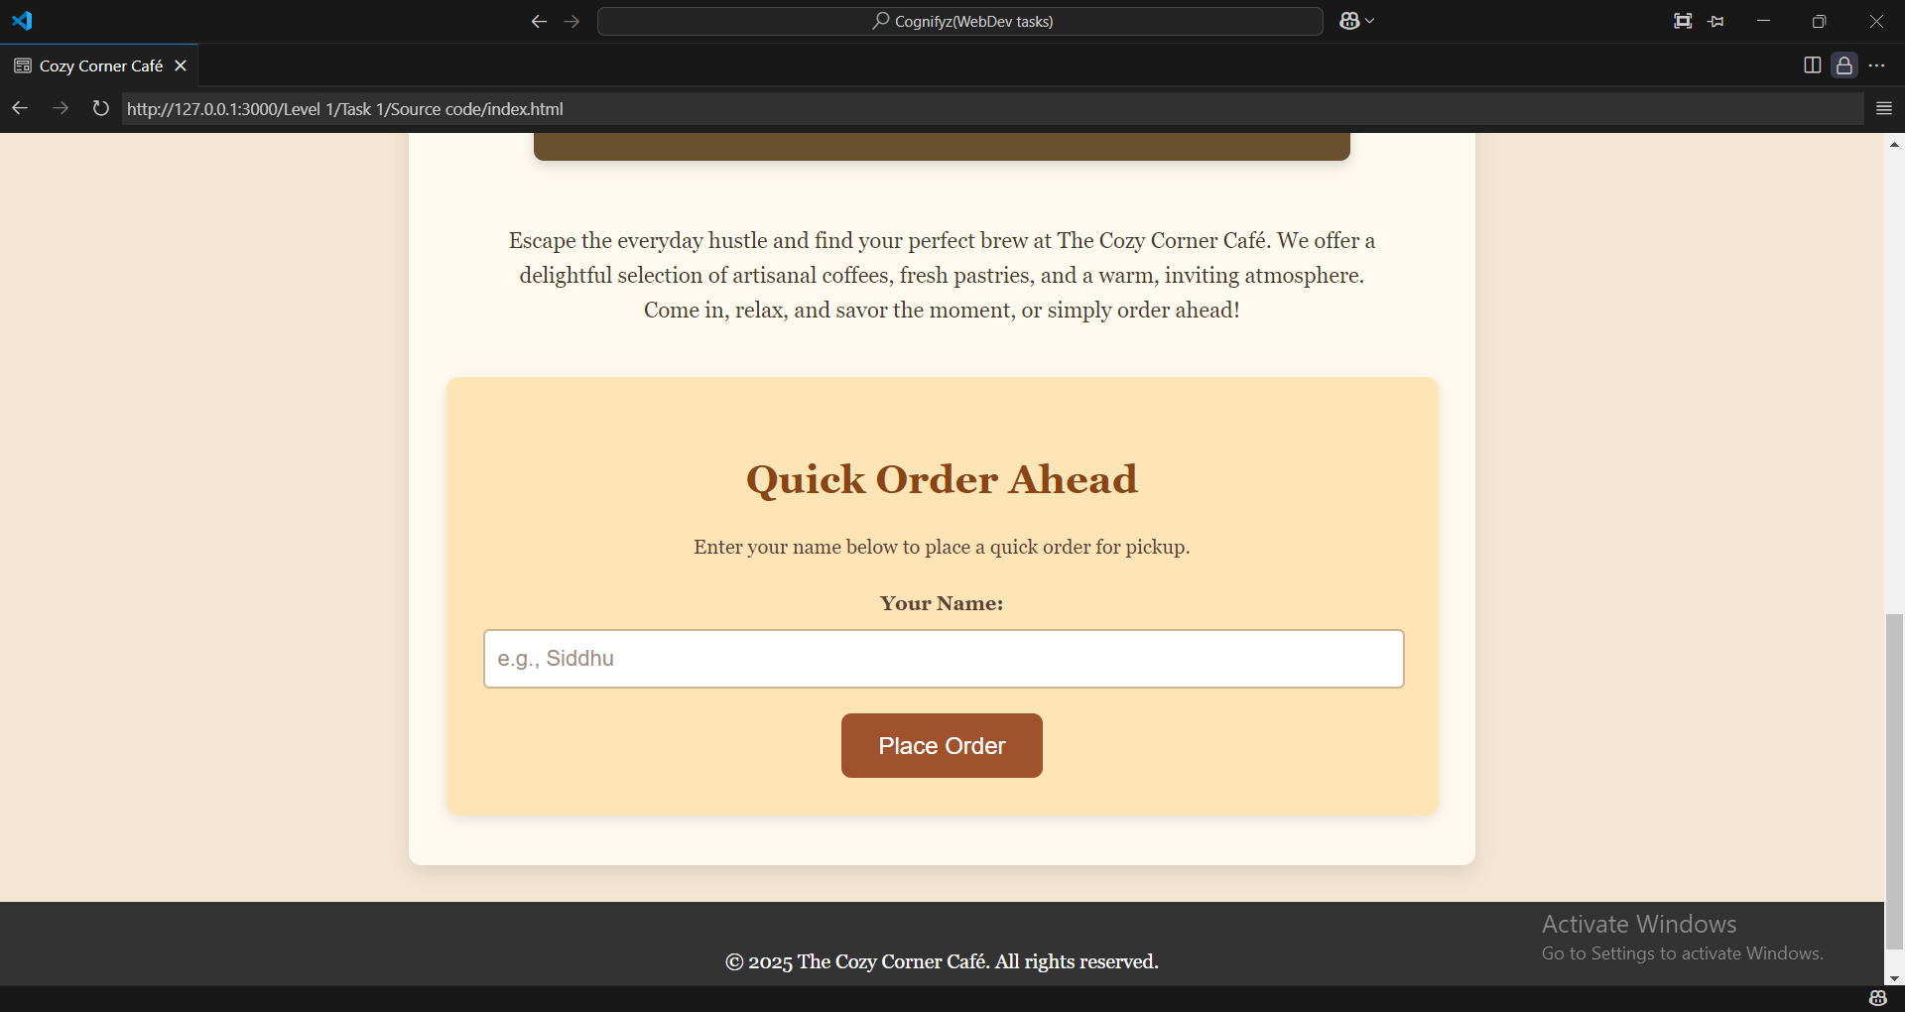

Here, it has an input field and a submit button.