**Output**

This webpage is a landing page designed to attract students to a web development internship. It introduces the internship program and its duration. The page highlights the benefits of joining, such as gaining real-world experience and mentorship. It also clearly lists the skills and qualifications needed from applicants.

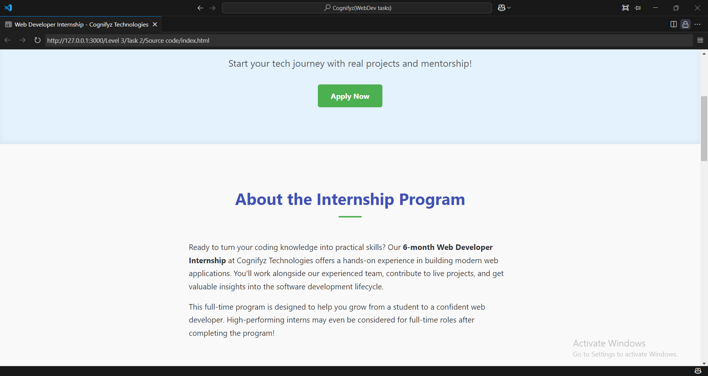

**About the Internship Program:** A section providing a concise overview of the 6-month internship, emphasizing hands-on experience and potential full-time roles.

**Why Intern with Us?** This section highlights key benefits in a grid format, such as "Hands-On Experience," "Dedicated Mentorship," and "Build Your Network," each with a relevant icon.

**What We're Looking For:** A section outlining the desired qualifications for interns, presented as a clear list with green checkmark icons.

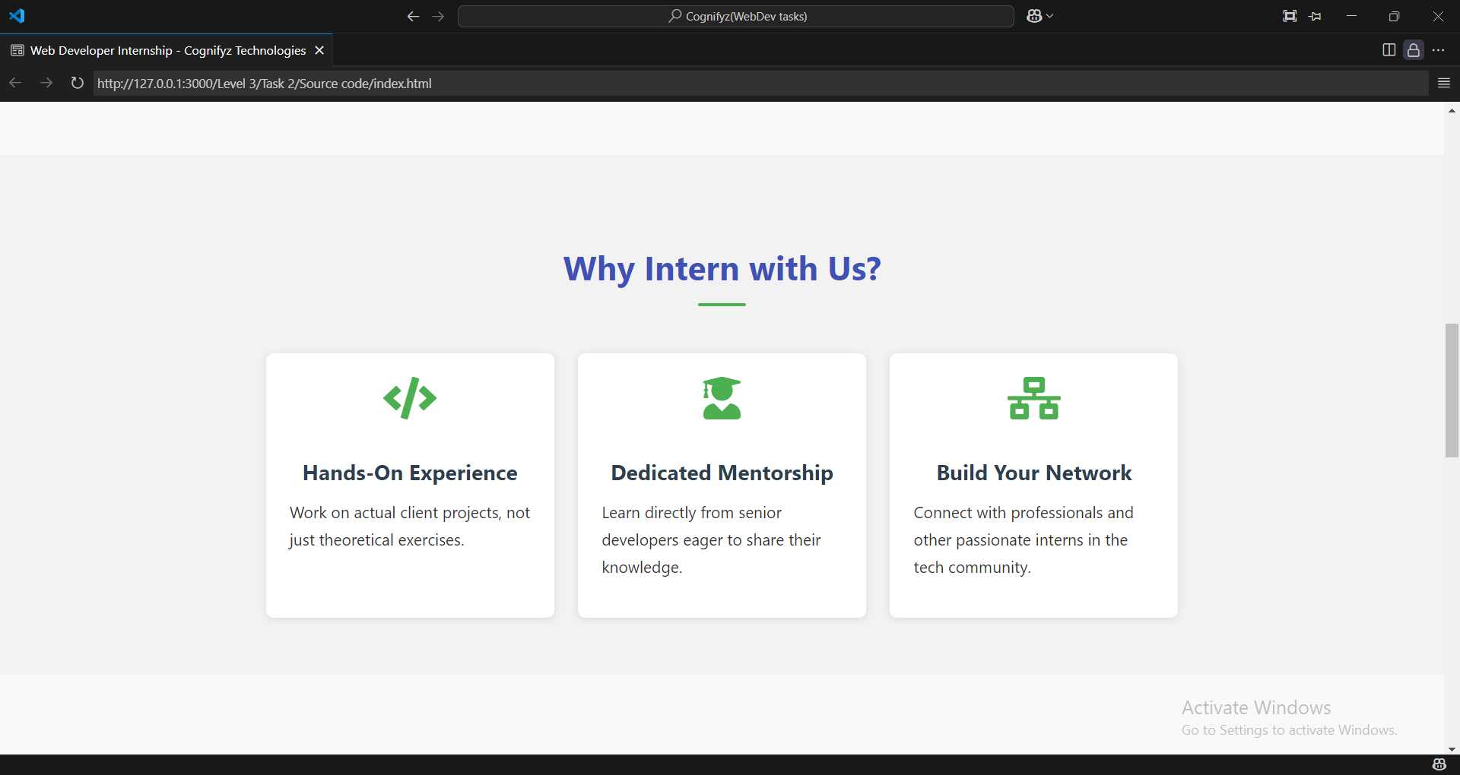

It is designed to persuade potential interns to choose Cognifyz Technologies. Its main purpose is to highlight the unique benefits and advantages an aspiring web developer would gain by interning with the company.

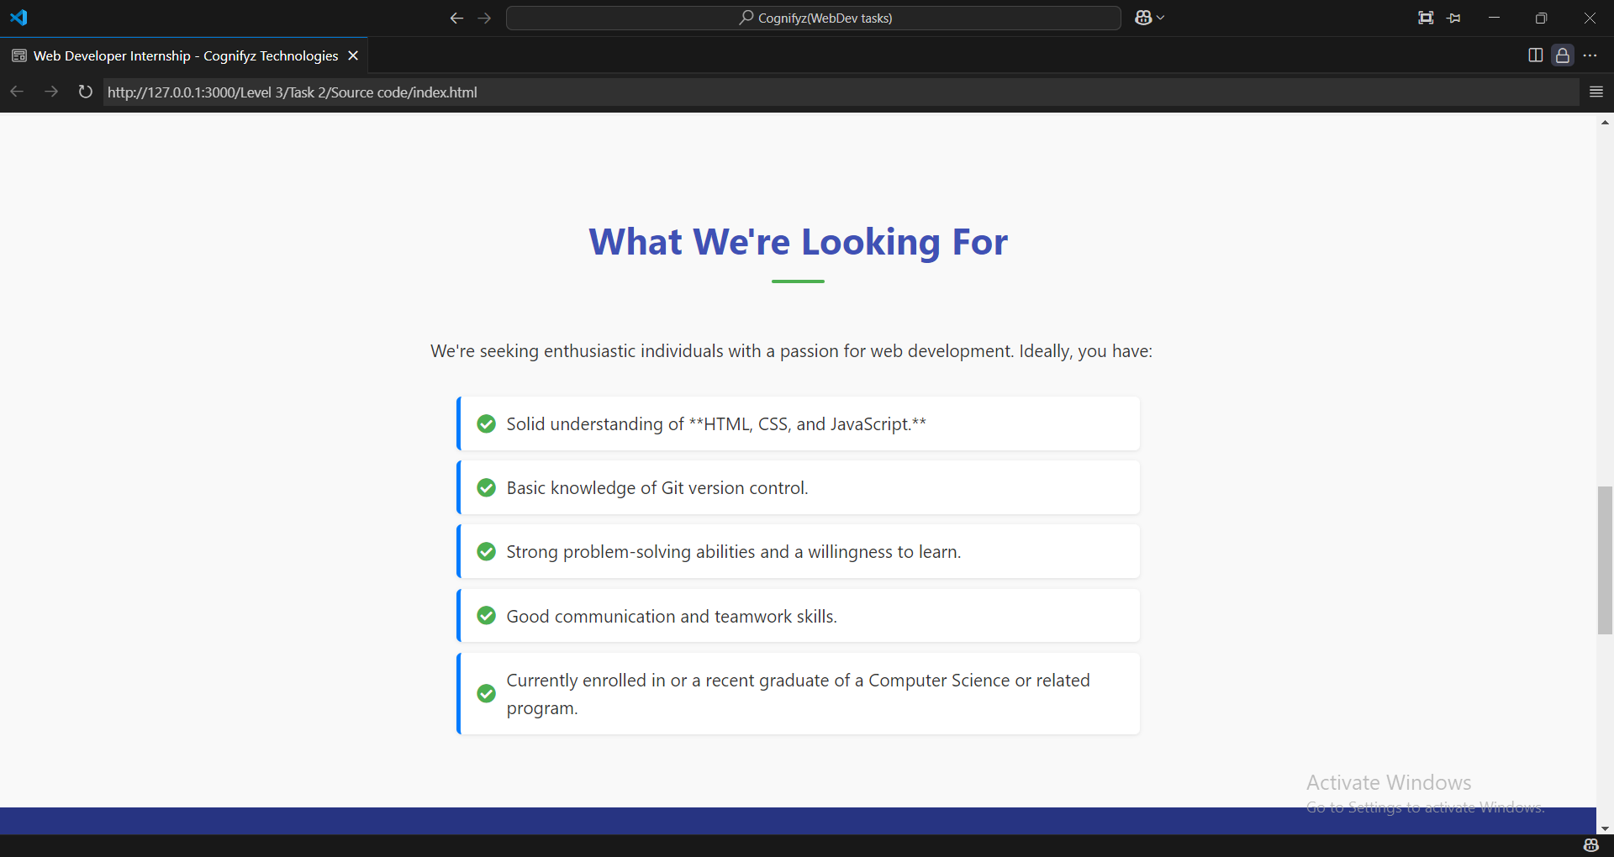

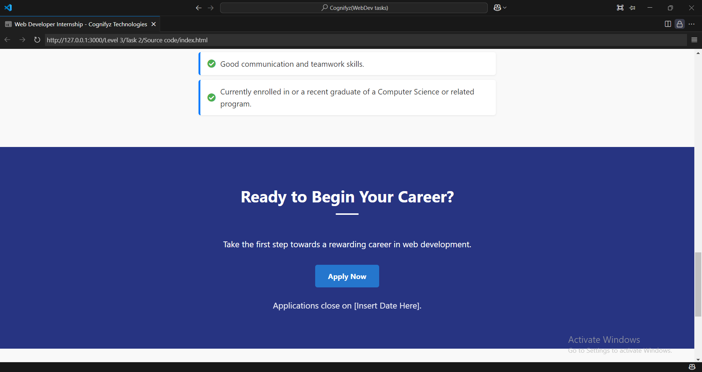

A call-to-action section with another "Apply Now" button that links to an email address for applications, along with a placeholder for the application deadline.

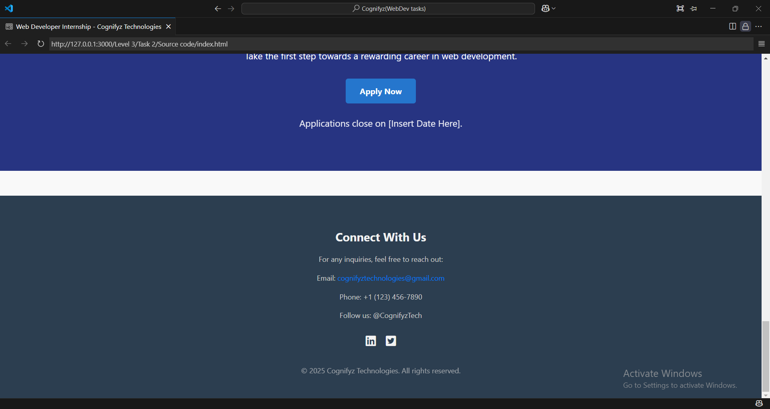

**Footer:** At the very bottom, a footer provides contact information (email, phone, social media links) and copyright details.