Freight Rate Prediction
Machine Learning Engineer Assessment — Validation & Modelling Report

1. Summary
The goal is to predict the posted rate (USD) for 12,000 truckloads in November–December 2025, using 48,000 labelled loads from January–October 2025. Because the loads to predict are later in time than all training data, the problem was treated as short-term forecasting and every validation step uses a time-based split.
Final model: Ridge regression on log(rate per mile) with lane, city, equipment, distance, weight, day-of-week and market-index features, trained with recency weights (30-day half-life). On a Sep–Oct 2025 hold-out it reaches MAPE 3.25% (MAE $77.27), beating a gradient-boosting model (4.44%) and a lane-median baseline (3.74%). It was also the best model in all four folds of a rolling 2-month backtest.

2. Data overview and key findings
- train_test.csv: 48,000 loads, 1 Jan – 31 Oct 2025; validation.csv: 12,000 loads, 1 Nov – 31 Dec 2025.
- 64 cities, ~4,000 lanes, 3 equipment types (Dry Van 57%, Reefer 25%, Flatbed 18%) — same mix in both files.
- Distance explains most of the price (correlation 0.91). Rate per mile is fairly stable (median ≈ $2.15/mile), so the model predicts rate per mile and multiplies by distance.
- Equipment matters: median $/mile Dry Van 2.05, Flatbed 2.22, Reefer 2.31.
- After removing lane effects, heavier loads cost more (~2.3% per additional 10,000 lb) and mid-week loads (Wed–Thu) cost slightly more than weekend loads.
- market_index is a daily market-wide level (spread within a day is tiny). The lane-adjusted price level follows it with some smoothing; a 7–14-day average correlates best (≈0.70). quote_signal shows almost no relationship with price.
- The market-wide price level moves by about ±4% across the year and the shift is the same for every equipment type, distance band and region.
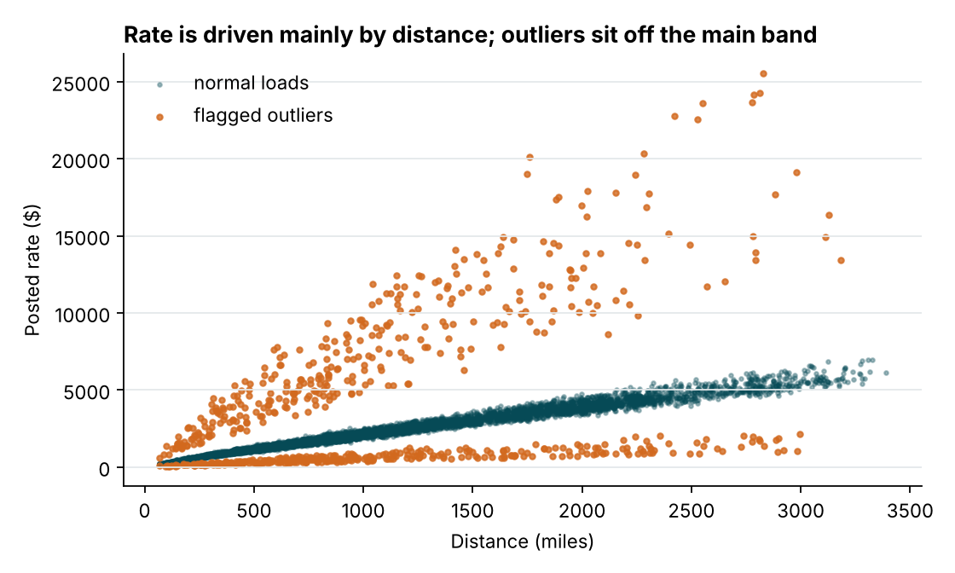
Figure 1 – Posted rate vs distance; flagged outliers shown in orange.
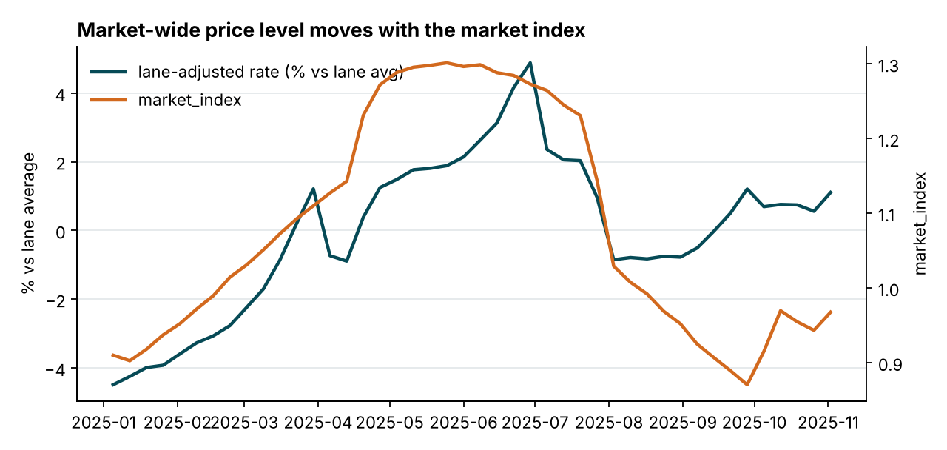
Figure 2 – Weekly lane-adjusted price level vs market_index.
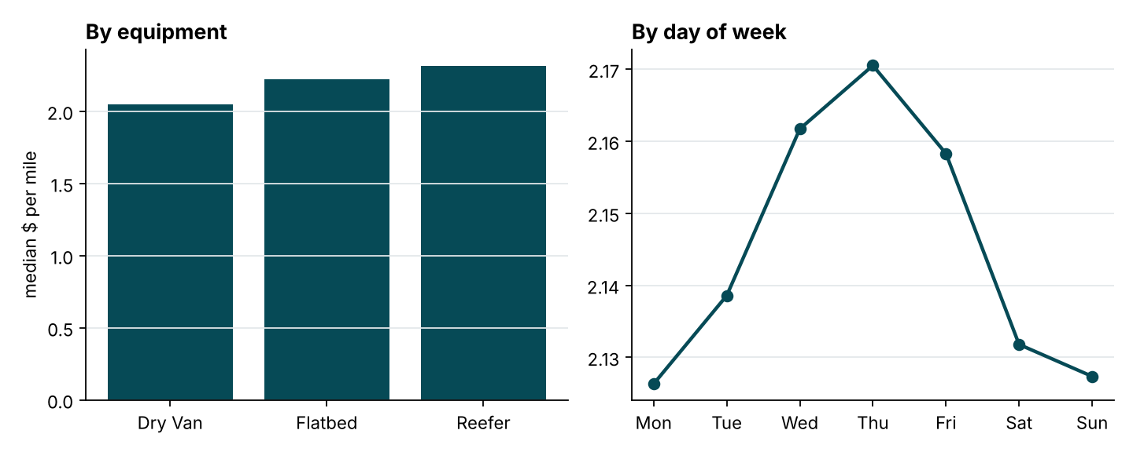
Figure 3 – Median rate per mile by equipment and by day of week.

3. Data-quality issues and how they were handled
Issue | Size | Handling
Negative weight values | 292 train / 145 validation | Same magnitude range as positive weights → sign error. Took absolute value.
Missing weight | 300 train / 165 validation | Filled with equipment median + weight_missing flag.
Missing market_index | 374 train / 249 validation | Filled with that day's average market_index (it is a daily market level) + missing flag.
Implausible posted_rate | 677 loads (1.4%) | $/mile < 0.6× or > 1.8× equipment-month median. Two separate clusters (≈0.2–0.4× and 2.5–6×) → entry/unit errors. Removed from training; hold-out reported with and without them.
Lanes unseen in training | 12.2% of validation loads | Model also uses pickup city, delivery city and distance, so unseen lanes still get sensible predictions.
December chart rows lack lat/lon, market_index, quote_signal | 31 rows | Coordinates from a city lookup; market_index = daily average from validation.csv for that date; quote_signal = training median.

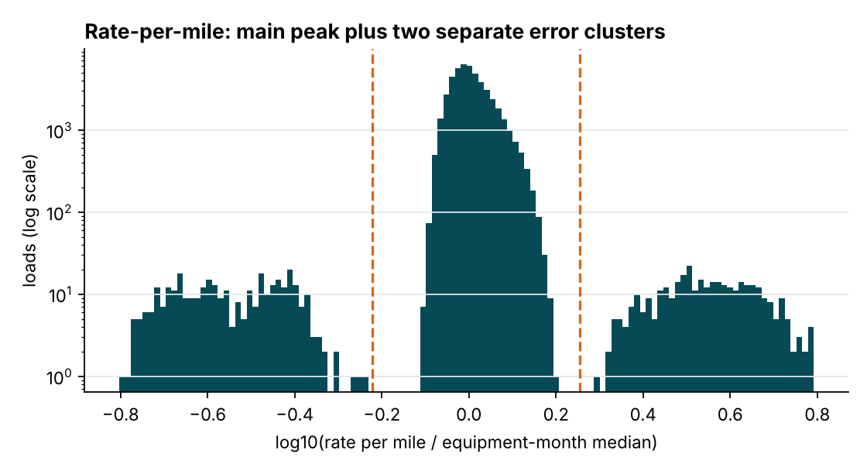
Figure 4 – Rate per mile relative to the equipment-month median (log scale). Dashed lines = removal thresholds.
All statistics used for imputation and encoding (medians, daily averages, lane statistics, category lists) are computed on the training portion only and then applied to the test portion, so no information from the evaluation period leaks into training.

4. Validation and data-split approach

4.1 Why a time-based split
A random split would place loads from the same week in both training and test data. Prices on a given day are strongly correlated (day-to-day autocorrelation of the market level ≈ 0.95), so a random split would leak the market level and overstate accuracy. The real task predicts the two months after the training data, so validation mimics exactly that.

4.2 Main hold-out
- Train: 1 Jan – 31 Aug 2025 (37,944 clean loads).
- Test: 1 Sep – 31 Oct 2025 (9,379 clean loads; 9,523 including outliers).
- Same 2-month horizon as the real Nov–Dec prediction task.

4.3 Rolling-origin backtest
To check that results are stable and not tied to one period, the model was retrained on an expanding window and tested on the following two months, four times:
Test period | Final (Ridge) | Gradient boosting | Lane-median baseline
2025-06-01 to 2025-07-31 | 2.06% | 3.84% | 5.67%
2025-07-01 to 2025-08-31 | 2.15% | 4.01% | 4.28%
2025-08-01 to 2025-09-30 | 3.53% | 3.75% | 3.92%
2025-09-01 to 2025-10-31 | 3.25% | 4.44% | 3.74%
Average | 2.75% | 4.01% | 4.40%

4.4 Metrics
MAPE (mean absolute percentage error) is the main metric because rates range from about $200 to $7,000 and a $50 error matters much more on a short haul. MAE, RMSE and median APE are also reported. Hold-out results are given on clean labels; including the 1.4% suspected bad labels, MAPE is 5.68% and median APE is 3.08%, showing the errors there come almost entirely from those rows.

5. Model selection and results
Model (hold-out Sep–Oct 2025) | MAE ($) | RMSE ($) | MAPE | Median APE
Ridge, log $/mile, recency-weighted (final) | 77.27 | 108.39 | 3.25% | 3.04%
Gradient boosting, same features | 103.01 | 133.70 | 4.44% | 4.34%
Baseline: lane median $/mile × distance | 88.15 | 134.37 | 3.74% | 3.08%

Why Ridge won: the target was transformed so the relationship is close to linear — log $/mile ≈ lane effect + equipment + weight + day-of-week + market level. A regularised linear model learns these additive effects with very little variance and extrapolates smoothly when the market index moves into a range not seen recently. Gradient boosting overfitted the month-specific market level and its error varied more between folds.
Recency weighting: the market level shifts over the year in a way the market index only partly explains. Weighting each load by 0.5^(age / 30 days) keeps the overall price level anchored to the most recent months. Half-lives of 20, 30 and 45 days and Ridge alphas of 0.3, 1 and 3 were compared on the backtest; 30 days and alpha 1.0 gave the lowest average error.
What was tried and rejected: adding a linear time trend (fits the past well but extrapolated badly out-of-sample), unweighted training (higher error in later folds) and averaging Ridge with gradient boosting (worse than Ridge alone).
Per-equipment hold-out MAPE: Dry Van 3.04%, Reefer 3.27%, Flatbed 3.85%.
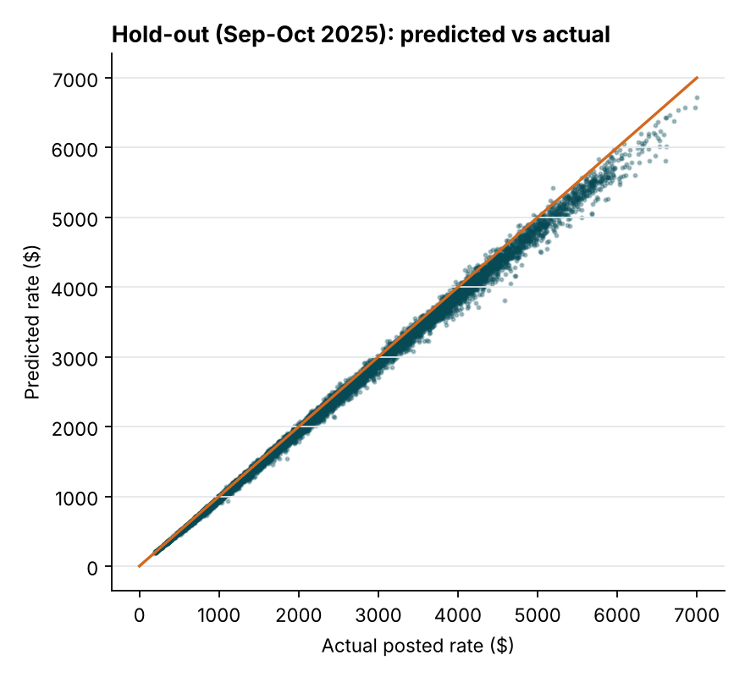
Figure 5 – Hold-out predictions vs actual posted rate.
The final model was retrained on all clean January–October data with the same settings and used to predict validation.csv (12,000 rows, all positive, validated by score.py).

6. December prediction chart
Fixed inputs: Lexington → Fort Wayne, 360 miles, Dry Van, 32,000 lb; only the date changes. The December market level comes from the daily average market_index in validation.csv.
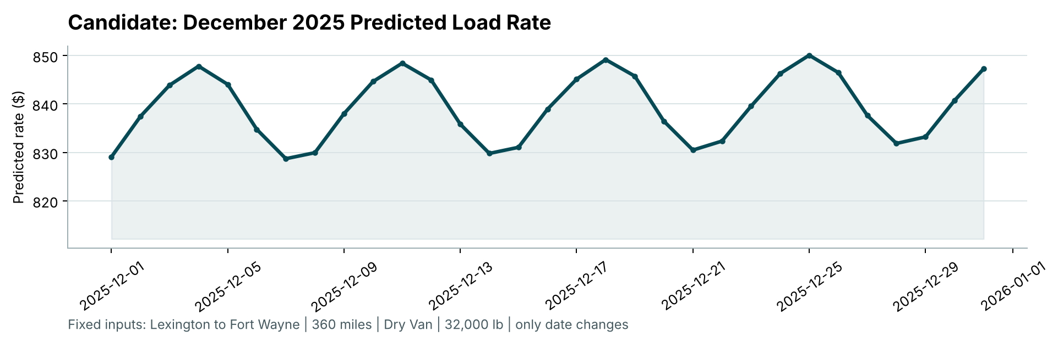
Figure 6 – Chart produced by the provided score.py.
Predictions range from about $829 to $850. The repeating weekly pattern comes from the day-of-week effect (higher mid-week, lower around the weekend) and the slight upward drift follows the December market index. For comparison, Dry Van loads on this lane in the training data were posted at roughly $760–$935.

7. Limitations and next steps
- Ten months of history cannot separate a long-term trend from yearly seasonality; with a second year of data a seasonal component could be added.
- Holiday effects (Thanksgiving, Christmas) are not explicitly modelled because no holidays of that kind exist in the training period.
- Outlier removal uses a fixed threshold; a production system would log and review those records with the data owners.
- Prediction intervals (e.g. quantile regression) would let users see how confident each quote is.

8. Reproducing the results
python -m pip install -r requirements.txt
python src/train.py
python src/eda.py
python score.py --predictions validation_predictions.csv --december-predictions data/december_chart_inputs.csv

