HI Team ,

Please find the project steps followed in completing this project –

**Pre-Requisite –**

Master Machine – Configured JAVA, JENKINS, ANNSIBLE, and Docker.

Slave Machine -- Configured JAVA, JENKINS, GIT, ANNSIBLE, Docker.

Established Master and Slave connection successfully in the backend.

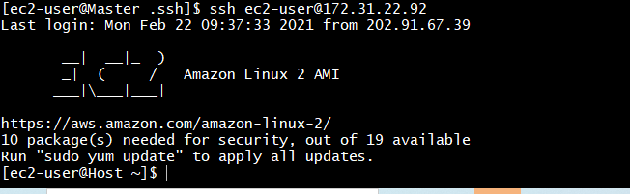

Setup of Jenkins slave --

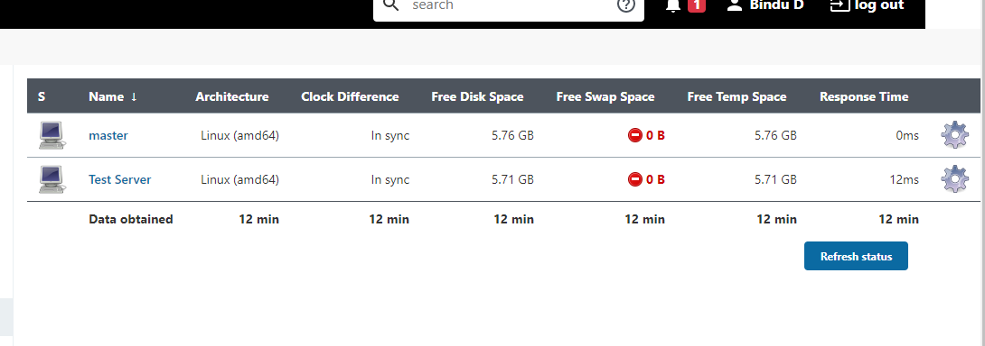

1. GIT HUB – Create Docker file in Github under projCert repository.

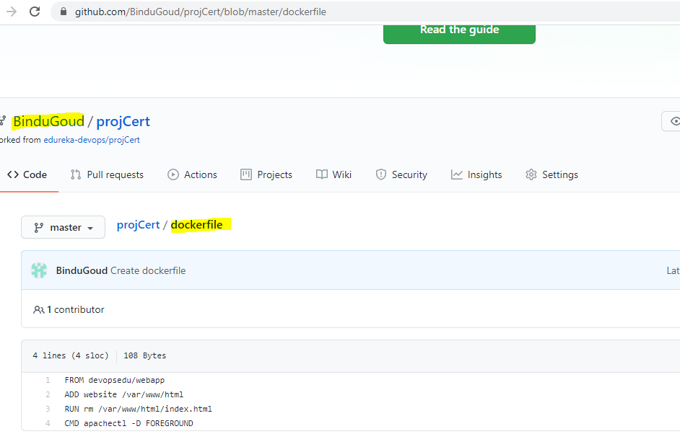

1. Configure Job [Deployment] on Jenkins Slave machine [Test Server Node] and provide repository url.

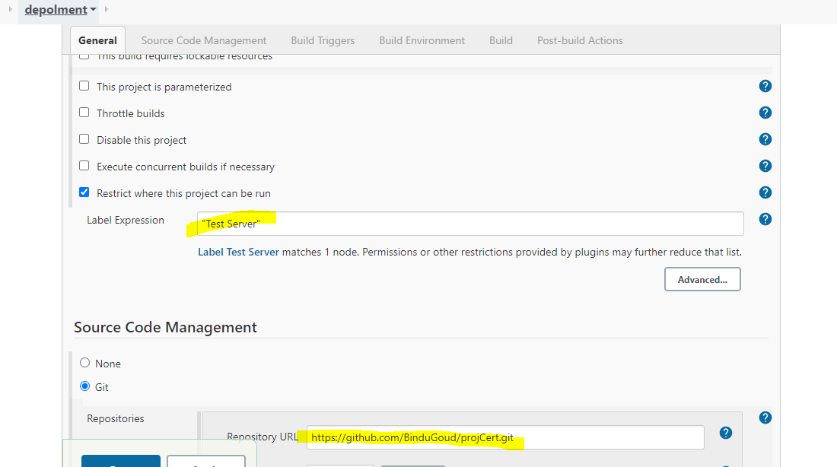

1. Run the job by providing the shell commands related to create image and container on slave machine.

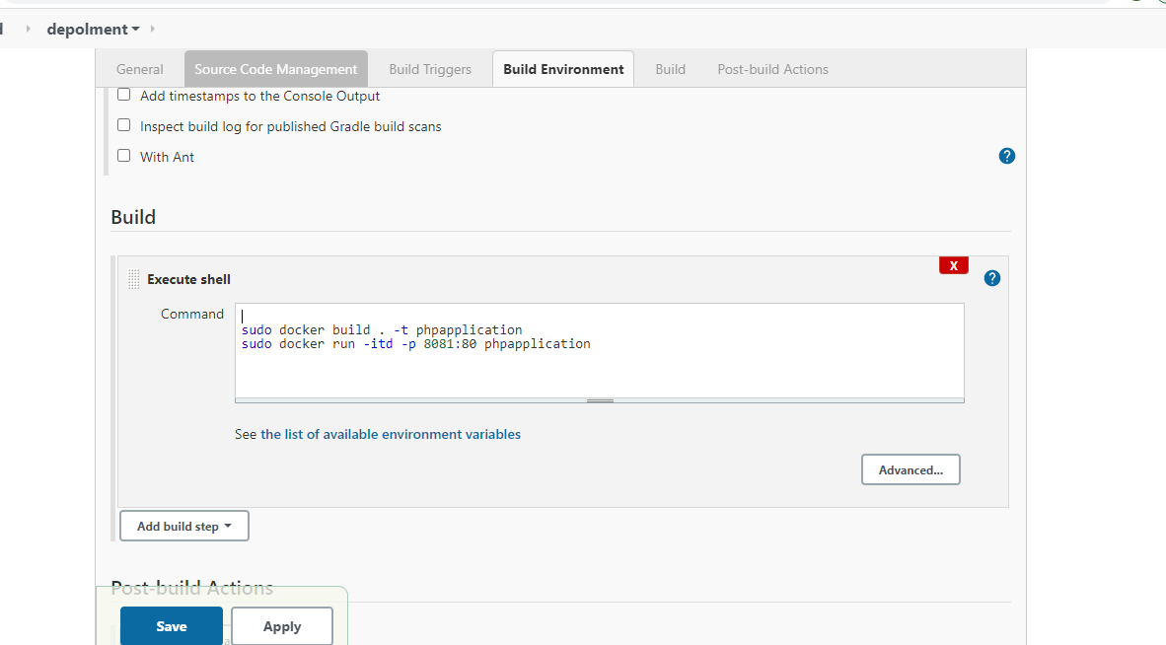

1. Jenkins Job Status Details --

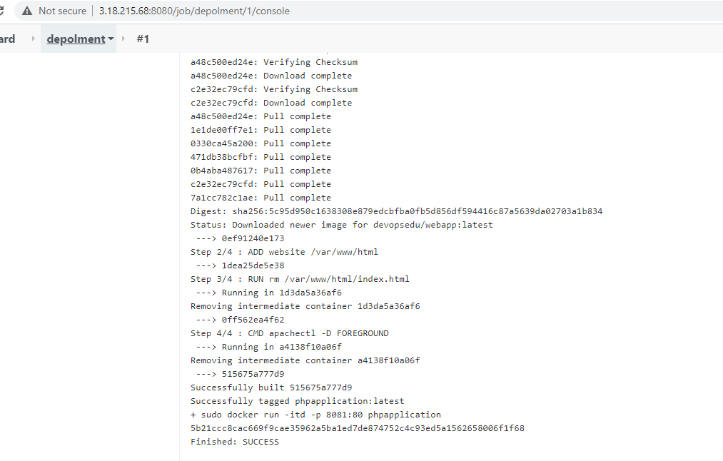

1. PHP Application accessed from Browser by proving public ip address of the slave machine followed by : and port number.

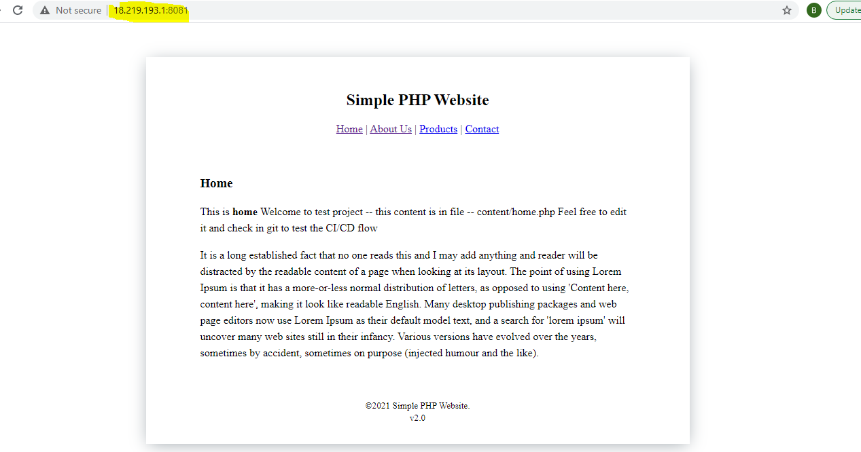

Thanks and Regards,

Bindu.