**Topics: Descriptive Statistics and Probability**

1. Look at the data given below. Plot the data, find the outliers and find out $μ, σ, σ^{2}$

|  |  |
| --- | --- |
| **Name of company** | **Measure X** |
| Allied Signal | 24.23% |
| Bankers Trust | 25.53% |
| General Mills | 25.41% |
| ITT Industries | 24.14% |
| J.P.Morgan & Co. | 29.62% |
| Lehman Brothers | 28.25% |
| Marriott | 25.81% |
| MCI | 24.39% |
| Merrill Lynch | 40.26% |
| Microsoft | 32.95% |
| Morgan Stanley | 91.36% |
| Sun Microsystems | 25.99% |
| Travelers | 39.42% |
| US Airways | 26.71% |
| Warner-Lambert | 35.00% |

Answer: one outlier at 0.9

Python code and compilation using spyder:

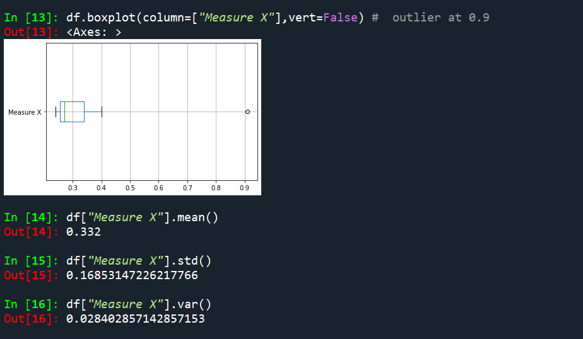



Answer the following three questions based on the box-plot above.

1. What is inter-quartile range of this dataset? (please approximate the numbers) In one line, explain what this value implies.

**Answer**: The interquartile range (IQR) is the box plot showing the middle 50% of scores (i.e., the range between the 25th(Q1) and 75th percentile(Q3)).IQR=Q3-Q1=12-5=7

1. What can we say about the skewness of this dataset?

**Answer**: When the median is closer to the bottom of the box, and if the whisker is shorter on the lower end of the box, then the distribution is positively skewed (skewed right).

1. If it was found that the data point with the value 25 is actually 2.5, how would the new box-plot be affected?

**Answer**: The median is same,but IQR range changes. Moreover there will be no outlier.



Answer the following three questions based on the histogram above.

1. Where would the mode of this dataset lie?

Answer: mode 4 to 8

1. Comment on the skewness of the dataset.

**Answer**: The tail on the right side of the distribution is longer then skewness is positive.

1. Suppose that the above histogram and the box-plot in question 2 are plotted for the same dataset. Explain how these graphs complement each other in providing information about any dataset.

**Answer**: Both are right(positive) skewed and their mode<median<mean.

1. AT&T was running commercials in 1990 aimed at luring back customers who had switched to one of the other long-distance phone service providers. One such commercial shows a businessman trying to reach Phoenix and mistakenly getting Fiji, where a half-naked native on a beach responds incomprehensibly in Polynesian. When asked about this advertisement, AT&T admitted that the portrayed incident did not actually take place but added that this was an enactment of something that “could happen.” Suppose that one in 200 long-distance telephone calls is misdirected. What is the probability that at least one in five attempted telephone calls reaches the wrong number? (Assume independence of attempts.)

Answer:

Python code and compilation using spyder:

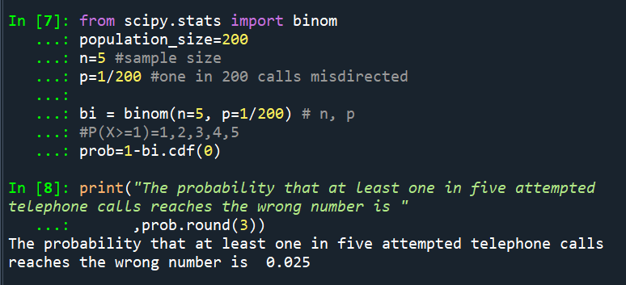

1. Returns on a certain business venture, to the nearest $1,000, are known to follow the following probability distribution

|  |  |
| --- | --- |
| x | P(x) |
| -2,000 | 0.1 |
| -1,000 | 0.1 |
| 0 | 0.2 |
| 1000 | 0.2 |
| 2000 | 0.3 |
| 3000 | 0.1 |

What is the most likely monetary outcome of the business venture? Answer:- P(x) is high(0.3) for 2000 then most likely monetary outcome is 2000.

1. Is the venture likely to be successful? Explain

Answer:- Yes, because sum of possible Returns probability is more than 0.5.

1. What is the long-term average earning of business ventures of this kind? Explain

Answer:- The long-term Average Earnings = Σ(x*P(x))= 800.

1. What is the good measure of the risk involved in a venture of this kind? Compute this measure

Answer:-

Python code and compilation using spyder:

