Q1: 1-1. Prepare a list of offices sorted by country, state, city.

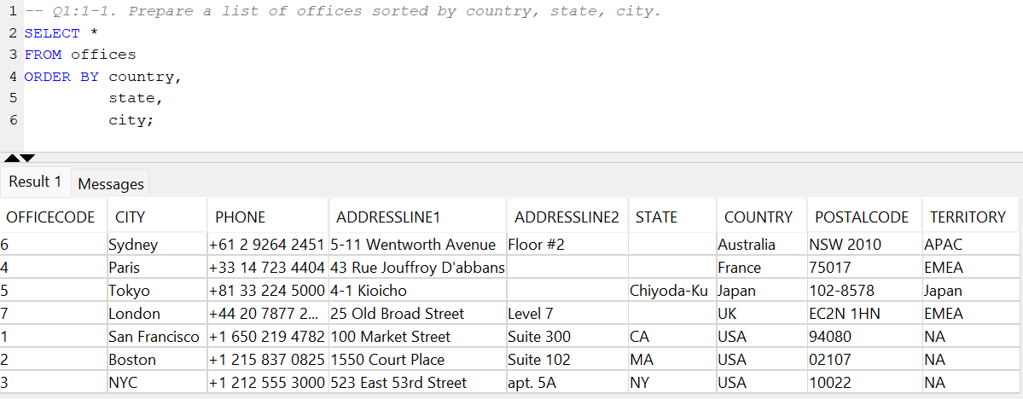

*SELECT \**

*FROM offices*

*ORDER BY country,*

*state,*

*city;*

Q2:2-7. List the products in each product line.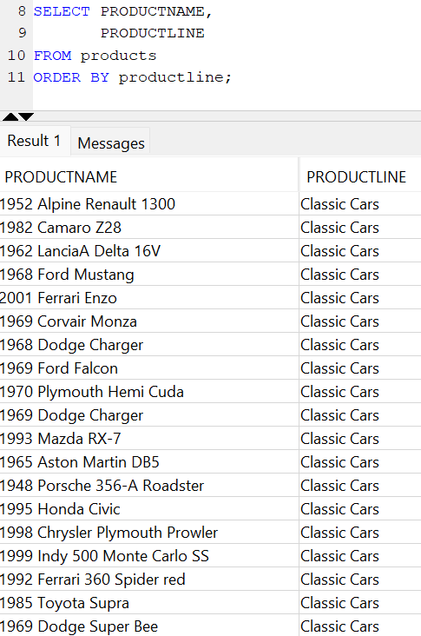

*SELECT PRODUCTNAME,*

*PRODUCTLINE*

*FROM products*

*ORDER BY productline;*

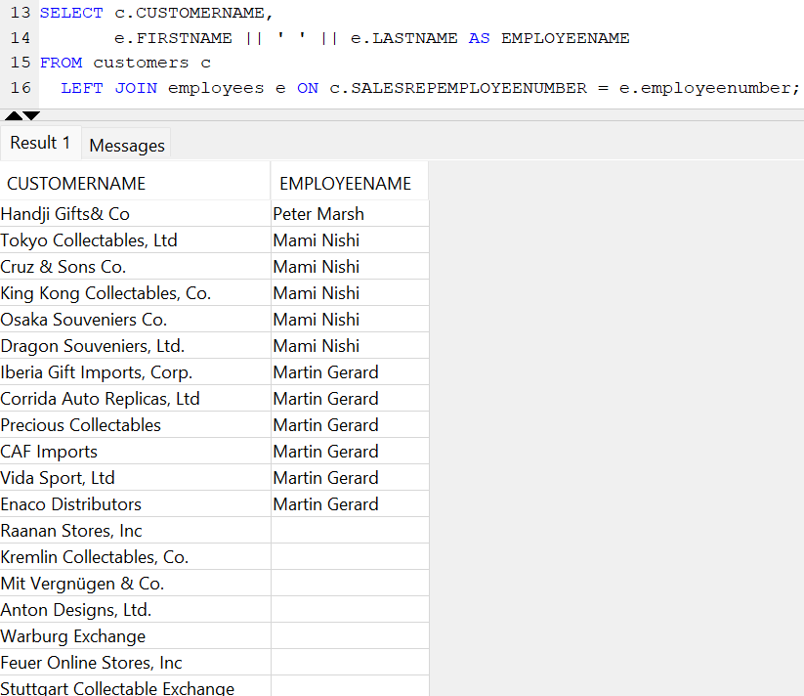

Q3:3-1. Report the account representative for each customer.

SELECT c.CUSTOMERNAME,

e.FIRSTNAME || ' ' || e.LASTNAME AS EMPLOYEENAME

FROM customers c

LEFT JOIN employees e ON

c.SALESREPEMPLOYEENUMBER = e.employeenumber

Q4:4-1. List products sold by order date.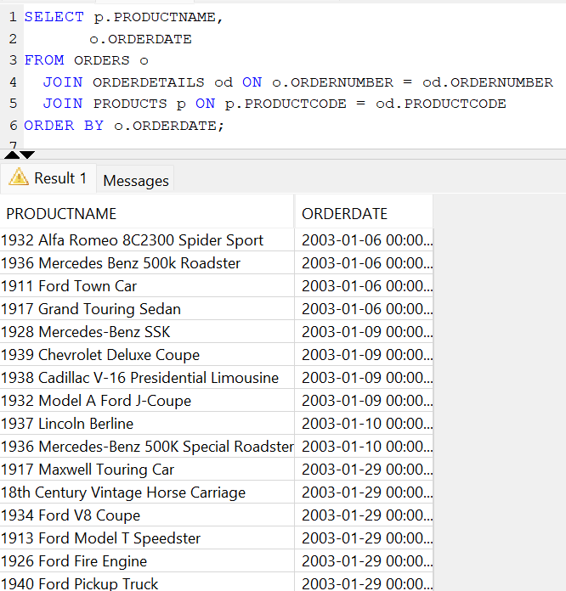

SELECT p.PRODUCTNAME,

o.ORDERDATE

FROM ORDERS o

JOIN ORDERDETAILS od ON o.ORDERNUMBER = od.ORDERNUMBER

JOIN PRODUCTS p ON p.PRODUCTCODE = od.PRODUCTCODE

ORDER BY o.ORDERDATE;

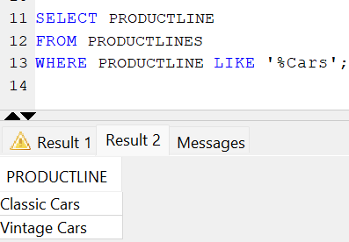

Q5:1-4. List the product lines that contain 'Cars'.

SELECT PRODUCTLINE

FROM PRODUCTLINES

WHERE PRODUCTLINE LIKE '%Cars'

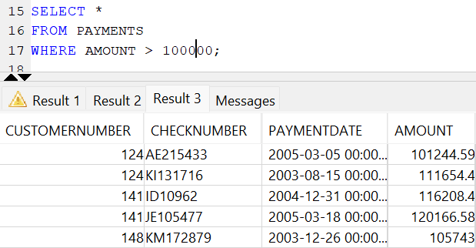

Q6:2-6. Report those payments greater than $100,000.

SELECT *

FROM PAYMENTS

WHERE AMOUNT > 100000;

Q7:3-14. What are the names of executives with VP or Manager in their title? Use the CONCAT function to combine the employee's first name and last name into a single field for reporting.

SELECT CONCAT(CONCAT (FIRSTNAME,' '),LASTNAME) FULLNAME

FROM EMPLOYEES

WHERE JOBTITLE LIKE 'VP%'

OR JOBTITLE LIKE '%Manager%';

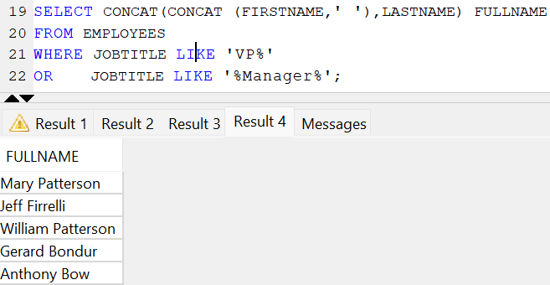

Q8:4-13. Report the name and city of customers who don't have sales representatives?

SELECT CUSTOMERNAME,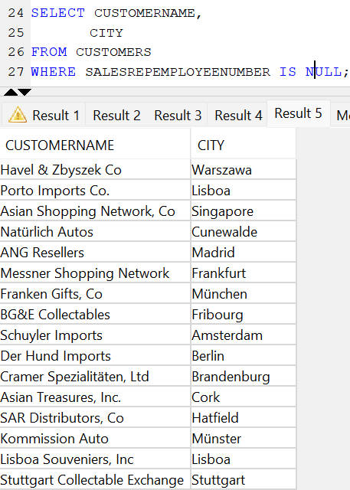

CITY

FROM CUSTOMERS

WHERE SALESREPEMPLOYEENUMBER IS NULL;

Q9:5-4. Report the products that have not been sold.

WITH cte AS

(

SELECT od.productcode

FROM products p

LEFT JOIN orderdetails od ON p.productcode = od.productcode

LEFT JOIN orders o ON o.ordernumber = od.ordernumber

WHERE LOWER(o.status) <> 'disputed'

GROUP BY od.productcode

)

SELECT p.productcode,

p.productname

FROM products p

LEFT JOIN cte c ON c.productcode = p.productcode

WHERE c.productcode IS NULL;

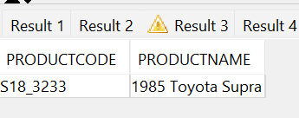

Q10:6-7. Who are the employees in Boston?

SELECT EMPLOYEENUMBER

FROM EMPLOYEES e

JOIN OFFICES o ON e.OFFICECODE = o.OFFICECODE

WHERE o.CITY = 'Boston'

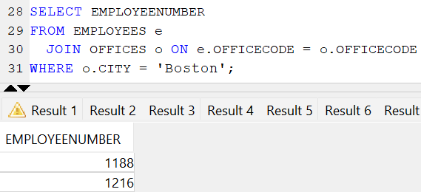

Q11:7-8. Report those payments greater than $100,000. Sort the report so the customer who made the highest payment appears first.

SELECT P.*

FROM CUSTOMERS c

JOIN PAYMENTS p ON c.CUSTOMERNUMBER = p.CUSTOMERNUMBER

WHERE p.AMOUNT > 100000

ORDER BY p.AMOUNT DESC

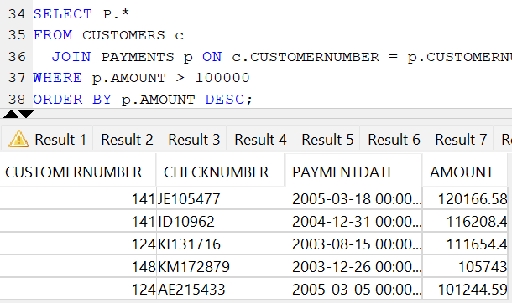

Q12:8-2. List the order dates in descending order for orders for the 1940 Ford Pickup Truck.

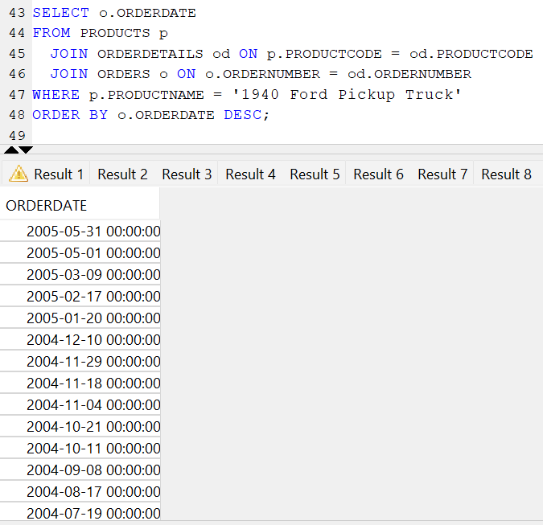

SELECT o.ORDERDATE

FROM PRODUCTS p

JOIN ORDERDETAILS od ON p.PRODUCTCODE = od.PRODUCTCODE

JOIN ORDERS o ON o.ORDERNUMBER = od.ORDERNUMBER

WHERE p.PRODUCTNAME = '1940 Ford Pickup Truck'

ORDER BY o.ORDERDATE DESC;

Q13:9-5. List the names of products sold at less than 80% of the MSRP.

SELECT p.PRODUCTNAME FROM PRODUCTS p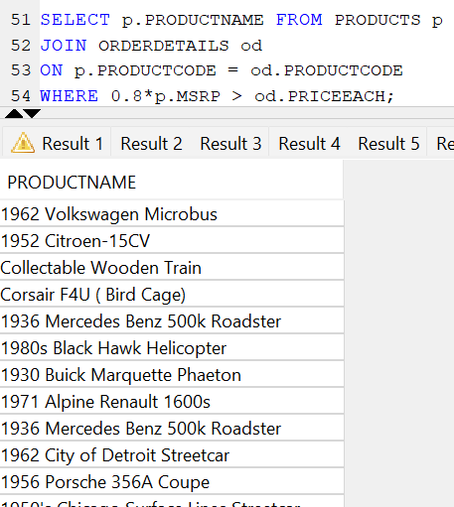

JOIN ORDERDETAILS od

ON p.PRODUCTCODE = od.PRODUCTCODE

WHERE 0.8*p.MSRP > od.PRICEEACH;

Q14:10-6. Reports those products that have been sold with a markup of 100% or more (i.e., the priceEach is at least twice the buyPrice)

SELECT DISTINCT p.productcode

FROM products p

JOIN orderdetails od ON p.productcode = od.productcode

WHERE od.priceEach >= 2*p.buyprice;

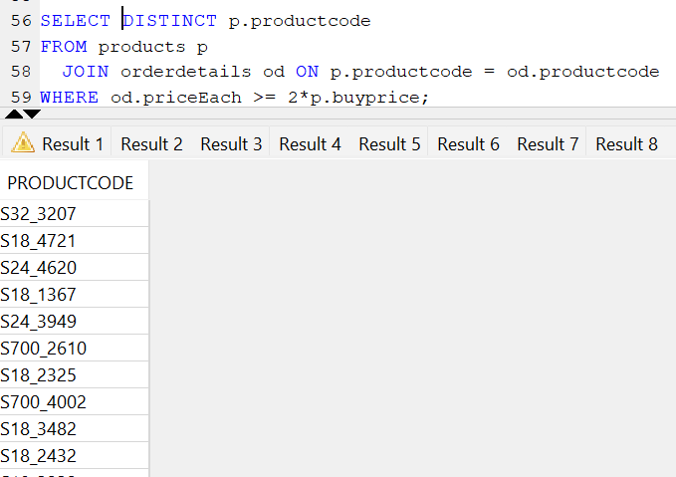

Q15:11-1. Find products containing the name 'Ford'.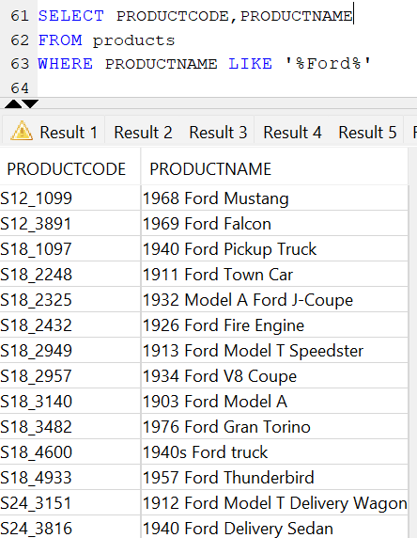

SELECT PRODUCTCODE,PRODUCTNAME

FROM products

WHERE PRODUCTNAME LIKE '%Ford%';

Q16:12-2. List products ending in 'ship'.

SELECT productcode

FROM products

WHERE LOWER(PRODUCTNAME) LIKE '%ship';

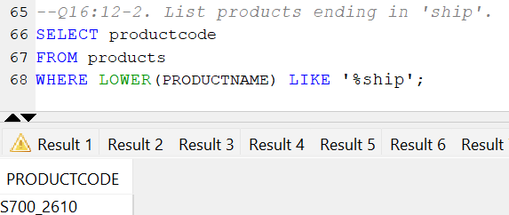

Q17:13-4. What are the products with a product code in the range S700_1000 to S700_1499?

SELECT productcode

FROM PRODUCTS

WHERE PRODUCTCODE BETWEEN 'S700_1000' AND 'S700_1499';

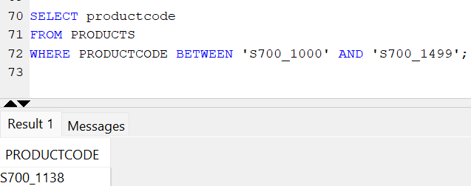

Q18:14-5. Which customers have a digit in their name?

SELECT CUSTOMERNUMBER

FROM customers

WHERE REGEXP_LIKE (customername,'[0-9]');

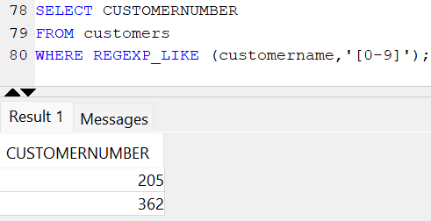

Q19:15-6. List the names of employees called Dianne or Diane.

SELECT FIRSTNAME || ' ' || LASTNAME EMPLOYEEFULLNAME

FROM EMPLOYEES

WHERE lower(FIRSTNAME) = 'dianne'

OR lower(FIRSTNAME) = 'diane'

OR lower(LASTNAME) = 'dianne'

OR lower(LASTNAME) = 'diane';

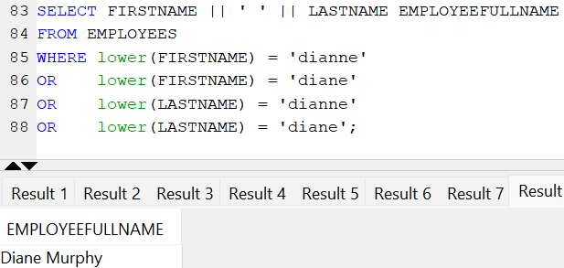

Q20:16-7. List the products containing ship or boat in their product name.

SELECT productcode

FROM PRODUCTS

WHERE PRODUCTNAME LIKE '%Ship%'

OR PRODUCTNAME LIKE '%ship%'

OR PRODUCTNAME LIKE '%boat%'

OR PRODUCTNAME LIKE '%Boat%';

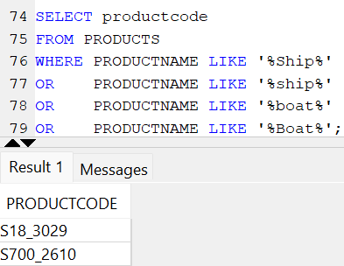

Q21:17-8. List the products with a product code beginning with S700.

SELECT productcode

FROM PRODUCTS

WHERE PRODUCTCODE LIKE 'S700%';

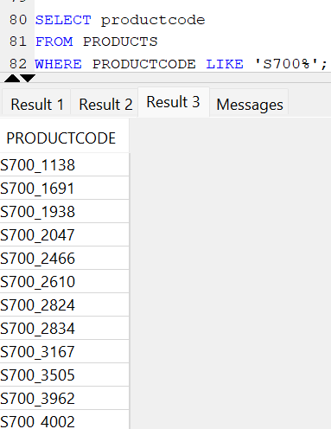

Q22:18-9. List the names of employees called Larry or Barry.

SELECT firstname || ' ' || lastname AS empname

FROM employees

WHERE lower(FIRSTNAME) LIKE '%larry%'

OR lower(FIRSTNAME) LIKE '%barry%'

OR lower(LASTNAME) LIKE '%larry%'

OR lower(LASTNAME) LIKE '%barry%';

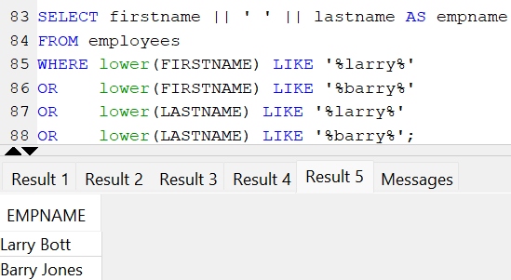

Q23:19-10. List the names of employees with non-alphabetic characters in their names.

SELECT FIRSTNAME || ' ' || LASTNAME FULLNAME

FROM EMPLOYEES

WHERE NOT REGEXP_LIKE (FIRSTNAME,'^[A-Za-z]+$')

OR NOT REGEXP_LIKE (LASTNAME,'^[A-Za-z]+$');

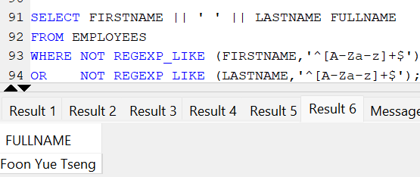

Q24:20-11. List the vendors whose name ends in Diecast

SELECT PRODUCTVENDOR

FROM PRODUCTS

WHERE PRODUCTVENDOR LIKE ('%Diecast');

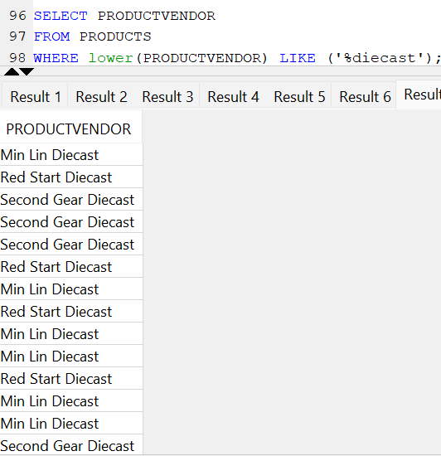

Q25:21-1. Who is at the top of the organization (i.e., reports to no one).

SELECT firstname || ' ' || lastname fullname

FROM employees

WHERE reportsto IS NULL;

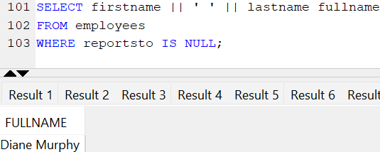

Q26:22-2. Who reports to William Patterson?

WITH cte AS

(

SELECT employeenumber

FROM employees

WHERE firstname || ' ' || lastname = 'William Patterson'

)

SELECT e.employeenumber

FROM employees e,

cte

WHERE reportsTo = cte.employeenumber;

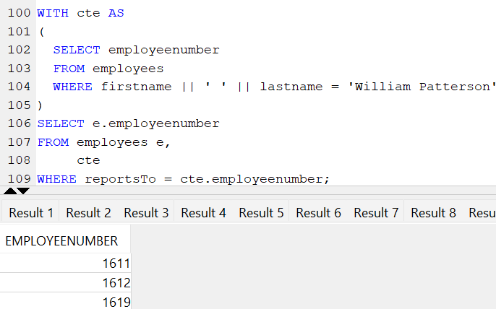

Q27:23-3. List all the products purchased by Herkku Gifts.

SELECT p.productname

FROM products p

JOIN orderdetails od ON od.productcode = p.productcode

JOIN orders o ON o.ordernumber = od.ordernumber

JOIN customers c ON c.customernumber = o.customernumber

WHERE c.customername = 'Herkku Gifts';

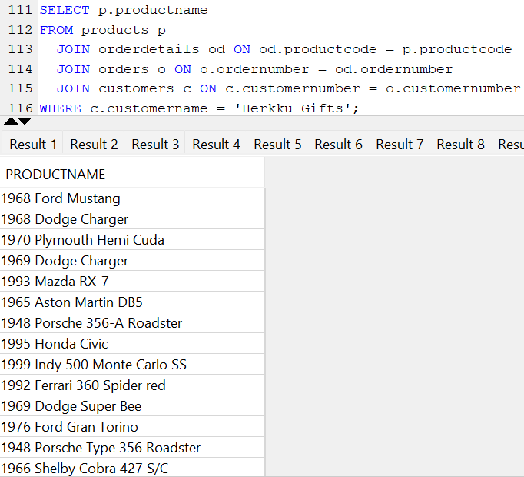

Q28:24-9. List the employees who report to those employees who report to Diane Murphy. Use the CONCAT function to combine the employee's first name and last name into a single field for reporting.

select e1.employeenumber from employees e1

join employees e2

on e1.reportsto = e2.employeenumber

join employees e3

on e2.reportsto = e3.employeenumber

where concat(concat(e3.firstname,' '),e3.lastname) = 'Diane Murphy';

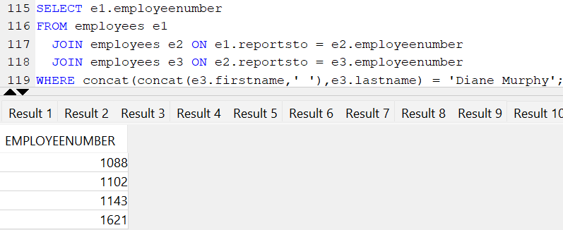

Q29:25-27. Find the products sold in May 2003 but not May 2004.

WITH reqtable

AS

(SELECT o.ordernumber,

o.orderdate,

od.productcode

FROM orders o

JOIN orderdetails od ON o.ordernumber = od.ordernumber

WHERE (EXTRACT(year FROM o.orderdate) = 2003 OR EXTRACT(year FROM o.orderdate) = 2004)

AND (EXTRACT(month FROM o.orderdate) = 5)),t2003 AS (SELECT productcode

FROM reqtable ra

WHERE EXTRACT(YEAR FROM ra.orderdate) = 2003),T2004 AS (SELECT productcode

FROM reqtable ra

WHERE EXTRACT(YEAR FROM ra.orderdate) = 2004)

SELECT t2003.PRODUCTCODE FROM t2003

LEFT JOIN t2004

ON t2003.PRODUCTCODE = t2004.PRODUCTCODE

WHERE T2004.PRODUCTCODE IS NULL;

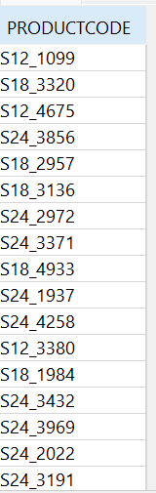

Q30:26-28. Find the customers without payments in 2003.

select distinct c.customernumber from customers c

left join payments p

on c.customernumber = p.customernumber

where extract(year from p.paymentdate) <> 2003;

Q31:27-1.Who reports to Mary Patterson?

WITH empcte AS

(

SELECT EMPLOYEENUMBER

FROM employees

WHERE firstname || ' ' || lastname = 'Mary Patterson'

)

SELECT E.employeenumber

FROM employees e

JOIN empcte ON empcte.employeenumber = e.REPORTSTO;

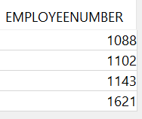

Q32:1-2. How many employees are there in the company?

SELECT COUNT(employeenumber) NUMBEROFEMPLOYEES

FROM employees;

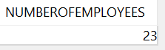

Q33:2-3. What is the total of payments received?

SELECT SUM(AMOUNT) TOTALPAYMENTS

FROM PAYMENTS;

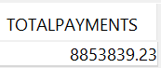

Q34:3-5. Report total payments for October 28, 2004.

SELECT SUM(AMOUNT) PAYMENTSONOCT282004

FROM PAYMENTS

WHERE PAYMENTDATE = TO_DATE('28-10-2004','DD-MM-YYYY');

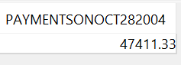

Q35:4-8. How many products in each product line?

SELECT pl.productline,

COUNT(*) noofproducts

FROM productlines pl

JOIN products p ON pl.productline = p.productline

GROUP BY pl.productline;

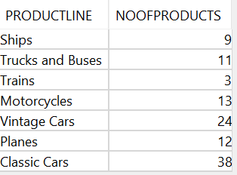

Q36:5-9. What is the minimum payment received?

SELECT MIN(amount) minpaymentreceived

FROM payments;

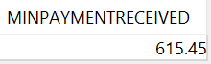

Q37:6-11. What is the average percentage markup of the MSRP on buyPrice?

SELECT AVG(((msrp - buyprice)*100) / buyprice) AVGPERCENTAGE

FROM products;

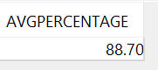

Q38:7-12. How many distinct products does ClassicModels sell?

SELECT COUNT(DISTINCT (productcode)) noofproducts

FROM products;

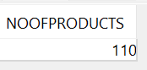

Q39:8-2. Report total payments for Atelier graphique.

SELECT SUM(p.amount) paymentsofateliergraphique

FROM payments p

JOIN customers c ON p.customernumber = c.customernumber

WHERE c.customername = 'Atelier graphique';

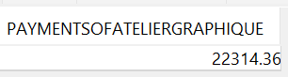

Q40:9-6. How many orders have been placed by Herkku Gifts?

SELECT COUNT(*) noofordersbyherkku

FROM orders o

JOIN customers c ON o.customernumber = c.customernumber

WHERE c.customername = 'Herkku Gifts';

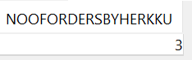

Q41:10-9. List the value of 'On Hold' orders.

SELECT SUM(od.quantityordered*od.priceeach) AS onholdvalue

FROM orders o

JOIN orderdetails od ON o.ordernumber = od.ordernumber

WHERE O.status = 'On Hold';

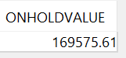

Q42:11-8. What is the quantity on hand for products listed on 'On Hold' orders?

SELECT P.PRODUCTCODE, SUM(P.QUANTITYINSTOCK) QUANTITYONHAND FROM PRODUCTS P

JOIN ORDERDETAILS OD

ON P.PRODUCTCODE = OD.PRODUCTCODE

join ORDERS O

on od.ordernumber = o.ordernumber

where o.status = 'On Hold'

GROUP BY P.PRODUCTCODE;

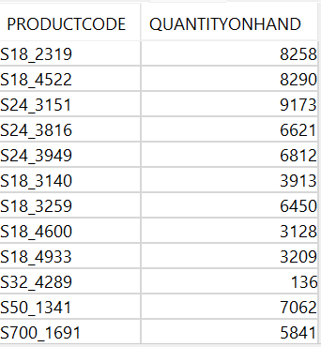

Q43:12-3. Report the number of customers in Denmark, Norway, and Sweden.

SELECT COUNTRY,COUNT(*) NOOFCUSTOMERS FROM CUSTOMERS

WHERE COUNTRY IN ('Denmark','Norway', 'Sweden')

GROUP BY COUNTRY;

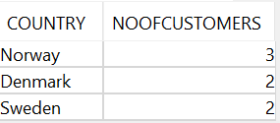

Q44:13-5. What is the difference in days between the most recent and oldest order date in the Orders file?

SELECT MAX(TRUNC(ORDERDATE)) - MIN(TRUNC(ORDERDATE)) DIFFERENCEINDAYS FROM ORDERS;

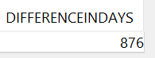

Q45:14-7. What is the value of orders shipped in August 2004?

SELECT SUM(OD.QUANTITYORDERED*OD.PRICEEACH) VALUESHIPPEDINAUG2004

FROM ORDERS O

JOIN ORDERDETAILS OD ON O.ORDERNUMBER = OD.ORDERNUMBER

WHERE O.STATUS = 'Shipped'

AND EXTRACT(YEAR FROM O.ORDERDATE) = 2004

AND EXTRACT(MONTH FROM O.ORDERDATE) = 8;

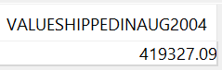

Q46:1-15. Which orders have a value greater than $5,000?

SELECT OD.ORDERNUMBER

FROM ORDERS O

JOIN ORDERDETAILS OD ON O.ORDERNUMBER = OD.ORDERNUMBER

GROUP BY OD.ORDERNUMBER

HAVING SUM(OD.QUANTITYORDERED*OD.PRICEEACH) > 5000;

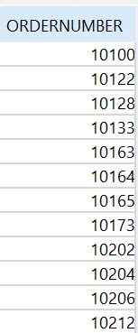

Q47:2-3. Report the total payments by date date

SELECT TRUNC(PAYMENTDATE) PAYMENTDATE,

SUM(AMOUNT) PAYMENTS

FROM PAYMENTS

GROUP BY TRUNC(PAYMENTDATE);

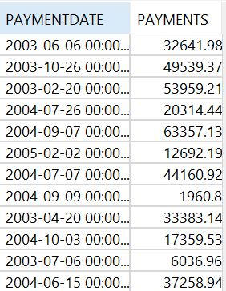

Q48:3-5. List the amount paid by each customer. Customer

SELECT C.CUSTOMERNUMBER,

CASE

WHEN SUM(P.AMOUNT) > 0 THEN SUM(P.AMOUNT)

ELSE 0

END AMOUNTPAIDBYCUSTOMER

FROM PAYMENTS P

RIGHT JOIN CUSTOMERS C ON P.CUSTOMERNUMBER = C.CUSTOMERNUMBER

GROUP BY C.CUSTOMERNUMBER;

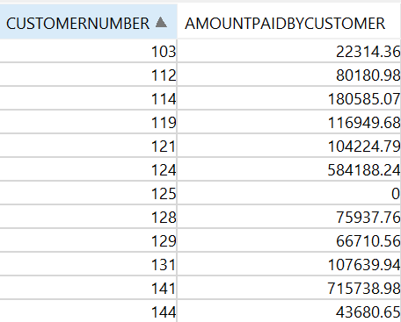

Q49:4-10. Report the number of orders 'On Hold' for each customer.

SELECT C.CUSTOMERNUMBER,

COUNT(O.ORDERNUMBER) ONHOLDFOREACHCUSTOMER

FROM CUSTOMERS C

LEFT JOIN ORDERS O

ON O.CUSTOMERNUMBER = C.CUSTOMERNUMBER

AND O.STATUS = 'On Hold'

GROUP BY C.CUSTOMERNUMBER

ORDER BY C.CUSTOMERNUMBER;

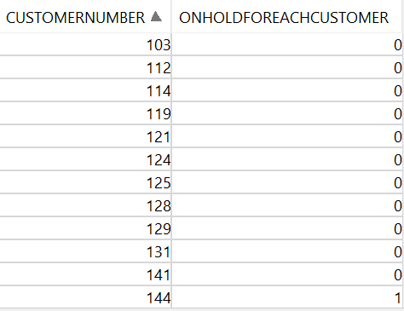

Q50:5-3. List the names of customers and their corresponding order number where a particular order from that customer has a value greater than $25,000?

WITH ORDERMORETHAN25000

AS

(SELECT O.ORDERNUMBER,

O.CUSTOMERNUMBER

FROM ORDERS O

JOIN ORDERDETAILS OD ON O.ORDERNUMBER = OD.ORDERNUMBER

GROUP BY O.ORDERNUMBER,

O.CUSTOMERNUMBER

HAVING SUM(OD.QUANTITYORDERED*OD.PRICEEACH) > 25000)

SELECT C.CUSTOMERNAME,OM.ORDERNUMBER FROM CUSTOMERS C JOIN ORDERMORETHAN25000 OM ON C.CUSTOMERNUMBER = OM.CUSTOMERNUMBER

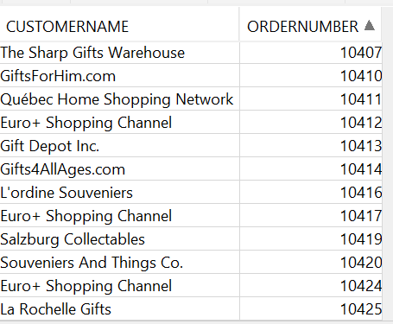

Q51:6-4. Compute the commission for each sales representative, assuming the commission is 5% of the value of an order. Sort by employee last name and first name.

WITH EMPTOCUST

AS

(SELECT E.*,

C.CUSTOMERNAME,

C.CUSTOMERNUMBER

FROM EMPLOYEES E

LEFT JOIN CUSTOMERS C ON E.EMPLOYEENUMBER = C.SALESREPEMPLOYEENUMBER),EACHORDERVALUEBYCUST AS (SELECT OD.ORDERNUMBER,

O.CUSTOMERNUMBER,

SUM(OD.PRICEEACH*OD.QUANTITYORDERED) ORDERTOT FROM ORDERS O

JOIN ORDERDETAILS OD ON O.ORDERNUMBER = OD.ORDERNUMBER

GROUP BY OD.ORDERNUMBER,

O.CUSTOMERNUMBER)

SELECT ET.FIRSTNAME, ET.LASTNAME, ET.EMPLOYEENUMBER,

CASE

WHEN SUM(EOC.ORDERTOT) >= 0 THEN 0.05*SUM(EOC.ORDERTOT)

ELSE 0

END AS REVENUEBYEACHEMP

FROM EMPTOCUST ET

LEFT JOIN EACHORDERVALUEBYCUST EOC ON ET.CUSTOMERNUMBER = EOC.CUSTOMERNUMBER

GROUP BY ET.FIRSTNAME, ET.LASTNAME, ET.EMPLOYEENUMBER

ORDER BY ET.LASTNAME, ET.FIRSTNAME;

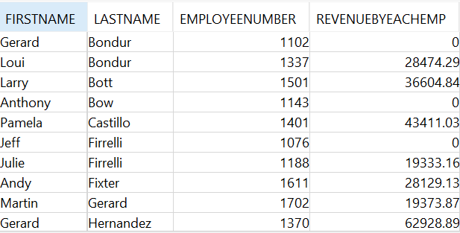

Q52:7-6. Compute the average time between order date and ship date for each customer ordered by the largest difference.

SELECT O.CUSTOMERNUMBER,

AVG(O.SHIPPEDDATE - O.ORDERDATE) AVG_diff_in_days

FROM ORDERS O

GROUP BY O.CUSTOMERNUMBER

ORDER BY AVG_DIFF_IN_DAYS DESC;

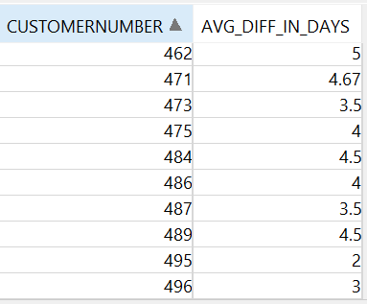

Q53:8-21. Compute the revenue generated by each sales representative based on the orders from the customers they serve.

BEFORE CTE:  
SELECT C.SALESREPEMPLOYEENUMBER,

SUM(TT.CUSTOTAL) AS REVGENBYEMP

FROM CUSTOMERS C

JOIN (SELECT O.CUSTOMERNUMBER,

SUM(T.ORDERTOT) CUSTOTAL

FROM ORDERS O

JOIN (SELECT OD.ORDERNUMBER,

SUM(OD.PRICEEACH*OD.QUANTITYORDERED) ORDERTOT

FROM ORDERS O

JOIN ORDERDETAILS OD ON O.ORDERNUMBER = OD.ORDERNUMBER

GROUP BY OD.ORDERNUMBER) T ON T.ORDERNUMBER = O.ORDERNUMBER

GROUP BY O.CUSTOMERNUMBER) TT ON TT.CUSTOMERNUMBER = C.CUSTOMERNUMBER

GROUP BY C.SALESREPEMPLOYEENUMBER;

AFTER CTE:

WITH EMPTOCUST

AS

(SELECT E.*,

C.CUSTOMERNAME,

C.CUSTOMERNUMBER

FROM EMPLOYEES E

LEFT JOIN CUSTOMERS C ON E.EMPLOYEENUMBER = C.SALESREPEMPLOYEENUMBER),EACHORDERVALUEBYCUST AS (SELECT OD.ORDERNUMBER,

O.CUSTOMERNUMBER,

SUM(OD.PRICEEACH*OD.QUANTITYORDERED) ORDERTOT FROM ORDERS O

JOIN ORDERDETAILS OD ON O.ORDERNUMBER = OD.ORDERNUMBER

GROUP BY OD.ORDERNUMBER,

O.CUSTOMERNUMBER)

SELECT ET.EMPLOYEENUMBER,

CASE

WHEN SUM(EOC.ORDERTOT) >= 0 THEN SUM(EOC.ORDERTOT)

ELSE 0

END AS REVENUEBYEACHEMP

FROM EMPTOCUST ET

LEFT JOIN EACHORDERVALUEBYCUST EOC ON ET.CUSTOMERNUMBER = EOC.CUSTOMERNUMBER

GROUP BY ET.EMPLOYEENUMBER;

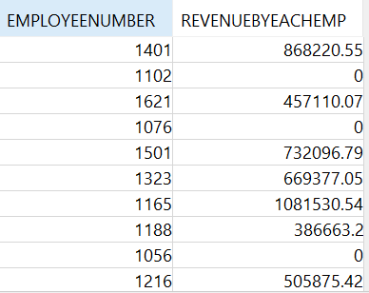

Q54:9-22. Compute the profit generated by each sales representative based on the orders from the customers they serve. Sort by profit generated descending.

WITH CUSTOMERPROFITS AS

(

SELECT O.CUSTOMERNUMBER,

SUM(OD.QUANTITYORDERED*(OD.PRICEEACH - P.BUYPRICE)) PROFIT

FROM orders o

JOIN orderdetails od ON o.ordernumber = od.ordernumber

JOIN PRODUCTS P ON P.PRODUCTCODE = OD.PRODUCTCODE

GROUP BY O.CUSTOMERNUMBER

),

emptocust AS

(

SELECT e.employeenumber,

c.customernumber

FROM employees e

LEFT JOIN customers c ON e.employeenumber = c.salesrepemployeenumber

)

SELECT employeenumber,

CASE

WHEN SUM(PROFIT) > 0 THEN SUM(PROFIT)

ELSE 0

END AS PROFIT

FROM emptocust ec

LEFT JOIN CUSTOMERPROFITS cp ON ec.customernumber = cp.customernumber

GROUP BY employeenumber

ORDER BY PROFIT DESC;

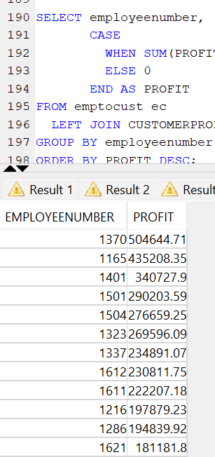

Q55:10-23. Compute the revenue generated by each product, sorted by product name.

SELECT P.PRODUCTCODE,

P.PRODUCTNAME,

CASE

WHEN SUM(OD.QUANTITYORDERED*OD.PRICEEACH) > 0 THEN SUM(OD.QUANTITYORDERED*OD.PRICEEACH)

ELSE 0

END AS REVENUE

FROM PRODUCTS P

LEFT JOIN ORDERDETAILS OD ON P.PRODUCTCODE = OD.PRODUCTCODE

GROUP BY P.PRODUCTCODE,

P.PRODUCTNAME

ORDER BY P.PRODUCTNAME;

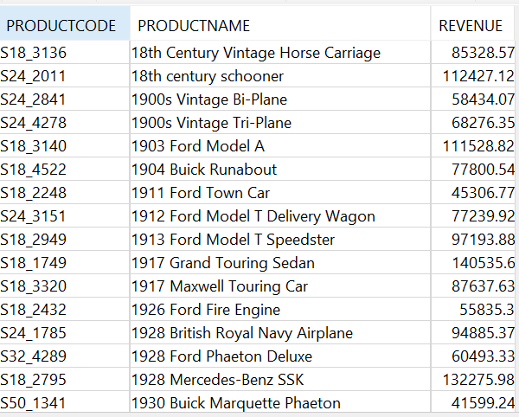

Q56:11-24. Compute the profit generated by each product line, sorted by profit descending. productline

SELECT P.PRODUCTLINE,

CASE

WHEN SUM(OD.QUANTITYORDERED*(OD.PRICEEACH-P.BUYPRICE)) > 0 THEN SUM(OD.QUANTITYORDERED*(OD.PRICEEACH-P.BUYPRICE))

ELSE 0

END AS PROFIT

FROM PRODUCTS P

LEFT JOIN ORDERDETAILS OD ON P.PRODUCTCODE = OD.PRODUCTCODE

GROUP BY P.PRODUCTLINE

ORDER BY PROFIT DESC;

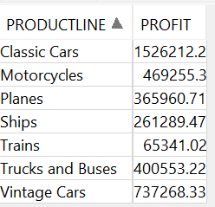

Q57:1-8. Compute the total value ordered, total amount paid, and their difference for each customer for orders placed in 2004 and payments received in 2004 (Hint; Create views for the total paid and total ordered).

WITH ORDERSONMAY

AS

(SELECT O.CUSTOMERNUMBER,

CASE

WHEN SUM(OD.quantityordered*OD.PRICEEACH) > 0 THEN SUM(OD.quantityordered*OD.PRICEEACH)

ELSE 0

END ORDERSAMOUNT

FROM ORDERS O

LEFT JOIN orderdetails od ON od.ordernumber = o.ordernumber

WHERE EXTRACT(YEAR FROM O.ORDERDATE) = 2004

AND EXTRACT(MONTH FROM O.ORDERDATE) = 5

GROUP BY O.CUSTOMERNUMBER),

PAYMENTSONMAY AS (SELECT P.CUSTOMERNUMBER,

CASE

WHEN SUM(P.AMOUNT) > 0 THEN SUM(P.AMOUNT)

ELSE 0

END PAIDAMOUNT

FROM PAYMENTS P

WHERE EXTRACT(YEAR FROM P.PAYMENTDATE) = 2004

AND EXTRACT(MONTH FROM P.PAYMENTDATE) = 5

GROUP BY P.CUSTOMERNUMBER)

SELECT C.CUSTOMERNUMBER,

CASE

WHEN OM.ORDERSAMOUNT > 0 THEN OM.ORDERSAMOUNT

ELSE 0

END ORDERSAMOUNT,

CASE

WHEN PM.PAIDAMOUNT > 0 THEN PM.PAIDAMOUNT

ELSE 0

END PAIDAMOUNT,

CASE

WHEN PM.PAIDAMOUNT IS NULL AND OM.ORDERSAMOUNT IS NULL THEN 0

WHEN PM.PAIDAMOUNT IS NULL THEN- OM.ORDERSAMOUNT

WHEN OM.ORDERSAMOUNT IS NULL THEN PM.PAIDAMOUNT

ELSE PM.PAIDAMOUNT - OM.ORDERSAMOUNT

END AS DIFFERENCE

FROM CUSTOMERS C

LEFT JOIN ORDERSONMAY OM ON C.CUSTOMERNUMBER = OM.CUSTOMERNUMBER

LEFT JOIN PAYMENTSONMAY PM ON PM.CUSTOMERNUMBER = C.CUSTOMERNUMBER;

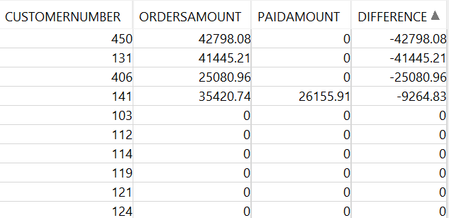

Q58:2-14. What is the ratio of the value of payments made to orders received for each month of 2004.

(i.e., divide the value of payments made by the orders received)?*

WITH MONTHPAYMENTS AS (SELECT EXTRACT(MONTH FROM PAYMENTDATE) MONTH, SUM(AMOUNT)PAIDAMOUNT FROM PAYMENTS

WHERE EXTRACT(YEAR FROM PAYMENTDATE) = 2004

GROUP BY EXTRACT(MONTH FROM PAYMENTDATE)), MONTHORDERS AS (

SELECT EXTRACT(MONTH FROM O.ORDERDATE) MONTH, SUM(OD.QUANTITYORDERED*OD.PRICEEACH) ORDEREDAMOUNT FROM ORDERDETAILS OD

JOIN ORDERS O

ON O.ORDERNUMBER = OD.ORDERNUMBER

WHERE EXTRACT(YEAR FROM O.ORDERDATE) = 2004

GROUP BY EXTRACT(MONTH FROM O.ORDERDATE))

SELECT MP.MONTH, MP.PAIDAMOUNT, MO.ORDEREDAMOUNT, MP.PAIDAMOUNT/MO.ORDEREDAMOUNT AS RATIO FROM MONTHPAYMENTS MP

JOIN MONTHORDERS MO

ON MP.MONTH = MO.MONTH;

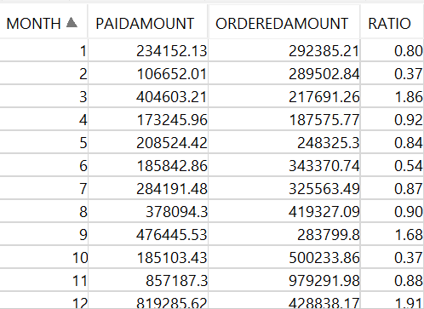

Q59:3-15. What is the difference in the amount received for each month of 2004 compared to 2003?

WITH T2003

AS

(SELECT EXTRACT(MONTH FROM PAYMENTDATE) MONTH,

SUM(AMOUNT) PAYIN2003

FROM PAYMENTS

WHERE EXTRACT(YEAR FROM PAYMENTDATE) = 2003

GROUP BY EXTRACT(MONTH FROM PAYMENTDATE)),

T2004 AS (SELECT EXTRACT(MONTH FROM PAYMENTDATE) MONTH,

SUM(AMOUNT) PAYIN2004

FROM PAYMENTS

WHERE EXTRACT(YEAR FROM PAYMENTDATE) = 2004

GROUP BY EXTRACT(MONTH FROM PAYMENTDATE))

SELECT T2.MONTH,

PAYIN2004 - PAYIN2003

FROM T2003 T1

JOIN T2004 T2 ON T1.MONTH = T2.MONTH;

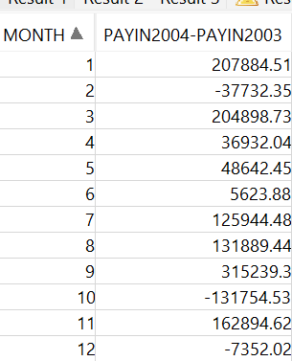

Q60:4-25. Compute the ratio for each product of sales for 2003 versus 2004.

WITH T2003

AS

(SELECT P.PRODUCTCODE,

P.PRODUCTNAME,

SUM(OD.QUANTITYORDERED) AS QUANTITYORDERED2003

FROM PRODUCTS P

JOIN ORDERDETAILS OD ON OD.PRODUCTCODE = P.PRODUCTCODE

JOIN ORDERS O ON O.ORDERNUMBER = OD.ORDERNUMBER

WHERE EXTRACT(YEAR FROM O.ORDERDATE) = 2003

GROUP BY P.PRODUCTCODE,

P.PRODUCTNAME),

T2004 AS (SELECT P.PRODUCTCODE,

P.PRODUCTNAME,

SUM(OD.QUANTITYORDERED) AS QUANTITYORDERED2004

FROM PRODUCTS P

JOIN ORDERDETAILS OD ON OD.PRODUCTCODE = P.PRODUCTCODE

JOIN ORDERS O ON O.ORDERNUMBER = OD.ORDERNUMBER

WHERE EXTRACT(YEAR FROM O.ORDERDATE) = 2004

GROUP BY P.PRODUCTCODE,

P.PRODUCTNAME)

SELECT T1.PRODUCTCODE, T1.PRODUCTNAME, T1.QUANTITYORDERED2003 / T2.QUANTITYORDERED2004 AS RATIO

FROM T2003 T1

FULL OUTER JOIN T2004 T2 ON T1.PRODUCTCODE = T2.PRODUCTCODE;

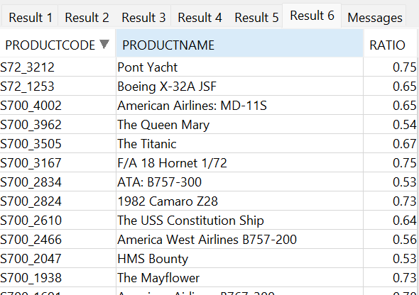

Q61:5-26. Compute the ratio of payments for each customer for 2003 versus 2004.

WITH T2003

AS

(SELECT C.CUSTOMERNUMBER,

SUM(AMOUNT) PAID_03

FROM PAYMENTS P

JOIN CUSTOMERS C ON P.CUSTOMERNUMBER = C.CUSTOMERNUMBER

WHERE EXTRACT(YEAR FROM P.PAYMENTDATE) = 2003

GROUP BY C.CUSTOMERNUMBER),

T2004 AS (SELECT C.CUSTOMERNUMBER,

SUM(AMOUNT) PAID_04

FROM PAYMENTS P

JOIN CUSTOMERS C ON P.CUSTOMERNUMBER = C.CUSTOMERNUMBER

WHERE EXTRACT(YEAR FROM P.PAYMENTDATE) = 2004

GROUP BY C.CUSTOMERNUMBER)

SELECT T2003.CUSTOMERNUMBER,

PAID_03 / PAID_04 RATIO

FROM T2003

JOIN T2004 ON T2003.CUSTOMERNUMBER = T2004.CUSTOMERNUMBER;

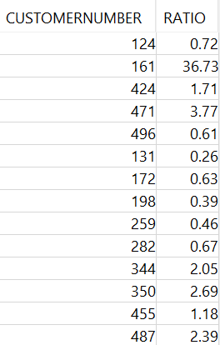

Q62:1-10. List all payments greater than twice the average payment.

WITH AVER AS

(

SELECT AVG(AMOUNT) AVERAGE FROM PAYMENTS

)

SELECT P.*

FROM PAYMENTS P,

AVER

WHERE P.AMOUNT > 2*AVER.AVERAGE;

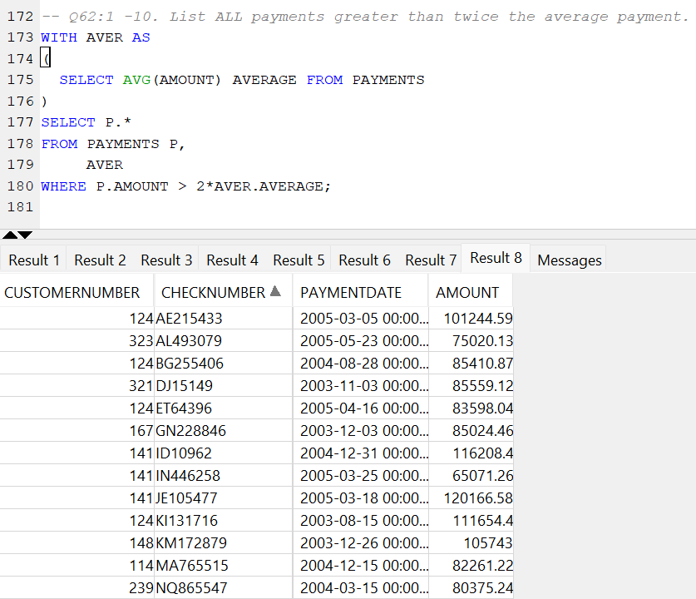

Q63:2-10. What is the percentage value of each product in inventory sorted by the highest percentage first

WITH MAXI

AS

(SELECT SUM(QUANTITYINSTOCK*BUYPRICE) TOTALSTOCK

FROM PRODUCTS)

SELECT P.PRODUCTCODE,P.PRODUCTNAME,QUANTITYINSTOCK*BUYPRICE*100.00 / M.TOTALSTOCK AS PERCENTAGE

FROM PRODUCTS P,MAXI M

ORDER BY PERCENTAGE DESC;

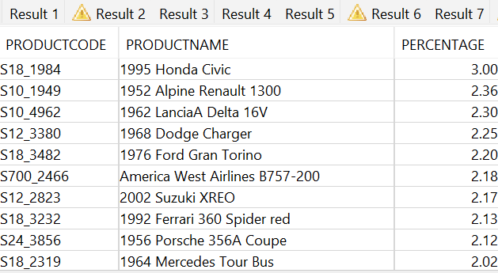

Q64:3-19. Compute the revenue generated by each customer based on their orders. Also, show each customer's revenue as a percentage of total revenue. Sort by customer name.

WITH TOTREV

AS

(SELECT SUM(QUANTITYORDERED*PRICEEACH) AS TOTALREVENUE

FROM ORDERDETAILS)

SELECT C.CUSTOMERNUMBER,C.CUSTOMERNAME,COALESCE((SUM(OD.PRICEEACH*OD.QUANTITYORDERED)*100 / T.TOTALREVENUE),0) REVENUEPERCENTAGE

FROM CUSTOMERS C

LEFT JOIN ORDERS O ON C.CUSTOMERNUMBER = O.CUSTOMERNUMBER

LEFT JOIN ORDERDETAILS OD ON O.ORDERNUMBER = OD.ORDERNUMBER

CROSS JOIN TOTREV T

GROUP BY C.CUSTOMERNUMBER,

C.CUSTOMERNAME,

T.TOTALREVENUE

ORDER BY C.CUSTOMERNAME;

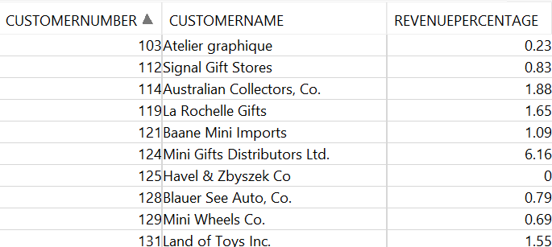

Q65:4-20. Compute the profit generated by each customer based on their orders. Also, show each customer's profit as a percentage of total profit. Sort by profit descending.

WITH TOTPROFITTABLE

AS

(SELECT SUM(OD.QUANTITYORDERED*(OD.PRICEEACH - P.BUYPRICE)) AS TOTALPROFIT

FROM ORDERDETAILS OD

JOIN PRODUCTS P ON P.PRODUCTCODE = OD.PRODUCTCODE),PROFITPERPRODCUTPERORDERNUMBERTABLE AS (SELECT P.PRODUCTCODE,

P.PRODUCTNAME,

OD.ORDERNUMBER,

SUM(OD.QUANTITYORDERED*(OD.PRICEEACH - P.BUYPRICE)) PROFITPERPRODCUTPERORDERNUMBER FROM ORDERDETAILS OD

JOIN PRODUCTS P ON OD.PRODUCTCODE = P.PRODUCTCODE

GROUP BY P.PRODUCTCODE,

P.PRODUCTNAME,

OD.ORDERNUMBER)

SELECT O.CUSTOMERNUMBER,

ROUND(SUM(A.PROFITPERPRODCUTPERORDERNUMBER)*100.0 / T.TOTALPROFIT,2) AS PROFITPERCUSTOMER

FROM ORDERS O

JOIN PROFITPERPRODCUTPERORDERNUMBERTABLE A ON A.ORDERNUMBER = O.ORDERNUMBER

CROSS JOIN TOTPROFITTABLE T

GROUP BY O.CUSTOMERNUMBER,

T.TOTALPROFIT

ORDER BY PROFITPERCUSTOMER DESC;

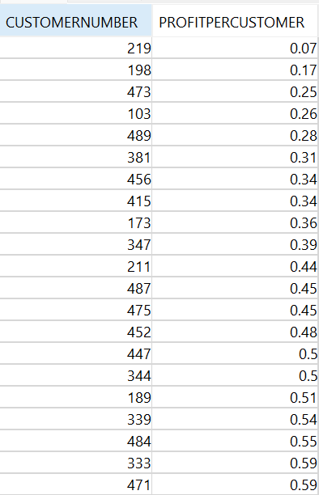

Q66:5-2. Which payments in any month and year are more than twice the average for that month and year (i.e. compare all payments in Oct 2004 with the average payment for Oct 2004)? Order the results by the date of the payment. You will need to use the date functions.

WITH AVGPAYMENTSTABLE AS

(

SELECT TO_CHAR(PAYMENTDATE,'YYYY-MM') YEARMONTH,

AVG(AMOUNT) AVGPAYMENTPERMONTH

FROM PAYMENTS

GROUP BY TO_CHAR(PAYMENTDATE,'YYYY-MM')

ORDER BY YEARMONTH

)

SELECT CHECKNUMBER,

AV.YEARMONTH

FROM PAYMENTS P

JOIN AVGPAYMENTSTABLE AV ON TO_CHAR (P.PAYMENTDATE,'YYYY-MM') = AV.YEARMONTH

WHERE AMOUNT > 2*AV.AVGPAYMENTPERMONTH

ORDER BY AV.YEARMONTH;

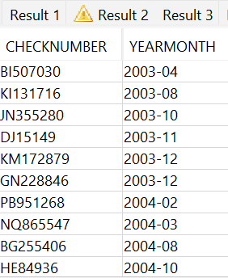

Q67:6-3. Report for each product, the percentage value of its stock on hand as a percentage of the stock on hand for product line to which it belongs. Order the report by product line and percentage value within product line descending. Show percentages with two decimal places.

WITH TOTALVALUE

AS

(SELECT SUM(QUANTITYINSTOCK*BUYPRICE) AS TOTVALUE

FROM PRODUCTS),PERCENTAGEVALUEPERPRODUCTLINE AS (SELECT P.PRODUCTLINE, SUM(P.QUANTITYINSTOCK*P.BUYPRICE) AS TOTVALUPERPRODUCTLINE,SUM(P.QUANTITYINSTOCK*P.BUYPRICE) / T.TOTVALUE AS TOTALQUANTITYPERCENTAGEPERLINE

FROM PRODUCTS P

CROSS JOIN TOTALVALUE T

GROUP BY P.PRODUCTLINE,

T.TOTVALUE)

SELECT P.PRODUCTCODE,

P.PRODUCTNAME,

P.PRODUCTLINE,

ROUND(P.QUANTITYINSTOCK*P.BUYPRICE*100.0 / PLL.TOTVALUPERPRODUCTLINE,2) AS PERCENTAGEPERPRODUCTLINE

FROM PRODUCTS P

JOIN PERCENTAGEVALUEPERPRODUCTLINE PLL ON P.PRODUCTLINE = PLL.PRODUCTLINE

ORDER BY P.PRODUCTLINE,

PERCENTAGEPERPRODUCTLINE DESC;

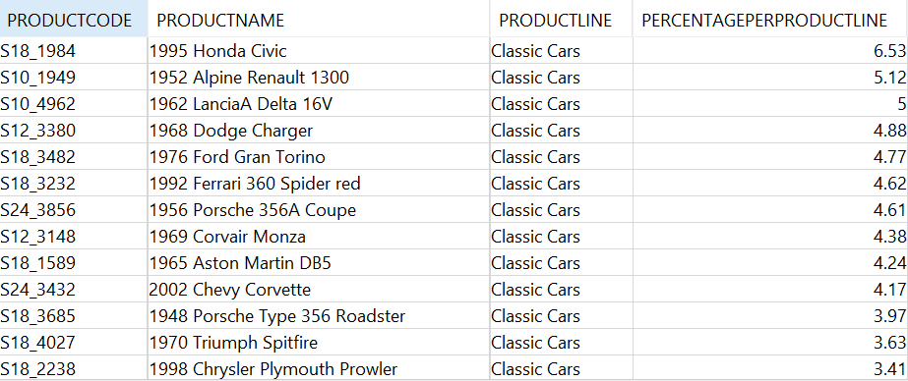

Q68:7-4. For orders containing more than two products, report those products that constitute more than 50% of the value of the order.

WITH REQUIREDORDERS

AS

(SELECT ORDERNUMBER,

SUM(QUANTITYORDERED*PRICEEACH) AS VALUEOFORDER

FROM ORDERDETAILS OD

GROUP BY ORDERNUMBER

HAVING COUNT(*) > 2),EACHPRODUCTANDORDERVALUE AS (SELECT OD.ORDERNUMBER,

OD.PRODUCTCODE,

SUM(OD.QUANTITYORDERED*OD.PRICEEACH) ORDERPRODUCTVALUE

FROM REQUIREDORDERS RO

JOIN ORDERDETAILS OD ON RO.ORDERNUMBER = OD.ORDERNUMBER

GROUP BY OD.ORDERNUMBER,

OD.PRODUCTCODE) SELECT EV.ORDERNUMBER, EV.PRODUCTCODE FROM EACHPRODUCTANDORDERVALUE EV

JOIN REQUIREDORDERS RO

ON EV.ORDERNUMBER = RO.ORDERNUMBER

WHERE ORDERPRODUCTVALUE>= 0.5*VALUEOFORDER

