Financial News Sentiment Prediction using Deep Learning & FinBERT
Project Report
Author: Binduja

Abstract
This project develops a financial sentiment classification system that categorizes finance-related tweets into Bearish, Bullish, and Neutral classes. Multiple deep learning models including RNN, LSTM, and GRU were implemented and compared against a fine-tuned FinBERT transformer model.

Dataset
The Financial News Sentiment dataset was used with training and validation splits. The task is a three-class sentiment classification problem involving finance-related tweets.

Data Preprocessing
Text cleaning included URL removal, mention removal, normalization, tokenization, and lemmatization for baseline models. Minimal preprocessing was applied for FinBERT to preserve financial context.

Models Implemented
1. Simple RNN
2. LSTM
3. GRU
4. FinBERT (Fine-Tuned)
The recurrent models used word embeddings and sequence modeling, while FinBERT leveraged transfer learning from a finance-specific transformer.

Results
RNN Accuracy: 59.55%, F1: 38.32%
GRU Accuracy: 78.56%, F1: 68.80%
LSTM Accuracy: 79.27%, F1: 70.73%
FinBERT Accuracy: 87.23%, F1: 82.45%

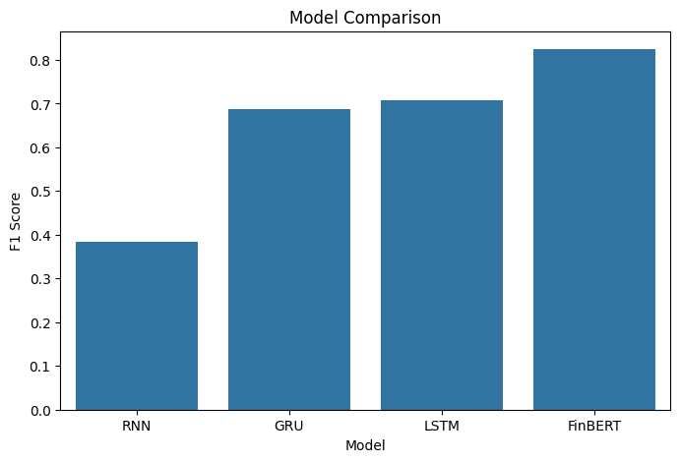

Analysis
FinBERT significantly outperformed all baseline models. The domain-specific pretraining enabled superior understanding of financial terminology and context. LSTM achieved the best performance among recurrent architectures.

Streamlit Application
A modern Streamlit dashboard was developed to provide real-time financial sentiment prediction. The application displays sentiment labels, confidence scores, probability charts, and model comparison visualizations.

Conclusion
FinBERT achieved the highest validation accuracy and macro F1-score. The project demonstrates the effectiveness of transformer-based models over traditional recurrent neural networks for financial sentiment analysis.

Performance Comparison
Model | Accuracy | F1 Score
RNN | 59.55% | 38.32%
GRU | 78.56% | 68.80%
LSTM | 79.27% | 70.73%
FinBERT | 87.23% | 82.45%



