Activity 03

Create a project in XCode with the name “**LastName_ElectronicStore**” where “LastName” is your last name. You have to create a electronic list application where you show a list of products as a list in the table and when you click on any of the product you show product name along with the price. App should also be able to create a product by providing name and price which will update products array and updates the table as well.

Download and make use of swift file given which has the list of products as a sample data. You should update the same whenever you create a product.

1. Your application will have three view controllers, first being default controller “**ViewController”** rename to **ElectronicViewController,** the second one which you need to create as “**DetailViewController”** and third being the **CreateProductViewController**.
2. In the **ElectronicViewController** you should have the following objects:

* **Table view:** Here you will show all the product names.
* **Segue from Table view cell:** Your view should navigate to **DetailViewController** whenever you click on cell.
* **Add product button with segue:**  Your view should navigate to **CreateProductViewController.**

1. In the **DetailViewController,** you should have the following objects:

* **Two labels**: One label for showing product name and other label for showing product price.

1. In the **CreateProductViewController,** you should have the following objects:

* **Two text fields:** one text field for providing product name, second field for providing product price.
* **Add product button:** when clicked on button, you should append the name and price to the array and view should be navigated back to **ElectronicViewController.**

1. Please find the flow of the application with the screenshots as follows:

* The initial view **ElectronicViewController** contains a table view with the data from electronics array which is located in Electronics.swift file. Since it is a global array you can access the variable as electronic directly. Below image depicts the initial screen with electronics data.

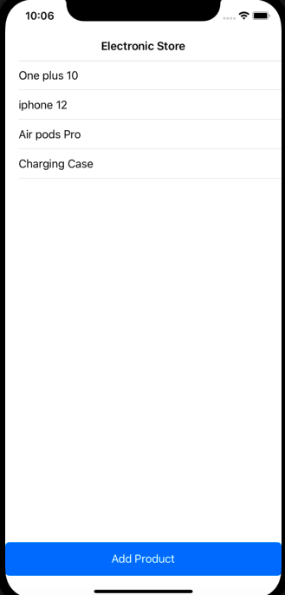

* When you click on any name i.e., table cell, your app should navigate to **DetailViewController** to which you pass the selected row’s name and price. Below image is the navigated **DetailViewController** when you clicked on iphone 12.

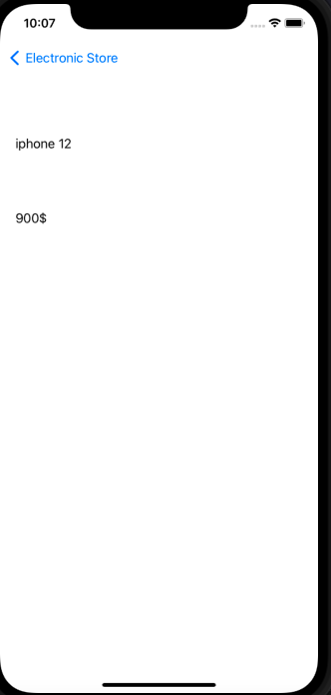

* Similarly, when you click on **create button** in **ElectronicViewController,** view should navigate to **CreateProductViewController.** When we enter the name and product price and click on **add product** button, app should add the name and price to electronic array, once added view should navigate back to **ElectronicViewController.**

In the below given images, first image is the view of **CreateproductViewController**, after you enter the details and click on **add product,** app is being navigated back to **ElectronicViewController** as shown in the second image**.**

Make use of hints given at the end of the document for updating the array, navigating back to **ElectronicViewController** and reloading the tableview.

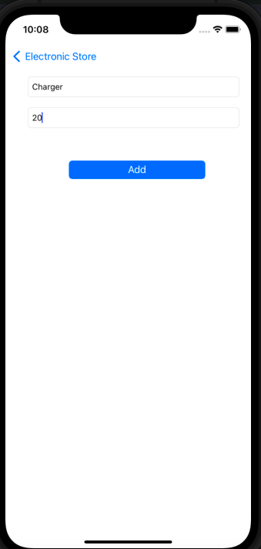 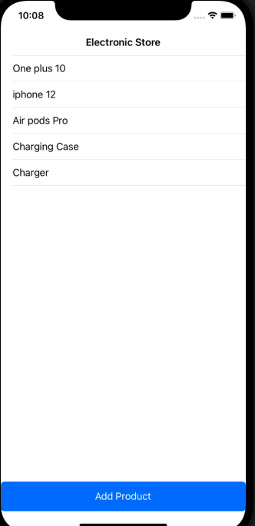

**Hints:**

* How do we append data to 2D array?

**var** newProduct = ["charger","20"]

Electronics.append(newProduct)

The above code adds “charger” and “20” to elctronics array.

* How to navigate back to **CreateProductViewController** once data is added to array?

Below line navigates back to main view controller, no need to create any segues to do this.

_ = navigationController?.popToRootViewController(animated: **true**)

* Does the newly added product visible in the table view.

When data is updated we need to reload the data, usually we reload the data in viewDidAppear() method by overriding it in **CreateProductViewController**, this will be called whenever we navigate back to **CreateProductViewController**.

**override** **func** viewDidAppear(_ animated: Bool) {

tableView.reloadData()

}