🩺
Book a Doctor
Healthcare Appointment Booking Platform — Project Documentation
Full Stack Development with MERN
Team ID: ______________
Team Members:
Kunapareddy Srivalli (Team Lead)
Bodi Deepak Sai
Kuthada Bindu Lavanya
Chinthala Prasanth
Raja Ravi Varma Vemula

1. Introduction

Project Title
Book a Doctor — Healthcare Appointment Booking Platform

Team ID
______________ (to be filled in)

Team Members
Name | Role
Kunapareddy Srivalli | Team Lead
Bodi Deepak Sai | Team Member
Kuthada Bindu Lavanya | Team Member
Chinthala Prasanth | Team Member
Raja Ravi Varma Vemula | Team Member

2. Project Overview

Purpose
Book a Doctor is a full-stack healthcare booking platform built on the MERN stack (MongoDB, Express.js, React.js, Node.js). It streamlines the process of connecting patients with healthcare providers by allowing patients to browse doctors, check availability, book appointments, upload medical documents, and receive real-time notifications, while giving doctors and administrators dedicated dashboards to manage appointments, profiles, and platform-wide oversight.

Features
- Doctor Browsing — search and filter doctors by name or specialization.
- Appointment Scheduling — patients book time slots; doctors can confirm, decline, or mark appointments complete.
- Secure Document Uploads — patients attach medical reports/prescriptions to their appointments (via Multer).
- Notifications — in-app alerts for appointment requests, confirmations, and status changes.
- Role-Based Access Control — separate experiences and permissions for Patients, Doctors, and Admins.
- Admin Controls — approve or revoke doctor accounts and view all appointments across the platform.

3. Architecture

Frontend
The frontend is a single-page application built with React.js and React Router DOM for client-side routing. It is organized into pages (route-level views), reusable components, a context layer, and an API layer:
- pages/ — Home, Login, Register, DoctorList, DoctorProfile, DoctorDashboard, DoctorProfileEdit, PatientDashboard, AdminDashboard, Notifications, NotFound.
- components/ — Navbar (navigation bar with role-aware links), DoctorCard (doctor summary card), ProtectedRoute (guards routes based on authentication/role).
- context/AuthContext.js — centralizes login, registration, logout, and the current user's session state, exposing it to the component tree.
- api/axios.js — a preconfigured Axios instance that attaches the JWT to outgoing requests via an interceptor, and points at the backend base URL.
Communication with the backend happens exclusively over REST API calls (JSON over HTTPS/HTTP), with the JWT sent as a Bearer token in the Authorization header on protected requests.

Backend
The backend is a RESTful API built with Node.js and Express.js, structured using the standard MVC-inspired pattern of routes → controllers → models:
- routes/ — Express routers that map HTTP verbs and URL paths to controller functions (authRoutes, doctorRoutes, appointmentRoutes, notificationRoutes).
- controllers/ — business logic for each resource (authController, doctorController, appointmentController, notificationController, notificationHelper).
- middleware/ — authMiddleware (JWT verification via protect, and role-based access via authorize), uploadMiddleware (Multer configuration for document uploads), errorMiddleware (centralized error handling).
- config/ — database connection, JWT helper utilities, and a seed script for demo data.
- server.js — the Express application entry point; wires together middleware, routers, and starts the HTTP server.
The API follows REST conventions and returns JSON responses. Errors are funneled through a centralized error-handling middleware for consistent error payloads.

Database
MongoDB is used as the primary data store, accessed through Mongoose schemas that enforce structure and validation. The core collections are:
- User — name, email (unique), hashed password, phone, role (patient / doctor / admin), avatar, isActive flag. Passwords are hashed with bcrypt in a pre-save hook, and a matchPassword instance method compares login credentials.
- Doctor — references a User; stores specialization, qualifications, experienceYears, consultationFee, bio, clinicAddress, an embedded availability array (day, startTime, endTime), rating, and an isApproved flag controlled by admins. Indexed by specialization for fast search.
- Appointment — references the booking patient and the target doctor; stores date, timeSlot, reason, status (pending / confirmed / cancelled / completed), an array of uploaded documents (fileName, filePath, uploadedAt), and doctor notes. Indexed on doctor + date + timeSlot to support availability checks.
- Notification — references a User; stores title, message, type (appointment / system / reminder), an optional relatedAppointment reference, and an isRead flag.

Technology Stack Summary
Layer | Technologies
Frontend | React.js, React Router DOM, Axios, CSS
Backend | Node.js, Express.js
Database | MongoDB with Mongoose ODM
Authentication | JSON Web Tokens (JWT) + bcrypt.js password hashing
File Uploads | Multer
Other Libraries | cors, dotenv, morgan, express-async-handler, nodemon (dev)

4. Setup Instructions

Prerequisites
- Node.js (v18 or above)
- MongoDB — a local instance, or a free MongoDB Atlas cluster
- npm (bundled with Node.js)

Installation
1. Clone the repository:
git clone <repository-url>
cd book-a-doctor
2. Backend setup — install dependencies and configure environment variables:
cd backend
cp .env.example .env # edit MONGO_URI / JWT_SECRET as needed
npm install
npm run seed # optional: populate demo doctors/patient/admin
3. Frontend setup — install dependencies and configure environment variables:
cd frontend
cp .env.example .env
npm install
Once both the backend and frontend dependencies are installed and the .env files are configured, the application is ready to run (see Section 6).

5. Folder Structure

Client (Frontend)
frontend/
└── src/
├── api/ # Axios instance with auth interceptor
├── components/ # Navbar, DoctorCard, ProtectedRoute
├── context/ # AuthContext (login/register/logout)
├── pages/ # Route-level pages (Home, Login, Register,
│ # DoctorList, DoctorProfile, Dashboards, etc.)
├── styles/ # Global CSS
├── App.js # Route definitions
└── index.js # Application entry point

Server (Backend)
backend/
├── config/ # DB connection, JWT helper, seed script
├── controllers/ # Route handler / business logic
├── middleware/ # Auth guard, role guard, error handling, uploads
├── models/ # Mongoose schemas (User, Doctor, Appointment,
│ # Notification)
├── routes/ # Express routers
├── uploads/ # Uploaded documents (gitignored)
└── server.js # Application entry point

6. Running the Application

Backend
From the backend directory, start the API server (defaults to http://localhost:5000):
cd backend
npm run dev # nodemon, auto-restarts on changes
or, for a production-style start:
npm start

Frontend
From the frontend directory, start the React development server (defaults to http://localhost:3000):
cd frontend
npm start

Demo Accounts
After running the seed script (npm run seed in the backend), the following demo accounts are available:
Role | Email | Password
Admin | admin@bookadoctor.com | admin123
Patient | patient@bookadoctor.com | patient123
Doctor | aisha.khan@bookadoctor.com | doctor123

7. API Documentation
All endpoints are prefixed with the backend base URL (e.g. http://localhost:5000). Protected endpoints require a valid JWT sent as a Bearer token in the Authorization header. Request and response bodies are JSON, except document upload which uses multipart/form-data.
Method | Endpoint | Access | Description
POST | /api/auth/register | Public | Register a new user as patient or doctor
POST | /api/auth/login | Public | Authenticate and receive a JWT
GET | /api/auth/profile | Authenticated | Get the logged-in user's profile
PUT | /api/auth/profile | Authenticated | Update the logged-in user's profile
GET | /api/doctors | Public | Browse/search approved doctors
GET | /api/doctors/:id | Public | View a single doctor's profile
GET | /api/doctors/me | Doctor | Get the logged-in doctor's own profile
PUT | /api/doctors/me | Doctor | Update own profile and availability
GET | /api/doctors/admin/all | Admin | List all doctors (approved and pending)
PUT | /api/doctors/admin/:id/approve | Admin | Approve or revoke a doctor account
POST | /api/appointments | Patient | Book a new appointment
GET | /api/appointments/my | Patient | View the patient's own appointments
GET | /api/appointments/doctor | Doctor | View appointments assigned to the doctor
PUT | /api/appointments/:id/status | Doctor | Confirm, decline, or complete an appointment
PUT | /api/appointments/:id/cancel | Patient | Cancel an appointment
POST | /api/appointments/:id/documents | Patient | Upload a document to an appointment (multipart/form-data)
GET | /api/appointments/admin/all | Admin | View all appointments across the platform
GET | /api/notifications | Authenticated | View the logged-in user's notifications
PUT | /api/notifications/:id/read | Authenticated | Mark a single notification as read
PUT | /api/notifications/read-all | Authenticated | Mark all notifications as read

Example — Login Request/Response
POST /api/auth/login
Body: { "email": "patient@bookadoctor.com", "password": "patient123" }
Response: { "_id": "...", "name": "...", "role": "patient", "token": "<JWT>" }

8. Authentication
Authentication is stateless and token-based, implemented using JSON Web Tokens (JWT):
- On registration or login, the backend verifies credentials — passwords are hashed using bcrypt.js before being stored, and compared using a matchPassword method on the User model — and issues a signed JWT containing the user's ID.
- The frontend stores the token (via the AuthContext) and attaches it to subsequent requests as an Authorization: Bearer <token> header, using an Axios request interceptor.
- The protect middleware on the backend verifies the JWT on every protected route, decodes it, and loads the corresponding user onto req.user. Requests with a missing, invalid, or expired token are rejected with a 401 Unauthorized response.
- The authorize(...roles) middleware performs role-based access control, restricting specific routes to patient, doctor, or admin roles as appropriate (e.g. only doctors can confirm appointments; only admins can approve doctor accounts). Unauthorized role access returns a 403 Forbidden response.
- On the frontend, ProtectedRoute wraps role-restricted pages/dashboards and redirects unauthenticated or unauthorized users away from them.

9. User Interface
The screenshots below showcase key screens of the Book a Doctor application.

Home Page
The landing page introduces the platform and highlights its core features: Doctor Browsing, Easy Scheduling, Secure Documents, and Notifications.
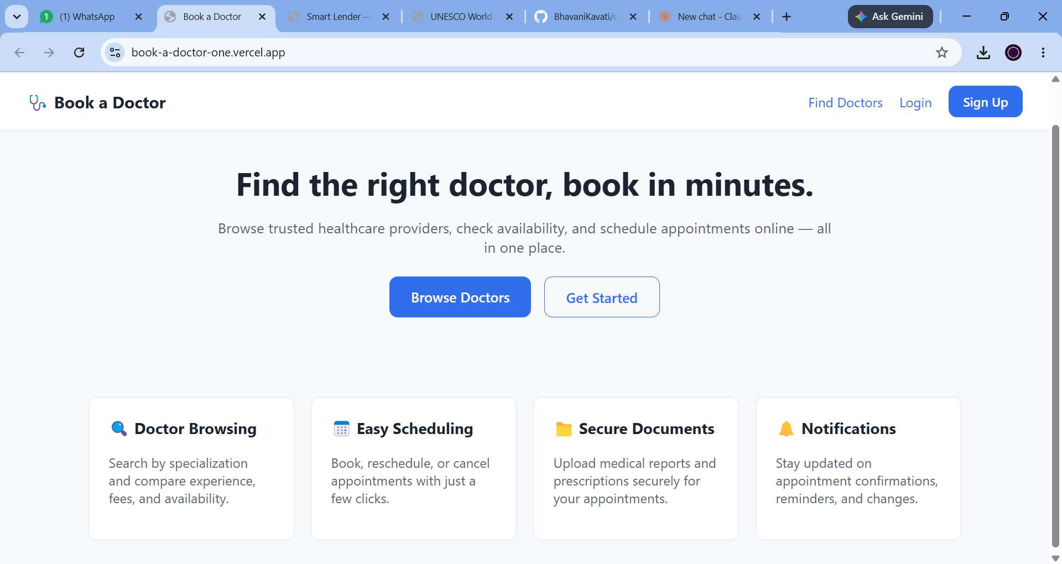
Figure 1: Home page (logged out)

Login Page
Registered users sign in with their email and password to access their role-specific dashboard.
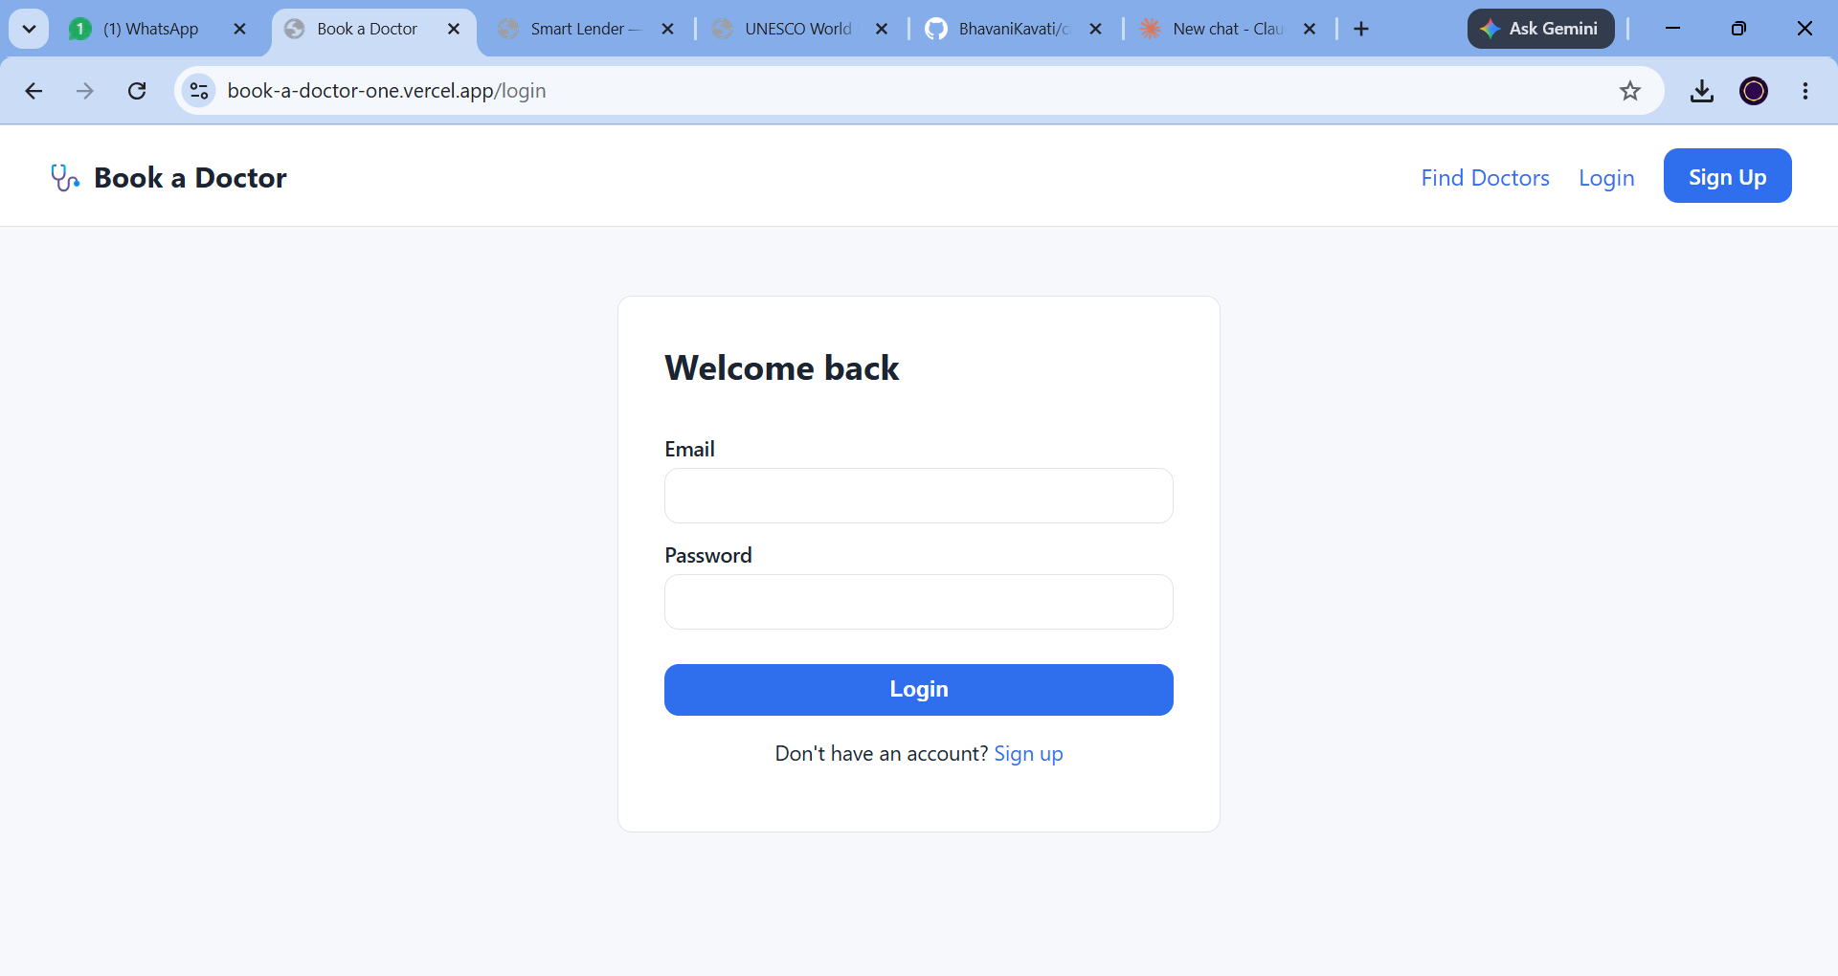
Figure 2: Login page

Registration Page
New users create an account by providing their name, email, password, phone number, and selecting their role (Patient, Doctor, or Admin).
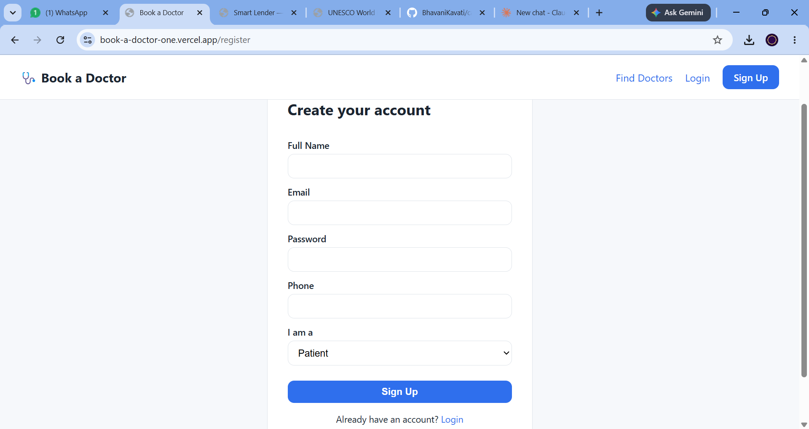
Figure 3: Registration page

Find a Doctor
Authenticated users can search and filter doctors by name or specialization, and view experience, consultation fee, and a button to view the full profile and book.
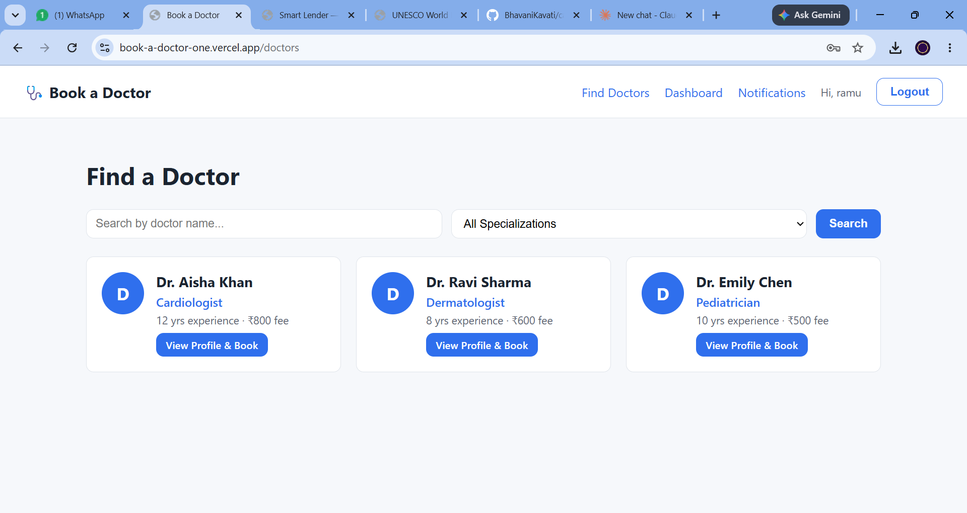
Figure 4: Find a Doctor listing page

Home Page (Logged In)
Once logged in, the navigation bar updates to show Find Doctors, Dashboard, Notifications, a personalized greeting, and a Logout option.
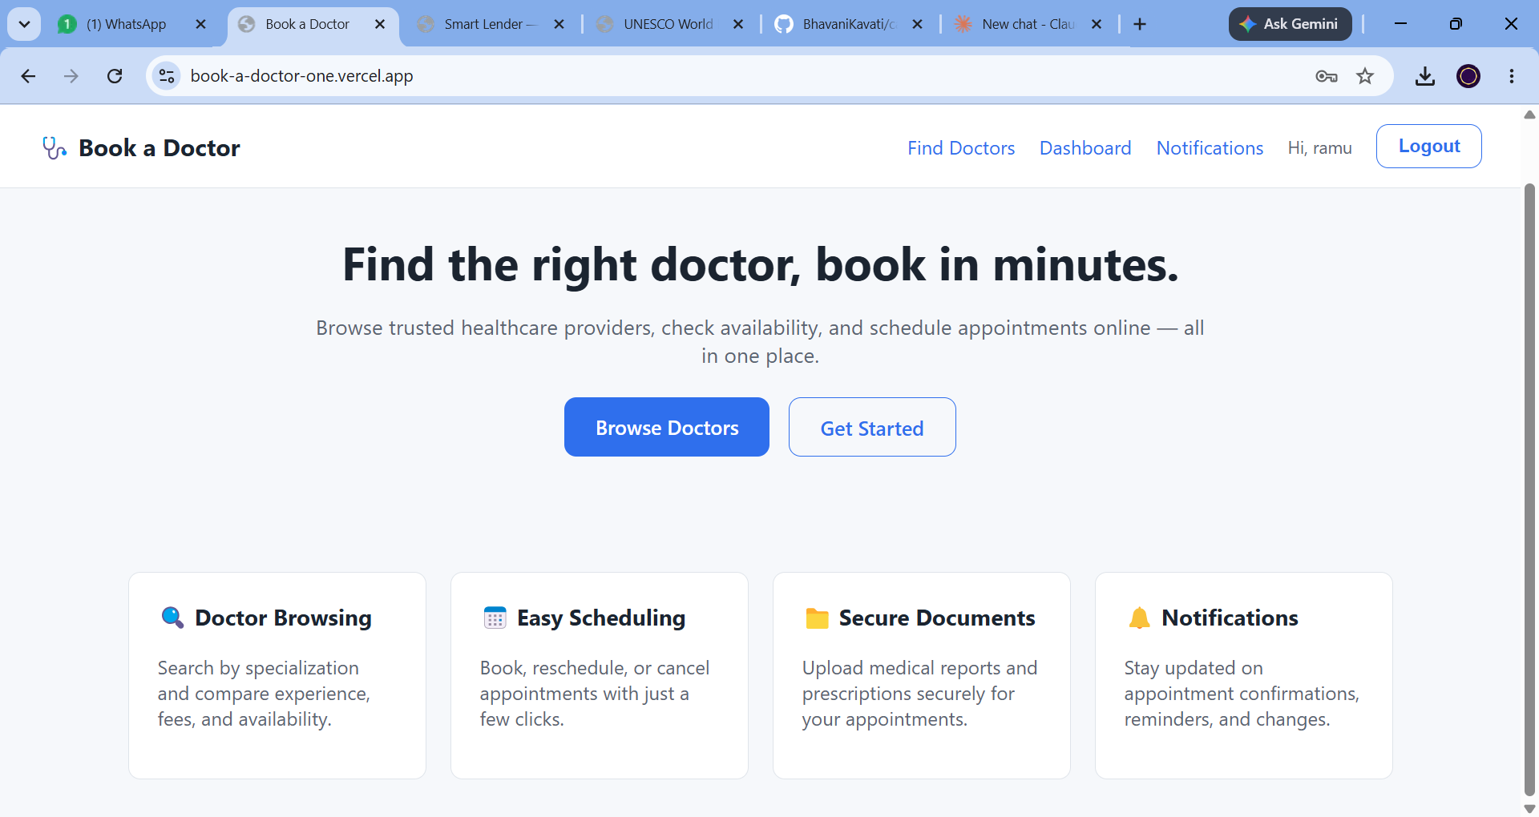
Figure 5: Home page (logged in)

10. Testing
The application was tested primarily through manual and exploratory testing across the three user roles (Patient, Doctor, Admin):
- API Testing — endpoints were tested using Postman/Thunder Client, verifying success and error responses, status codes, and role-based access restrictions (401/403 cases).
- Functional/UI Testing — manual walkthroughs of core flows: registration and login, doctor search and filtering, appointment booking, appointment status updates (confirm/decline/complete/cancel), document upload, and notification delivery/read state.
- Role-Based Access Testing — verified that patients, doctors, and admins can only access the routes and actions permitted for their role, both on the frontend (ProtectedRoute) and backend (authorize middleware).
- Cross-Browser Checks — the deployed application was verified in Google Chrome.
Automated unit/integration tests were not included in this version of the project; this is noted as a future enhancement in Section 13.

11. Screenshots or Demo
Representative screenshots of the application are provided in Section 9 (User Interface) above, covering the home page, login, registration, and the doctor search/listing screen.
Live Demo: _add your deployed demo link here_
GitHub Repository: _add your GitHub repository link here_

12. Known Issues
- No automated test suite (unit/integration tests) is currently included.
- Doctor availability slots are defined generically per day of the week and are not yet validated against already-booked time slots at the UI level before submission.
- Notifications are in-app only; there is no email/SMS delivery channel yet.
- Uploaded documents are stored on the local server filesystem (backend/uploads), which is not suitable for scaled, multi-instance production deployments without migrating to cloud storage.
- Live demo and GitHub repository links in the README are placeholders and need to be updated with the deployed URLs.

13. Future Enhancements
- Add automated unit and integration tests (e.g. Jest, React Testing Library, Supertest) and CI pipeline.
- Integrate email/SMS notifications for appointment reminders and status changes.
- Add online payment integration for consultation fees.
- Migrate document uploads to cloud storage (e.g. AWS S3 / Cloudinary).
- Add doctor ratings and patient reviews after completed appointments.
- Add a calendar-based availability picker with real-time slot conflict prevention.
- Add video consultation support for remote appointments.

