# **Phase 2: Org Setup & Configuration**

👉 Goal: Prepare Salesforce environment.

**1.Salesforce Editions**

○Use **Developer Edition Developer Org** (free dev org).

## **2.Company Profile Setup**

○ Go to **Company Settings** → add company info, local time zone.

**Use Case:**  
A national retail chain wants to roll out a loyalty and feedback CRM across all stores. To ensure consistency, the Salesforce **Company Profile Setup** is configured with the company’s fiscal year, currency, time zone, business hours, and default language.

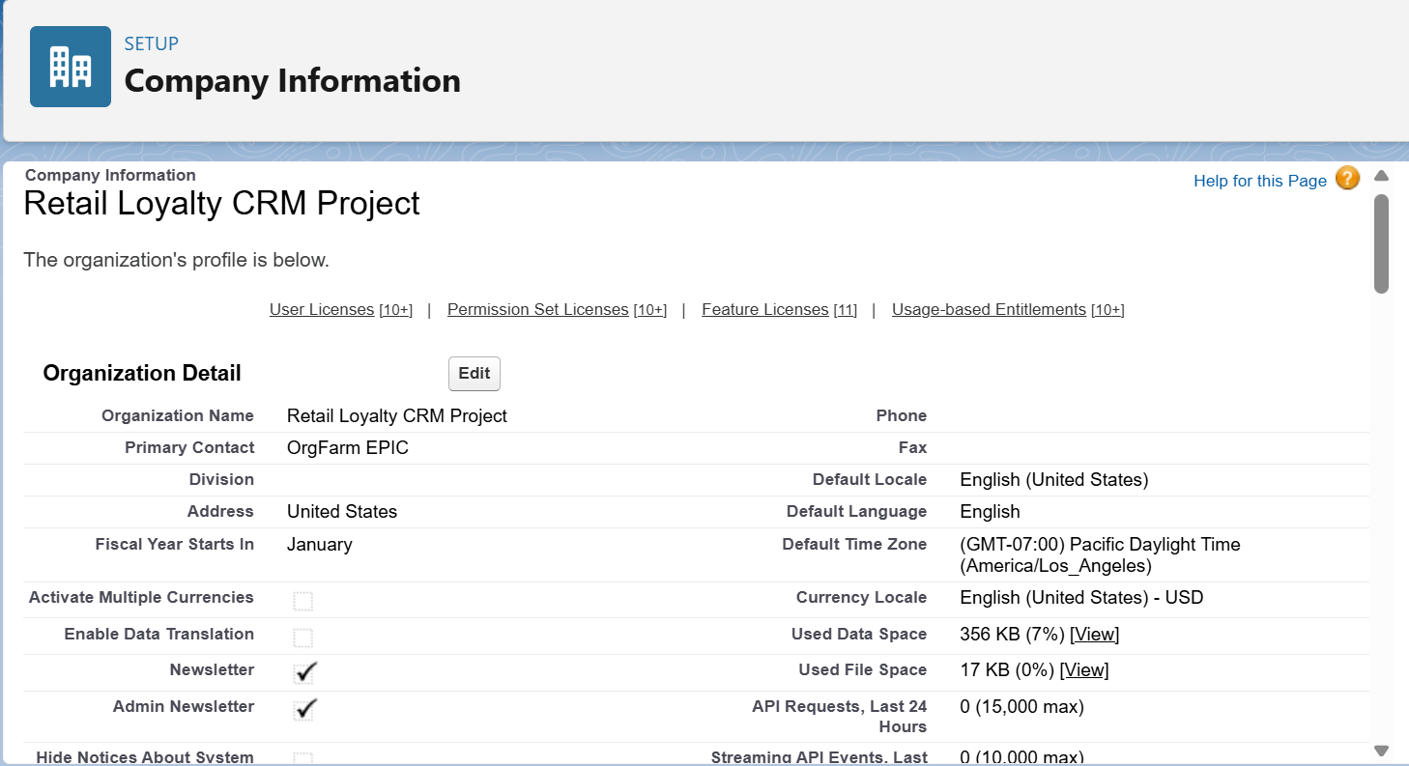

## **3.Business Hours & Holidays**

○ Define working hours (9am–6pm).

○ Add public holidays (no approvals on these days).

**Use Case:**

In the retail loyalty and feedback CRM, Business Hours are set to align with store operating times (10 AM – 9 PM). Holidays (like Diwali or Christmas) are configured so escalated customer complaints don’t trigger notifications to service teams on non-working days. This ensures customer issues are managed within agreed service levels (SLAs) without burdening staff during off hours.

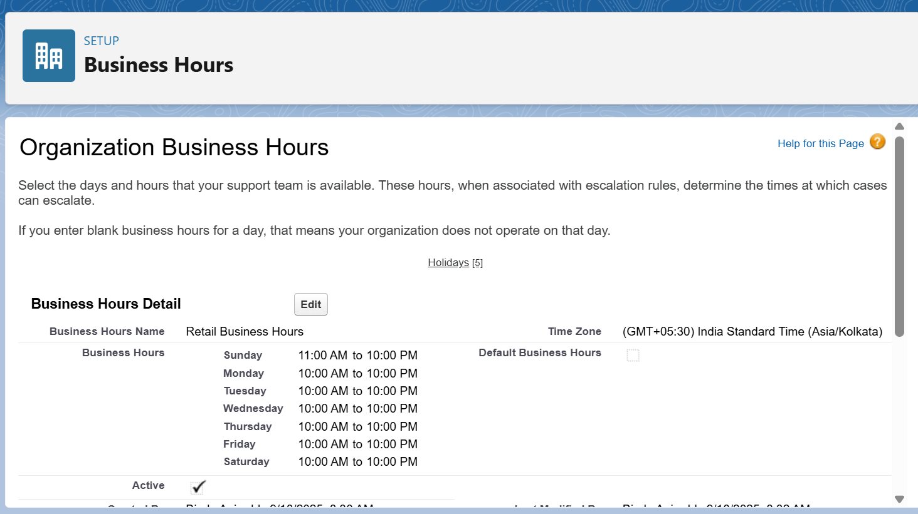

**4.Fiscal Year Settings**

○ Standard (Jan–Dec) → good for revenue reporting.

**Use Case:**  
The company runs loyalty point summaries and redemption reports based on its fiscal year (April–March). Configuring Fiscal Year in Salesforce ensures all loyalty analytics, reward calculations, and financial tracking for customer offers align with corporate accounting periods.

**5.User Setup & Licenses**

○ Create users: Rental Agent, Manager. Assign them Salesforce licenses.

**Use Case:**  
Store Managers, Customer Service Reps, and Regional Admins are set up with appropriate Salesforce licenses. Roles and Profiles ensure store managers can monitor escalations, while service reps handle feedback cases. This controlled access ensures data security and role-based operations.

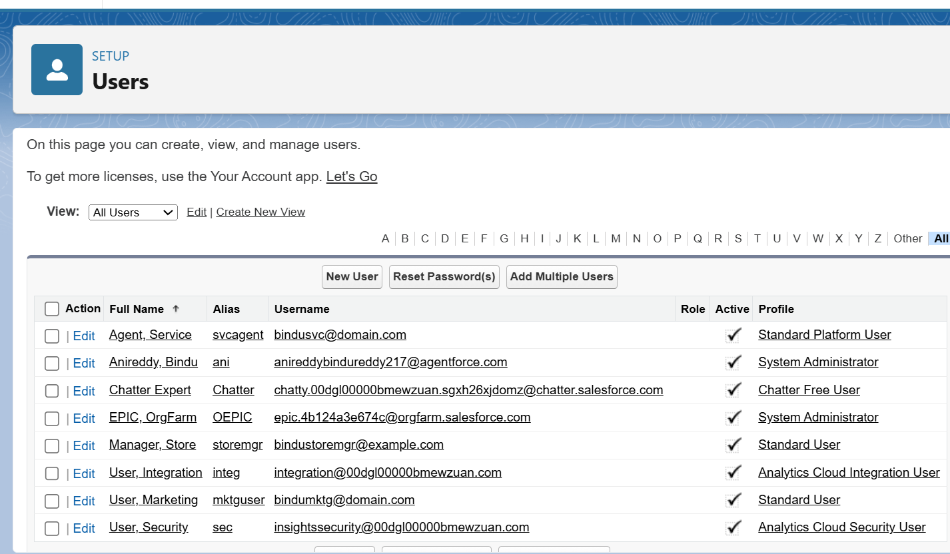

**6.Login Access Policies**

○ Restrict login hours (9am–6pm for agents).

**Use Case:**  
For data security, login IP ranges are restricted to corporate networks, and session timeouts are enforced for store devices. Multi-Factor Authentication (MFA) ensures that only authorized staff can access loyalty and feedback data, protecting customer trust.

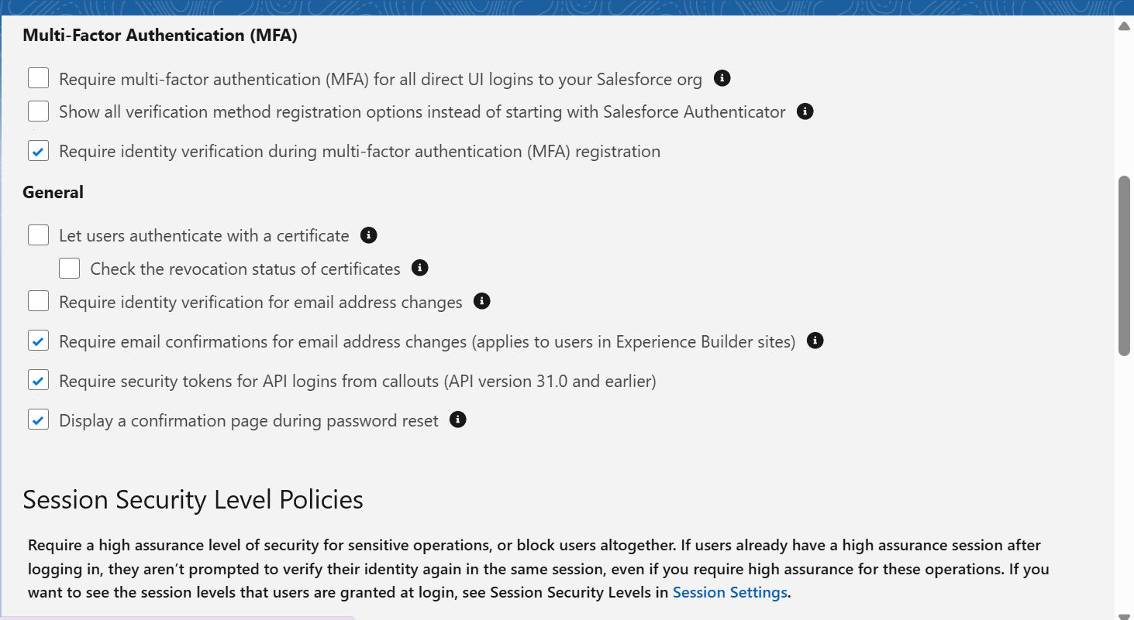

**7.Dev Org Setup**

○This is your sandbox → where you build/test.

**Use Case:**  
A Salesforce Developer Org is created to build and test the loyalty CRM features (like automated feedback flows and custom notifications) without affecting production data. This allows safe prototyping and iterative development.

**8.Sandbox Usage**

○ If this were a real company, we’d build in Sandbox, then deploy to Production.

**Use Case:**

A **Full Sandbox** is used to replicate real customer and transaction data for UAT (User Acceptance Testing). A **Developer Sandbox** is used for individual feature testing (e.g., complaint escalation flows). This separation prevents testing errors from impacting live customer data.

## **9.Deployment Basics**

○ Deployment is moving config/code from sandbox → production using **Change Sets**.

**Use case:**

New features, such as feedback automation and loyalty rewards calculation, are first tested in Sandboxes. Change Sets are then used to deploy these features into Production. This structured deployment ensures stable, error-free rollout of CRM functionality across all retail stores.