Machine Learning
Machine Learning is making the computer learn from studying data and statistics.
Machine Learning is a step into the direction of artificial intelligence (AI).
Machine Learning is a program that analyses data and learns to predict the outcome.
Types:
Supervised: label data we give input, output
Unsupervised: data driven
Reinforcement: Learn from mistakes
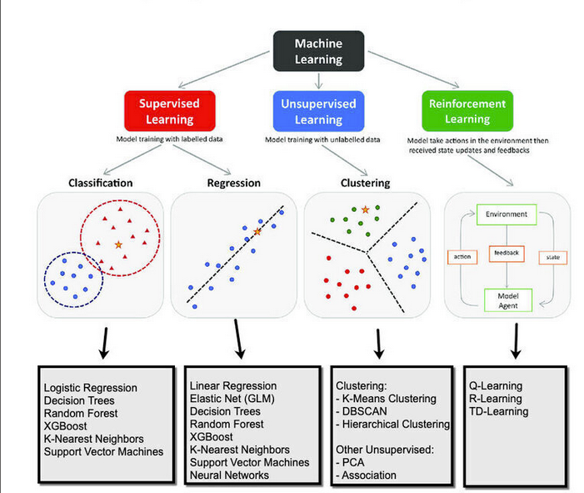
Step1: Data gathering
From sources like google,Microsoft, third party
Step2: Data Preprocessing
Use Data preprocessing libraries like pandas,Numpy, tools like ETL
Step3: Data Visualization:
Data Visualization is the graphical representation of information and data by visual elements like charts, graphs and maps:
Libraries:
Matplotlib, seaborn,plotly
Tools:
PoweBI, Tableau
Step4: Data Modeling:
Selecting the Algorithm
Raing the model
Testing the model
Uses sklearn
Step5: Deployment:
Deployment of ML model into PROD using Django or flask,SQL, Github, Azure, Heroku

