Executive Summary of Environmental Impact Assessment Study

& Environment Monitoring Plan for Kochi Metro Rail Project
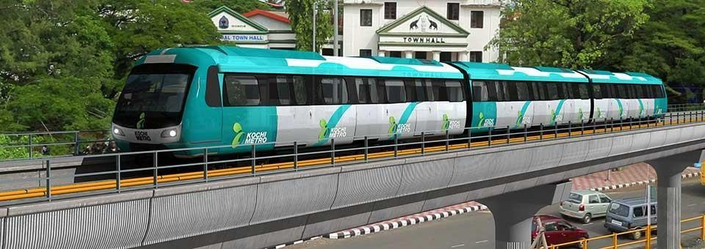


Prepared for
8thFloor, Revenue Tower, Park Avenue, Kochi, Kerala, India

Prepared by
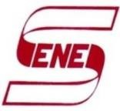 SENES Consultants India Pvt. Ltd.

Kochi Metro Rail project has been planned by Government of Kerala. Special Purpose Vehicle (SPV) called Kochi Metro Rail Ltd. (KMRL) is formed for the implementation, operation and maintenance of the Metro Project. Around 25 km length metro line with 22 stations with Maintenance Depot at Muttom will be developed between Aluva to Petta.




The EIA notification, 2006 and its subsequent amendments and the Schedule which gives ‘List of Projects or Activities Requiring Prior Environmental Clearance’ does not include Metro Rail Project & thus Metro Rail project does not require environmental clearance from Ministry of Environment & Forest (MoEF). The main objective of this EIA study is to document the assessment of environmental impacts associated with development of metro rail along with associated Environment Monitoring Plans and facilitate KMRL the EIA report as per requirement of funding agency. This document gives the summary of environmental Impacts Assessment and Environment Monitoring Plans suggested through the above mentioned study.

The proposed Kochi metro will have 22 stations. Stations have been located so as to serve major passenger destinations and to enable convenient integration with other modes of transport. However effort has also been made to propose station locations, such that inter station distances are as uniform and the average spacing of stations is close to 1 km as possible.












The proposed rolling stock shall have design speed of 90 kmph and maximum running speed of 80 kmph. Average commercial speed will be 33 kmph. In order to maximize the passenger carrying capacity, longitudinal seating arrangement is adopted. The train composition will be as follows:
- 1 unit of Driving Motor Car
- 1 units of TC
- 1 unit of Driving Motor Car
{Total 975 Passengers capacity per train (Sitting- 136, Crush Standing-839}

Third Rail traction system is considered for Kochi Metro System based on SCADA system. CBTC system will be used for signaling and train control. Maintenance Depot along with repair and stabling facilities for the corridor is located in Muttom area on National Highway 47 adjacent to the Metro corridor. Two receiving sub stations (110 / 33 kV) are proposed to be set up for the proposed project.
P a g e | 2


The proposed viaduct structure for the Kochi Metro is pre-stressed concrete deck, carrying two tracks supported on single pier located on the median of the road. Piers are circular (of 1.6 m diameter) but in for eccentric loading and in stations, the shape is rectangular. Road clearance of 5.5 m is ensured below the viaduct structure. The foundation is pile foundation at all pier location.









Proposed stations along with their chainages are given in table and figure below:

S.  No | Name of Station | Chainage (in km) N–North S–South | Distance from Previous Station  (km) | Height of Rail Level in mtr. From road level | Platform Type and Nos | Alignment Description
1 | Aluva | .118 |  | 16.37 | Side Platform, | On 1000 m  curve
2 | Pulinchode | 1.779 | 1.66 | 13.25 | 2 Side Platforms | Curved
3 | Companypady | 2.78 | 1.00 | 13.10 | 2 Side Platforms | Straight
4 | Ambattukavu | 3.78 | 1.00 | 12.83 | 2 Side Platforms | Straight
5 | Muttom | 4.723 | 0.943 | 13.81 | 1 Side Platform &  1 Island Platform | Straight  Curved
6 | Kalamassery | 6.769 | 2.04 | 12.98 | 2 Side Platforms | Straight
7 | CUSAT | 8.174 | 1.405 | 12.98 | 2 Side Platforms | Straight
8 | Pathadipalam | 9.428 | .972 | 12.5 | 2 Side Platforms | Straight
9 | Edapally | 10.492 | 1.453 | 18.33 | 2 Side Platforms | Straight
10 | Changampuzha  Park | 12.063 | 1.424 | 13.30 | 2 Side Platforms | Straight
11 | Palarivattom | 13.065 | 1.048 | 13.09 | 2 Side Platforms | Straight
12 | J L Nehru  Stadium | 14.183 | 1.055 | 10.47 | 2 Side Platforms | Straight
13 | Kaloor | 15.221 | 1.095 | 16.19 | 2 Side Platforms | Straight
14 | Lissie | 15.711 | 0.490 | 17.77 | 2 Side Platforms | Straight
15 | M.G.Road | 16.899 | 1.188 | 12.98 | 2 Side Platforms | Straight
16 | Maharaja College | 18.103 | 1.204 | 12.98 | 2 Side Platforms | Straight
17 | Ernakulam South  Station | 19.332 | 1.229 | 12.98 | 2 Side Platforms | Straight
18 | Kadavanthra | 20.185 | 0.853 | 12.98 | 2 Side Platforms | Straight
19 | Elamkulam | 21.341 | 1.156 | 12.98 | 2 Side Platforms | Straight
20 | Vyttila | 22.447 | 1.106 | 19.25 | 2 Side Platforms | Straight
21 | Thaikoodam | 23.703 | 1.256 | 12.98 | 2 Side Platforms | Straight
22 | Petta | 24.822 | 1.119 | 12.98 | 2 Side Platforms | Straight
Source: Kochi Metro Rail Ltd.

P a g e | 3

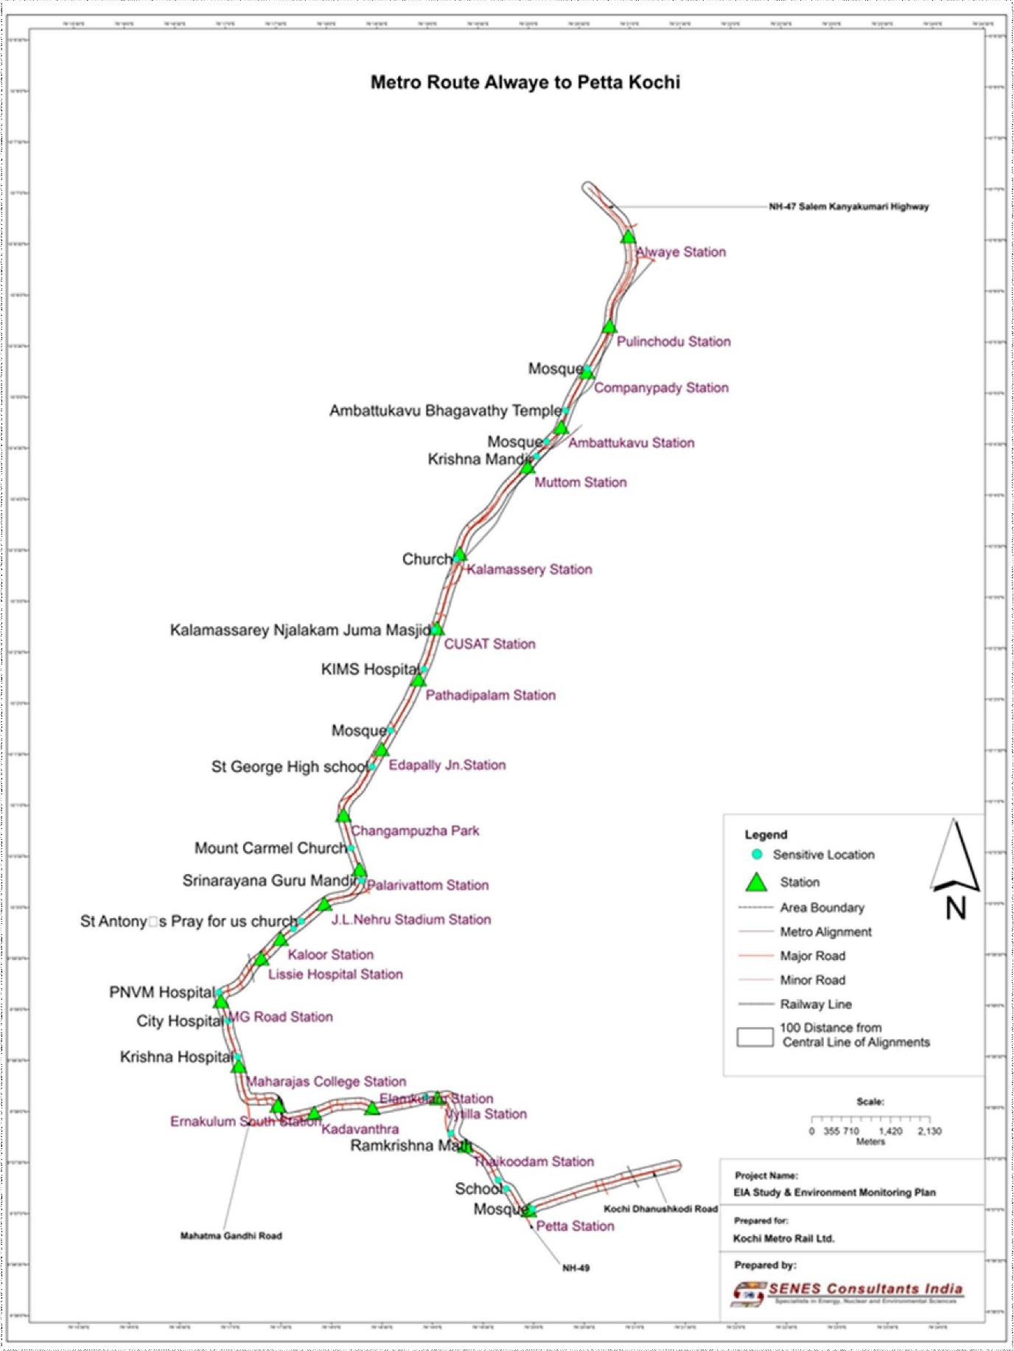

P a g e | 4


To assess the baseline environmental status of the proposed project area, primary baseline monitoring had been conducted at various locations for prominent environmental attributes like air, water, noise, soil during Dec’13 to Jan’14. In formulating the baseline environmental monitoring plan MoEF guidelines along with the various Indian Standards (IS) by Bureau of Indian Standards were followed. Data on various environmental attributes has been collected through field surveys and also compiled from various reports/secondary sources available in public domain.
Topography - Geology and Soil: The topography of Kochi is almost flat. The soil of the region can be broadly classified into two categories i.e, alluvial and lateritic. Geologically Kochi areas consist of thick sedimentary rock alternating clay and sand. Metro project is planned in well developed urban areas, so the soil samples were collected from Muttom area where maintenance depot is planned. The soil analysis indicated that pH was 6.7, electrical conductivity in the range of 184 µmhos/cm to 188 µmhos/cm, nitrogen values range between 14016.6 -14085.9 kg/ha. As per the rating limits for soil test values used in India, phosphorus values range between 201.9 to 210.7 kg/ha indicating high value, potassium value was 215 kg/ha indicting medium value.
Land Use/Cover: The land-use pattern of the area has been identified mainly as residential, commercial, roads, public and semi-public and water bodies. The field study and mapping indicates that around 41% (239.0 ha) area is under commercial use followed by around 22% (125.8 Ha) of mixed use (i.e. both commercial & residential).
Seismicity: As per the current regional zoning map, Kerala lies in seismic zone III, where the Modified Mercalli (MM) intensity scale intensity would correspond to VIII.
Water Quality: Ground Water is commonly tapped from aquifers through dug wells in city. Kochi has canals spread near coastal areas. These are, at places, used for navigation. As per the Central Ground Water Board, the water level is shallower in western coastal part and is less than 2 metres below ground level (mbgl) in general. The proposed route is passing through the creek and canal in seven locations. The major creeks/river are Chillavanoor near Elankulam, Kaniyampuzha near Vytilla and Chembakkara near Thykoodam.
Ground water: The ground water quality was monitored for bore wells at Aluva, Eranakulam South, Kalamassery and Petta through single grab sample. The ground water samples were collected from dug wells in residential / institutions to understand the water quality along the project route on. The values were compared with Indian Standard Drinking Water Specification (Second Revision), IS 10500: 2012. The pH ranged between 6.7 to 7.0, well within the specified standard of 6.5 to 8.5. Total hardness was observed to be ranging from 21.8 to 940 mg/l. Hardness level exceeds acceptable limits at all locations except at Ernakulam and exceeds permissible limits only at Petta. Among the metals analyzed copper, zinc, cadmium, selenium, mercury and arsenic were observed within desirable limits/observed to be nil at all locations. Coliforms were not observed in all samples.
P a g e | 5

Surface water: The surface water quality was monitored at Champakara Canal at Vytilla, Champakara Canal at Thaikoodam and Kaloor nalla at Kaloor through single grab sample. The quality of the surface water was compared to the Class SW V waters for Navigation and controlled waste disposal. The physico- chemical characteristics such as pH, total hardness, chlorides, dissolved solids, sulphates and nitrates were within limits.
Air Environment: Kochi’s maximum temperatures range between 28.9°C to 32.7°C with minimum temperature in the range of 22.1°C to 25.4°C. Air Quality was monitored at 7 locations as Aluva (L& T Temporary Site Office), Apollo Tyre (L& T Temporary Site Office), Edapally Junction (L& T Temporary Site Office), South Ernakulum (Railway Staff Quarters), Vytilla (Era –Ranken Site Office), Thaikoodam (opposite Ramkrishna Mattam) and Petta. Ambient air quality monitoring was carried out at a frequency of two days per week for 4 weeks at each location. Observed concentration of PM_{2.5}, PM₁₀, SO₂, NOx, CO is within the National Ambient Air Quality Standards, 2009 at all the identified locations. Lead is below the detectable limit at all locations.
Noise Environment: The noise quality was observed at 7 locations as Aluva, Rajagiri School (Pathadipalam), Edapally Junction, Lissi Hospital at JN Stadium, Maharaja College near Marine drive, Madhav Pharmacy at M. G. Road and Petta. It was observed that day and night time noise levels are within National Ambient Air Quality Standards for Noise (NAAQSN) for commercial area for the respective day and night time.
Ecology: The reconnaissance visit reveals that the proposed route is not passing through any forest area or plantation area. The major tree species observed along the route are Coconut, Golden Flamboyant, Rain Tree, Mango and Jack tree. Teak is the only commercially valued tree. No rare or endangered species of trees were observed. In Fauna, since the route is urban area, urban fauna like street dogs, cows and buffaloes were observed during field studies. Mangalavanam Bird Sanctuary is located beyond approximately 1.2 km distance from metro line. Mangalavanam is primarily a bird refuge. The true mangrove and mangrove associate species that exist in the sanctuary are Avicennia officinalis, Rhizophora mucronata, Acanthus ilicifolius and Acrostichum aureum. Secondary information reveals that it supports mammals like Indian flying-fox, painted bat, three-striped palm squirrel/dusky palm squirrel, amphibians and fish species.














Archaeological Structure: During the field visit no structures which were having archaeological importance as per archeological survey of India list were observed along the metro rout from Aluva to Petta.

- Project Affected People (PAPs): For construction of around 25 km stretch of Kochi Metro project, around 40 Ha land is required.

P a g e | 6

The land acquisition is being done though negotiated purchase. For properties which will be affected owners will be paid compensation as per the mutually agreed rates. A separate study for collection of socioeconomic profile of land sellers is being carried out which will then lead to Rehabilitation and Resettlement (R&R) plan and Social Management Plan for affected/displaced families.
- Change of Landuse: Being a linear project land use change is limited. Also the project is coming up majorly on the existing road, passing through well-developed m residential & commercial areas. Some of the areas like maintenance depot will come up on a b a n d o n e d agricultural land where landuse change will be prominent (~ 15 Ha).
- Muttom Depot: Maintenance depot is planned at Muttom which is low laying area compared to surrounding region. The depot area has experienced water logging in monsoon, so drainage management is important aspect.
- Utility/Drainage Diversion: The proposed Metro alignment is passing along major arterial roads of the city road network. Utility services, viz. water mains, storm water drains, telephone cables, electrical transmission lines, electric poles, traffic signals etc. are existing along the proposed alignment. These utility will have to be maintained in working order/diverted, as per need.
- Loss of Ecology: The proposed metro line is in well- developed urban area with prominent commercial and mixed landuse. The metro alignment is not passing through any forest area. Hence limited loss due to tree cutting (477 no.) is anticipated due to the project.
- Impact on Archaeological Sites: No structures which were having archaeological importance as per Archeological Survey Of India list were observed along the metro rout from Aluva to Petta.




- Metro Station Planning: The Metro station locations and its entry-exist if not planned properly may lead to creation of traffic congestion and may become cause trouble to passengers and nearby communities. For Kochi Metro station entries have been planned in such a way to provide easy access for passengers from main bus terminals like Rajiv Gandhi Bus Terminal located on the side of NH-47 and other roads. At few metro stations’ entry will be planned in such a way that there will be space for passenger vehicles for pick-up & drop.
- Waste Generation From Metro Stations: The refuse from metro station includes; garbage, rubbish, and floor sweepings. The total refuse generated at each station will be about 4.5 T/day on the assumption that only about 25 % of the passengers visiting various stations will be producing refuse. Improper waste handling can lead to problems like odour, unpleasant view, pest/vector

P a g e | 7

issues. So avoid this, measures like provisions of containers/collection bins equipped with side handles, adequate toilet facilities with appropriate refuse collection and disposal system will be provided. Sewage generated in each station can be disposed to a combination of septic tank and soak pit facility. Disposal for solid waste, sewage & sludge will be finally handled by Kochi Municipal authorities.
- Ventilation and Lighting: The platforms, open space, staircase and escalator areas for elevated stations will have adequate and uniform lighting and ventilation to provide pleasant environment.
- Seismological Risk: Designing of metro have been taken by considering structural stability from seismic effect.



- Soil Excavation, Erosion And Disposal Of Excavated Earth Material: Kochi Metro is planned as an elevated metro, the amount of soil excavation required will be lesser compared to underground metro. The soil excavated for pile foundation and piling waste collected from the construction sites are main waste components. Run off from unprotected excavated areas, at foundation locations and at construction sites can lead to soil erosion. Problems could arise from dumping of construction spoils (Concrete, bricks) waste materials (from contractor camps) etc. causing surface and ground water pollution. Soil collection, transportation, disposal and its treatment needs to be carried out in a systematic manner.
- Traffic Diversion: During construction, traffic diversions on roads will be essentially required. The traffic diversions during peak hours can lead to traffic congestion at other routes and increase travel time for commuters.
- Resource requirement During Construction Phase: Water requirement for construction of proposed project will be met through the tube-wells bored specially for the purpose of metro construction after taking approval from competent authority, like Corporation of Kochi & Kerala Water Authority. Hence proper care shall be taken while deciding the location of these activities or drawing water from public facilities.
- Dust Generation: The entire metro route is elevated and hence foundation work will require activities like foundation, fill and embankment, thus leading to dust generation. During excavation, site will be properly barricaded to avoid spreading of dust to nearby areas. During the transportation of the excavated material to disposal area, the material will be covered by tarpaulin / plastic sheets so that dust is not spread while movement of material.
- Noise Pollution: Noise generation from construction equipments varies depending upon type of equipment, specific model, operation being performed and condition of equipment. In order to reduce the noise impacts during construction phase sites will be provided with proper barricading.

P a g e | 8

Construction activities with high noise generation potential will be avoided during night time to the extent possible. All the construction equipments will be maintained/ serviced regularly.
- Health & Safety Issue at Construction Site: Metro construction activity demand high skilled workers. Thus often skilled labour requirements which cannot be met by locals will necessitate employment of skilled labour from outside the locality or region through contractors. Around 2270 workers are employed for construction work, which may increase or decrease depending upon work load. Workers are required to be provided with accommodation facilities along with proper water supply, sanitation, drainage, health care and human waste disposal facilities as health risks are generated due to lack of sanitation facilities. Workers will be provided with proper personal protective equipments like noise muffs, gloves, helmets, etc. in order to prevent/control any safety related mishaps.
- Supply of Construction Material: Different types of construction material will be required for construction of metro corridor which is bought from quarries which are not directly under project proponent. Around four lakh cubic meter sand is required for the works of Kochi Metro. Due to ban on sand quarrying, manufactured sand is procured and used for the works of Kochi Metro. The cement, metal and other construction material required is procured by contractors as per the specifications finalized with DMRC.









- Noise Pollution: in operation phase noise will be mainly generated due to movement of metro on track structures. Metro noise level studies were carried out by National Physical Laboratory for Delhi Metro estimates that operation of metro can cause a cumulative increase in ambient noise level by maximum 2 to 3 dB(A) in medium and high traffic density areas. Baseline noise monitoring indicate that day time noise levels are in the range of ~56 to ~60 dB(A) and night time levels are in the range of ~45 to ~49 dB(A), which are within National Ambient Air Quality Standards for Noise (NAAQS) for commercial area for the respective day [65 dB(A)] and night time [55 dB(A)]. Consider cumulative increase in ambient noise level by due to metro operation as maximum 2 to 3 dB(A) still the resulting noise is envisaged to be within National Ambient Air Quality Standards for Noise (NAAQSN) for commercial area for the respective day and night time. Thus based on this, it is suggested, if required, noise barriers can be erected based on the noise levels observed in operational phase at isolated locations.
- Water Supply and Sanitation at Station: Water requirement at stations has various components, viz, personal use of staff, fire demand, make up water for air conditioning and ventilation and wastage. The water requirement will be fulfilled by Kerala Municipal Corporation. For the maintenance of adequate sanitary facilities, containers/collection bins with adequate capacity
equipped with side handles will be appropriately designed and installed at stations and platforms. The solid waste will be disposed off with help of Kerala Municipal Corporation. In Kochi municipal
P a g e | 9

sewage disposal system is still under construction, therefore sewage generated in each station can be disposed to a combination of septic tank and soak pit facility.
- Impacts Due To Depot: The water requirement will be met through tube wells at depot or Kerala Water Authority water supply. The used water will be treated in in-house Waste Water Treatment Plant with oil separation unit before discharging. The trapped / collected oil may be disposed after proper treatment with the help of pollution control board authorised vendors/sites. The treated water could be used for developing a greenbelt around the depot. Sewage generated can be disposed to a combination of septic tank and soak pit facility till sewer line is developed. Solid waste generated will be taken care by the cleaning contractor weekly and disposed to the authorised waste disposal sites.








- Reduction in Air Pollution: Metro operation are based on electricity which when compared to air pollution due to vehicles is considered as less polluting option. This is supported by the fact that during traffic studies, many commuters had shown wiliness to shift from public & private transport to metro. This shift will lead to reduction in passenger kilometre travelled. Emission from road traffic was estimated using Auto Fuel Policy based on the distance travelled by different types of vehicle in without Metro and with Metro scenarios in year 2018, 2033 & 2048. The details of no. of traffic share in passenger trips were referred from CDM smith report - Ridership Updation on Kochi Metro and Impact on Pollutants. This estimation indicates that there will be CO2 reduction (in kg) through year 2018, 2033 & 2048 as around 5074, 7752, & 9827 kg respectively. The reduction in PM (in kg) through year 2018, 2033 & 2048 will be around 259, 459 & 684 kg respectively. The reduction in NOx (in kg) through year 2018, 2033 & 2048 will be around 9709, 14143 & 17167 kg respectively.

- Increasing vehicle number: Kochi City has the reported highest number of vehicles in the State of Kerala. Traffic problems are mainly due due to growth of motor vehicles and also the absence of a quality public transport system to cater to large intra city demand.
- Traffic Congestion: The road infrastructure in Kochi has not been able to meet the growing traffic demand and hence traffic congestion is a major problem in the city. Based on the traffic study carried out by CDM Smith in May 2013 it is projected that Kochi will generate 1.41 million road transport based passenger trips in 2018, which is likely to increase to 2.87 million passenger trips in 2048.
- Concerns on Road Safety: As per the report ‘Road Accidents in India: 2010’ by Ministry of Road Transport & Highways, India during 2010, Kerala ranked 3rd with 102 number of road accidents per lakh of population. Kochi is one of the 23 cities accounted for a much higher share of 27% in

P a g e | 10

total vehicles registered in the country in 2009. In year 2010, Kochi was ranked 10th on road accident profile of prominent cities with accident severity was noted to be 9.3.


Some of the benefits which are expected from Metro are as follows:
  - Reduced road stress
  - Better accessibility to facilities in the influence area
  - Economic stimulation in the micro region of the infrastructure
  - Increased business opportunities
  - Overall increased mobility
  - Facilitating better planning and up-gradation of influence area.
  - Improving the image of the city

- Mode Share Shift from Inefficient and High Energy Intensive Modes to Metro & Reduction in Traffic Congestion: The traffic on metro will come from the shift majorly from buses, two wheeler and car modes considering the comfort and convenience factor, resulting in lesser traffic congestion. With the introduction of metro, the mode switch from the road based transport to metro is likely to be in an extent of 30%². As metro uses electricity as main source of energy & since it has potential to attract commuters that are using less efficient road transport vehicle to the metro, it is likely to lead to reduced fossil fuel consumption
- Reduction in Emission: With Metro system, it is expected that large number of commuters will shift from road transport like public transport or private transport to metro. This shift will lead to reduction in number of kilometres travelled by road and thus will reduce the fuel consumption, leading to reduction in air pollution.
- Carbon Emission Estimate: The carbon emission estimates for project are calculated by CDM Smith. Taking into consideration the carbon emissions from Metro operations (electricity consumption), the net emission reduction is estimated at 31,719 tCO₂e in 2018 and increasing to 79,060 t CO₂e in 2048


- Tree Plantation: Kochi Metro will adopt a strategy to plant 10 trees for every tree that is felled as per the DMRC’s corporate policy. So for 477 trees to be cut, around 4770 tree be have to be planted. KMRL has planned to plant 8000 trees out which 5159 already planted. The KMRL plans to plant trees at open spaces available at various educational institutions in and around Kochi. Also plantation has been undertaken along the Metro alignment in Sahodaran Ayyappan Road.

² Ridership Updation on Kochi Metro and Impact on Pollutants, CDM Smith

P a g e | 11

Guidelines for felling of trees are developed which indicate that contractor shall identify chain age wise the number, girth size and type of trees that are required to be felled for which prior approval from competent authorities will be taken.
- Landscape and Greenery: Based on the list of trees that will be cut for project, it is evident that coconut is predominant followed by Golden Flamboyant & Rain Tree. In order to maintain the native/prevailing trees in the area, it is advised that during plantation, local/native trees should be given preference along with other existing tree species. List of tree species is suggested based on ‘Guidelines For Developing Greenbelts by Central Pollution Control Board, March 2000’.
- Utility/Drainage Management: The Contractors shall maintain close coordination with the following utility companies for shifting of the utility; prepare a utility shifting plan which would be reviewed by Engineer.
- Air Pollution Control Measures: During the construction period, the impact on air quality will be mainly due to increase in Suspended Particulate Matter (SPM) along roads and emission from vehicles and construction machinery. The measures proposed are sprinkling of water, covering of material transport vehicles, fencing of excavation site with high raised metal sheets to prevent fugitive mission, regular maintenance of construction vehicles and other equipment, etc.
- Noise & Vibration Control Measures: The ballast-less track is supported on two layers of rubber pads to reduce track noise and ground vibrations. The baseline study and noise level studies for earlier metro projects envisages that with project ambient noise levels will be within National Ambient Air Quality Standards for Noise. Thus it is suggested that noise barriers can be erected based on the noise levels observed in operational phase, if required at isolated places. Regular maintenance of rail coaches and tracks so that any noise/vibration on account of track geometry could be reduced.
- Traffic Diversions & Managements: Traffic Diversion Plans will be developed to insure that alternate routes are provided for access to all the places which have been closed or access has been restricted. The people would be informed about diversions well in advance through different communications channels. The help of traffic wardens and traffic police will be taken to maintain traffic flow.

- Soil Erosion Control: The Contractor shall also take adequate precautions e.g. creating bunds, setting up silt fences etc to ensure that no spoil or debris of any kind is pushed, washed falls or deposited on land adjacent to the site perimeter including public roads or existing stream courses and drains within or adjacent to the site. A drainage system should be constructed at the commencement of the Works, so that the water does not stagnate in the construction site. The Contractor shall also take adequate measure e.g. sedimentation tank so that debris of construction are not carried out by the runoff.

P a g e | 12

- Construction Waste Disposal: Concrete blocks should not be kept such that they cause traffic hazards or inconvenience to pedestrian or traffic, removed to the temporary waste storage areas once it generated and sprinkled with water to reduce pollution due to small friable materials. Temporary storage areas and disposal site for the storage and disposal of the excavated earth will be identified by contractors. DMRC would obtain necessary clearances from different government agencies permission required for the disposal of the waste. The transportation of the excavated material shall be done in water tight tipper trucks to prevent spillage.
- Supply & Management Of Construction Material: The major construction material to be used for construction of Kochi metro are coarse aggregates, cement, coarse sand, reinforcement steel, structural steel, water supply, drainage and sanitary fittings etc. During the construction period, the construction material storage site is to be regularly inspected for the presence of uncontrolled construction waste.
- Labour Camp Management: All the contractors would comply with local and KMRL’s labour standards. All temporary accommodation must be constructed and maintained in such a fashion that uncontaminated safe water is available for drinking, cooking and washing. Adequate washing and bathing places shall be provided, and kept in clean and drained condition. At every workplace, shelter shall be provided free of cost, separately for use of men and women labourers. A cooked food canteen on a moderate scale shall be provided for the benefit of workers wherever it is considered necessary. A readily available first-aid unit including an adequate supply of sterilized dressing materials and appliances will be provided.
- Water Supply, Sanitation & Solid Waste Management: During the construction & operation period the water required shall be provided from municipal source. In Kochi municipal sewage disposal system is still under construction, therefore sewage generated can be disposed to a combination of septic tank and soak pit facility. Solid waste will be generated at stations and depot shall be segregated and stored separately to be disposed of scientifically with the help of Kochi municipal Cooperation. The other wastes i.e. recyclables and oil waste would be disposed through the recyclers and authorized recyclers respectively. Rain water harvested at stations can be stored in sumps at station and can be re-used for green area, flushing and floor cleaning
at stations and depot to save the fresh water.

- Water Management Plan: To prevent contamination of surface water, the Contractor is not allowed to discharge water from the site without undertaking necessary treatment. The Contractor shall ensure that earth, polymer, chemicals and concrete agitator washings etc. are not deposited in the watercourses but are suitably collected and residue disposed off in a manner approved by local authorities. Oil removal /interceptors shall be provided to collect & the dispose oil waste with help of authorized vendor.

P a g e | 13

- Hazardous Waste Management: If the waste classified as hazardous under the ‘Hazardous Wastes (Management, Handling and Transboundary Movement) Rules, 2008 and its subsequent amendments, is generated, the same shall be disposed off in a manner in compliance with the procedure given in the rules under the aforesaid act. Storage area shall have an impervious floor and shall be bunded on all side. Such waste will be disposed off with help of authorized vendors.
- Energy Management: The station designing can be done in such a way to have maximum utilization of natural day light and reduce the dependency on other lighting. Energy efficient luminaries e.g. LED and CFL shall be used at all station. At the depots also energy efficient luminaries shall be used.
- Depot Management Plan: Water supply will be from Kochi Municipal Corporation or through boring tube well into the ground with permission from competent authority. Oil handling areas should be made up of firm concrete/impervious platform to avoid any seepage of accidental oil spill. The storm water of the depot will be collected through the drain with oil water separators. The collected oil/grease, oily rugs, containers should be disposed to pollution control board authorized collectors/vendors. The sewage and waste water may be treated by installing STP. The treated water could be used for horticulture purpose, if required discharged into the nearby stream or drainage. The greenbelt development / plantation will be done along boundary of depot. Rainwater harvesting will be done and the water will be used green belt development, floor cleaning, flushing.


Detailed project specific disaster management plan should be developed by KMRL in consultation with District Disaster Management Authority. Kerala State Disaster Management Authority shall function as the apex decision-making body and shall facilitate, co-ordinate, review and monitor all disaster management related activities in the State. Hence, prevention and mitigation process of Disaster Management for all the metro projects will be ultimately governed by this body. An Emergency Action Committee (EAC) may be constituted by KMRL comprising of representatives from Station Master, Police Officer, Transport Corporation, Home Guard, Fire Brigade, Health Department, Department of Information and Publicity, etc.
KMRL will establish and maintain suitable systems, and employ/contract skilled and trained personal, necessary and efficient communication equipment and all other equipment and facilities for prompt application at any time for disaster management. The operating personnel will be extensively trained in firefighting and metro in operation. The system will be designed with the standards adopted by the metro/railway industry and approved by the statutory bodies. Automatic firewater systems will be provided in key areas. Local firefighting stations will be contacted for any required support. Offsite Emergency Response Plans will involve nearby settlements and this can include training and awareness, alarms, procedures for evacuation, firefighting, emergency communication systems, first aid, etc. Procedure and plans will be developed and established for major emergency with district and
state authorities.
P a g e | 14


Construction activity and to some extend project operation may affect the baseline environmental conditions. The effect can be on various environmental attributes like air, noise, water, etc. depending upon nature of construction and operation method/technology. Though with the help of proper implementation of various management plans and use of environment friendly technologies, contribution of project towards environmental pollutants can be controlled to large extent, monitoring of key environmental parameters helps in establishing the baseline. The monitoring schedule for during construction & operation phase for air, noise, and water with probable parameters, frequency and locations are proposed. The environmental monitoring can be undertaken through MoEF/NABL recognized laboratory. The Environment Division / external agency will be set up/engaged by KMRL which will be responsible for monitoring the implementation of conditions & parameters suggested in this EIA & EMP study and other relevant regulations. Organizational setups with reporting guidelines and responsibilities will be established.

