BrandBoost AI: LinkedIn Branding Assistant
Project Description:
BrandBoost AI harnesses Generative AI to provide intelligent LinkedIn profile analysis and content generation, offering users a comprehensive branding experience. The platform includes a Profile Analyzer module, which evaluates a user's LinkedIn profile and provides actionable feedback, a Content Generator for creating tailored posts, headlines, and about sections, and a Branding Score calculator to track visibility and professionalism.
Utilizing Groq’s API with the LLaMA 3.3-70B Versatile model, BrandBoost AI processes user inputs to deliver fast, high-quality LinkedIn insights. Built with Python Flask and a MongoDB backend, the platform ensures a seamless and user-friendly experience. With secure API key management via environment variables and robust user authentication, BrandBoost AI empowers professionals and job seekers to elevate their LinkedIn presence with confidence.
Scenarios
Scenario 1: A user wants to improve their LinkedIn profile visibility but doesn't know where to start. They input their current profile details and receive a comprehensive Branding Score along with actionable feedback to optimize their profile.
Scenario 2: A professional is struggling to write an engaging profile summary. They use the About Section Generator and Headline Generator to instantly create compelling, recruiter-friendly content that highlights their expertise.
Scenario 3: A marketer needs to maintain an active presence on LinkedIn but lacks the time. They utilize the LinkedIn Post Generator and Hashtag Generator to draft highly engaging posts tailored to their target audience and chosen professional tone.

Technical Architecture:
Description: BrandBoost AI utilizes a modular three-tier architecture to deliver rapid, AI-driven profile analysis. The frontend provides a responsive user interface built with HTML, CSS (Bootstrap), and Vanilla JavaScript, while the Flask-based backend orchestrates data validation and prompt construction. It interfaces with the Groq API using the LLaMA 3.3-70B model to generate tailored content. Data is securely stored in database, with secure deployment managed locally via Flask.
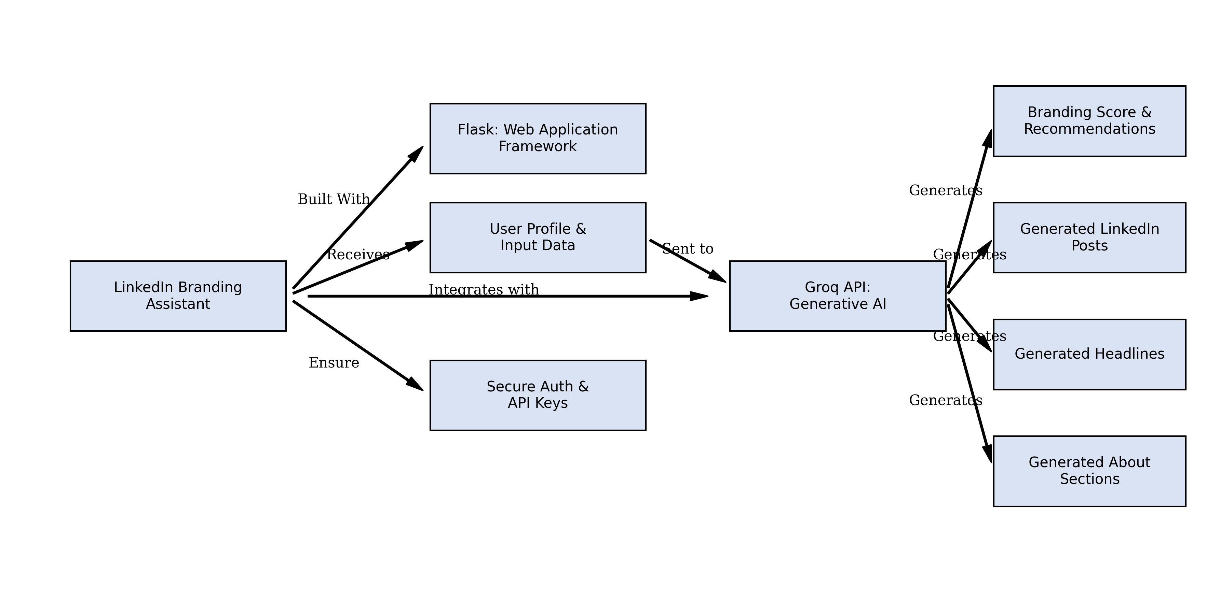

Pre-requisites:
- Flask Framework Knowledge: Flask Documentation
- Groq API Familiarity: Groq API Documentation
- HTML, CSS, and JavaScript Skills: W3Schools HTML/CSS/JavaScript Tutorials
- Python Programming Proficiency: Python Documentation
- Version Control with Git: Git Documentation

Project Workflow:
Milestone 1: Model Selection and Architecture
- Activity 1.1: Generate a Groq API key and configure it securely in the project environment.
- Activity 1.2: Research and select the appropriate generative AI model from Groq.
- Activity 1.3: Define the architecture of the application.
- Activity 1.4: Set up the development environment.
Milestone 2: Core Functionalities Development
- Activity 2.1: Develop the core functionalities: Profile Analyzer, Content Generators, and Branding Score.
- Activity 2.2: Implement the Flask backend to manage routing and user input.
Milestone 3: App.py Development
- Activity 3.1: Write the main application logic in app.py, establishing routes and AI integration.
Milestone 4: Frontend Development
- Activity 4.1: Design and develop the user interface using HTML, CSS, and JavaScript.
- Activity 4.2: Create dynamic JavaScript logic to handle API calls and display charts.
Milestone 5: Deployment
- Activity 5.1: Prepare the application for local deployment and configuration.
- Activity 5.2: Local Testing & Verification
Milestone 6: Conclusion

Milestone 1: Model Selection and Architecture
In this milestone, we lay the foundational groundwork for BrandBoost AI. This involves acquiring API keys, selecting the correct model, and ensuring the development environment is properly initialized for a robust Flask and MongoDB stack.
Activity 1.1: Generate a Groq API Key
To integrate Generative AI into our platform, we require access to Groq's high-performance LLM infrastructure. The Groq API provides lightning-fast inference for LPU (Language Processing Unit) acceleration.
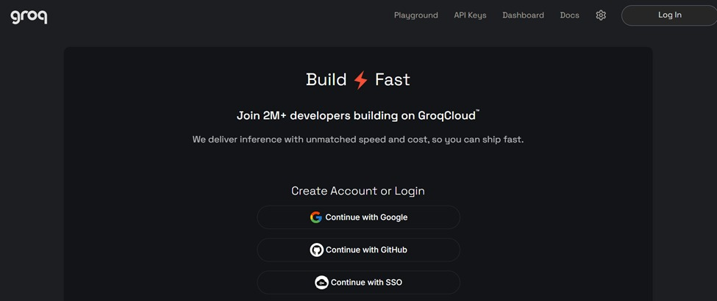
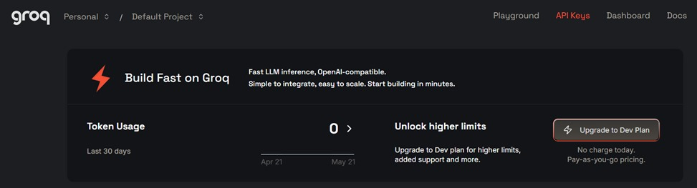
Activity 1.2: Research and Select the Appropriate Generative AI Model
After evaluating several models, we selected the LLaMA 3.3-70B Versatile model on Groq. This model offers an exceptional balance of speed, high parameter count (70 billion), and a large context window, making it perfect for ingesting entire LinkedIn resumes and outputting detailed JSON responses.
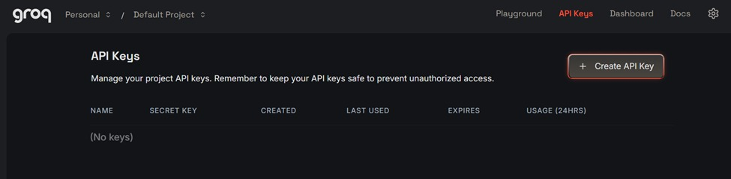
Activity 1.3: Define the Architecture of the Application
The architecture was designed following the MVC (Model-View-Controller) pattern, adapted for an API-first backend. The frontend acts as the View, built entirely independently using HTML, CSS, and JS. The Flask routes act as the Controller, handling requests, and communicating with the Groq API.
Activity 1.4: Set Up the Development Environment
We initialized the development environment by creating a Python virtual environment to isolate dependencies. We structured the folders into frontend, backend, routes, and models to ensure scalable development.
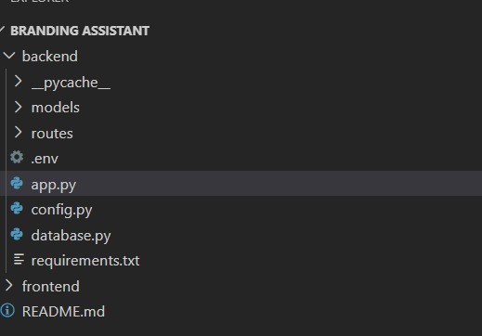

Milestone 2: Core Functionalities Development
In this milestone, we shift focus to the actual core features that make BrandBoost AI unique.
Activity 2.1: Develop Core Content Generation Features
The core features of the platform were built to address all aspects of personal branding. We developed specific modules for each requirement:
Dashboard module
The central hub where users log in to see their latest statistics. It ties into MongoDB to retrieve historical generation data, providing an overview of total posts and headlines created.
Profile Analyzer
This module takes raw profile inputs (skills, experience, about) and constructs a structured prompt. The AI returns a parsed JSON containing a comprehensive completeness score, professionalism score, and a recruiter visibility index.
About Generator
A specialized feature that uses the user's role and experiences to craft a compelling 'About' section narrative. It formats the output with appropriate spacing and emojis, ensuring the summary stands out to recruiters.
Headline Generator
This tool takes a target role and selected tone, querying the LLaMA model to generate 10 unique, high-converting headline variations. These range from standard professional titles to creative, value-driven hooks.
Branding Score
The ultimate metric aggregating the user's profile performance. The AI evaluates keyword optimization and content quality to output a final percentage score, guiding the user on whether their profile is fully optimized.
Activity 2.2: Implement the Flask Backend
The backend logic was segregated into dedicated Blueprints (routes/auth.py, routes/profile.py, routes/content.py). This separation of concerns ensures that the logic for profile analysis doesn't interfere with content generation.

Milestone 3: App.py Development
This milestone focuses on the core server configuration in app.py, setting up the foundation for handling HTTP requests, routing, and environment management.

Activity 3.1: Writing the Main Application Logic in app.py
Flask Initialization & Configuration
We initialize the Flask application using the factory pattern, which sets the static folder paths to allow serving the frontend HTML, CSS, and JS files seamlessly from the backend structure.
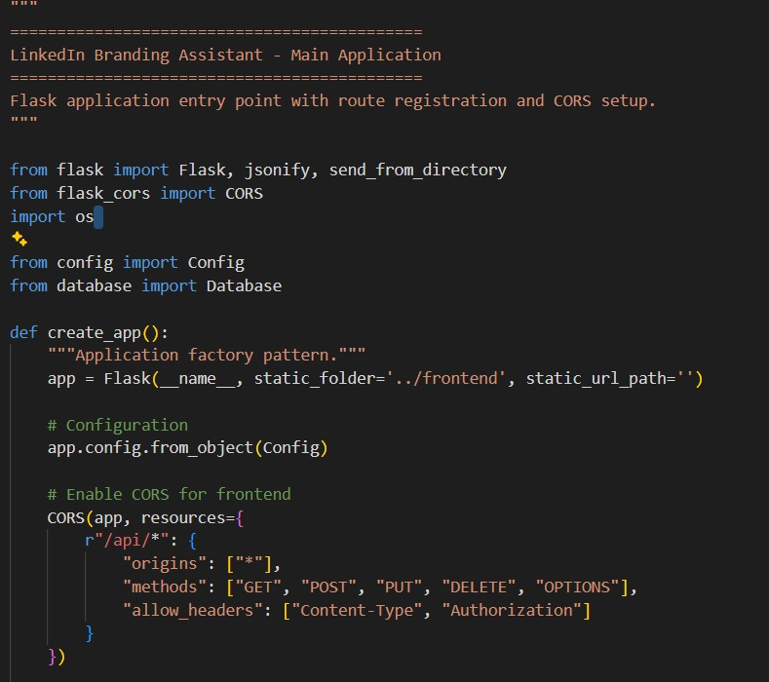

Database and CORS Setup
Cross-Origin Resource Sharing (CORS) is enabled to allow frontend scripts to communicate securely with the API routes. Simultaneously, the Database connection pool is initialized to ensure smooth access to MongoDB.
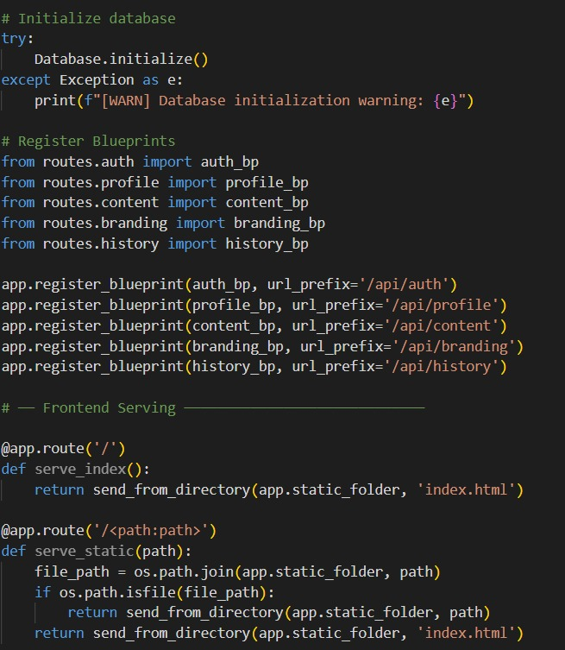
Blueprint Routing and Registration
To maintain a clean app.py, all endpoint logics are imported as modular Blueprints (auth_bp, profile_bp, content_bp, branding_bp). These are registered with their respective URL prefixes, structuring the API logically.
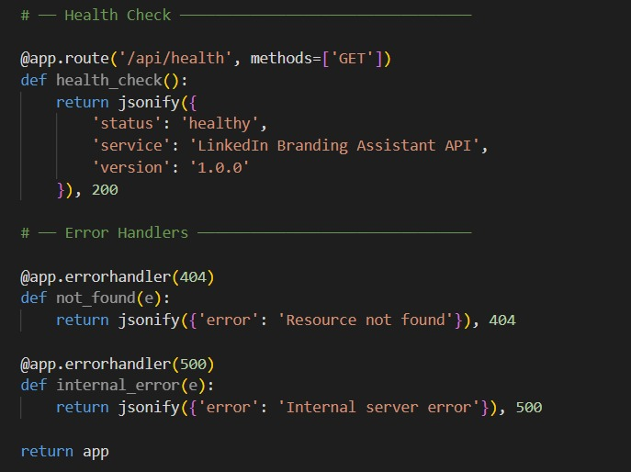
Static File Serving and Error Handling
Finally, custom routes are established to serve the root index.html and handle 404 and 500 errors gracefully by returning standardized JSON error messages instead of raw HTML crash pages.

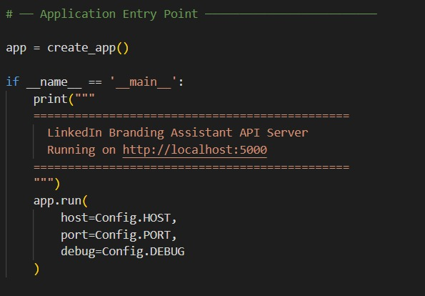

Milestone 4: Frontend Development
Milestone 4 focuses on developing a user-friendly and visually appealing interface for BrandBoost AI. This involves designing a modern, responsive layout with HTML and CSS to enhance usability, and creating dynamic content rendering with vanilla JavaScript to seamlessly display AI-generated posts, headlines, and profile scores based on user interactions.
Activity 4.1: Designing and Developing the User Interface
Set Up the Base HTML Structure:
1) Develop the main HTML files (index.html, dashboard.html, etc.) as the core interface, including headers with the BrandBoost AI brand logo, intuitive navigation sidebars, and dedicated input/results sections.
2)Use semantic HTML elements to keep the structure organized and ensure the interface is accessible for all users.
3)Integrate Font Awesome icons for platform indicators and specific generator tool headings, alongside Google Fonts (Inter) for clean, professional typography.
Design a Responsive Layout Using CSS:
1)Create a custom CSS stylesheet (css/style.css) implementing a premium aesthetic with subtle shadows and rounded components for visual depth.
2)Use Bootstrap 5 alongside flexbox and grid layouts to organize the results into responsive structures (e.g., side-by-side comparison for profile analysis or clean vertical lists for headlines).
3)Add media queries to ensure the dashboard layout and form inputs adapt perfectly across desktop, tablet, and mobile screen sizes.
Create Separate UI Components for Each Output Type:
1)Content Cards: Individual cards for each generated post or headline, equipped with one-click copy-to-clipboard functionality that provides visual feedback (green highlight on success).
2)Interactive Charts: Canvas elements utilized by Chart.js to render visually rich radar and bar graphs for the Branding Score analytics.
3)Data Tables: Displayed as clean, responsive tables within the History section to log past interactions, easily accessible for the user.
Activity 4.2: Creating Dynamic Content Rendering with JavaScript
Handle Form Submission Asynchronously:
1)Attach a submit event listener to the generator forms (such as the Post or About Generator) that prevents default form submission and sends the payload as a JSON POST request to the respective Flask API endpoints via the Fetch API.
2)During the AI processing phase, disable the submit button and show an animated loading spinner in place of the button text to inform the user of ongoing operations.
Render Results Dynamically:
1)Implement dynamic rendering functions in the JavaScript modules (e.g., ai.js) which construct DOM elements on-the-fly to display the returned JSON data—such as injecting the 10 headline variations directly into the DOM.
2)After rendering, automatically smooth-scroll the viewport to the newly generated results section using scrollIntoView().
Restore UI State After Generation:
In the finally block of the asynchronous fetch handler, re-enable the submit button and restore its original text and icon, ensuring the UI remains usable regardless of a successful generation or an API error.

Milestone 5: Deployment
This milestone ensures the application is ready to transition from a local development environment to an accessible platform.
Activity 5.1: Preparing the Application for Local Deployment
Set Up a Virtual Environment:
- Open a New Terminal
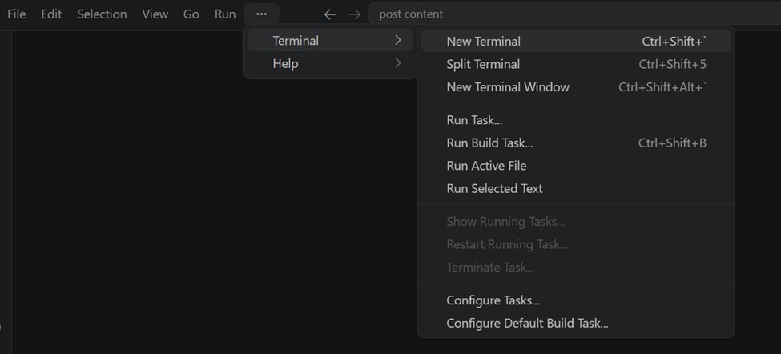
- Then open “Command Prompt”

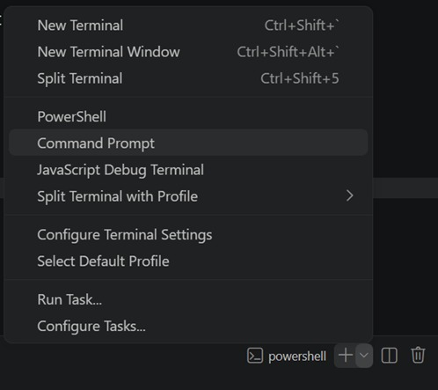
- Create and activate a virtual environment, then install all required dependencies from requirements.
D:\projects>python -m venv myenv
D:\projects>"d:\projects\venv\Scripts\activate"
(myenv) D:\projects>pip install -r requirements.txt

Configure Environment Variables:
- Create a .env file in the project root and add your Groq API key. The app loads this automatically using python-dotenv at startup:
GROQ_API_KEY=your_groq_api_key_here
Activity 5.2 : Local Testing & Deployment
Start the Flask Development Server:
- Run the application locally using:
(myenv) D:\projects>python app.py
- Once running, open a browser and navigate to “http://127.0.0.1:5050” to access the app.

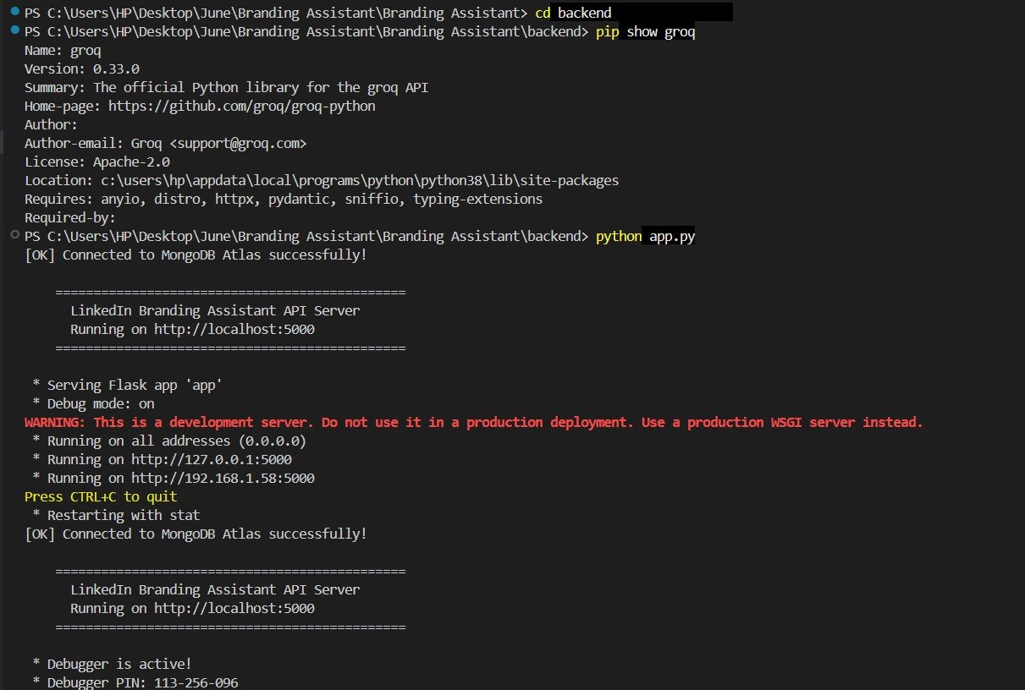
Exploring the Website’s Web Pages:
Home / Landing Page:
This clean, modern landing page serves as the entry point for BrandBoost AI, instantly conveying the platform's core value proposition to users. It features an intuitive navigation bar and a strong call-to-action button, encouraging professionals to start optimizing their LinkedIn presence immediately.
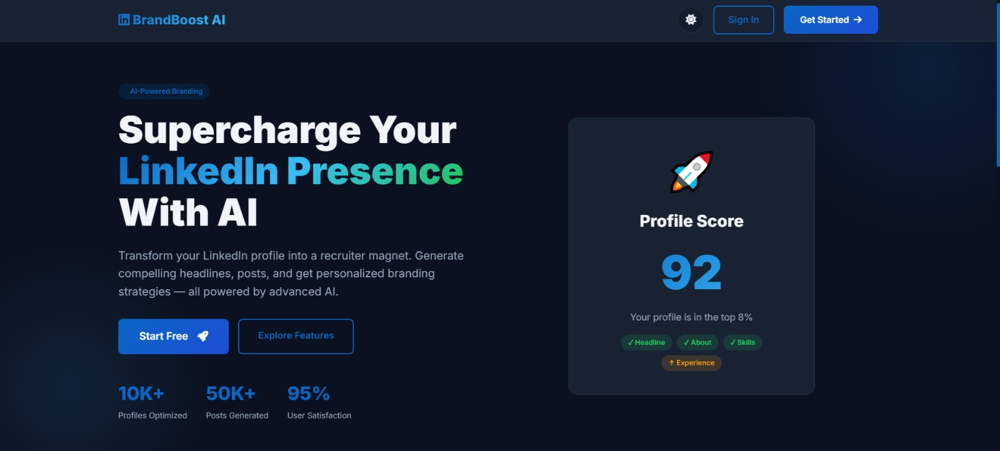
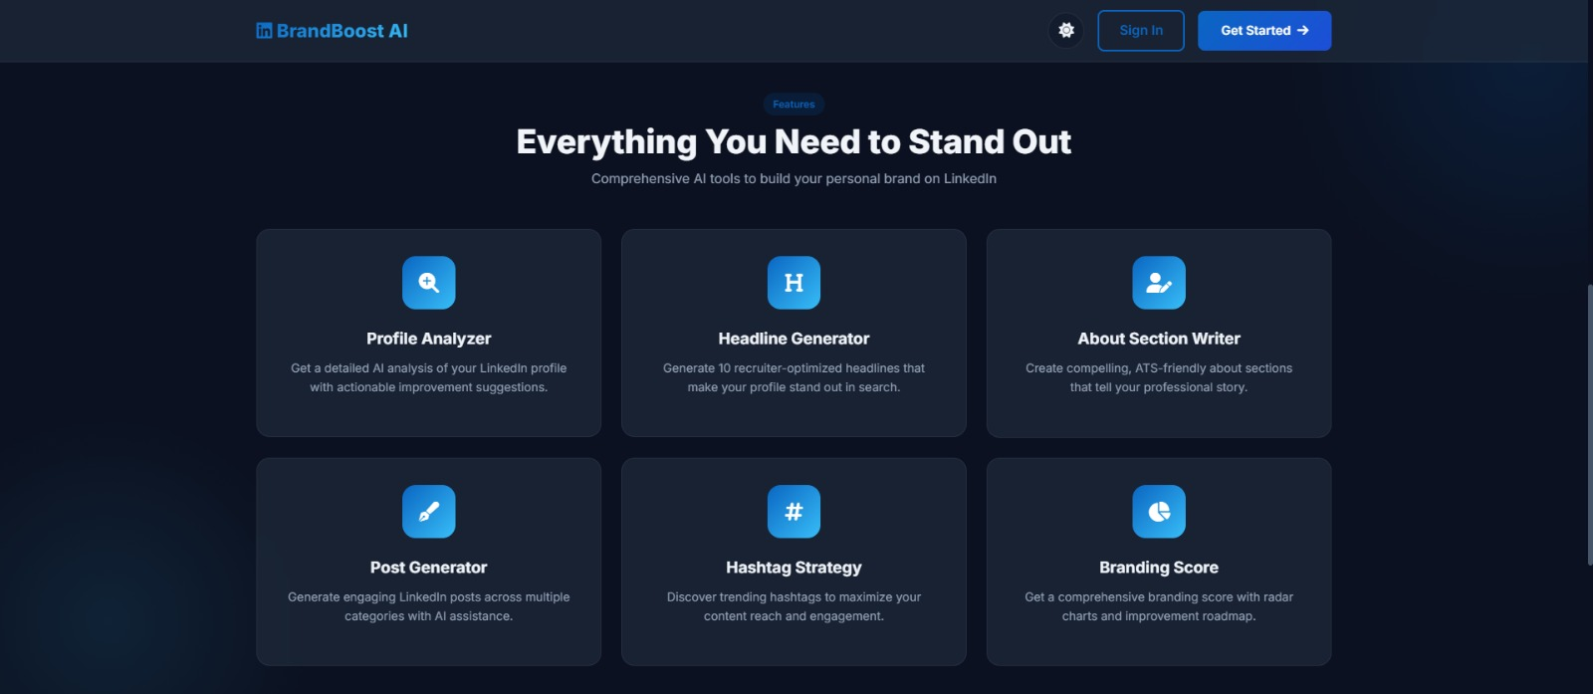
Authentication:
Input Section: Designed with security and simplicity in mind, the login page utilizes a centralized glassmorphism card for user authentication. It features real-time form validation and seamless integration with the backend to generate secure session tokens upon entry.
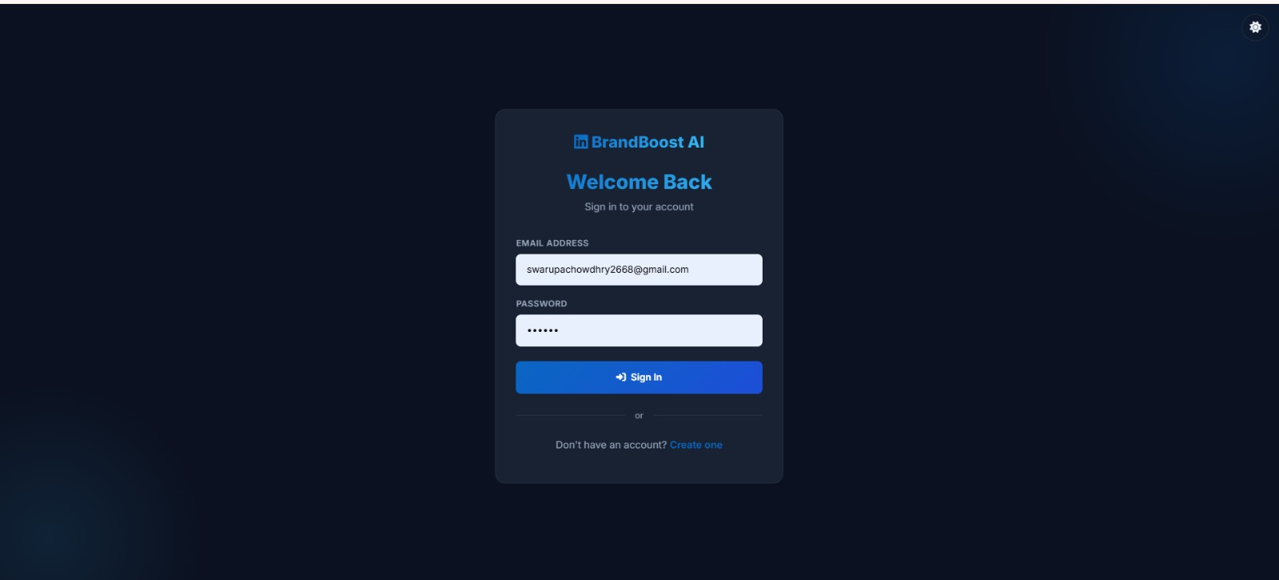
User Dashboard:
Results Section: The dashboard acts as the central command center, aggregating the user's most critical branding metrics into an easily digestible grid format. It features quick-access tiles to launch various generators and displays a high-level summary of recent AI interactions.
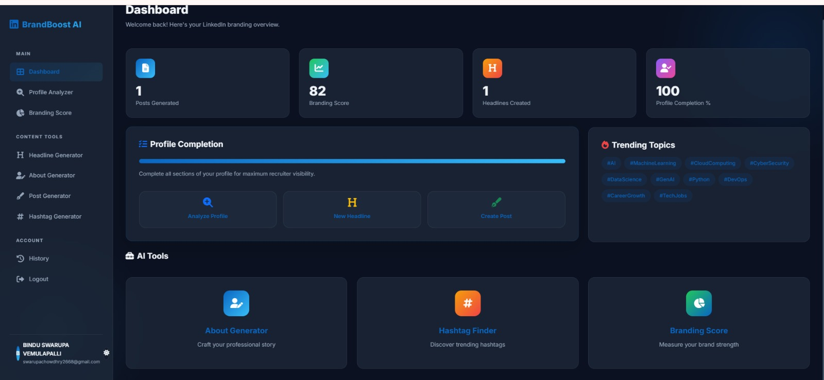
Profile Analyzer:
This interface allows users to input their current LinkedIn details to receive an instant, AI-driven critique of their profile's strength. The results dynamically highlight areas for improvement, providing actionable feedback tailored to increase recruiter visibility.
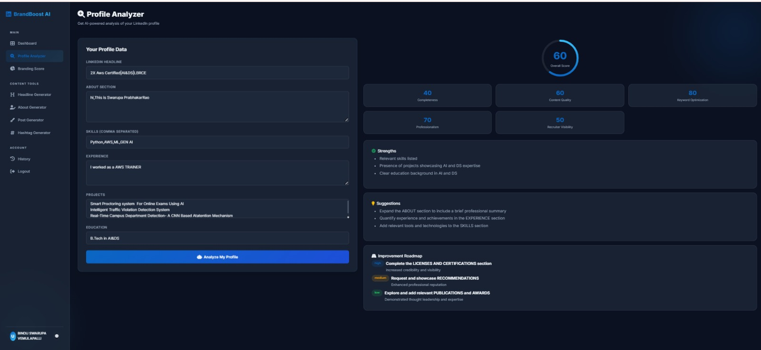
Content Generators (Headline & About):
Focused on first impressions, this tool prompts the user for their target role and preferred tone to generate 10 unique, high-converting headline variations. The output is displayed in clean, individual cards equipped with convenient one-click copy functionality.
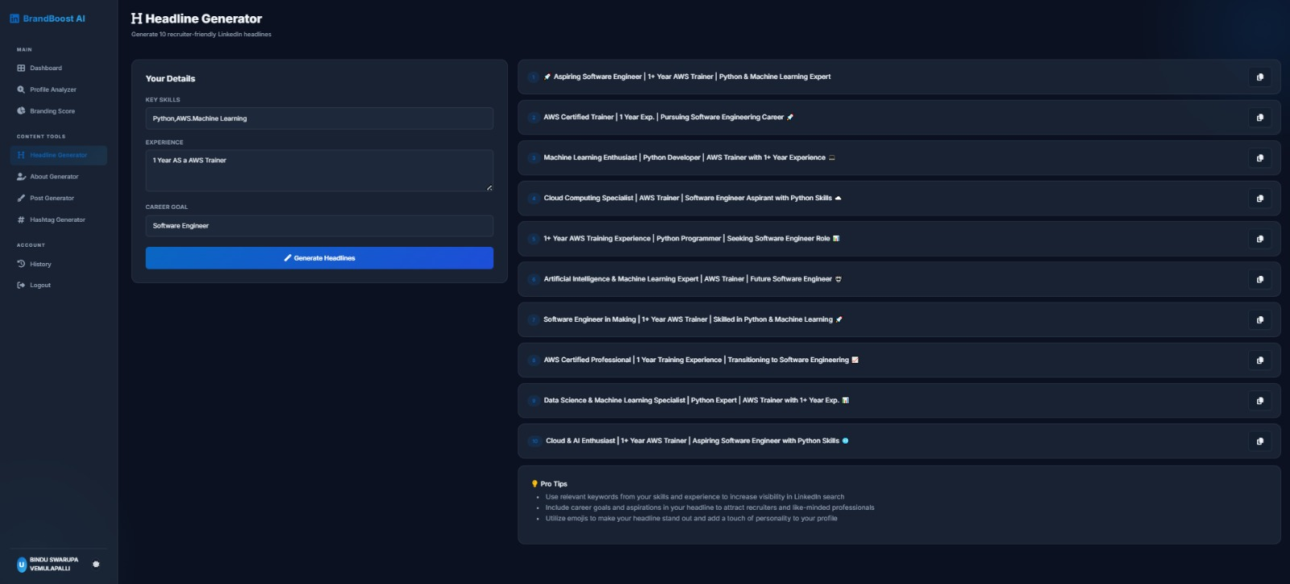

This feature takes raw bullet points of a user’s experience and seamlessly weaves them into a compelling, professional narrative. The resulting summary is beautifully formatted with strategic spacing and emojis to maximize engagement on LinkedIn.
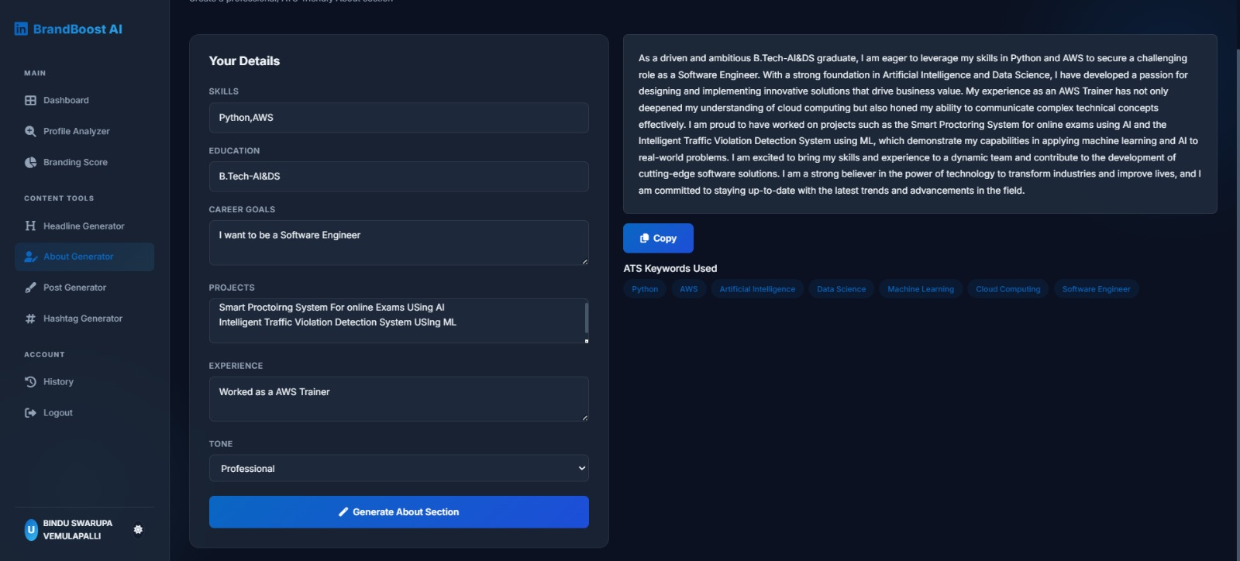
Post & Hashtag Generators:
Designed for users looking to maintain an active timeline, this page allows users to specify a topic and tone to draft a complete LinkedIn post. The AI instantly generates a fully structured post containing an engaging hook, informative body, and a clear call to action
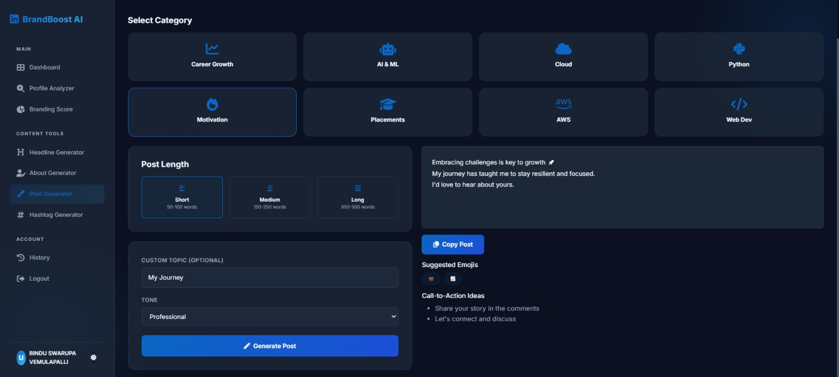

A perfect companion tool for content creators, this generator analyzes a specific topic to produce a highly targeted list of hashtags. It outputs a mix of broad and niche tags designed to drastically expand the reach of the user's LinkedIn posts.
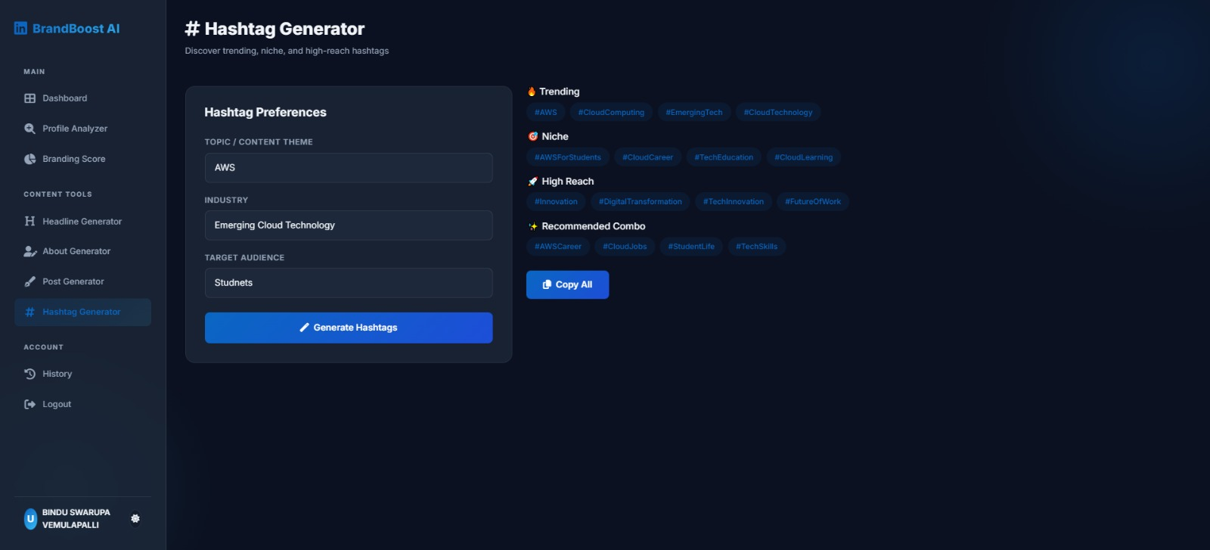
Branding Score & History:
This page visually represents the user's overall profile strength using dynamic Chart.js radar and bar graphs. It gamifies the optimization process by breaking down the score into specific metrics like keyword optimization, completeness, and professionalism.
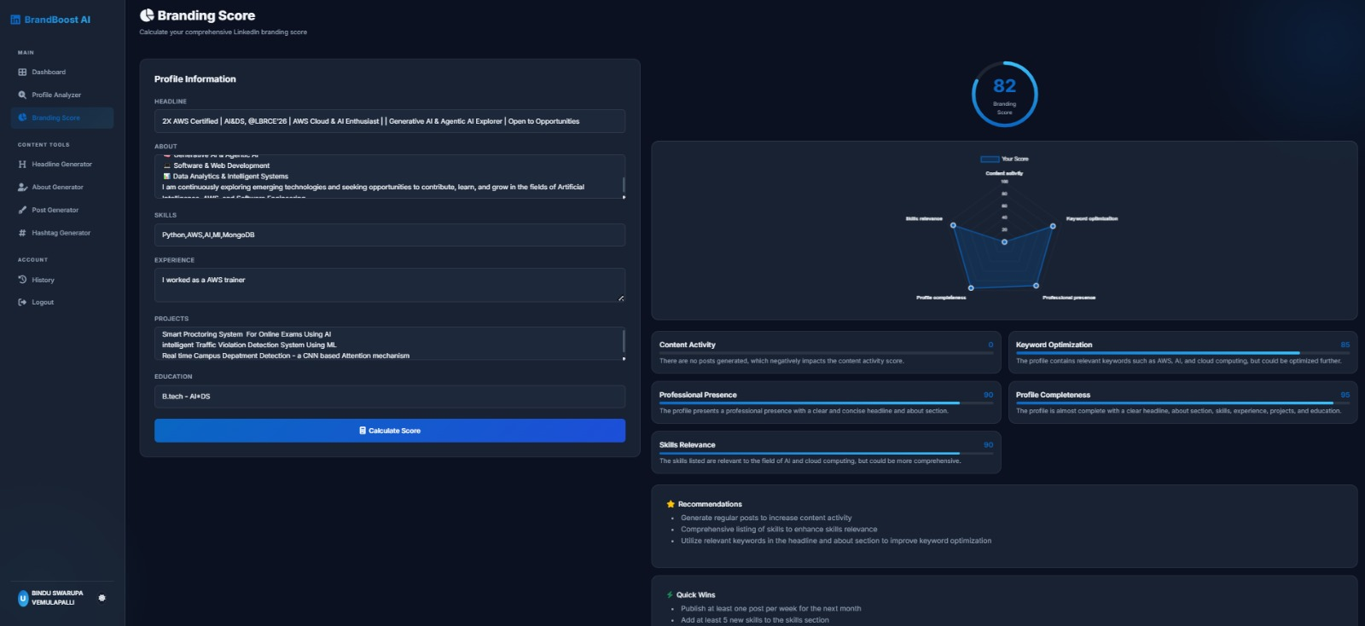
]The place where the User History stores
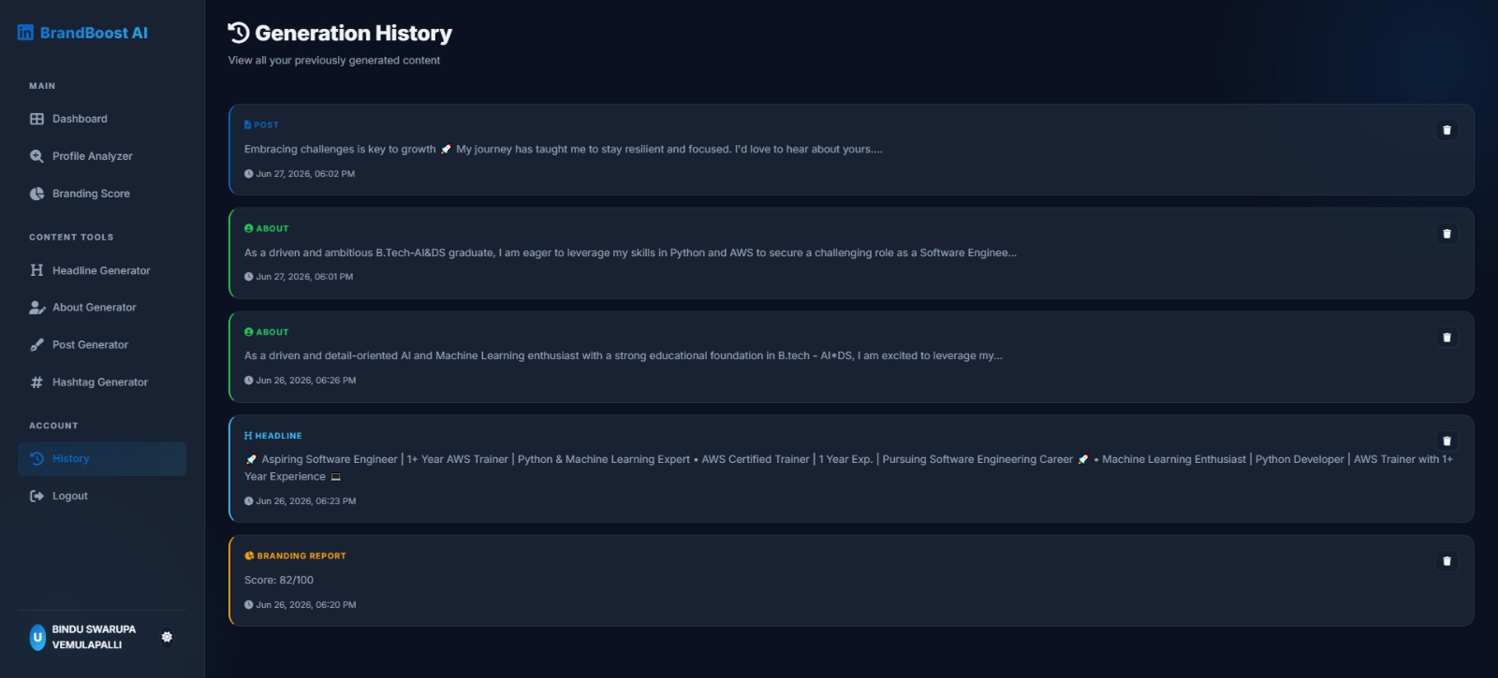

Milestone 6: Conclusion
The BrandBoost AI project successfully demonstrates the immense potential of integrating state-of-the-art Generative AI into practical, everyday web applications. By leveraging Groq’s high-speed inference alongside the LLaMA 3.3-70B model, the platform delivers near-instantaneous content generation without the typical latency bottlenecks. The implementation of a modular architecture—separating the robust Flask and MongoDB backend from the dynamic JavaScript frontend—ensures the system remains highly scalable. Users are empowered with a comprehensive suite of tools, seamlessly allowing them to optimize their LinkedIn headlines, craft compelling summaries, and generate engaging posts in seconds. The intuitive glassmorphism UI design, coupled with real-time visual feedback and secure JWT authentication, provides a premium experience tailored for modern professionals. Features like the dynamic Branding Score successfully gamify the optimization process, turning the often daunting task of personal branding into an engaging and highly actionable journey. Furthermore, the persistent database architecture ensures that users can effortlessly track their optimization progress over time and retrieve historical generations from their dashboard. Ultimately, BrandBoost AI stands as a production-ready solution that drastically simplifies digital networking and empowers individuals to confidently elevate their professional presence.

