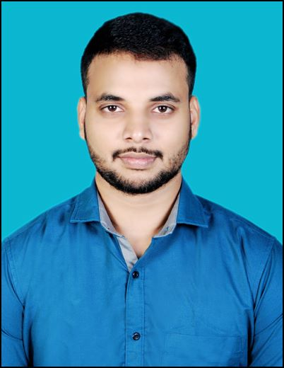BINESH MAHARANA

Mobile No.: +91- 8456982334

Email Id: binesh.maharana.mca.2022@nist.edu

Address: Jagannath Panda Buildings, Narayani Colony, Purusottampur, 761018, Ganjam, Odisha, India.

Languages: English, Hindi, Odia

Portfolio <https://12ivkp63kzsebaglt4r6cg.on.drv.tw/portfolio/>

LinkedIn: https://[www.linkedin.com/in/binesh-maharana-06815b253/](http://www.linkedin.com/in/binesh-maharana-06815b253/)

# CAREER OBJECTIVE

To secure an integral position in a reputable organization to expand my learnings, knowledge, and skills while making a significant contribution to the success of the company.

# ACADEMIC QUALIFICATIONS

|  |  |  |  |  |
| --- | --- | --- | --- | --- |
| **S.N.** | **DEGREE / DIPLOMA** | **BOARD / UNIVERSITY / INSTITUTE** | **PERCENTAGE**  **/CGPA**  **DIVISION** | **YEAR OF PASSING.** |
| **1** | MCA(Master in computer application) | BPUT/ NIST Institute of Science & Technology (Autonomous) | 7.90 | 2024 |
| **2** | BCA(Bachelor of Computer Application) | Berhampur/ Science Collage (AUTONOMOUS), Hinjilicut, Odisha | 8.69 | 2022 |
| **3** | Intermediate | CHSE/Tara Tarini College, Purusottampur, Ganjam, Odisha | 51% | 2019 |
| **4** | Matriculation | BSE/Sri Jhadeswar High School, Danapur, Ganjam, Odisha | 69% | 2017 |

**TECHNICAL SKILLS**

* **Programming Languages**: C programming, SQL, Core JAVA, Web Development.
* **Microsoft Office**: Excel, Word, PowerPoint, Access.
* **OS**: Windows, Linux

# SOFT SKILLS

* Team Player, Punctual, and Adaptable.

# CERTIFICATIONS

* Introduction to Object-Oriented Programming with Java Certification Course from LearnQuest. (Coursera)
* SQL for Data Science course from UCDAVIS (Coursera)