Introduce

Water source means a lot to all life on this planet, so do we human. However, about 85% people is living in the driest half of the planet. 783 million people cannot access the clean water and 2.5 billion people is suffering the inadequate sanitation problem now. Moreover, by 2025, around 60% population on earth may encounter water scarcity and if we still remain the same fresh water consumption rate, 90% of the fresh in the world will be run out in the next 15 years. These problems are all imminent which need the batter solutions.
There is no doubt there are many water treatment technologies, such as activated sludge plants (ASPs), trickling filter, rotating biological contactors to server the water reclamation and recycling purpose. These conventional technologies, however, have existed for half a century and needs to update / or be replaced in the future to encounter a more severe water quality requirement.
In the past 20 years. A new water treatment technology called moving bed biofilm reactor (MBBR) has been establish and develop well. It not only shows a higher removal efficiency but also relies single and is easy to maintain. MBBR is developing a promising alternative technology for wastewater treatment. According to the research, about 1200 wastewater treatments (WWTPs) has been applied with MBBR over 50 countries in the past decade. This review of MBBR includes its function and evaluation, in additional, a case study will discussion to illustrate how it applied in reality and modification in the future.

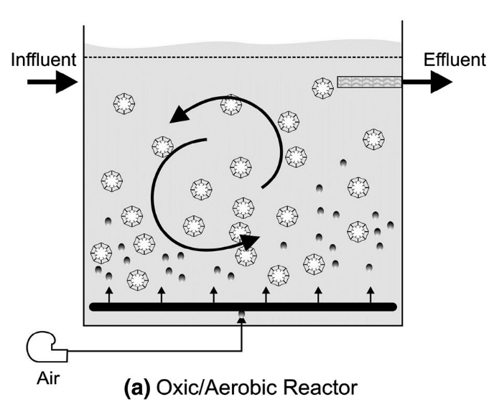
Mechanics
Generally, the principle of the MBBR is not very complicated. The reactor is like continuous stirred tank reactor (CSTR). The flow rate of influent and effluent remain the same to reach the latest retention time. In addition, the process of most MBBRs is aerobic. The air is pumped into the reactor via pipes to support the microorganisms community growth and degrade the target chemical or biochemical concentration in the reactor. The air servers two purposes in this reactor. It not only provide energy for microorganisms but also allows the reactor mix well. As can be seen in the fig (a), there are many biocarriers in the reactor. These biocarriers are the most important part of the wastewater treatment process. Because it provide a surface to support the different microorganisms living on the surface to form communities, called biofilm.

There are different types and sizes of the biocarriers mentioned above, made up of high density polyethylene (HDPE), polypropylene(PP) or polyethylene (PE) with a specific materials whose density is lower than one of the water, around 0.95 g/cm3. In this way, the buoyancy of the biocarriers is lager than water so these biocarriers can move freely by the air flow driven in the reactor. According to this biocarriers design, the contact surface will increase, compared to the conventional wastewater treatment microbial process, which provide a enough contact surface for microorganisms thriving.
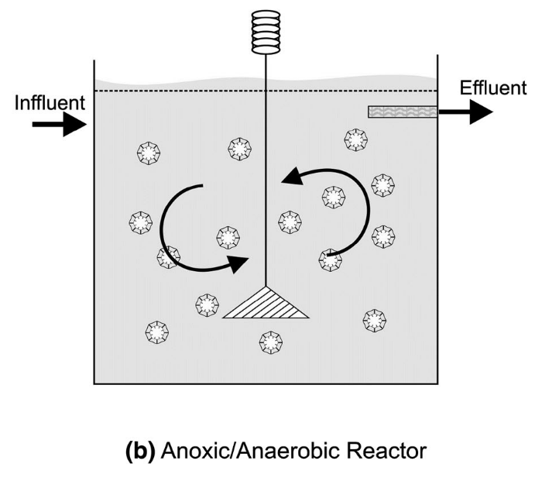
In the other situation, MBBRs can be applied in a anoxic/ Anaerobic environment. Because oxygen is toxic to some specific microorganisms. Those microorganisms are benefit for advanced processes, such as denitrification, sulfate reduction and phosphates removal. However, the application number of aerobic reactor is much higher than one of anoxic and the more related researches are needed for anoxic process in MBBRs as well.

There are some factors affecting the MBBRs performance. (1) percent of reactor volume comprised of media, according to Odegarrd 1999, the percentage from 60 to 75% is preferred, benefiting the removal efficiency. The removal efficiency will decrease with percent increase. The efficiency shows various in the different process. For example, when percent is 35%, the efficiency of COD removal is larger than the percentage of 66%. On the other hand, 66% volume comprised of media presents a higher efficiency in denitrification. Secondly, specific area of carrier media is also a significant factor to BMMRs performance. Outer of the biocarriers has less microorganisms concentrations due to the biofilm detachment. In general, 70% of biocarrier total area is active microorganisms community. The concentration of biomass is 3000 - 4000 g TSS m-3, which is close to the one in the sludge with an higher age. Thirdly, presence of dissolved oxygen and flow conduction affect the performance, respectively. According the researches, 2m/L dissolved oxygen is required to assure the microbial activity. The range of DO do have a great influence on removal efficiency. For example, the efficiency of COD removal decline about 13% with the 2g/L decrease to 1g/L of DO. In the same way, COD removal efficiency increase about 5.8% with an increase 4 mg/L of DO. In addition, flow condition should not be ignored. Adequate turbulence is ideal for reactor mixing and biofilm attachment. Thick and fluffy biofilm is not recommend due to detachment easily and < 100$μm$ thickness is preferred. Unfortunately, detachment machines is unknown, especially, the process from the inter-phase to liquid. In addition, grazing, slogging, erosion and abrasion can effect the attachment process greatly.(Characklis 1990)

Evaluation

Firstly, A higher removal efficiency and lower capital. Compared to the other conventional waster water technologies, MBBR shows. Secondly, MBBR can encounter a higher water quality requirement. For example, it is capable to remove up to 90 chemical oxygen demand and 95% biochemical oxygen demand with nutrient from the effluent. In my opinion, this benefit is the most important. As we known, many conventional conventional WWTPs has existed for a long time, it can be time consuming and cost for updating or being replaced by a new technology. Therefore, like MBBR with lower capital maintenance is more likely to be considered. It can fit different types of wastewater treatment, in the other word. It’s applicable to wide range wastewater flow from 10000 m3/d to 150000 m3/d. On the other hand, it not only can be applied in the industrial wastewater treatment system but also for municipal systems. Compared to other WWTPs system, it is single reliable and has a robust operation procedure.

Secondly, Tolerant of high pH range and temperature. There are thousands of biocarriers suspend in the reactor and different types microorganisms communities existed in these biocarriers. In some degree, each biocarriers represent various microorganisms proportion due to competitive process. Therefore, the thousands of biocarriers can provider enough contact surface for microorganisms to grow and digestion. On the other hand, the diversity of this ecosystem is more complicated so that it can recovery quicker when it lose one or more microorganisms species. Therefore, compared to the other conventional WWTPs, it is more tolerant in the high range of pH and temperature. Lastly, the life-span of the biocarriers are relatively longer. Usually, the life of those can reach from 10 to 30 years, which means it does not need to replacement or replenishment in a short term.

However, nothing is perfect. MBBR still have some disadvantages. Firstly, excessive anaerobic digestion microorganisms may lead to the sulfate emission, but there are few researches to support this point and more detailed researches need to to done in the future. Secondly, MBBRs, although, has been applied well in both municipal and industrial wastewater treatment system, there still are high demand for fresh water treatment reuse. What if MBBRs can improve the dinking water system quality with some modification in the future? More relative researches should be invested.

Example

As mentioned before, biofilm process plays a role in the whole MBBRs performance. Therefore, the case study is about the performance effected by the different materials of biocarriers. According to the Bolton 2006, fourteen materials has been tested to optimize the biofilm process and the removal efficiency.

Working on this part

Conclusion and Discussion

Through this review, the MBBRs proof its potential to the WWSPs. This technology can work efficiently with varying scales of treatment platforms. According to the case study, there are many factors can be affect the performance of MBBRs. There is no doubt that human is facing the more severe problem that higher demand of fresh water. MBBRs is a promising alternative wastewater treatment due to its convenience of operation and removal efficiency. However, there are some modification can be done in the further, helping MBBRs solve more environment problems. Biofilm kinetics model in the MBBRs process is not illustrated clear, specifically for the denitrification process in the different reactors. On the other hand, the materials of the biocarriers chosen, is the very interested topic in the future. As we can seen from the case study and the mechanics of the MBBRs mentioned above, the shape and materials of biocarriers is playing a role in biofilm process. It can affect in both suspend and attached process. Moreover, the life-span and land saving will be the biggest problems, limiting many companies update / or replace the old waste water treatment system. Therefore, the researches of materials is necessary and promising.

Reference
[]UN Water World Water Day (2013) Water cooperation: facts and figures—an increasing demand. www.unwater.org/ water-coorperation-2013/water-coorporation/facts-andfigures/Vaidhegi
[] Judd S (2006) The MBR book: principles and applications of membrane bioreactors in water and wastewater treatment. Elsevier Ltd., Oxford
[] Ødegaard H, Rusten B, Siljudalen J (1998) The development of the Moving Bed Biofilm Process—From Idea to Commercial Product, Proceedings of WEC/EWPCA/ IWEM Speciality Conference, Innovations 2000, Cam- bridge, UK
[] Kraume M, Drews A (2010) Membrane bioreactors in waste water treatment—status and trends. Chem Eng Technol 33(8):1251–1259
[] Biswas, K., Taylor, M. W., & Turner, S. J. (2014). Successional development of biofilms in moving bed biofilm reactor (MBBR) systems treating municipal wastewater. Applied microbiology and biotechnology, 98(3), 1429-1440.
[] Luo, Y., Jiang, Q., Ngo, H. H., Nghiem, L. D., Hai, F. I., Price, W. E., ... & Guo, W. (2015). Evaluation of micropollutant removal and fouling reduction in a hybrid moving bed biofilm reactor–membrane bioreactor system. Bioresource technology, 191, 355-359.
[] Bolton, J., Tummala, A., Kapadia, C., Dandamudi, M., & Belovich, J. M. (2006). Procedure to quantify biofilm activity on carriers used in wastewater treatment systems. Journal of Environmental Engineering, 132(11), 1422-1430.
[] Barwal, A., & Chaudhary, R. (2014). To study the performance of biocarriers in moving bed biofilm reactor (MBBR) technology and kinetics of biofilm for retrofitting the existing aerobic treatment systems: a review. Reviews in Environmental Science and Bio/Technology, 13(3), 285-299.
[] Jenkins, A. M., & Sanders, D. (2012). Introduction to fixed-film bio-reactors for decentralized wastewater treatment. Contech, Engineered Solutions.
[] Ødegaard H (1999a) The moving bed biofilm reactor. In: Igar- ashi T, Watanabe Y, Tambo N (eds) Water environmental engineering and reuse of water. Hokkaido Press, Sapporo, pp 250–305
[] Rev Environ Sci Biotechnol (2014) 13:285–299
Orantes JC, Gonzalez-Martinez S (2003) A new low-cost bio- film carrier for the treatment of municipal wastewater in a moving bed reactor. Water Sci Technol 48(11/12):243–250
[] Wang XJ, Xia SQ, Chen L, Zhao JF, Renault NJ, Chovelon JM (2006) Nutrients removal from municipal wastewater by chemical precipitation in a moving bed biofilm reactor. Process Biochem 41:824–828
Weiss
[] Characklis WG (1990) Biofilm processes. In: Characklis WG, Marshall KC (eds) Biofilms. Wiley, New York
Das
[] Ødegaard H, Rusten B, Westrum T (1994) A new moving bed biofilm reactor-applications and results. Water Sci Technol 29(10/11):157–165

