Review of Moving Bed Biofilm Reactor
Shengbin Jia
Shj66@pitt.ediu

Introduce
Availability to clean water is increasingly important in todays society. However, about 85% people are living in the driest half of the planet. 783 million people cannot access the clean water and 2.5 billion people are suffering from the inadequate sanitary conditions (UN Water World Water Day 2013). Moreover, by 2025, around 60% population on earth may encounter water scarcity and if we still consume fresh water at the same rate (Judd 2006). 90% of the fresh water in the world will be gone in the next 15 years. These problems are all imminent and need the better solutions. (Kraume and Drews 2010)
There is no doubt there are many water treatment technologies, such as activated sludge plants (ASPs), trickling filter, rotating biological contactors, which can server the water reclamation and recycling purposes. (Barwal 2014) These conventional technologies, however, needs to be updated or be replaced in the future if more stringent water quality regulations are enacted.
In the past 20 years. A new water treatment technology called moving bed biofilm reactor (MBBR) has been establish and develop well. It not only shows a higher removal efficiency but also relies single and is easy to maintain. MBBR is developing a promising alternative technology for wastewater treatment. According to the research, about 1200 wastewater treatments (WWTPs) has been applied with MBBR over 50 countries in the past decade. This review of MBBR includes its function and evaluation, in addition, a case study will be discussed to illustrate how MBBR technology can be applied and modified in the future

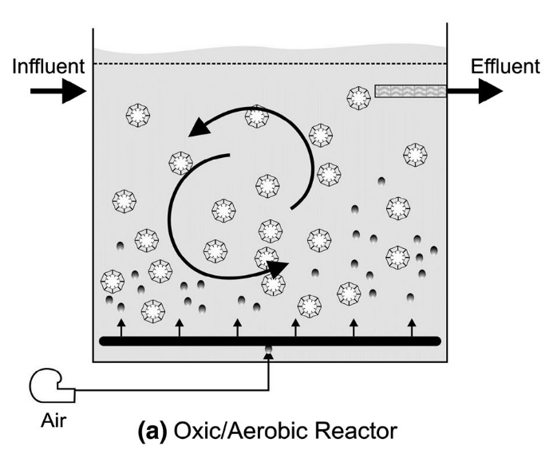
Mechanics
Generally, the principle of the MBBR is not very complicated. The reactor is like a continuous stirred tank reactor (CSTR). The flow rate of influent and effluent remain the same. In addition, the process of most MBBRs is aerobic. The air is pumped into the reactor via pipes to support the microorganisms community growth and degrade the target chemical or biochemical concentration in the reactor. The air servers two purposes in this reactor. It not only provides energy for microorganisms but also allows the reactor mix well. As can be seen in the fig (a), there are many biocarriers in the reactor. These biocarriers are the most important part of the wastewater treatment process. Because it provides a surface to support the different microorganisms living on the surface to form communities, called a biofilm.
(Barwal 2014)

There are different types and sizes of the biocarriers mentioned above. They are made up of high density polyethylene (HDPE), polypropylene(PP) or polyethylene (PE) with a specific materials whose density is lower than one of the water, around 0.95 g/cm3. (Ødegaard H 1999a) In this way, the density of the biocarriers is smaller than water so these biocarriers can move freely by the air flow driven in the reactor. Based on this biocarriers design, the contact surface will increase, compared to the conventional wastewater treatment microbial process, which provide a enough contact surface for microorganisms thriving.

(Barwal 2014)

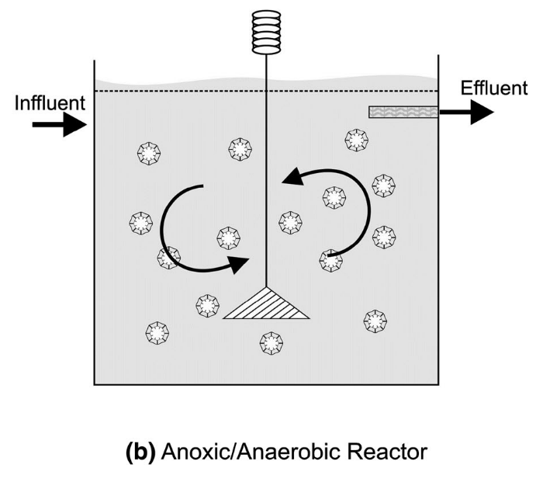
In the another situation, MBBRs can be applied in a anoxic / Anaerobic environment. Because oxygen is toxic to some specific microorganisms. Those microorganisms are benefit for advanced processes, such as denitrification, sulfate reduction and phosphates removal. (Ødegaard H 1998) However, the application number of aerobic reactor is much higher than one of anoxic and the more related researches is needed for anoxic process in MBBRs to be fully understood.
There are some factors affecting the MBBRs performance. percent of reactor volume comprised of media, according to the research of Odegarrd, the percentage from 60 to 75% is preferred, benefiting the removal efficiency (Ødegaard H 1999a). The removal efficiency will decrease with percent increase. The efficiency shows various in the different process. For example, when percent is 35% (percent of reactor volume comprised of media), the efficiency of Chemical oxygen demand (COD) removal is larger than the percentage of 66%. On the other hand, 66% volume comprised of media presents a higher efficiency in denitrification (Trapani et al. 2008). Secondly, specific area of carrier media is also a significant factor to BMMRs performance. The outer of the biocarriers has less microorganisms concentrations due to the biofilm detachment. In general, 70% of biocarrier total area is active microorganisms community. The concentration of biomass is 3000 - 4000 g TSS m-3 (Ødegaard H 1994), which is close to levels in activated sludge with a higher age. Thirdly, presence of dissolved oxygen and flow conduction affect the performance, respectively. According the researches, 2m/L dissolved oxygen is required to assure the microbial activity (Wang et al 2006). The range of dissolved oxygen (DO) do have a great influence on removal efficiency. For example, the efficiency of COD removal decline about 13% with the 2g/L decrease to 1g/L of DO. In the same way, COD removal efficiency increase about 5.8% with an increase of 4 mg/L of DO (Wang et al 2006). In addition, flow condition should not be ignored. Adequate turbulence is ideal for reactor mixing and biofilm attachment. Thick and fluffy biofilm is not recommended due to detachment easily and < 100$μm$ thickness is preferred (Ødegaard H 2001). Unfortunately, detachment machines are unknown, especially, the process from the inter-phase to liquid. In addition, grazing, slogging, erosion and abrasion can effect the attachment process greatly.(Characklis 1990)

Evaluation

Firstly, MBBRs provide a higher removal efficiency and lower capital. Compared to the other conventional waster water technologies. Secondly, MBBR can provide a higher water quality requirement. For example, it is capable to remove up to 90 chemical oxygen demand and 95% biochemical oxygen demand from the effluent. In my opinion, this benefit is the most important. As we known, many conventional conventional WWTPs have existed for a long time, and it can be time consuming and costs to update or replace by a new technology. Therefore, a process like MBBRs with lower capital maintenance is more likely to be considered. It can fit different types of wastewater treatment, in the other word. It’s applicable to wide range wastewater flow from 10000 m3/d to 150000 m3/d. On the other hand, it not only can be applied in the industrial wastewater treatment system but also for municipal systems. Compared to other WWTPs system, it is standalone and has a robust operation procedure.
Secondly, MBBRs are tolerant of high pH range and temperature (Jenkins, A. M., & Sanders, D. 2012). There are thousands of biocarriers suspend in the reactor and different types microorganisms communities existed in these biocarriers. In some degree, each biocarriers represent various microorganisms proportion due to competitive process. Therefore, the thousands of biocarriers can provider enough contact surface for microorganisms to grow and digestion. On the other hand, the diversity of this ecosystem is more complicated so that it can recovery quicker when it lose one or more microorganisms species. Therefore, compared to the other conventional WWTPs, it is more tolerant in the high range of pH and temperature. Lastly, the life-span of the biocarriers are relatively longer. Usually, the life of those can reach from 10 to 30 years (Ødegaard H 1999a), which means it does not need to replacement or replenishment in a short term.
However, nothing is perfect. MBBR still have some disadvantages. Firstly, excessive anaerobic digestion microorganisms may lead to the sulfate emission (Orantes et al. 2003), but there are few researches to support this point and more detailed researches need to to done in the future. Secondly, MBBRs have been applied well in both municipal and industrial wastewater treatment systems (Biswas et al 2014), but there still are high demand for fresh water treatment reuse. What if MBBRs can improve the dinking water system quality with some modification in the future? More relative researches should be invested.

Example

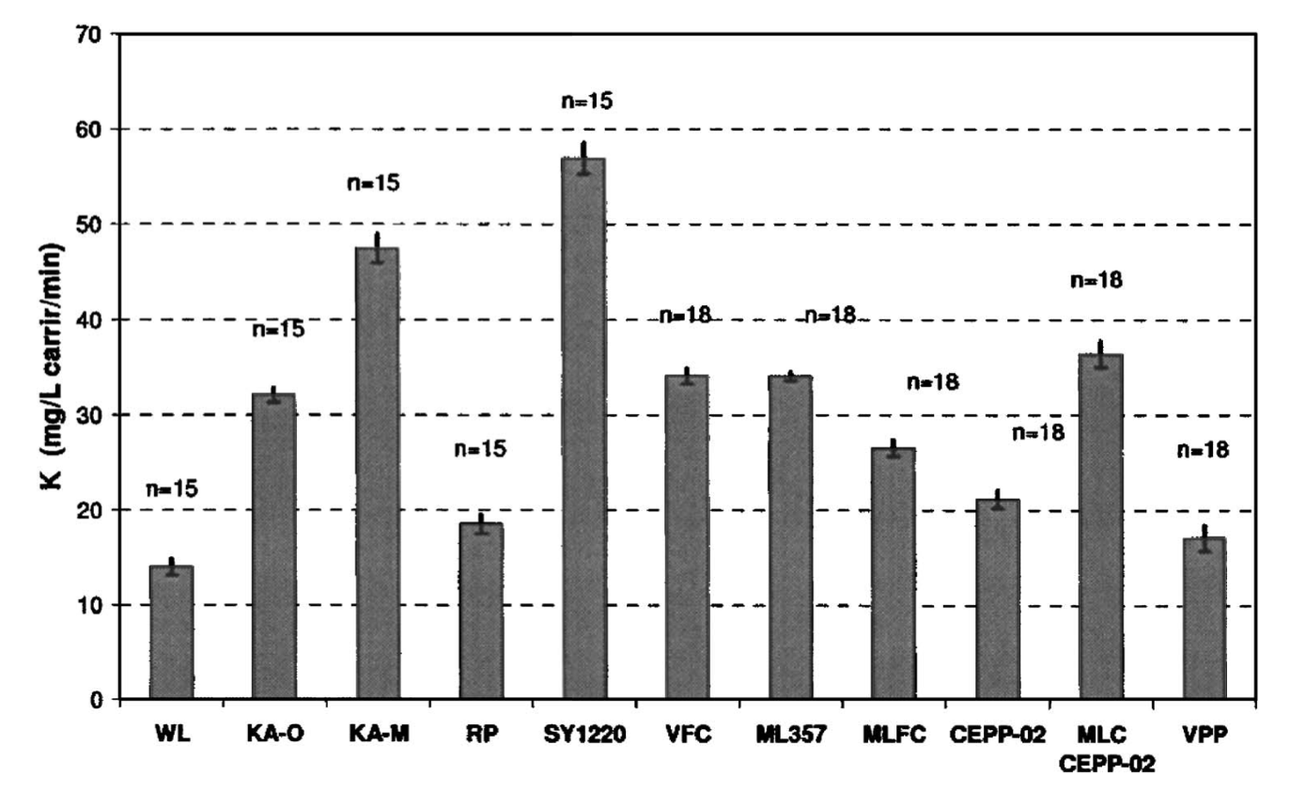
As mentioned before, biofilm process plays a role in the whole MBBRs performance. The physical properties of the surface, such as surface roughness, specific area, surface charge and pore size, impact the biofilm process will be the most important factor, affecting the result of the removal efficiency. Therefore, this case study is about the performance effected by the different materials of biocarriers chosen. According to the Bolton 2006, fourteen materials has been tested to optimize the biofilm process and the removal efficiency.
At the first, this team calculates and evaluates the biofilm attachment rate in terms of glucose use rate with different fourteen materials. These materials can be accessed from commercial to novel experimental materials. They found that the MBBRs remove efficiency depends strongly on surface roughness and specific, which are the top two most important factors. As we can seen in the fig c. The most roughness materials (SY 1220 ) shows the highest glucose consumption rate due to more pores in the biocarriers provide more surface area for microbial communities. On the other hand, the specific area is significant for biofilm as well. 30 psia (Pound/square inch) corresponds to the cumulative area of all pores are greater than 6.5$μm$, 100 psia corresponds to the cumulative area of all pores are greater than 1.75$μm$ and 180 psia are greater than 1$μm$. Aa a result, the
glucose consumption rate cross these
(Bolton 2006)
three different specific area are 0.64, 0.72 and 0.91 mg/m2/min, respectively ( Bolto 2006). Therefore, the distance between the pores do play a role on the consumption rate as well.
However, this team also states some shortages about this research, and these problems may be encountered in the other situations. Firstly, oscillation of glucose rate has been observed. In terms of that, they inferred that oxygen limitation existed during complicated microbial metabolism. Insufficient oxygen is likely to slow the microbial activity and cause microorganisms death in this like “anaerobic” environment. However, the amount of microorganisms rebounds with the level of competitive decline. Therefore, the dynamic model is needed in the future. On the other hand, this experiment only use the glucose as a sole carbon and energy source. As we known, the condition in the wastewater treatment is so much complicated, containing many kinds of substrates. In some degree, the relationship between the biocarriers materials chosen and substrate consuming is too ideal to the reality. For example, it is possible that the phy-chemical properties could impact the attachment process as well.

Conclusion and Discussion
Through this review, the MBBRs proofs its potential to the WWSPs. This technology can work efficiently with varying scales of treatment platforms. According to the case study, there are many factors that can be affected the performance of MBBRs. There is no doubt that human society is facing the more severe problem with higher demand of fresh water. MBBRs are a promising alternative wastewater treatment due to its convenience of operation and removal efficiency. However, there are some modification can be done in the future, helping MBBRs solve more environmental problems. Biofilm kinetics model in the MBBRs process is not understood clearly, specifically for the denitrification process in the different reactors. On the other hand, the materials of the biocarriers chosen, is the very interested topic in the future. As we can seen from the case study and the mechanics of the MBBRs mentioned above, the shape and materials of biocarriers is playing a role in biofilm process. It can affect in both suspend and attached process. Moreover, the life-span and land saving will be the biggest problems, limiting many companies update / or replace the old waste water treatment system. Therefore, it stands a big chance that MBBRs is getting popular in the future if we can fully understand the machines behinds this, such as detachment process, dynamic biofilm kinetics models and novel biocarriers materials chosen.

Reference
[1]UN Water World Water Day (2013) Water cooperation: facts and figures—an increasing demand. www.unwater.org/ water-coorperation-2013/water-coorporation/facts-andfigures/Vaidhegi
[2] Judd S (2006) The MBR book: principles and applications of membrane bioreactors in water and wastewater treatment. Elsevier Ltd., Oxford
[3] Ødegaard H, Rusten B, Siljudalen J (1998) The development of the Moving Bed Biofilm Process—From Idea to Commercial Product, Proceedings of WEC/EWPCA/ IWEM Speciality Conference, Innovations 2000, Cam- bridge, UK
[4] Kraume M, Drews A (2010) Membrane bioreactors in waste water treatment—status and trends. Chem Eng Technol 33(8):1251–1259
[5] Biswas, K., Taylor, M. W., & Turner, S. J. (2014). Successional development of biofilms in moving bed biofilm reactor (MBBR) systems treating municipal wastewater. Applied microbiology and biotechnology, 98(3), 1429-1440.
[6] Bolton, J., Tummala, A., Kapadia, C., Dandamudi, M., & Belovich, J. M. (2006). Procedure to quantify biofilm activity on carriers used in wastewater treatment systems. Journal of Environmental Engineering, 132(11), 1422-1430.
[7] Barwal, A., & Chaudhary, R. (2014). To study the performance of biocarriers in moving bed biofilm reactor (MBBR) technology and kinetics of biofilm for retrofitting the existing aerobic treatment systems: a review. Reviews in Environmental Science and Bio/Technology, 13(3), 285-299.
[8] Jenkins, A. M., & Sanders, D. (2012). Introduction to fixed-film bio-reactors for decentralized wastewater treatment. Contech, Engineered Solutions.
[9] Ødegaard H (1999a) The moving bed biofilm reactor. In: Igar- ashi T, Watanabe Y, Tambo N (eds) Water environmental engineering and reuse of water. Hokkaido Press, Sapporo, pp 250–305
[10] Rev Environ Sci Biotechnol (2014) 13:285–299
Orantes JC, Gonzalez-Martinez S (2003) A new low-cost bio- film carrier for the treatment of municipal wastewater in a moving bed reactor. Water Sci Technol 48(11/12):243–250
[11] Wang XJ, Xia SQ, Chen L, Zhao JF, Renault NJ, Chovelon JM (2006) Nutrients removal from municipal wastewater by chemical precipitation in a moving bed biofilm reactor. Process Biochem 41:824–828
Weiss
[12] Characklis WG (1990) Biofilm processes. In: Characklis WG, Marshall KC (eds) Biofilms. Wiley, New York
Das
[13] Ødegaard H, Rusten B, Westrum T (1994) A new moving bed biofilm reactor-applications and results. Water Sci Technol 29(10/11):157–165

