[Bing Zhang] HW1_EXCEL

What are three conclusions we can make about Kickstarter campaigns given the provided data?  
 Note: since 74% of the projects are launched at U.S,  
 the results we conducted may have a tendency towards U.S.

1. Conclusion:  
   -Among all categories, the success rates of music, theater, film&video(77.1%,60.2%,57.7%) are relatively higher than others. I speculate those daily entertainment projects which relate to audio-visual expression might be more attractive to donors.  
   -The success rates of technology and games are only 34.8% and 36.4%. However, their average of percent funded are much higher than other categories. I speculate that technology and games are potential categories that worth a try in the future.

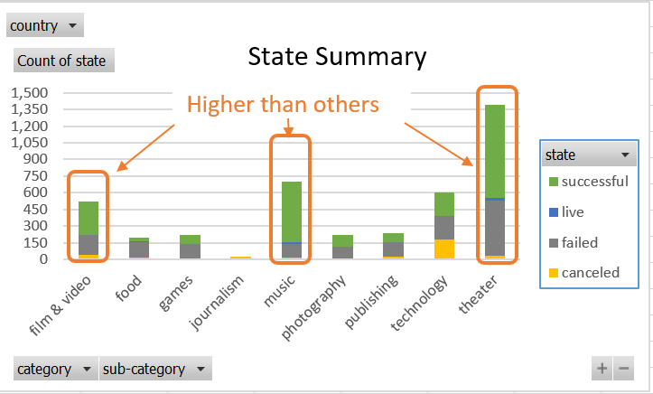

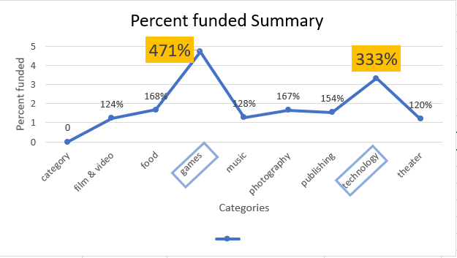

1. Conclusion:  
   -I speculate those sub-categories enclosed by are potential categories have a greater chance of success, Especially the Hardware in technology, which in spite of conducted by large number of projects, still keeps high success rate.

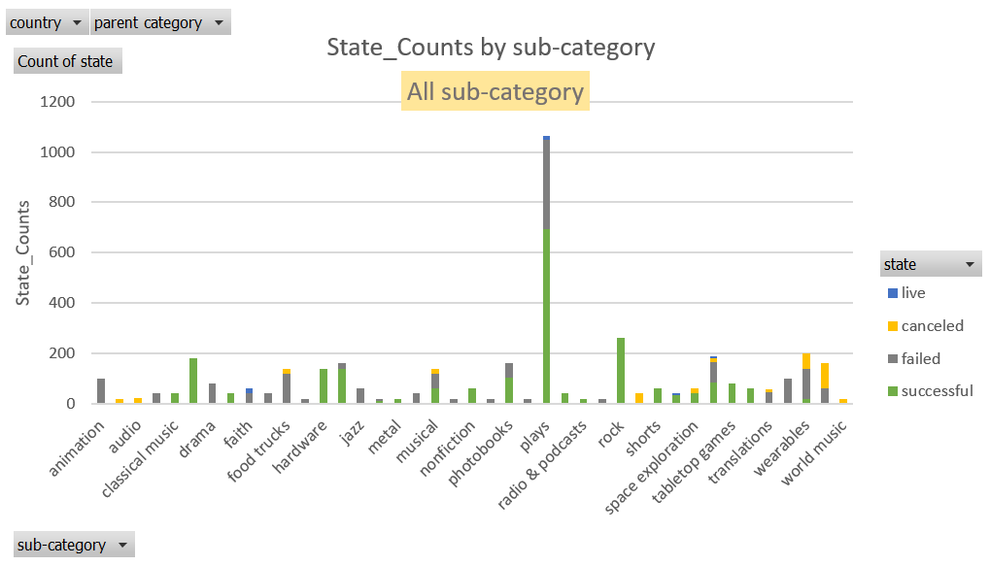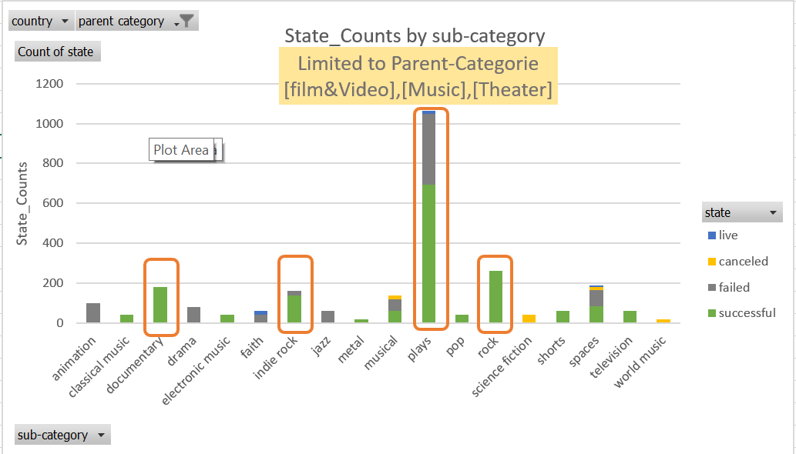

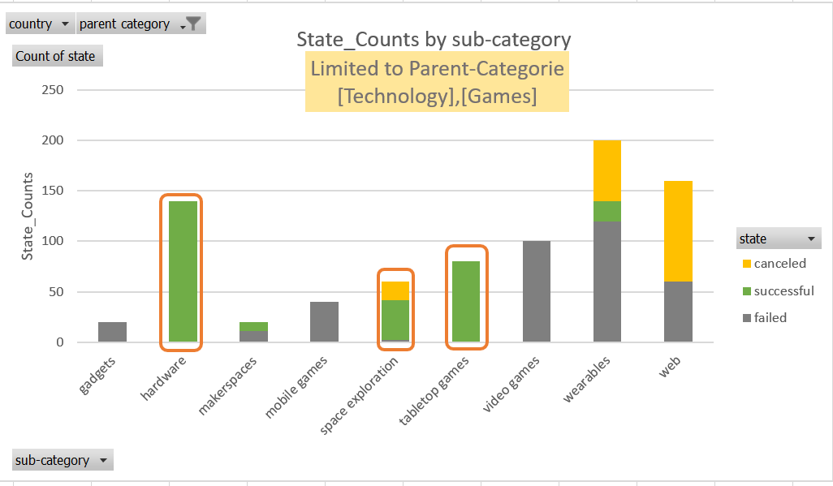

1. ・Conclusion:   
    -The projects start at first half year (especially Feb-May)tend to have higher success rate.   
    -To get higher success rate, Project leaders can try to launch projects between Feb-May. 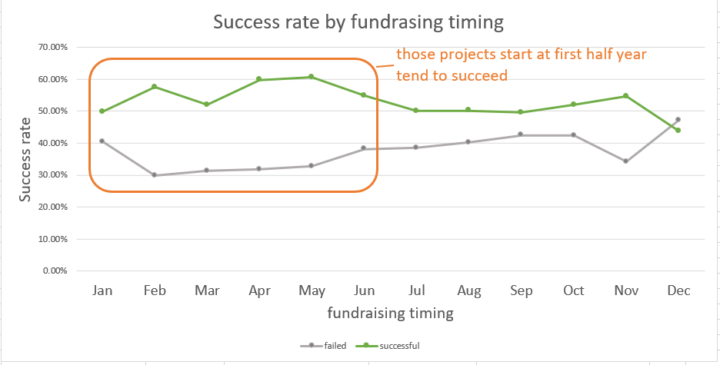

What are some of the limitations of this dataset?  
①Since the currency unit is various for each project, it’s hard for us to do the comparison. Even I scandalized the currency as USD, it’s pointless to compare the amount of money directly since I believe different country has different values.  
②Besides the factors we can get from the dataset, such as category, project launch location, period and timing, other factors may also affect the success rate. For instance, the way to fundraise, advertising approach and the content of those projects. Even we have a column ”blurb”, which simply describe the purpose of projects, it be written as a short paragraph. If we can get the information that categorize those content as service projects, service attributes (such as NPO like local charity, public service like education, research institutions and institutions like clubs.), we can conduct more detailed analysis.  
③Since 74% of the projects are launched at U.S, we could conduct more targeted analysis if we have more information related to the U.S area. For instance, if we can get the geographically distribution and characters of backers, we can analyze to see what kind of person are more likely to donate. If we can get the geographically distribution of launched states, we can analyze to uncover if there is relationship between success rate and the launched location.

What are some other possible tables/graphs that we could create?  
◆Comparison of **success rate**   
 ┗based on country  
 ・Conclusion: we can find out which countries have relatively higher success rate

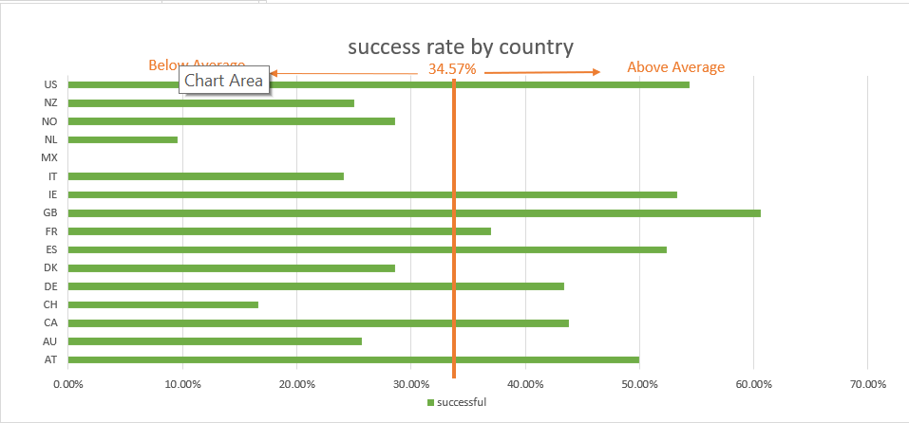

┗based on category  
・Conclusion: we can find out which categories have relatively higher success rate

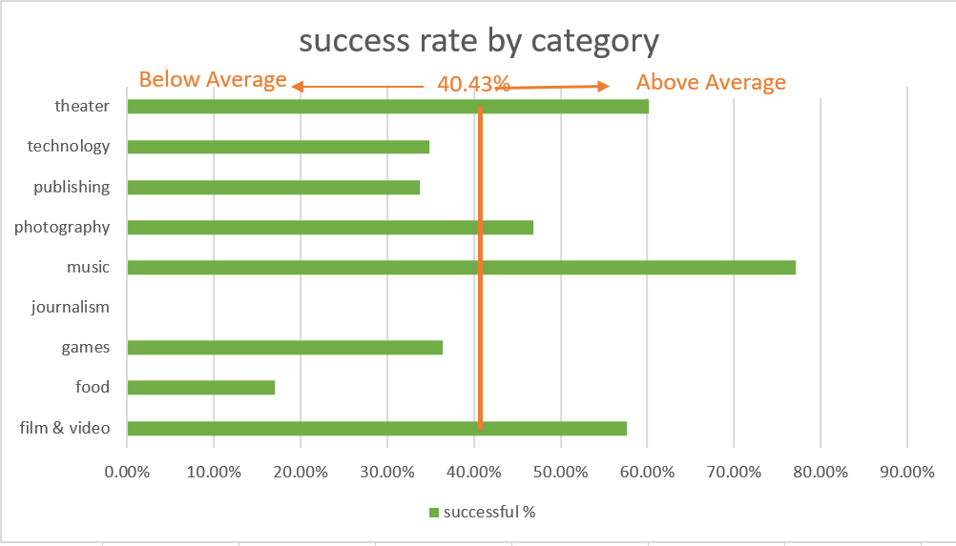

┗based on fundraising period(days)  
 ・Conclusion:   
 The relationship between the success rate and the fundraising period is not positive associated.   
 The time period that less than 50 days or larger than 70 days tends to fail.  
 ・ Future Reference:   
 In order to get higher success rate,  
 Project leaders can try to set their fundraising period as 10-20 days or 70-80 days.

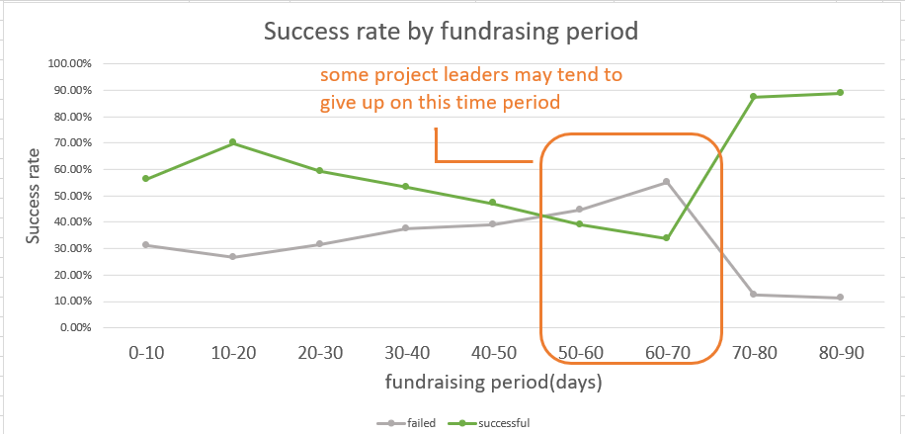

*I also tried to visualize the relationship between percent funding and fundraising period or timing by using scatter plot (Excel-Sheet data_scatterplot_regression), but it seems there is no significant relationship between those variables.  
 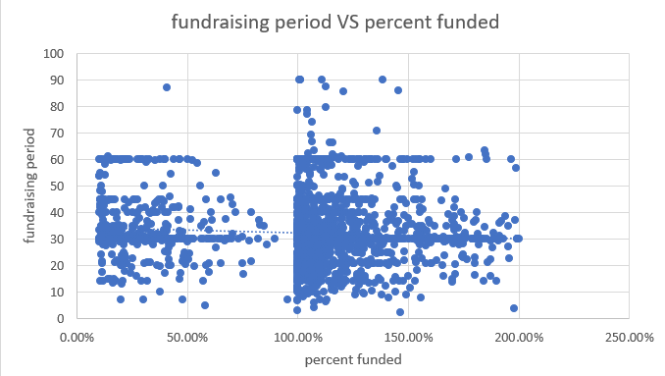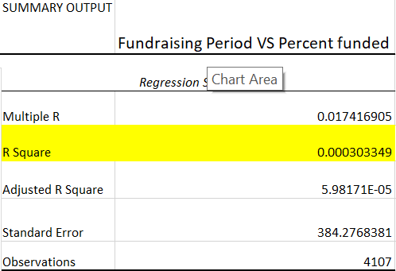

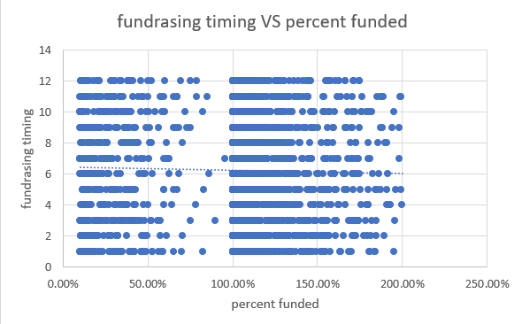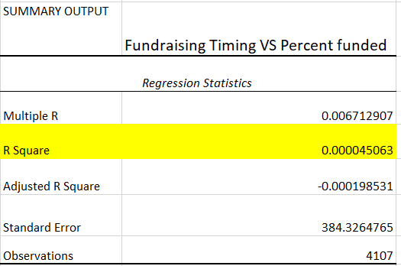

┗based on fundraising year  
・Conclusion:   
 The Success rate for all projects continues to decrease annually from 2009-2017.   
 However, the trends based on each country are various.  
 I speculate that the success rate for each year might be related to the economies of each country.  
・ Future Reference:   
 The project leaders should do research on economic trends, target marketing, policy changes and  
 other new developing trends that may affect the fundraising projects.   
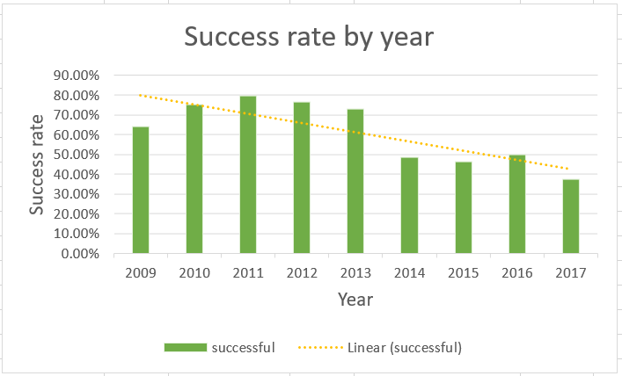

◆Comparison of **Average donation and backer_counts by Country  
 \***the currencies are standardized to USD  
・Conclusion:  
 There is no enough evidence to prove that the relationship between the amount of average donation  
 and average backer_counts is statistically significant.  
