Dinosaur hips Site Plan

Spencer Vanderpool

WDD 130

Overview

Purpose
[provide a site that provides comprehensive descriptions and comparisons of the dinosaur hip structures that define saurischians and ornithischians]

Audience
[Anyone wanting to know more about dinosaur classifications]

Branding

Website Logo
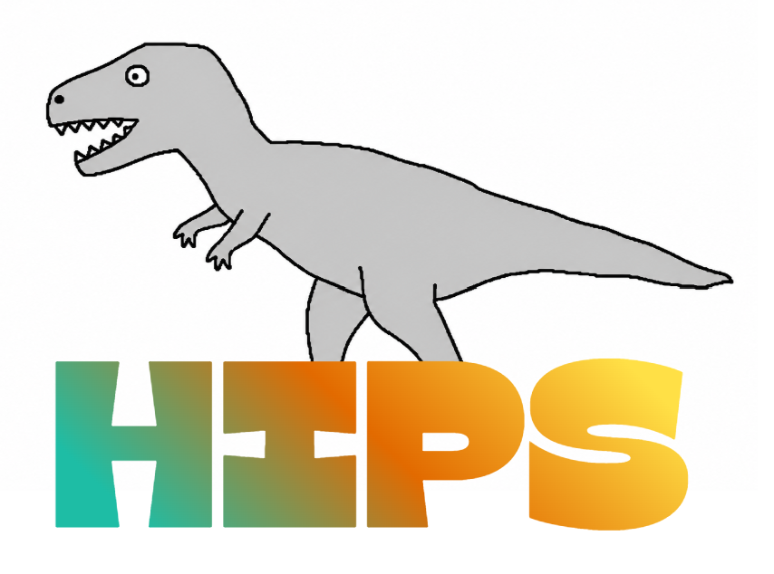

Style Guide

Color Palette
Primary | Secondary | Accent 1 | Accent 2 | Accent 3
#3F4B3B | #44633F | #EDF2F4 |  | #568EA3

Typography

Heading Font: Gulfs display (for the nav buttons)

Paragraph Font: Canva sans (or “Work sans” if the font is unavailable)

Navigation
Home Ornithischians Saurischians

Content

[put all content for the pages here, including written text and images]

Instructions
The background color for each button in the navigation should turn to #5CAB7D on hover.

Wireframes

Main

Text box content:

Nav:

Home

Saurischians

Ornithischians

Body

Dinosaurs come in 2 main classifications

These classifications are based on the hip structure of the skeleton

Ornithischians (meaning “bird hipped”)

Saurischians (meaning “lizard hipped”)

Ornithischian pelvis

Saurischian pelvis

Footer

Copyright 2026

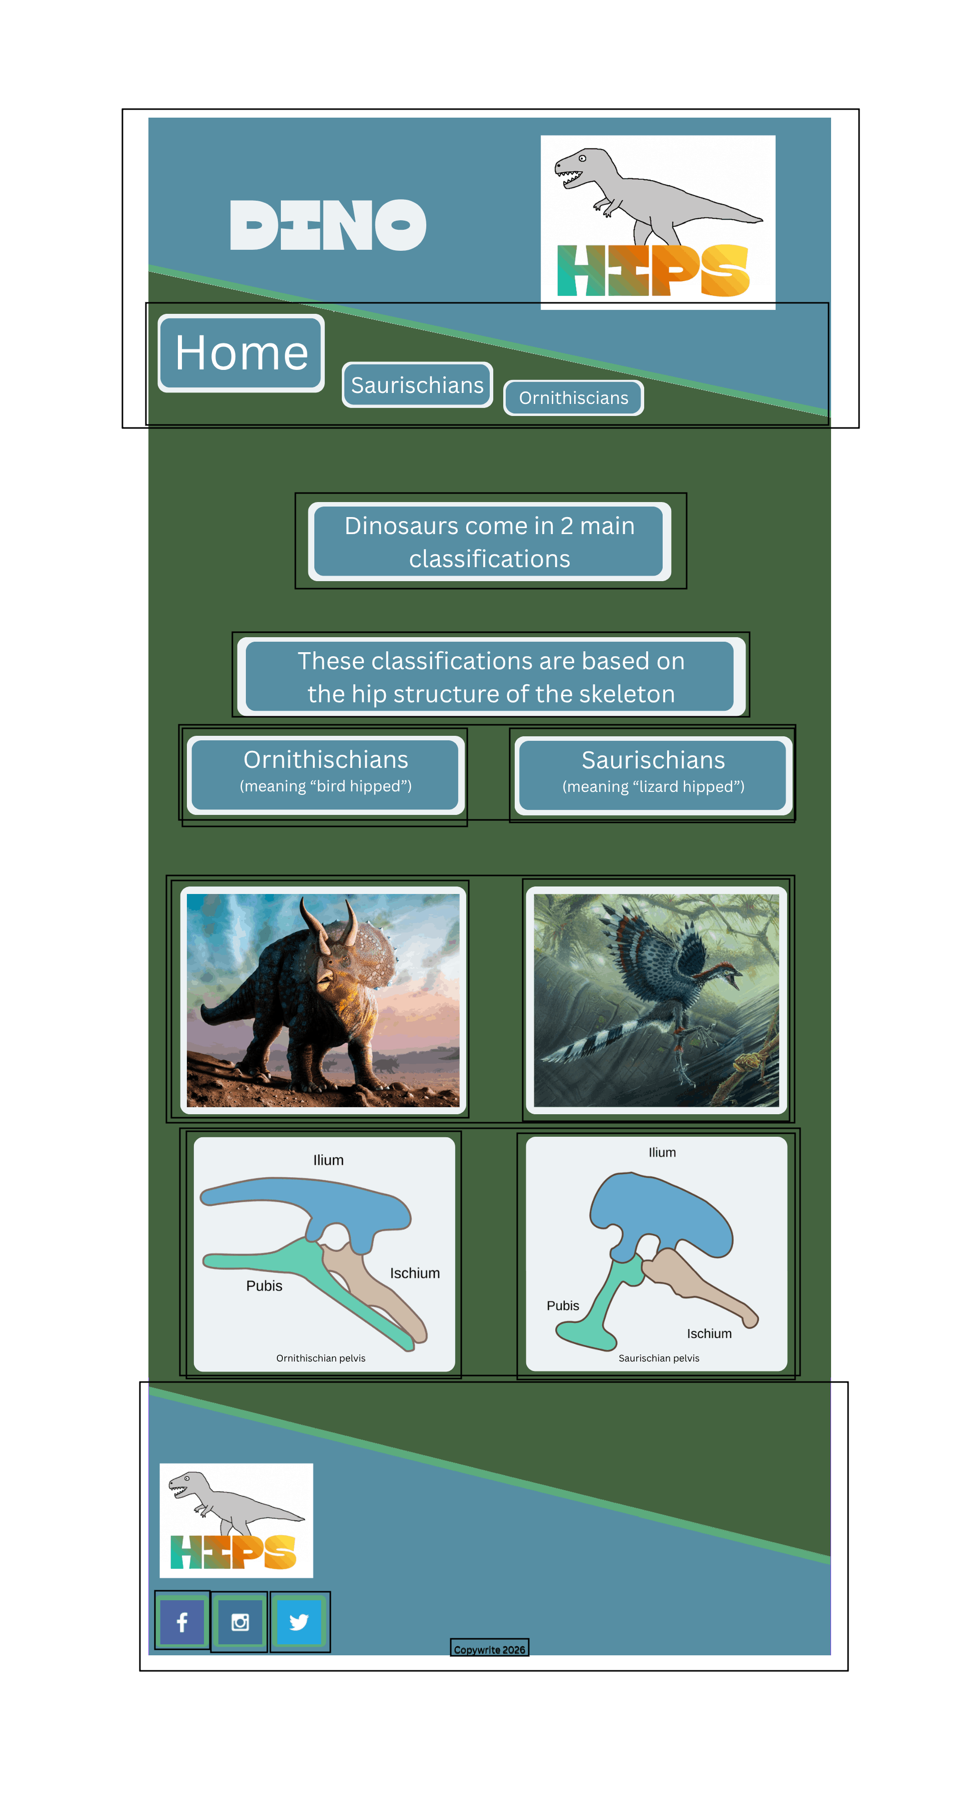

Ornithischians page (sub page 1)

Nav:

Home

Saurischians

Ornithischians

Body:

Ornithischia

“Ornithischia” means “bird hip.” Ornithischians were typically herbivorous (plant eaters) or omnivorous (plant and meat eaters).

Popular Ornithischians include triceratops, ankylosaurus, and stegosaurus.

The Ilium bone is the uppermost bone that acts as the critical attachment point for leg and tail muscles to the skeleton

The Pubis bone is pointed backwards to give space for the massive gut required to digest plant matter

The Ischium bone is the key pelvic bone that extends backwards and anchors the legs’ retractor muscles

Unfortunately, all Ornithischians are extinct as of the K-Pg mass extinction 66 million years ago

Footer

Copywright 2026

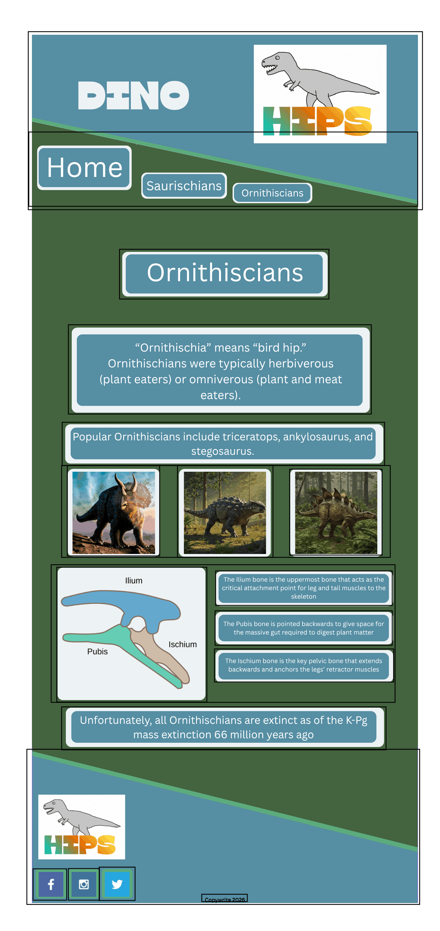
Saurischians page (sub page 2)

Nav:

Home

Saurischians

Ornithischians

Body:

Saurischia

“Saurischia” means “lizard hip.” All carniverous (meat eating) dinosaurs are classified as saurischians, along with 2 lines of herbiverous (plant eating) sauropodomorphs.

Popular Saurischians include Archaeopteryx, T-rex, and Brontosaurus.

The Ilium bone is the uppermost bone that acts as the critical attachment point for leg and tail muscles to the skeleton

The Pubis bone is pointed backwards to give space for the massive gut required to digest plant matter

The Ischium bone is the key pelvic bone that extends backwards and anchors the legs’ retractor muscles

Modern saurischians include birds exclusively. Examples include cassowary, secretary bird, and harriers.

Footer:

Copywright 2026

