1. Introduction
Stock price prediction is a challenging time-series problem because market prices are influenced by historical trends, investor behaviour, company-specific information, news events, macroeconomic conditions, and volatility shocks. Although historical price data cannot capture every market driver, machine learning models can still be used to examine whether previous trading patterns contain useful predictive structure.
The objective of this project is to design and apply an RNN-based model for next-day TSLA closing price prediction. The chosen RNN model is an LSTM network trained on 60-day sequences of engineered market features. The model predicts next-day return, which is then converted into a next-day closing price. This modelling choice improves numerical stability because returns are more stationary than raw stock prices over a long historical period. Although the model is trained to predict next-day return for numerical stability, the predicted return is converted back into next-day closing price, and all main evaluation metrics are reported on the closing-price scale.

2. Data Collection and Preprocessing
The dataset was downloaded from Yahoo Finance using the TSLA ticker. The requested window covered the past 10 years from the notebook run date, from 25 June 2016 to 25 June 2026. The available trading data spanned 27 June 2016 to 24 June 2026, giving 2,512 clean daily observations after validation.
Item | Value
Ticker | TSLA
Data source | Yahoo Finance via yfinance
Requested date window | 25 June 2016 to 25 June 2026
Available trading range | 27 June 2016 to 24 June 2026
Clean rows retained | 2,512
Required columns | Open, High, Low, Close, Adj Close, Volume
The preprocessing stage checked for required columns, missing values, duplicate rows, infinite values, and correct chronological ordering. The dataset contained no missing values in the required columns and no duplicate rows. Feature normalization was performed after the chronological training split so that the validation and test periods did not influence the fitted scalers.
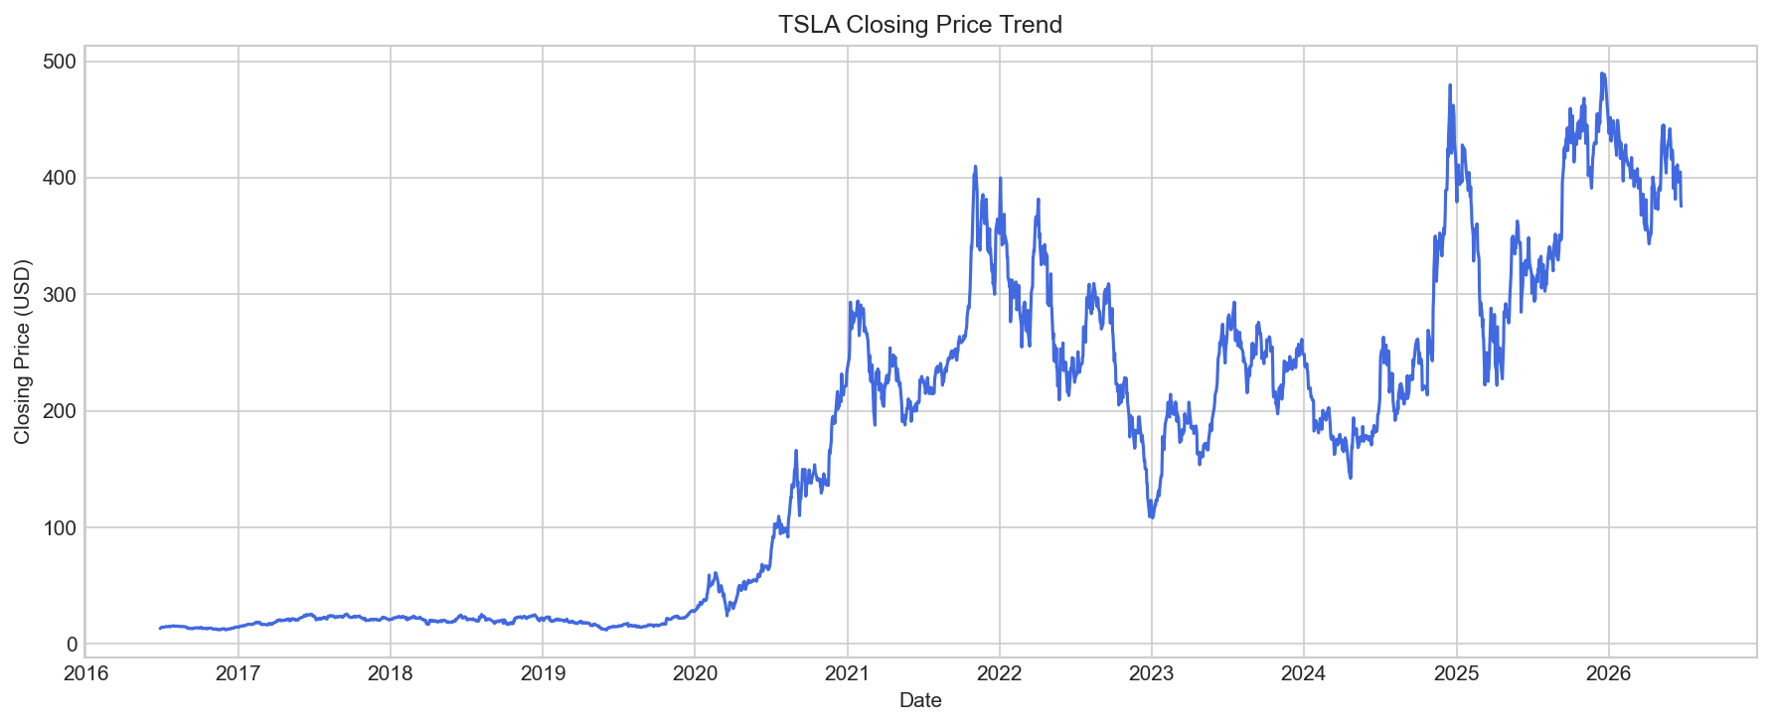
Figure 1. TSLA closing price trend over the available 10-year window.
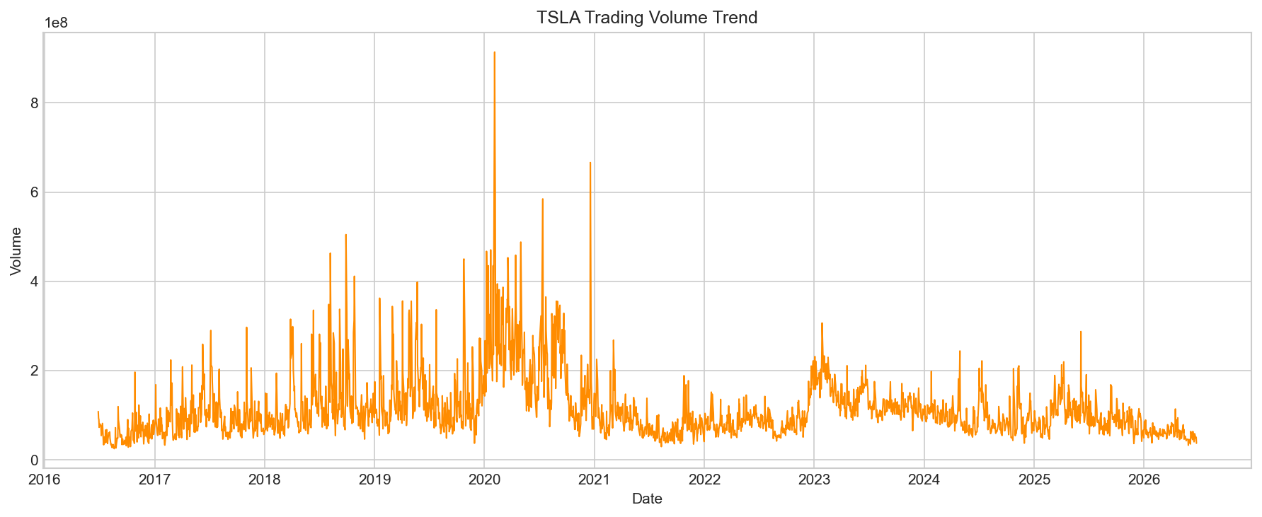
Figure 2. TSLA trading volume trend over the available 10-year window.
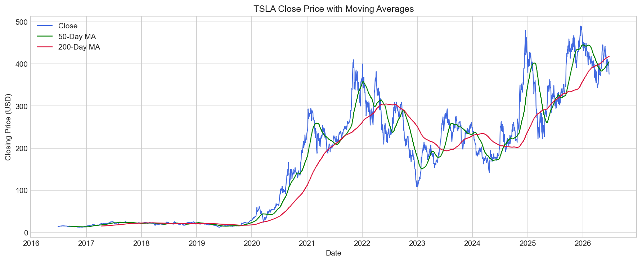
Figure 3. TSLA closing price with 50-day and 200-day moving averages.

3. Feature Engineering and Target Construction
The modelling frame was constructed from price-level variables, movement variables, trend indicators, volatility features, and momentum information. The final modelling frame contained 2,462 rows after rolling-window features and the next-day target were created.
- Price-level inputs: Open, High, Low, Close, Adjusted Close, and Volume.
- Short-term movement inputs: daily return, high-low range, open-close change, and volume change.
- Trend inputs: 10-day, 20-day, and 50-day moving averages, plus close-to-moving-average ratios.
- Risk and momentum inputs: 10-day volatility, 20-day volatility, and 14-day Relative Strength Index.
- Prediction target: next-day return, converted back into next-day closing price for evaluation.

4. RNN Technique Investigation
The proposed machine learning technique is Long Short-Term Memory, a type of recurrent neural network developed for sequential data. Standard feed-forward models treat observations as independent rows, whereas an RNN processes ordered sequences and can learn relationships across time steps. LSTM improves on a basic RNN by using input, forget, and output gates to control how information is retained or discarded.
This characteristic is relevant for stock prediction because recent price movements, volatility, and trend behaviour may influence the next trading day. In this project, each input sample contained 60 consecutive trading days, allowing the LSTM to learn from approximately three months of recent market history before predicting the following day's return.

5. Model Development
The data was split chronologically into training, validation, and testing sets. Chronological splitting is necessary for financial forecasting because random splitting would leak future market conditions into the training process.
Split | Sequences | Target Start | Target End
Training | 1,664 | 30 November 2016 | 13 July 2023
Validation | 369 | 14 July 2023 | 30 December 2024
Testing | 370 | 31 December 2024 | 24 June 2026
The LSTM architecture used two recurrent layers followed by dropout and dense layers. The first LSTM layer contained 64 units and returned sequences to the second LSTM layer, which contained 32 units. Dropout of 20 percent was applied after each LSTM layer to reduce overfitting risk. The final dense layers mapped the learned sequence representation to a single scaled next-day return prediction.
Model Component | Configuration
Input sequence | 60 trading days x 19 engineered features
LSTM layer 1 | 64 units, return sequences
Dropout layer 1 | 0.20
LSTM layer 2 | 32 units
Dropout layer 2 | 0.20
Dense layer | 16 units, ReLU activation
Output layer | 1 predicted scaled next-day return
Loss function | Huber loss
Callbacks | Early stopping and learning-rate reduction
Trainable parameters | 34,465
The model trained for 18 epochs before early stopping. The final training loss was 0.3748, and the best validation loss was 0.3611. The training and validation curves indicate that the validation loss did not continue to deteriorate strongly after training, which suggests that the regularisation and early stopping controls helped limit overfitting.
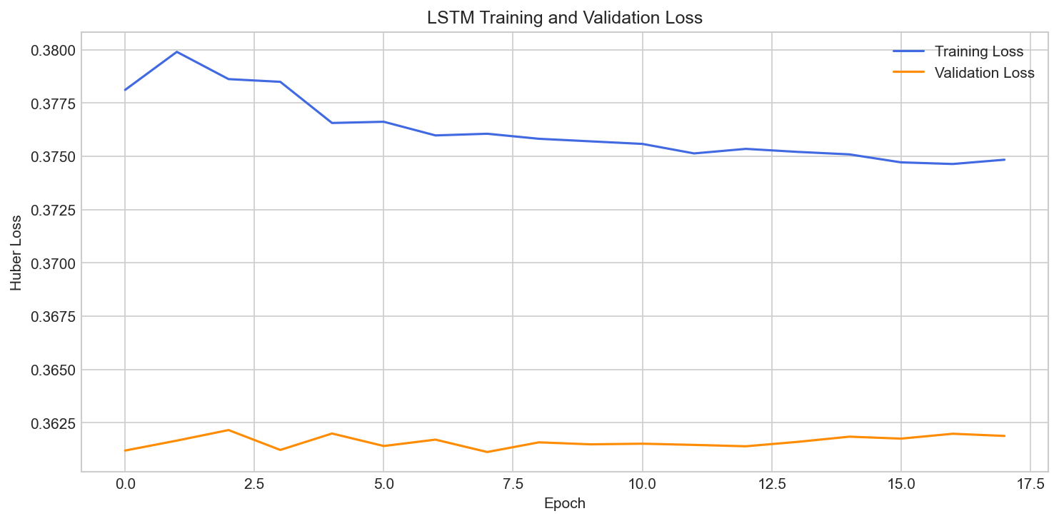
Figure 4. LSTM training and validation loss.

6. Results and Evaluation
The LSTM model was evaluated on the unseen chronological test period. Its performance was compared with two benchmarks: a previous-close baseline and a Random Forest Regressor. The previous-close baseline predicts that the next close will be equal to the current close, while the Random Forest provides a non-RNN machine learning alternative.
Model | MAE | RMSE | R2 | MAPE | Direction Accuracy
LSTM RNN | 9.4496 | 12.1502 | 0.9633 | 2.6464% | 50.2703%
Previous-close baseline | 9.4438 | 12.1711 | 0.9632 | 2.6469% | 0.0000%
Random Forest | 12.7647 | 16.5036 | 0.9323 | 3.3853% | 50.5405%
Direction accuracy is mainly interpreted for the LSTM and Random Forest models. It is less meaningful for the previous-close baseline because that baseline predicts no price change, so its directional signal is neutral.
The LSTM produced the lowest RMSE and MAPE among the machine learning models and slightly outperformed the previous-close baseline on RMSE and MAPE. However, the margin of improvement over the baseline was very small. This indicates that the LSTM was effective at tracking the price level but did not produce a large predictive advantage over a simple autocorrelation-based assumption.
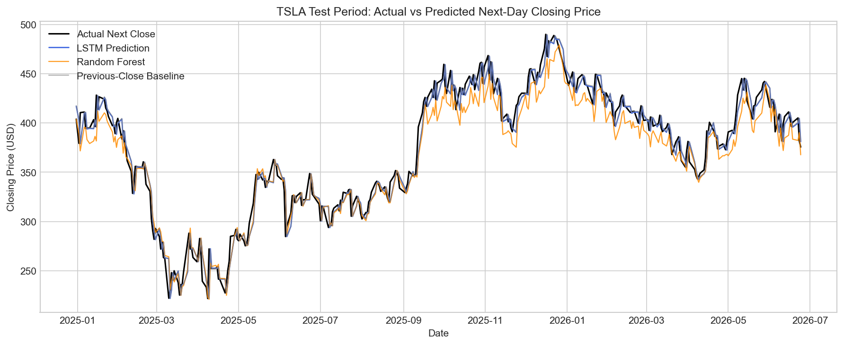
Figure 5. Actual versus predicted TSLA next-day closing price during the test period.
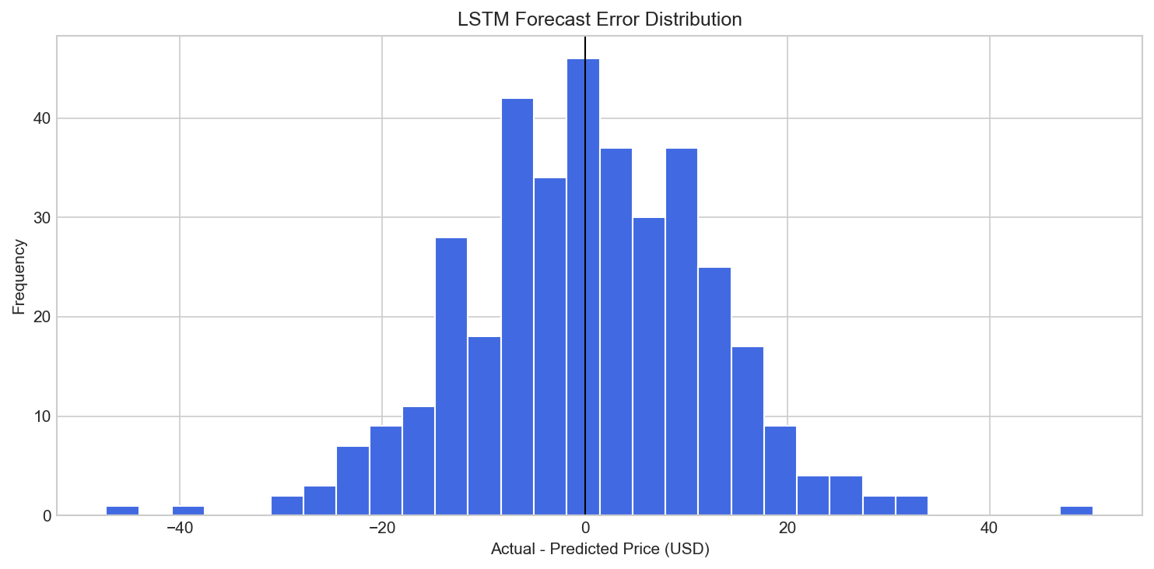
Figure 6. Distribution of LSTM forecast errors.
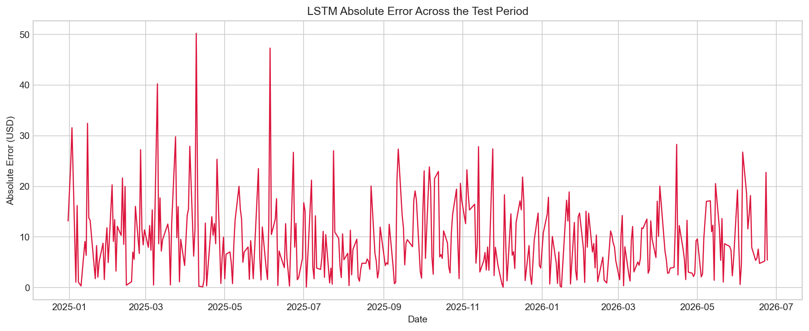
Figure 7. LSTM absolute error across the test period.

7. Critical Analysis

7.1 Strengths of the LSTM Model
The first strength of the LSTM model is its suitability for sequential financial data. Stock prices are not independent observations; each trading day is connected to previous price movement, recent volatility, market momentum, and short-term trend behaviour. By using a 60-day lookback window, the LSTM model was able to process TSLA data as an ordered sequence rather than as isolated rows. This is important because the model can learn how recent trading patterns evolve over time before producing the next-day return forecast.
The model also benefited from a richer feature set than raw closing price alone. The inputs included price-level variables, daily return, trading range, open-to-close change, volume change, moving averages, close-to-moving-average ratios, rolling volatility, and RSI. These features gave the LSTM information about trend, momentum, risk, and trading activity. As a result, the model was not limited to memorising historical prices but could learn from several technical aspects of TSLA's market behaviour.
Another strength is the modelling workflow. The dataset was split chronologically into training, validation, and test periods, which is more appropriate for stock forecasting than random splitting. The scalers were fitted only on the training period, preventing information from the validation and test periods from leaking into model training. Dropout, early stopping, and validation monitoring were also used to reduce the risk of overfitting. These choices make the evaluation more realistic and academically stronger because the final test results are based on unseen future data.
In terms of measured performance, the LSTM achieved a test RMSE of 12.1502, MAPE of 2.6464 percent, and R2 score of 0.9633. These values show that the model followed the general TSLA price level well during the test period. The LSTM also produced lower RMSE and MAPE than the Random Forest alternative, suggesting that the recurrent structure was useful for this time-series task.

7.2 Limitations of the Model
A key limitation is the risk of overfitting. Although dropout and early stopping were applied, an LSTM with 34,465 trainable parameters can still learn patterns that are specific to the historical training period rather than patterns that generalise reliably to future market conditions. Stock data is noisy, and many apparent short-term patterns may occur by chance. If the model learns these noise patterns too strongly, it may perform well on past data but fail when market structure changes.
The training results do not show severe overfitting, because the best validation loss remained close to the training loss. However, the small improvement over the previous-close baseline suggests that the model's practical predictive advantage is limited. A high R2 score can be misleading in stock-price prediction because daily closing prices are highly autocorrelated. A model can achieve a strong R2 simply by predicting a value close to the latest observed price, even if it does not truly understand the next market movement.
Data dependency is also a major limitation because the model is only as informative as the data used for training. This project used historical OHLCV data and derived technical indicators, but it did not include earnings reports, company announcements, macroeconomic variables, interest rates, market index movements, option activity, social media sentiment, analyst revisions, or news events. These omitted factors can strongly affect TSLA's price. Therefore, the model may be less reliable when the next-day movement is driven by new information that is not present in the historical price data.
Sensitivity to market volatility is another major limitation. TSLA is a volatile stock, and sudden price movements can occur after earnings announcements, product updates, regulatory news, changes in investor sentiment, or broader market shocks. The LSTM can learn typical volatility patterns from the past, but it cannot anticipate unexpected events. This weakness is visible in the forecast errors: the model generally tracks the price level, but larger errors occur when actual prices move sharply away from the recent trend.
The direction accuracy was approximately 50.27 percent, which is close to random guessing for predicting whether the next closing price will rise or fall. This is an important limitation because a model that tracks price level does not necessarily provide useful directional forecasting. For investment decisions, direction and risk-adjusted return matter more than simply producing a close numerical estimate of tomorrow's price.

7.3 Comparison with Alternative Model
The alternative model used in this project was a Random Forest Regressor. Unlike the LSTM, the Random Forest does not process the full 60-day sequence as a time-dependent structure. It uses tabular input from the final day of each sequence and learns nonlinear relationships through an ensemble of decision trees. This makes it a useful comparison because it represents a non-RNN machine learning approach.
The Random Forest performed worse than the LSTM on the main regression metrics. Its MAE was 12.7647, RMSE was 16.5036, MAPE was 3.3853 percent, and R2 score was 0.9323. In comparison, the LSTM achieved MAE of 9.4496, RMSE of 12.1502, MAPE of 2.6464 percent, and R2 score of 0.9633. This indicates that the LSTM was better at capturing TSLA's test-period price behaviour than the tree-based alternative.
The likely reason for this difference is that the LSTM uses sequential information more directly. A stock's recent path may contain useful information about trend persistence, volatility clustering, or momentum changes. The Random Forest can model nonlinear relationships, but it does not naturally preserve the order of the 60-day window in the same way as an LSTM. Therefore, for this forecasting task, the RNN-based model is more suitable than the Random Forest benchmark.
However, the previous-close baseline remained highly competitive. Its RMSE was 12.1711 and MAPE was 2.6469 percent, which are only slightly worse than the LSTM. This means that although the LSTM outperformed the Random Forest, it did not strongly outperform the simple assumption that tomorrow's close will be similar to today's close. This comparison is important because stock prices often change gradually from one trading day to the next, making the previous-close baseline difficult to beat.
Overall, the LSTM is the strongest model among the machine learning methods tested, but its advantage should be interpreted carefully. The model is useful as an academic demonstration of RNN-based forecasting and performs better than the Random Forest alternative, but it is not sufficient on its own for reliable investment decision-making. A stronger future system would need additional market features, walk-forward validation, transaction-cost-aware testing, and robustness checks across different stocks and market regimes.

8. Conclusion
This project successfully developed an RNN-based stock price prediction workflow for TSLA using Yahoo Finance data from the past 10 years. The LSTM model satisfied the project requirement by applying a recurrent neural network to historical financial data, converting the data into sequential training format, evaluating the model with appropriate metrics, and presenting results through graphs and tables.
The LSTM achieved strong price-level tracking and outperformed the Random Forest alternative. However, its improvement over the previous-close baseline was small, and its direction accuracy was close to 50 percent. Therefore, the model should be viewed as a structured academic forecasting exercise rather than a reliable trading system. Future improvements could include richer external features, walk-forward validation, transaction-cost-aware evaluation, and comparison with more advanced time-series architectures.

9. Source Code and Reproducibility
The full source code is provided in the GitHub repository. The notebook includes the complete workflow for data download, preprocessing, feature engineering, model training, evaluation, and visualisation. All key outputs, including graphs, metric tables, and model comparison results, are displayed directly in the notebook to support reproducibility.
GitHub repository: https://github.com/BingJun69/ML_Final_Assesment

