MINI CASE STUDY: NEW STUDENT
STEP1: ISPF
- Allocate a PS dataset with record length 80 with naming convention as below.
PS1 - <USERID>.L1L.STUDENT.PS1
- Using the details from below file layout, enter records into the PS1 file as per the instructions given,
  - Do not enter 1st row in PS file. 1st row contains header details for reference.
  - Do not enter 2nd row in PS file. 2nd row contains layout details for reference.
  - One space filler had to be inserted between each field in the PS file.
  - All alphanumeric data to be entered in CAPITAL letters.

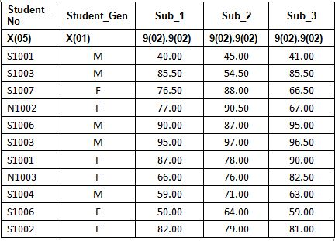

STEP2: JCL
1. JCL member naming convension JA11L<yyy>, where <yyy> denotes last 3 digits of your user ID. Proper JOB card without any RESTART step to be given.
  - Allocate a VSAM ESDS dataset with the following specifications,
RECORDSIZE (80, 80)
Name: <USERID>.L1L.STUDENT.ESDS

STEP3: JCL
1. JCL member naming convention JA21L<yyy>, where <yyy> denotes last 3 digits of your user ID. Proper JOB card without any RESTART step to be given.
  - Using Sort utility perform the below operations on PS1 and store the output in PS2 file. First step in this job should be the DELETE step for PS2 file.
PS1 -> <USERID>.L1L.STUDENT.PS1.
PS2 -> <USERID>.L1L.STUDENT.PS2.
i. Sort records in ascending order based on Student_No.
ii. Include records only which have Student _No starting with ‘S’.
iii. Remove duplicates for each Student_No.
[Ex : If Student No SO441 contains 3 records after sorting, write the first record Alone to output file]
2. Step1:Split the PS2 file into two equal parts(PS3 &PS4). The layout for the two new files will be the same as the PS2 file layout.
PS3 -> <USERID>.L1L.STUDENT.PS3
PS4 -> <USERID>.L1L.STUDENT.PS4
Ex: If the PS2 file has 6 records , then records1,3 5 should come to PS3 file and the records 2,4,6 should come to PS4 file.
Step2: Insert a word ‘SPLIT’ at 27th column of both the files. The Job steps have to be stored in JA31L<yyy>.Execute Step2, only if Step1 is ended successfully. Use COND codes to achieve this.
First step should be the delete step for the PS3 &PS4 files.
Sample record:
S1001 M 80.00 65.00 55.00 SPILT
S1006 F 50.00 64.00 59.00 SPILT
Filler Details: - One space between each field.
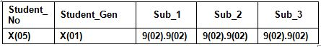
STEP4: COBOL

Input file to be used in the program : <USERID>.L1L.STUDENT.PS2
DD name to be used : INPSTDPS
Output file to be used in the program : <USERID>.L1L.STUDENT.ESDS
DD name to be used : OUTSTDES
Output file to be used in the program : <USERID>.L1L.STUDENT.ERR
DD name to be used : ERRSTDPS
Output file to be used in the program : <USERID>.L1K.STUDENT.EXCEL
DD name to be used : OUTSTDPS
Note: Please use only the above-mentioned DD names.
Write a COBOL program to perform the following,
  - Read records from input PS2 dataset (<USERID>.L1L.STUDENT.PS2) and validate input values for each field in the input file.
    - Check whether STUDENT_GEN field is not blank.
    - Check whether SUB_1 is numeric before and after decimal point.
    - Check whether SUB_2 is numeric before and after decimal point
    - Check whether SUB_3 is numeric before and after decimal point.
  - If the input record does not pass through the validations specified above successfully, then write that input record into error PS file <USERID>.L1L.STUDENT.ERR and start processing the next record.
    - Layout of ERROR file is as below.
    - The first record must be a header record with required spacing between the fields as mentioned below.
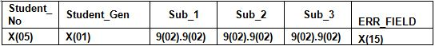
Note : One space filler to be inserted between each field.
    - ERR_FIELD contains the error field name.
Ex:If the Sub_1 field is not numeric, then the ERR_FIELD should contain ‘SUB-1’
If Student_Gen is blank, then the ERR_FIELD should contain ‘STUDENT-GEN’
  - Do the following processing for every record which has passed through the validations successfully.

    - Total marks and Percentage calculation

      - Using a sub-program, calculate TOT_MARK and Percentage using below formula
TOT_MARK value should be rounded off to two decimal places.
TOT_MARK=Sub_1+ Sub_2 + Sub_3
TOT_PER = (TOT_MARK/ 300) * 100

Note : Suppress the leading zeroes of TOT_PER while writing to output file.
    - Return the values of TOT_MARK and TOT_PER to the main program.

  - Do the following two calculations in the Main program.

2. Calculation of Grade and Level
      - For Students with TOT_PER <= 45
        - Write GRADE of corresponding record as ‘D’ and LEVEL as ‘POOR’
      - For Students with TOT_PER > 45 <=65
        - Write GRADE of corresponding record as ‘C’ and LEVEL as ‘AVERAGE’
      - For Students with TOT_PER > 65 <=85
        - Write GRADE of corresponding record as ‘B’ and LEVEL as ‘GOOD’
      - For Students with TOT_PER > 85
        - Write GRADE of corresponding record as ‘A’ and LEVEL as ‘EXCELLENT’

3. Calculation of Scholarship Eligible students
      - For Students with GRADE as A and TOT_PER > 90
        - Write SCH_ELIG of corresponding record as ‘Y’ .
      - For all other records
        - Write SCH_ELIG of corresponding record as ‘N’ .

- Write output record into ESDS file in the below format.
One space filler to be inserted between each field.
TOT_PER should be displayed after suppressing the leading zeroes.
Ex: ‘096’ should be displayed as ‘ 96’
- Load the fields student No, Student Gender, Total marks, Total percentage, Level into a COBOL one dimensional table. The layout of the table for reference is given below:

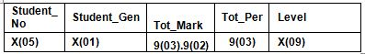
Note: TOT_PER should be displayed after suppressing the leading zeroes.
- Find the records with level = ‘EXCELLENT’ in the COBOL one dimensional table loaded in previous step.
    - Write all records having Level=’EXCELLENT’ into PS file
<USERID>.L1L.STUDENT.EXCEL

Note: Layout of the PS files should be same as table layout mentioned above.
One space filler to be inserted between each field.
- Compile and run the above COBOL program to achieve the results.
JCL Member Naming Convention: JA41L<yyy>, where <yyy> denotes the last 3 digits of your user ID. Proper JOB card without any RESTART step to be given.
INSTRUCTIONS:
- Follow the proper coding standards.
- Provide proper error handling routines.
- Place all the final deliverables into the PDS dataset : ‘<USERID>.<X>.<Y>.PDS’ .
Where X -> L1 and Y denotes 8 digit Batch name. Example: Y- CHNMJ001
[Example of L1 PDS – TECN001.L1.CHNMJ001.PDS]
For JCL’s, the member name should be “JA<x>1G<yyy>”
Note: Where <x> denotes the member no.(1 for 1st, 2 for 2nd member) and <yyy> denotes the last 3 digits of your user ID.
    - JCL's should be named in the member names as suggested in the respective steps.
- For COBOL Program, the member name should be “CA<x>1G<yyy>”
Note: Where <x> denotes the member no. (1 for 1st, 2 for 2nd member) and <yyy> denotes the last 3 digits of your user ID.
If there are 2 members for a COBOL (Main program and sub program) created by ID TECN001, the member name should be “CA11G001” and”CA21G001”.
EXPECTED DELIVERABLES in Mainframe PDS ‘<USERID>.<X>.<Y>.PDS
’:
- JCL for STEP2 and STEP3 in member names suggested in steps.
- COBOL programs in member names suggested.
- RUNJCL for the COBOL program.

