The information for 2_20210910WA_ data_input_CVM_network and vectors.pdf:

We divide the process of building CO2 sequestration networks and vectors to three part and total seven steps.
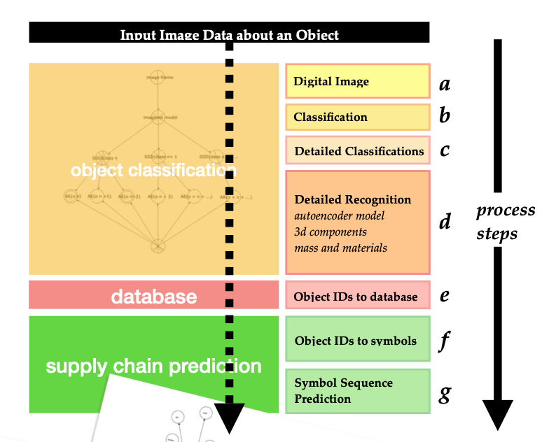

The output: a Circularity Accounting Model of the object is the simplified version of the graph is what we are using as the ‘circularity economy’ diagram, which shows the carbon values as distances from a circle.
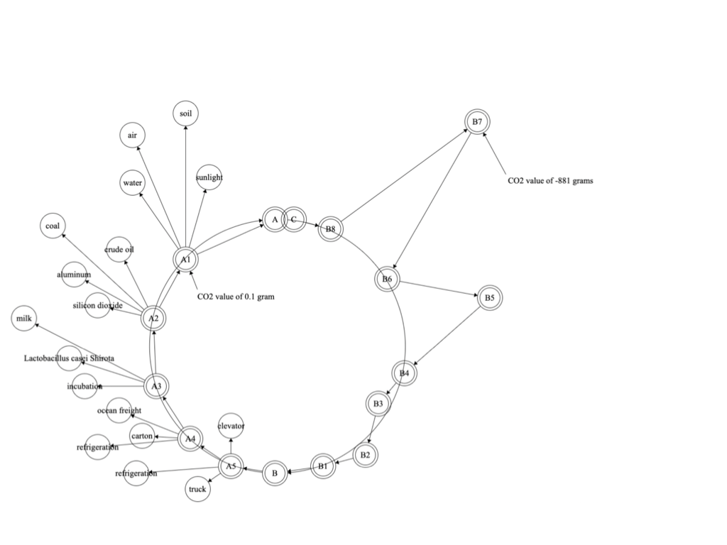

We requires data that describes the supply chain and the disposal chain by conceptualizing and encoding the steps in a supply-destruction chain model

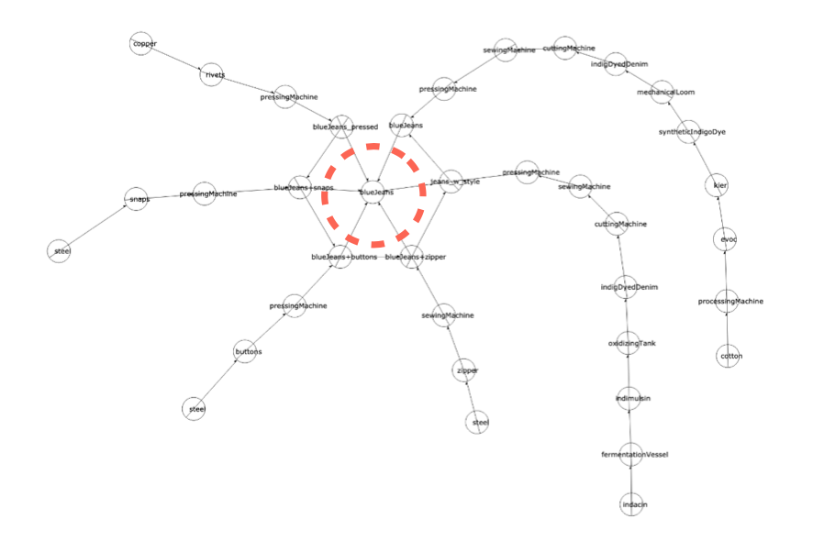
From the consumption vectors, we can make this graph, which shows the inputs of carbon on the production ‘circle’ of blueJeans. The circle is the the beginning to the end of the blueJeans product.

We can make a realistic graph, from the inputs of carbon on the production network of Yakult.
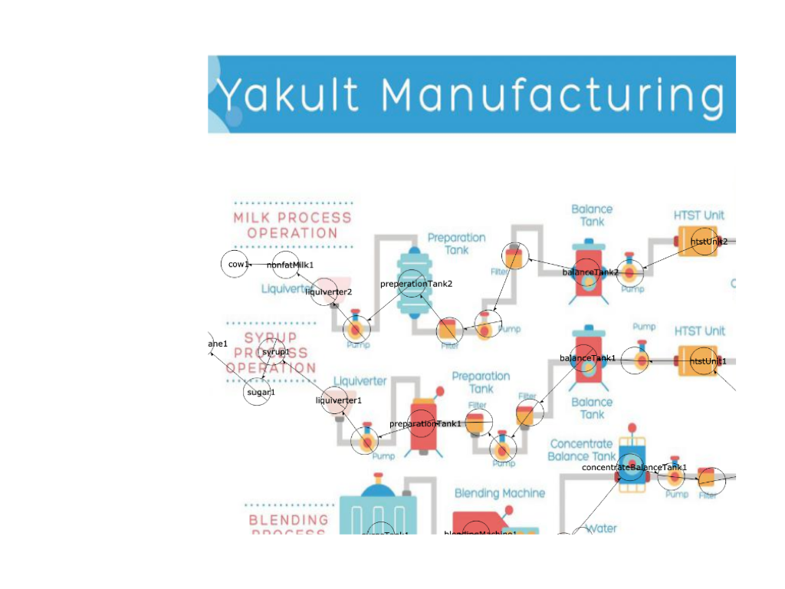
Then, we get consumption vectors (CV) from the entropy graph by use this tool http://www.entropynetwork.com/doc2/? jsonURL=%2Fpub%2Fdata%2Feco2%2F20210910023129- jesse-yakult-CVM-diverge6-segment2- diagram.json&xres=2048&yres=2048&imageURL= and add the top vector.

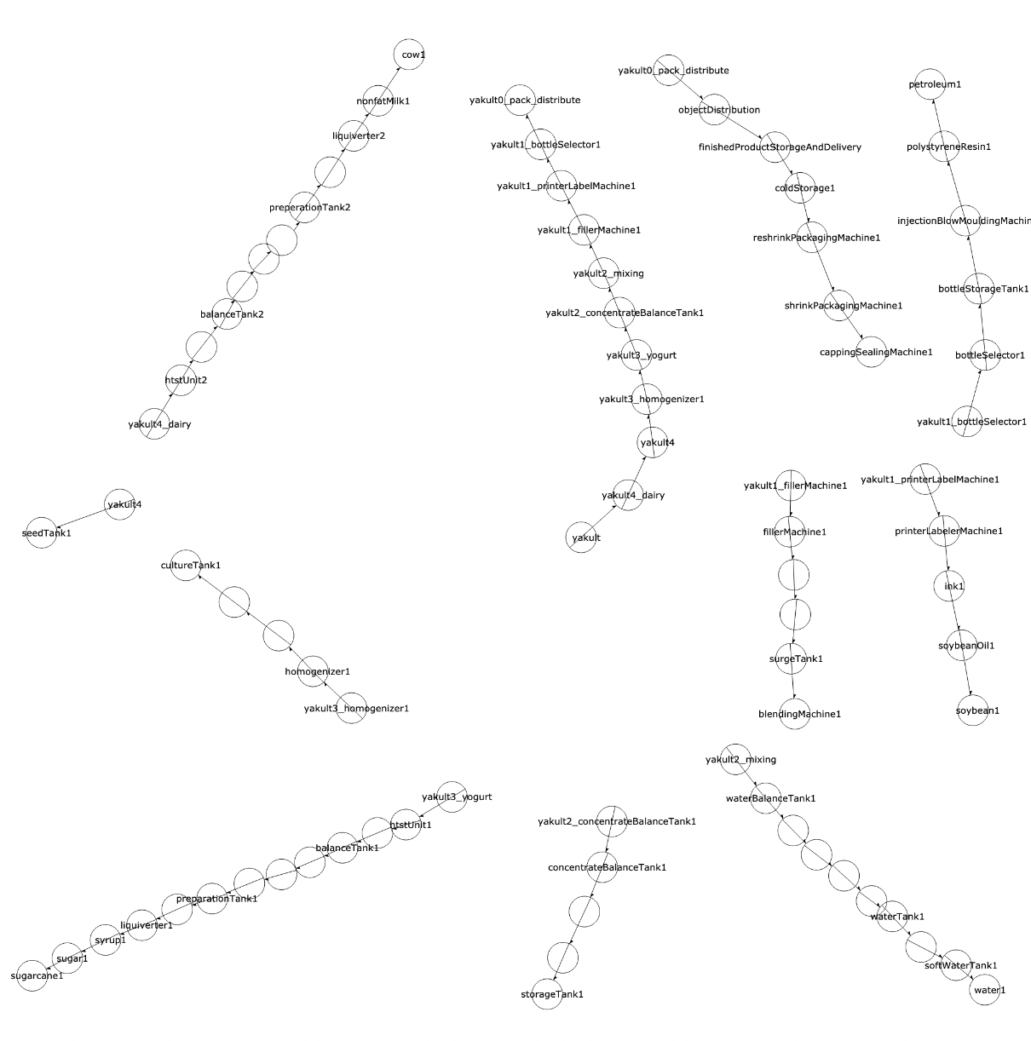
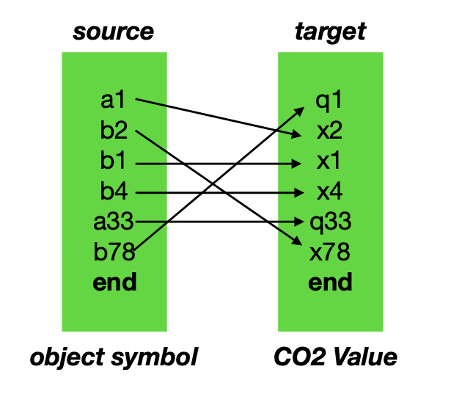
We provide a finite deterministic mapping of objects between model domains.

In production we may describe the actions of a machine, as in:
Machine + Protocol. In our model, instead of being domain restricted, we can use general terms, 'Object', and 'Behavior' of the object.

The Symbols which we use, that represent positions in the chain, can only have one CO2 value. If an object may have multiple CO2 values, it is necessary to create multiple symbols. For example,
Person_DriveCar1 Person_DriveCar2

