1. The ID number and the gender of the students are partly show out.



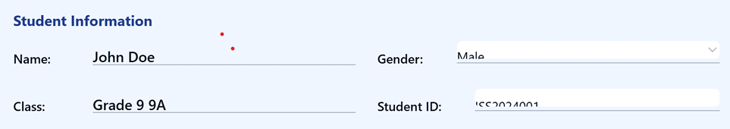



1. Academic year and term partly show out.





1. Class teacher and principles signature is partly show out.

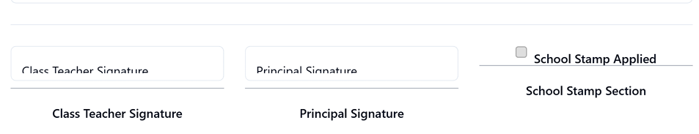



1. After downloading, the download PDF Actions cancel, and upload functions must not be appeared.

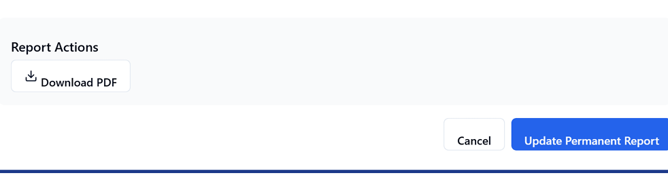



1. The last sentences are partly show out.

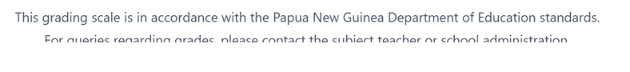



1. After printing, the whole words and sentences must be with in the body of the document as word document