This is the page after clicking on ‘Plan’ icon at the bottom. It shows future plans and past plans.

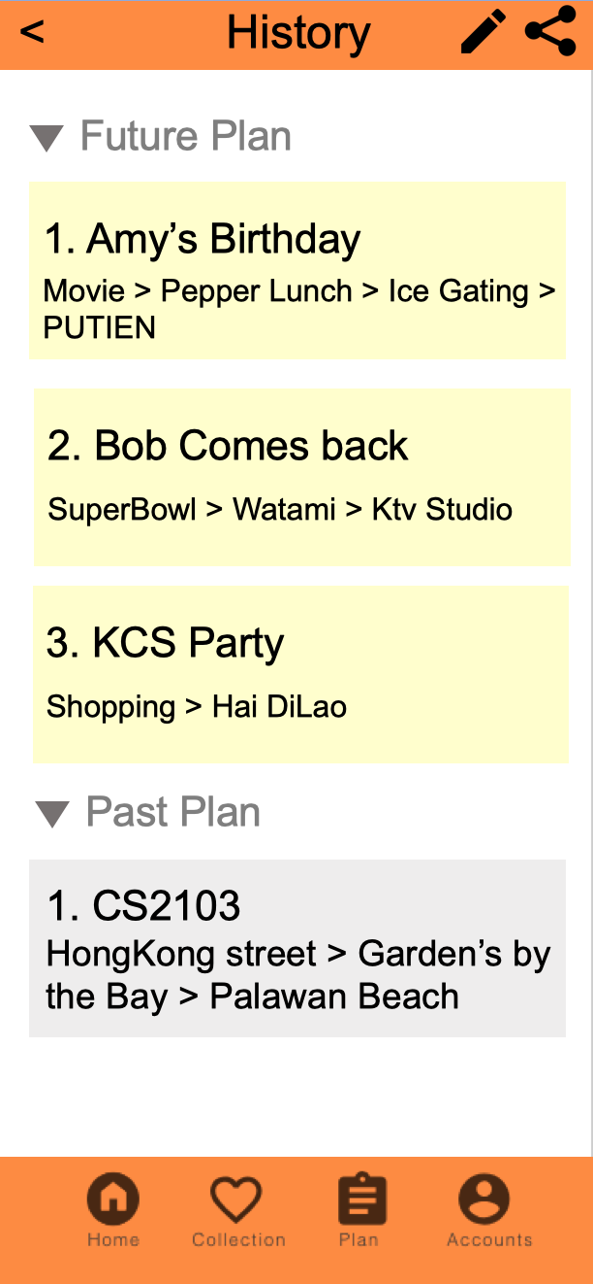

User can drag the location on the left panel into the schedule on the right panel. He can also adjust the timing of events by drag the event up and down.

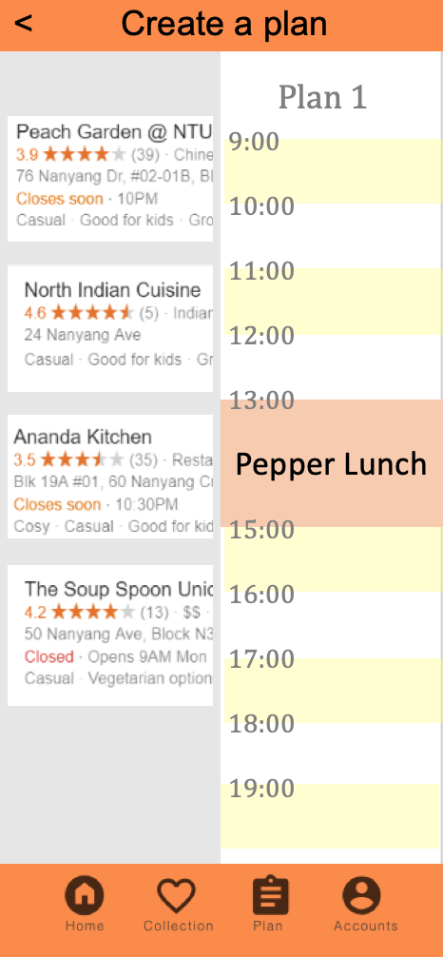

By clicking on ‘Plan 1’, the application generates a plan for user. User can edit it or share to Telegram, WhatsApp or Facebook.

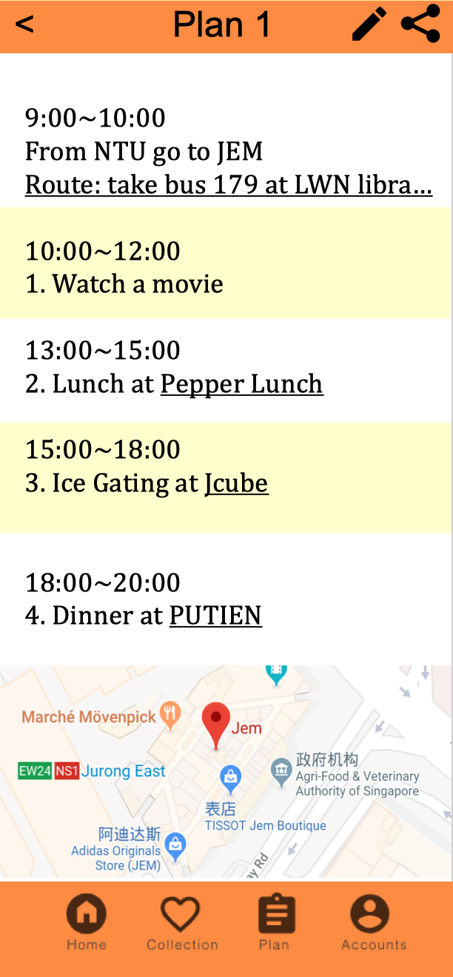

This is the page after clicking on ‘Account’ icon at the bottom. User can edit profile and settings here.

