**UNIVERSITY OF WOLLONGONG AUSTRALIA**

**School of Computing and Information Technology**

Object Oriented Design and Programming

Subject code: CSIT121

Assignment 1 - Autumn Session 2024

Instructor: Dr Fenghui Ren

Student name: Nguyen Van Binh

Student number: 8568418

Topic: Program for user can input the new projects, organizations, companies, and categories.

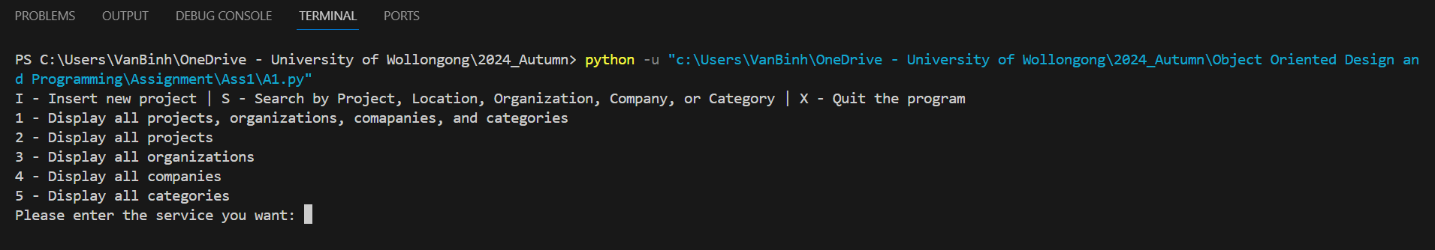

At the beginning of the program, the program has 8 functions such as “Insert new project”, “Search by project title, location, organization name and role, company, category name, and achievement”, “Quit the program”, “Display all projects, organizations, companies, and categories”, “Display all projects”, “Display all organizations”, “Display all companies”, and “Display all categories”. Users can choose a function by clicking the letter and number that is written before the function (including upper cases and lower cases).

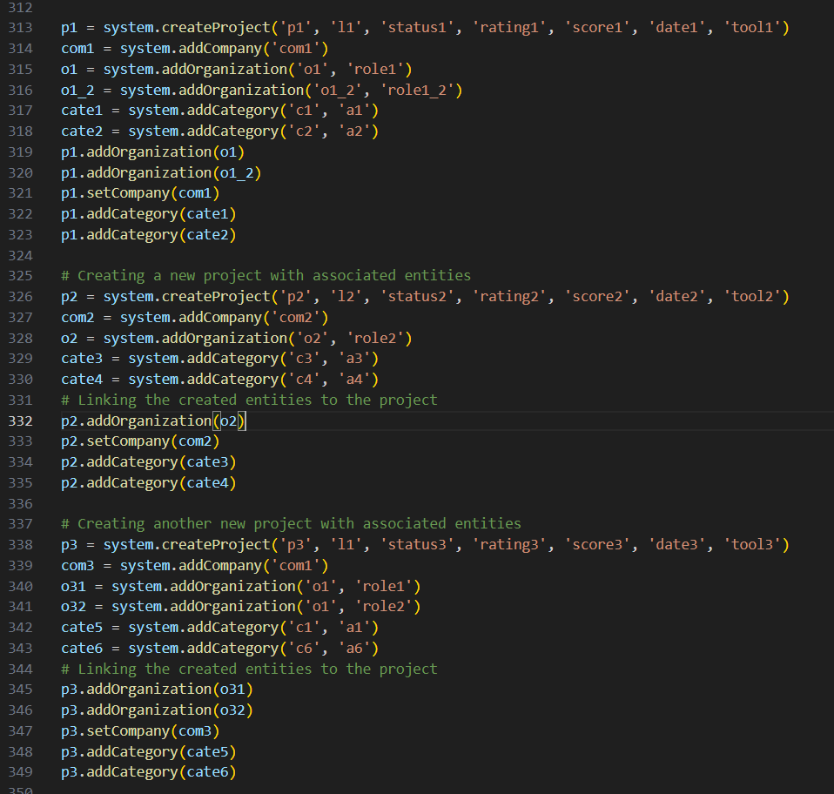

I created manually the first instance including a project, a company, two organizations, and two categories. Then I use AI of ChatGPT to create similar instances. Next I will use these 3 instances to test all functions of my code.

These 5 pictures are 5 functions that are used to display projects, and organizations,… depending on the requirement of the user.

After that, I will use the function “Insert” and input the data in the first picture. When completing the “Insert” function I use the “Display all projects, organizations…” function to check whether my data from input had been created and added to the program.

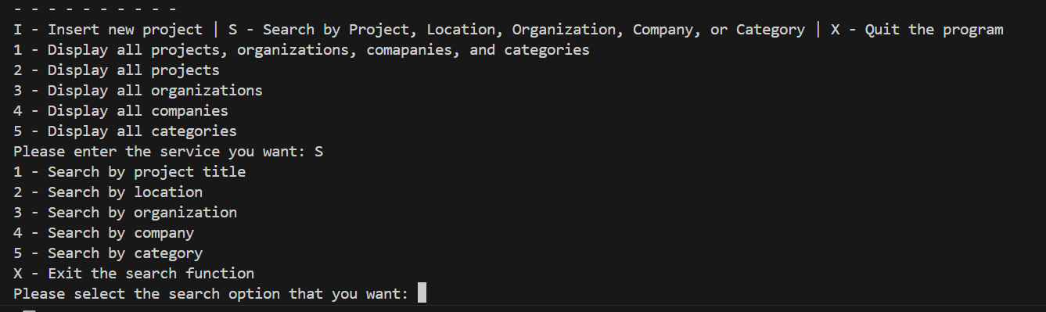

When choosing the “Search” function, the program will display more than 6 functions including search by project title, location, organization, company, category, and the “Exit” function to exit the search function and go back to the beginning services of the program. The search function will run repeatedly until the user choose the “Exit” function.

As the picture I use search by project title and search the title “p1” and “p2” respectively.

This is search by location and location l1 has 2 projects “p1” and “p3”, l2 and l4 have just had the project “p2” and “p4” respectively.

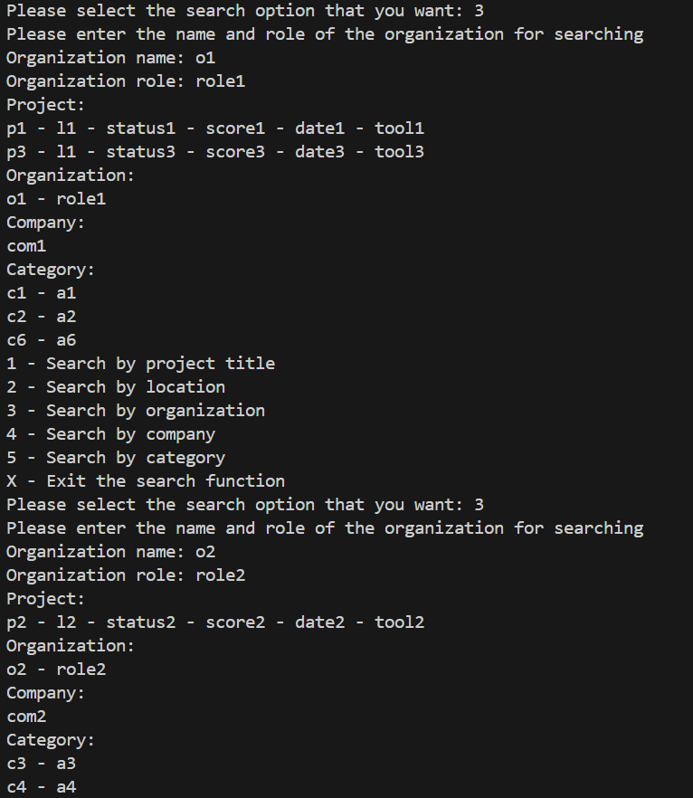

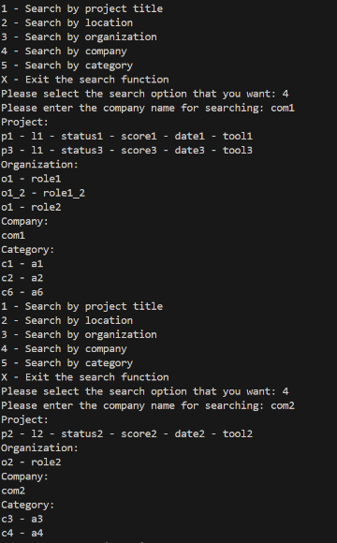

These pictures are “Search” function by category, company, and category respectively.

These are some examples the user inputs project title, location, or company that does not exist and the program cannot find relevant information on the data the user inputs.

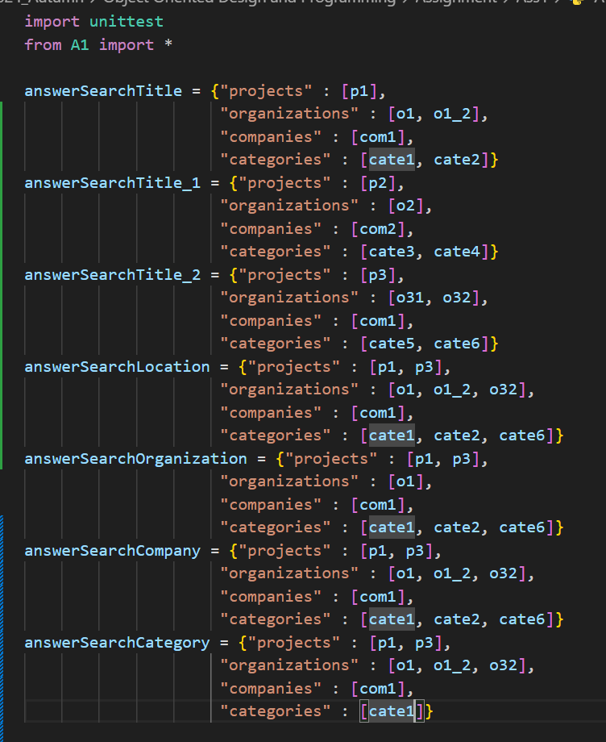

These are unittest program to test my code. To implement the A1_unittest.py, let a comment from lines 351-435. I make a test case for all “Search” functions and especially find 3 separated projects by function “seachByProjectTitle”.

This is the UML diagram for my program. The diagram illustrates the system used to control objects including Project, Organization, Company, and Category. All this objects are contained in the array of systems. The system has some functions for creating objects, searching objects by the requirement of the user, and displaying objects. Projects is the general object and has a unique title so it can be identified by its title which contains 3 remaining objects Organization, Company, and Category. A project can have many organizations and categories but it just can have one company. However, an organization, a company, and a category can belong to many projects.

Project class includes attributes title, location, status, rating, score, date, tool which are string data type, company is Company class, and organizations, categories are a list of Organization class and Category class respectively. Methods addOrganization(Organization), setCompany(Com), and addCategory(Category) used to add objects that belong to the Project. Methods getTitle(), getLocation(), getStatus(), getRating(), getScore(), getDate(), getTool(), getOrganization(), and getCompany(), are used to get the attributes of the Projects class. checkOraganization(name, role) and checkCategory(name, achievement) return boolean value, they check whether the object organization or category belongs to the project. Finally, getAllAttributes() is used to concat all attributes of the project and return to print it to the screen.

Organization class has attributes including name and role. Method getName() and getRole() return the name and role of the organization object, and getAllAttributes() returns the concatenation of all attributes.

Company class just has an attribute name and a method getName().

Organization class has category_name and achievement for attributes. Method getName() and getAchievement() return category_name and achievement, getAllAttributes() returns the concatenation of all attributes of the category.

System class contains attributes that include projects, organizations, companies, and categories which are a list of Project, Organization, Company, and Category. Method createProject(…), addOrganization(…), addCompany(…), and addCategory(…) create objects. checkProjectTitle(…) to guarantee the title is unique. 5 methods find all relevant information of the user’s requirement. 5 display methods to print the relevant information of requirement. printSearchResult() displays the list of results that are gained from search functions. userInput prints the service for the user and gets the information of the user to create the data.