**UNIVERSITY OF WOLLONGONG AUSTRALIA**

**School of Computing and Information Technology**

Object Oriented Design and Programming

Subject code: CSIT121

Assignment 2 - Autumn Session 2024

Instructor: Dr Tianbing Xia, Dr Fenghui Ren, and Mr Kevin Malysiak

Student name: Nguyen Van Binh

Student number: 8568418

Topic: A program allows users to input new projects, organizations, companies, and categories by an input file and export the result to an output file by I/O file mechanism and can handle Python exceptions.

At the beginning of the program, the program has 8 functions such as “Insert new project”, “Search by project title, location, organization name and role, company, category name, and achievement”, “Quit the program”, “Display all projects, organizations, companies, and categories”, “Display all projects”, “Display all organizations”, “Display all companies”, and “Display all categories”. Users can choose a function by clicking the letter and number that is written before the function (including upper cases and lower cases).

I created the first sample and then used ChatGPT to create 20 samples with different attributes (I modified some samples to make them similar in some attributes to have dynamic and interesting results when using the searching function) in the input file “input.txt”, the user can modify any attributes in the project, and add or remove projects, organizations, companies, or categories,… in the input.txt. The program will read and save the data of input.txt to the system to serve the functions of the system.

These 5 pictures are 5 functions that are used to display projects, organizations, companies, and categories… depending on the requirement of the user.

After that, I will use the function “Insert” and input the data in the first picture. When completing the “Insert” function I use the “Display all projects, organizations…” function to check whether my data from input had been created and added to the program.



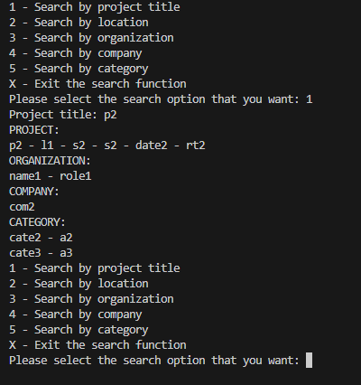



As the picture I use search by project title and search the title “p1” and “p2” respectively. The output will be displayed on the terminal and txt file (output.txt) with 2 different forms).

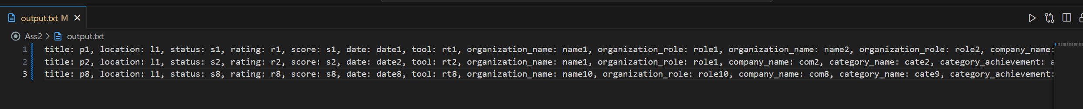



As in the picture, the program searches by location and searches the location “l1” and l3” respectively.

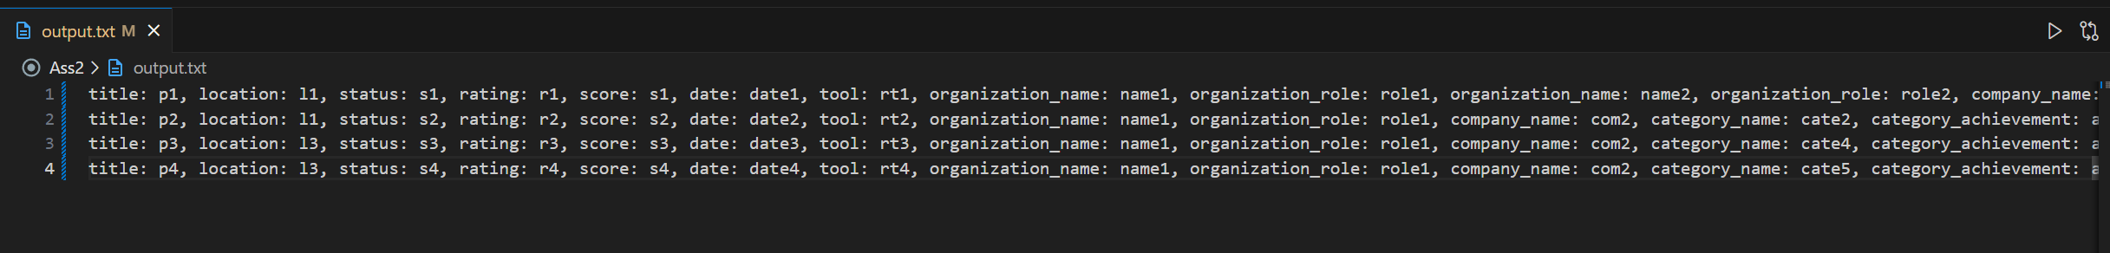

As in the picture, the program searches by organization with its name and role are “name1” and role1” respectively.

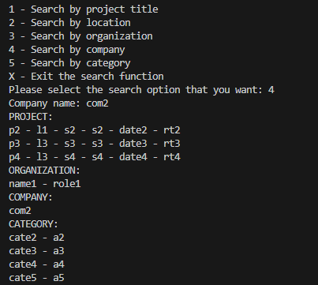



As in the picture, the program searches by company with its name is “com1”.

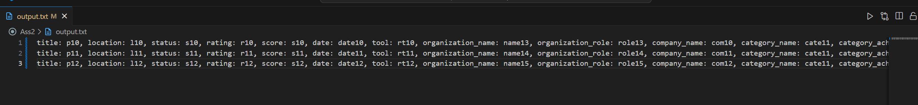

As in the picture, the program searches by category with its name and achievement are “cate11” and “a11” respectively.

These are some examples the user inputs project title, location, or company that does not exist and the program cannot find relevant information on the data the user inputs.

The input.txt has some errors like the project has the same title with existing one or some titles are empty so the program still run and have some exceptions of those lines to eliminate them from import data to system.

I created some sample in txt file to run unittest. To implement the A2_unittest.py, let comment from lines 779-782. I make test cases for all “Search” functions.

This is report which is created by coverage command.

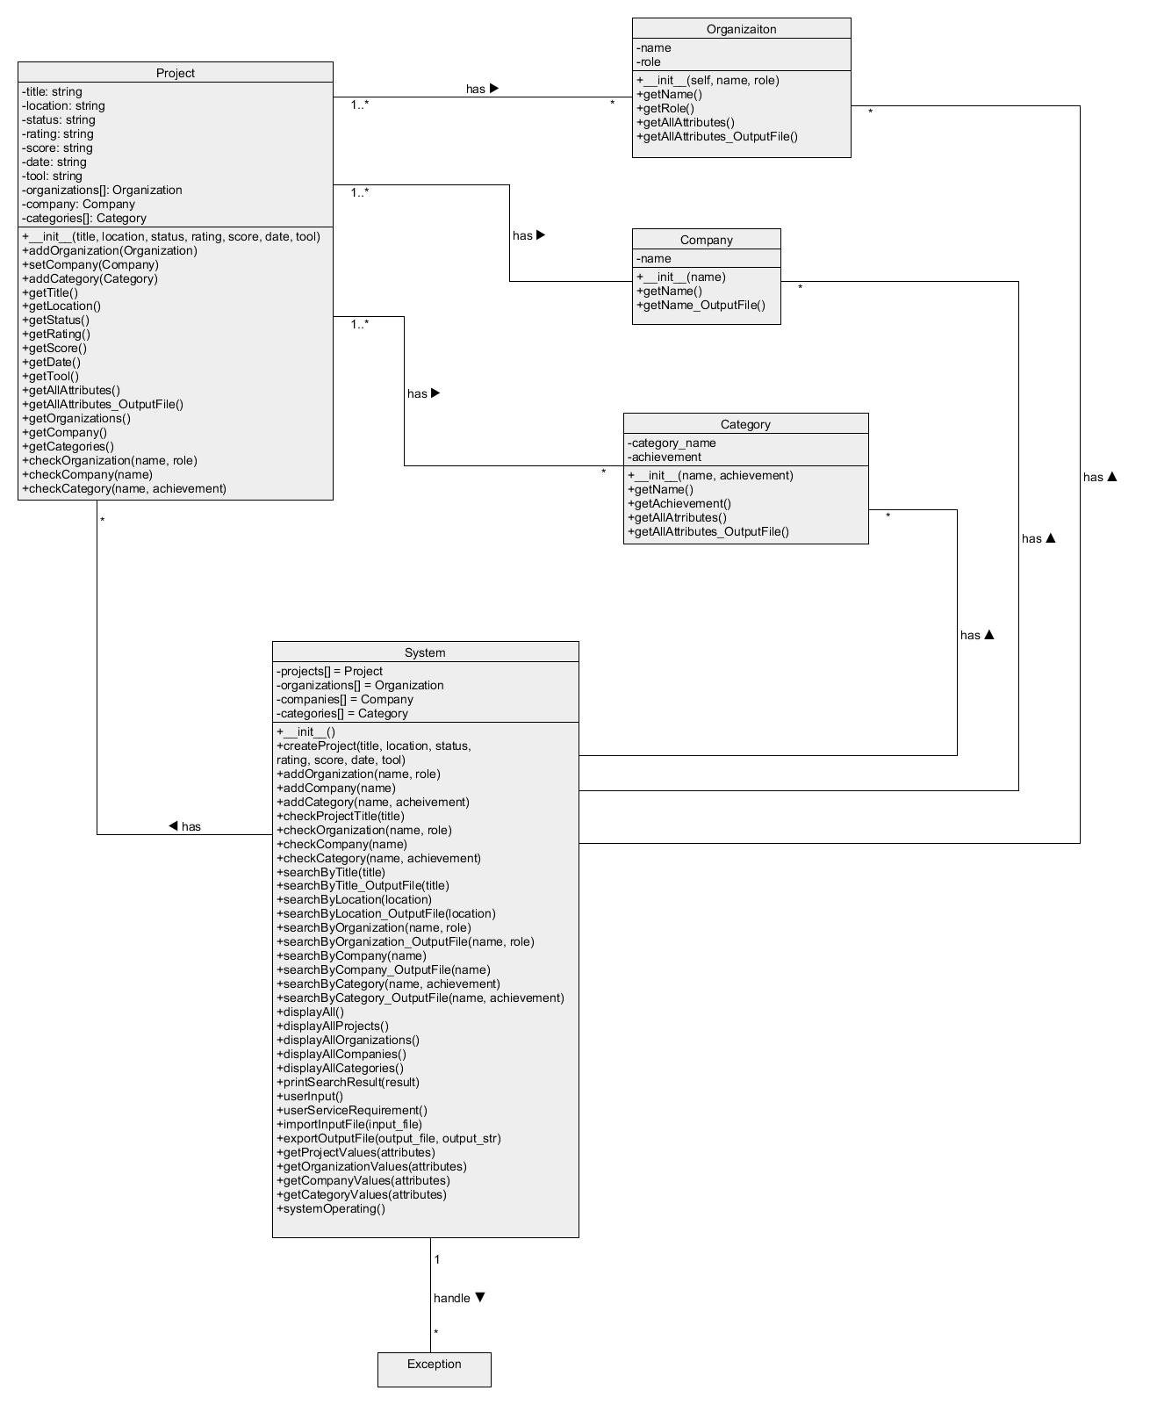

This is the UML diagram for my program. The diagram illustrates the system used to control objects including Projects, Organizations, Company, and Category. All these objects are contained in the array of systems. The system has some functions for creating objects, searching objects by the requirement of the user, and displaying objects. Projects is the general object and has a unique title so it can be identified by its title which contains 3 remaining objects Organization, Company, and Category. If the user set the project’s title which same as exist one, the system will requre user to input again. A project can have many organizations and categories but it just can have one company. However, an organization, a company, and a category can belong to many projects.

Project class includes attributes title, location, status, rating, score, date, tool which are string data type, company is Company class, and organizations, categories are a list of Organization class and Category class respectively. Methods addOrganization(Organization), setCompany(Com), and addCategory(Category) used to add objects that belong to the Project. Methods getTitle(), getLocation(), getStatus(), getRating(), getScore(), getDate(), getTool(), getOrganization(), and getCompany(), are used to get the attributes of the Projects class. checkOraganization(name, role), checkCompany(name) and checkCategory(name, achievement) return boolean value, they check whether the object organization or category belongs to the project. Finally, getAllAttributes() is used to concat all attributes of the project and return to print it to the screen, and getAllAttributes_OutputFile() is used to return the concatenation string for displaying in the output-file.

Organization class has attributes including name and role. Method getName() and getRole() return the name and role of the organization object, getAllAttributes() returns the concatenation of all attributes, and getAllAttributes_OutputFile() returns the string to display on the output-file.

Company class just has an attribute name and a method getName().

Organization class has category_name and achievement for attributes. Method getName() and getAchievement() return category_name and achievement, getAllAttributes() returns the concatenation of all attributes of the category, and getAllAttributes_OutputFile() returns the string to display on the output-file.

System class contains attributes that include projects, organizations, companies, and categories which are a list of Project, Organization, Company, and Category. Method createProject(…), addOrganization(…), addCompany(…), and addCategory(…) create objects. checkProjectTitle(…) to guarantee the title is unique. 5 methods find all relevant information of the user’s requirement. 5 display methods to print the relevant information of requirement. printSearchResult() displays the list of results that are gained from search functions. userInput() prints the service for the user and gets the information of the user to create the data. The function userServiceRequirement() is used to get the require from the user and for repeat until user enter ‘X’ or ‘x’. systemOperating() contains userServiceRequirement() and have some exceptions to handle errors of the program to help it can run although meet error. importInputFile(…) is used to read and analyze data and put data to the system. getProjectValues(attributes), getOrganizationValues(attributes), getCompanyValues(attributes), and getCategoryValues(attributes) help the import the input-file. Finally, the exportOutputFile(output_file, output_str) receive the result from the import function and write it again to the output-file.