From Statistical Analysis to Physics-Informed Reconstruction
A Diffusion-Based Framework for Surface PM2.5 Estimation
- Summary of Published Academic Work
Journal 1: Exploiting the Results of Running the GEOS-CF Model to Evaluate PM2.5 Concentration in Near Real-Time in Vietnam. Published: Journal of Hydro-Meteorology, 2024
In this study, the authors focused on creating a tool to visualize and interpret global air quality data specifically for the entire territory of Vietnam.
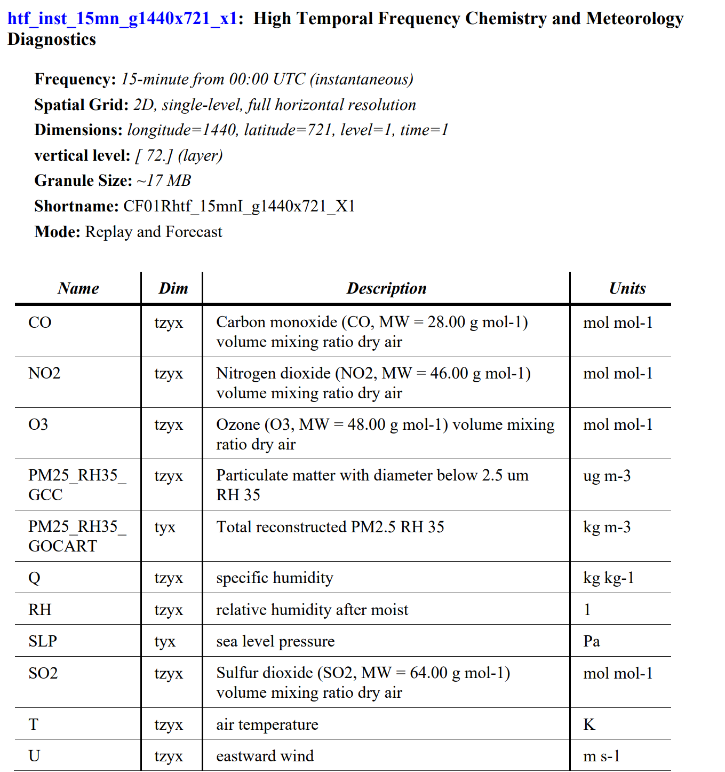
Objective: The goal was to exploit the "GEOS-CF" (Goddard Earth Observing System Composition Forecast) model provided by NASA to build hourly $PM_{2.5}$ pollution maps for Vietnam. The authors aimed to provide near real-time information to help forecast air quality and manage environmental disasters.
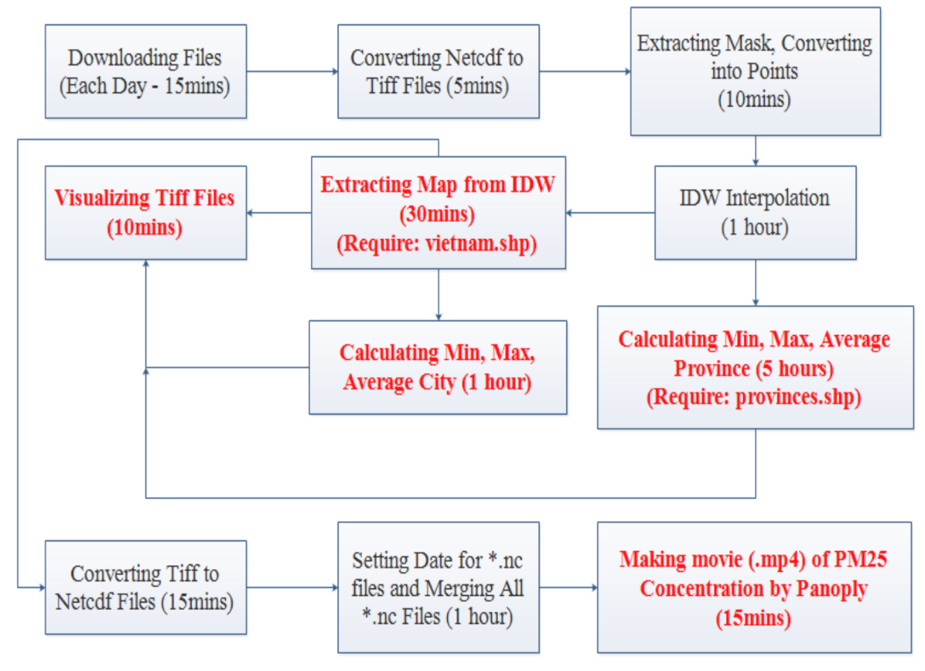
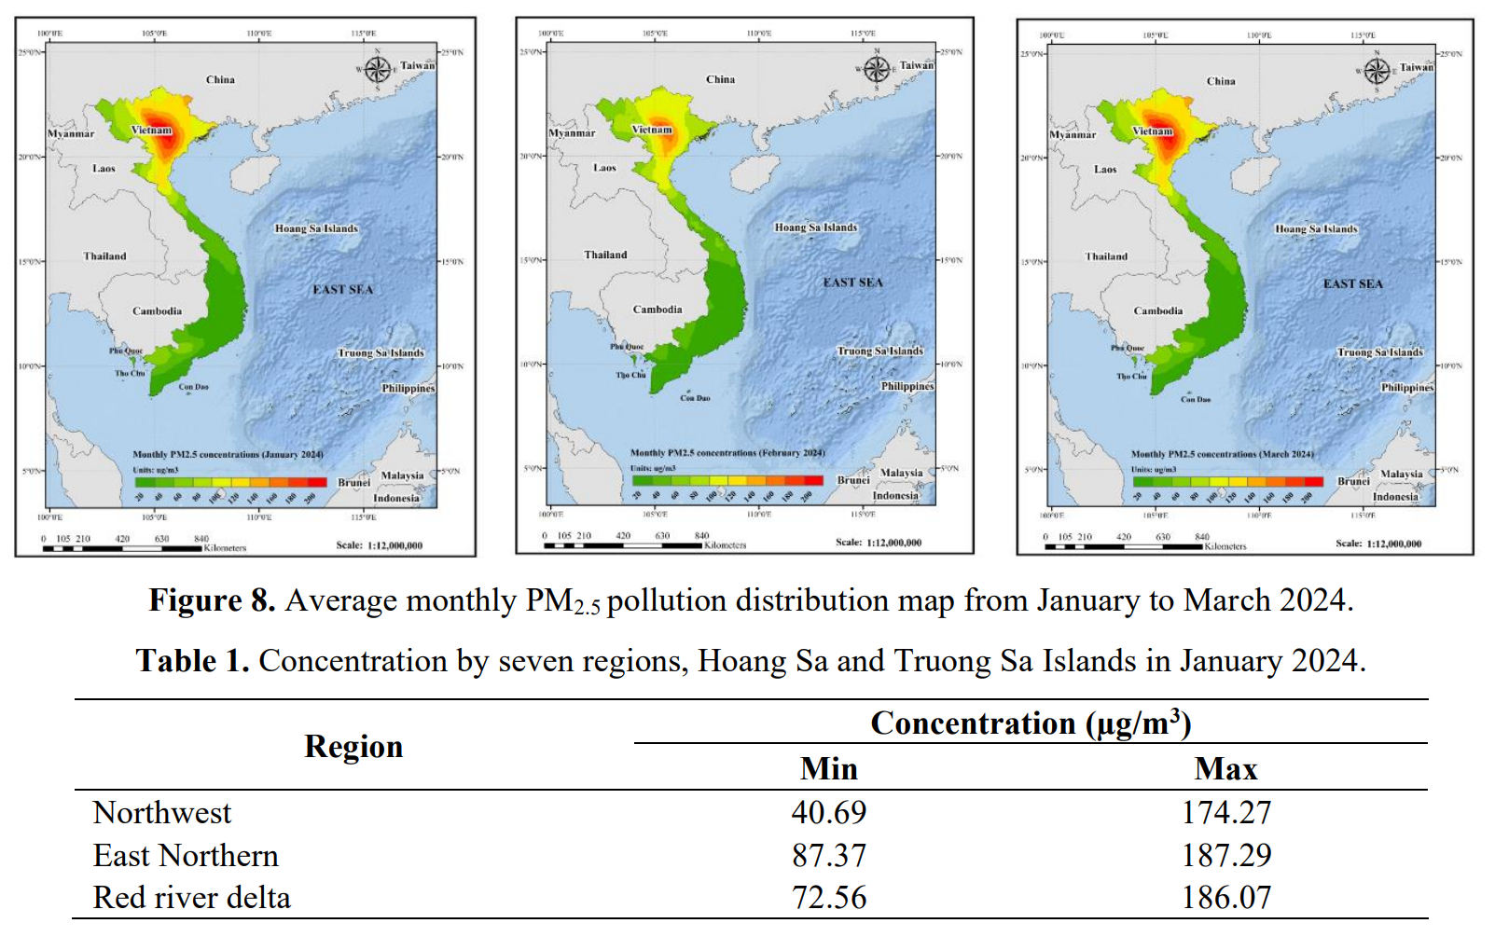

Journal 2: Exploiting the Results of Running the GEOS-CF Model to Evaluate PM2.5 Concentration in Near Real-Time in Vietnam. Published: Journal of Hydro-Meteorology, 2024
Title: Developing PM2.5 mitigation solutions based on the analysis of the relationships between PM2.5 concentrations and precursor factors: a case study of Hanoi, Vietnam
Published: Asian Journal of Atmospheric Environment, 2025
This study narrowed the scope to Hanoi to understand why pollution occurs by analyzing the chemical precursors and meteorological factors contributing to $PM_{2.5}$.
Objective: The study aimed to identify $PM_{2.5}$ cluster regions based on precursor emissions and propose mitigation solutions by clarifying the relationship between pollution concentrations, emissions, and meteorology.
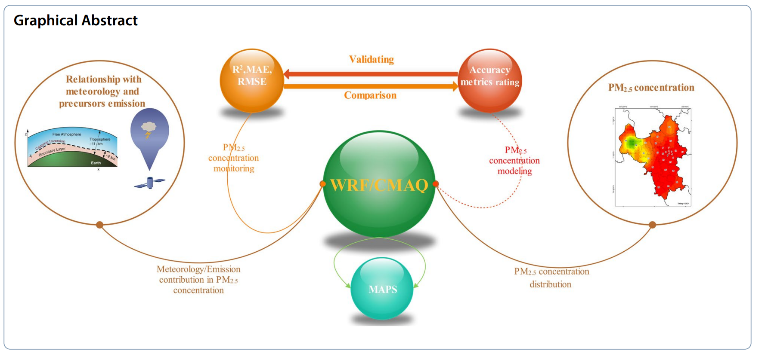
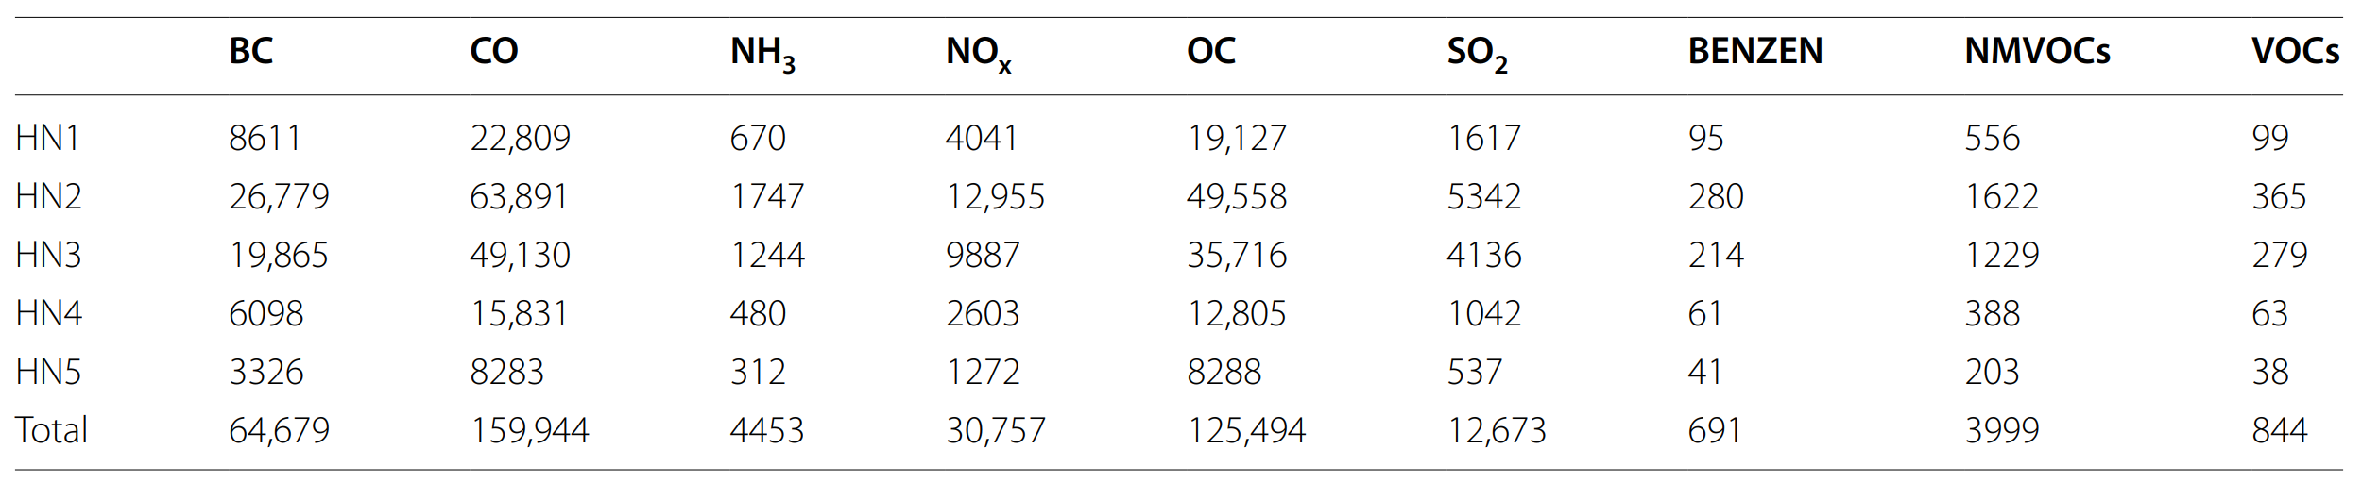
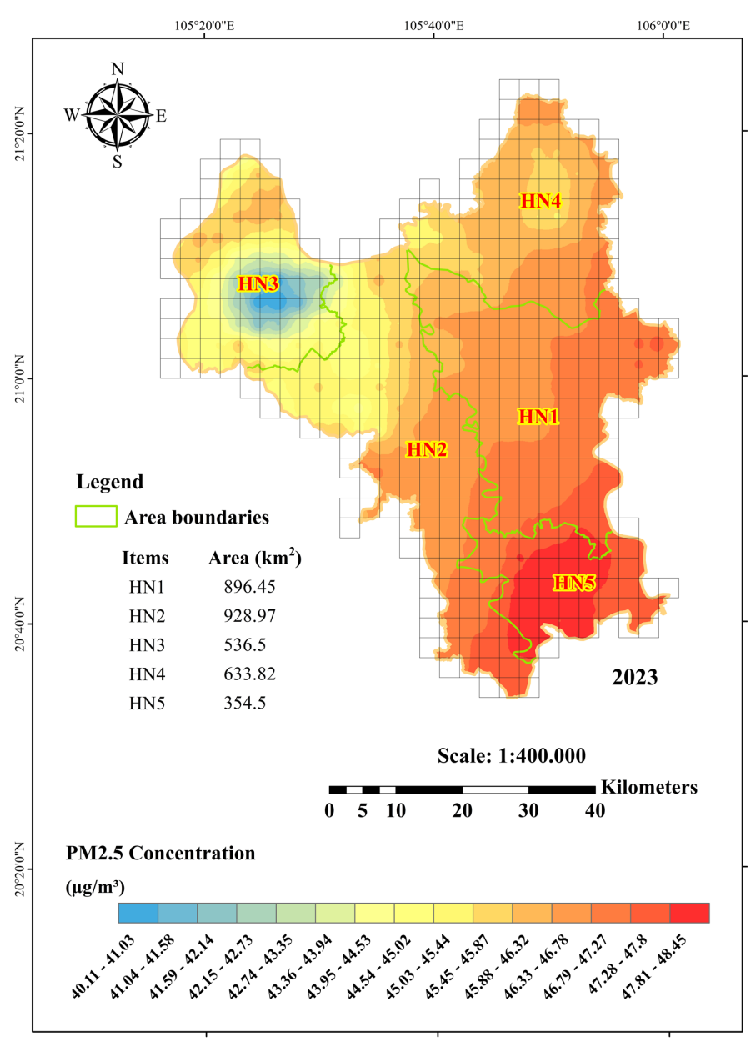
- Motivation for a Physics-Informed Reconstruction Framework
PM2.5 is governed by physical processes including advection, turbulent diffusion, emission injection, and atmospheric dilution. Ignoring these mechanisms limits the reliability and interpretability of PM2.5 estimation.
To address the limitations of both statistical and purely data-driven approaches, this study proposes a diffusion-based reconstruction framework that integrates:
- Physical transport mechanisms
- Emission source information
- Meteorological drivers
- Ground-based observations
- Global chemical background constraints
The goal is not merely to predict PM2.5, but to reconstruct a physically consistent surface PM2.5 field over the entire study region.
2.1. State Variable: Let $C\left(x,y,z\right)=$ surface $PM_{2.5}$ concentration
2.2. Governing Equation (Core Diffusion Model)
Lagrangian Particle Transport – Advection and Diffusion
$$\frac{∂C}{∂t}=-∇⋅(\vec{u}C)+∇⋅(K∇C)+E(x,y,t)-D(x,y,t)$$
Where:
- $\vec{u}(x,y,t)$: wind field (from MCIP)
- $K(x,y,t)$: turbulent diffusivity
$$K=α⋅u_{*}⋅h_{PBL}$$
- $E$: emissions (ANT + AIR + BIO)
- $D$: deposition (optional parameterization)
2.3. Initial Condition:
$$C(x,y,t_{0})=C_{\text{GEOS-CF}}(x,y,t_{0})$$
This ensures chemical realism at large scale.
2.4. Emission Modulation (Critical)
$$E_{\text{eff}}=E⋅f(u,h_{PBL},\text{stability})$$
$$f=\frac{1}{1+βu}⋅\frac{1}{h_{PBL}}$$
2.5. Sensor Assimilation
At sensor locations:
$$C^{a}=C^{f}+K_{g}(C^{obs}-HC^{f})$$
Where:
- $C^{f}$: forecast (physics-only)
- $C^{obs}$: sensor PM2.5
- $H$: observation operator
- $K_{g}$: gain matrix
Gain weighting:
$$K_{g}∝\exp\left(-\frac{d^{2}}{L^{2}}\right)⋅\exp\left(-\frac{θ^{2}}{σ_{θ}^{2}}\right)$$
(distance + wind direction)

