Items

# Pernament items:

Ores and bars: Use Furnace to convert ores to bars

+Nickle

+Aluminium

+Copper

+Cobalt : atomic number : 27. Used for making powerful magnets

+Molybdenum : A silvery metal, Molybdenum is in the top ten of metals with highest melting points. Most of the world production of the element(about 80%) is used in stainless steel and many superalloys. It also used for catalysts and glass manufactoring

+Boron

+Iridium

+Lead

+Gold: having a shiny yellow color. Used to make jewelry and it’s a stable currency

+Tungsten(Vonfram). Used for making light bulbs.

+Iron

+Titanium : same stiffness with Al, twice as light as steel

**Log:** “Currently, the forest area has decreased drastically, so you should save wood for more useful purposes. For a green earth!”

**Stone**: “Stone is a resource that can be found in limited quantities on the ground. Long time ago, human beings have known how to craft stone tools. Today, people use stones for make roads, manufacture lime and cement, contruct wall, floor, for cladding purposes ”

Cog

Screw

Microchip

Tempered glass

Wire

**Steel** : Steel is an alloy with the main composition being iron (Fe), with carbon (C), from 0.02% to 2.14% by weight, and some other chemical elements(Ni, Si , Mo, Mg, Cr…) to adjust stiffness, elasticity, Anti-oxidation ability, durability. There are so many many types of steel, some popular are : Stainless steel(containing more than 10% Crom), Carbon steel(containing low amount of other alloying elements), Tool steel(excel in cutting and drilling equipment)

**Amber(Hổ phách)** :

VI : Hổ phách là loại nhựa cây hóa thạch có tuổi hàng triệu năm được tìm thấy trong các cây cổ thụ lâu năm. Do dễ mài dũa và cắt gọt nên hổ phách đã trở thành nguyên liệu quý cho ngành thủ công mỹ nghệ

EN: Amber is a fossil tree resin that is millions of years old and is found in old trees. Because of its ease of sharpening and cutting, amber became a precious material for the handicraft industry.

**Amethyst(thạch anh tím):**

This stone is often used in improving health and healing. For those who are often stressed due to high work pressure or insomnia, regularly wearing amethyst will help you overcome stress and have a better sleep. Beside reducing stress, energy from amethyst makes a good impact on brain, help you amend memory, enhance concentration. Therefore, it's good for white-collar workers. Amethyst is also well-known for its spiritual and feng shui values.

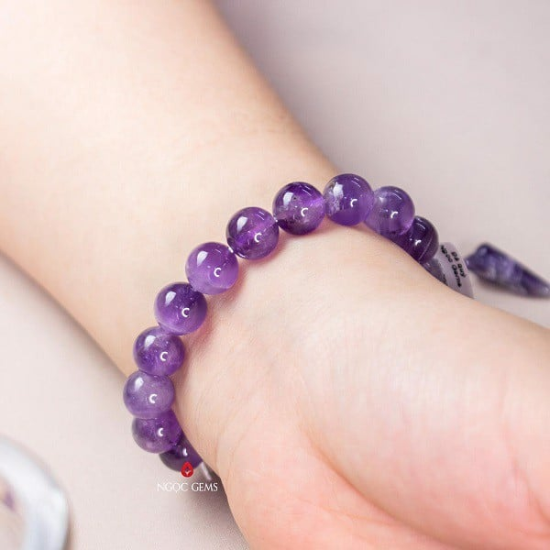

# Temporary items:

Definition: items that can be found and used only in battlefield

First Aid Kit