MINISTRY OF EDUCATION AND TRAINING
FPT UNIVERSITY

Efficient and Explainable Automation of Medical Purchase Order Processing using a Retrieval-Augmented Generation Framework
by
Nguyen Van Tuan
A thesis submitted in conformity with the requirements
for the degree of Master of Software Engineering

© Copyright by Nguyen Van Tuan 2025
MINISTRY OF EDUCATION AND TRAINING
FPT UNIVERSITY

Efficient and Explainable Automation of Medical Purchase Order Processing using a Retrieval-Augmented Generation Framework
by
Nguyen Van Tuan
A thesis submitted in conformity with the requirements
for the degree of Master of Software Engineering

Supervisor:
Assoc. Prof. Phan Duy Hung
Dr. Vu Thu Diep
© Copyright by Nguyen Van Tuan 2025

Abstract
In healthcare, accurately mapping materials from purchase orders into the SAP system is a critical but challenging operational task, often fraught with inefficiencies and errors. To address the limitations of manual handling and conventional automation, we introduce a multi-modal Retrieval-Augmented Generation framework. The proposed system is designed to capture the contextual complexity of healthcare supply chains by integrating information from heterogeneous sources, including textual descriptions, product specifications, and images. We evaluate the framework on a dataset of 102 real-world purchase orders, demonstrating significant improvements in both efficiency and accuracy compared to existing approaches. Furthermore, the system enhances trustworthiness by incorporating explainable AI mechanisms, ensuring transparency in decision-making. Our findings highlight the potential of the proposed framework to provide an intelligent, scalable, and reliable automation solution for material management workflows in healthcare facilities.
Keywords: Retrieval-Augmented Generation, Healthcare supply chain, Purchase order processing, SAP integration.

Acknowledgments
I would like to express my deepest gratitude to my supervisor, Assoc. Prof. Phan Duy Hung and Dr. Vu Thu Diep, for their invaluable assistance, guidance, and insightful feedback throughout the development and writing of this thesis.
I am particularly grateful to all members of staff at the FTP School of Business & Technology for their kind support during my master study.

List of Figures
Figure 1. Example of a purchase order 7
Figure 2. Purchase order workflow 7
Figure 3. Comparative Evaluation of Retrieval Models 10
Figure 4. Overall Architecture 18
Figure 5. Representative Purchase Order Formats from the Dataset 23
Figure 6. Implementation stages: Stage 1: Query Understanding and AI Enhancement; Stage 2: Multi-Vector Retrieval and Safety Validation; Stage 3: Response Generation and Enrichment 26

List of Table
Table 1. Multi-collection weight hyperparameters 27
Table 2. Comparative Evaluation of Retrieval Models on the Pharmaceutical Dataset 28

Table of Contents
Acknowledgments 2
List of Figures 3
List of Table 4
Table of Contents 5
Chapter 1 Introduction 6
1.1. Problem And Motivation 6
1.2. Related Works 8
1.3. Contribution 10
1.4. Thesis structure 11
Chapter 2 Background Study 12
2.1. Natural Language Processing 12
2.2. Data mining 13
2.3. Evaluation Metrics 14
Chapter 3 System Design 17
3.1. System Architecture 17
3.2. Data Preprocessing 18
3.3. Multi-Vector Retrieval and Knowledge Core 20
3.4. Validation, Enrichment, and Response Generation 21
Chapter 4 Experiments And Results 23
4.1. Dataset 23
4.2. Implementation Detail 24
4.3. Results 27
4.4. Conclusion And Future Work 28
References 29

Introduction

Problem And Motivation
The precise mapping of materials from external purchase orders (POs) to an enterprise's internal SAP system is an absolutely critical, though often overlooked, function within the healthcare supply chain. While the potential for automation in this area is vast, so too are the significant technical and operational challenges that must be addressed [1]. The workflow typically begins when a pharmaceutical retailer places an order through a web portal, which is then automatically transmitted to the distributor via an email folder or, in more integrated setups, through an Electronic Data Interchange (EDI) channel. This automated reception, however, marks the beginning of a significant manual bottleneck.
Before a sales order can be generated, customer service personnel must meticulously map several key data points from the incoming PO to the master data within the SAP Sales and Distribution (SD) module. This includes validating the customer code, the correct ship-to code, and, most critically, the specific material code for each line item. This mapping is not merely an identification step; it is the crucial trigger that unlocks a cascade of complex business logic. It allows the system to retrieve vital commercial information, such as customer-specific discounts, active bidding or contract pricing, and special promotional arrangements. Furthermore, each material is often subject to its own intricate set of rules for calculating tiered discounts or determining eligibility for bonus products (e.g., "buy-one-get-one" offers). Only after this meticulous, labor-intensive, and error-prone process of mapping and calculation is complete can a formal sales order be created and confirmed back to the customer.
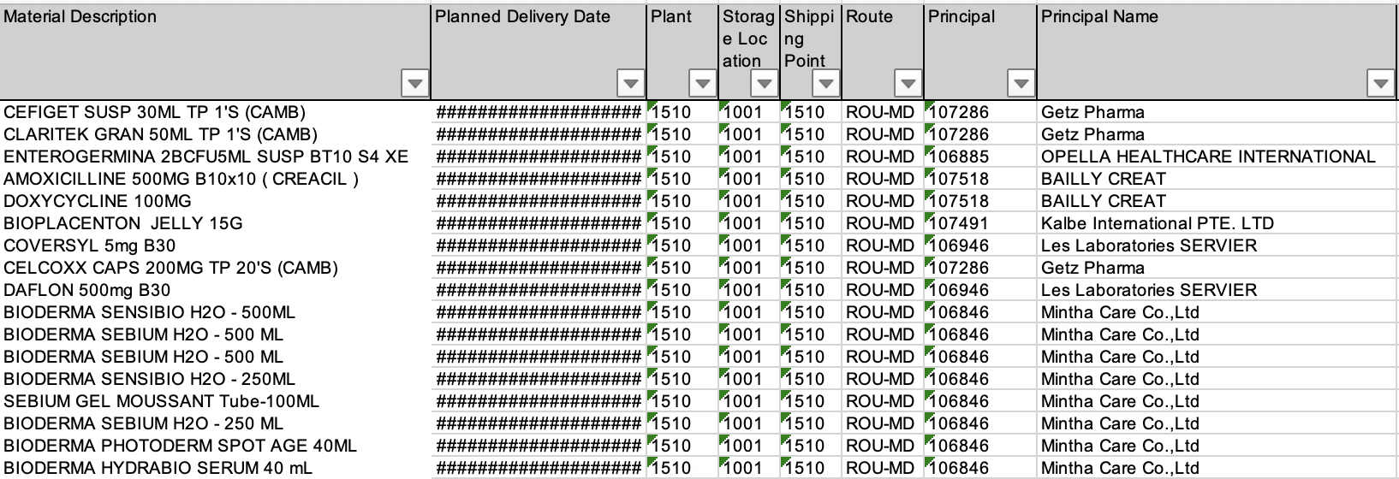
Figure 1. Example of a purchase order
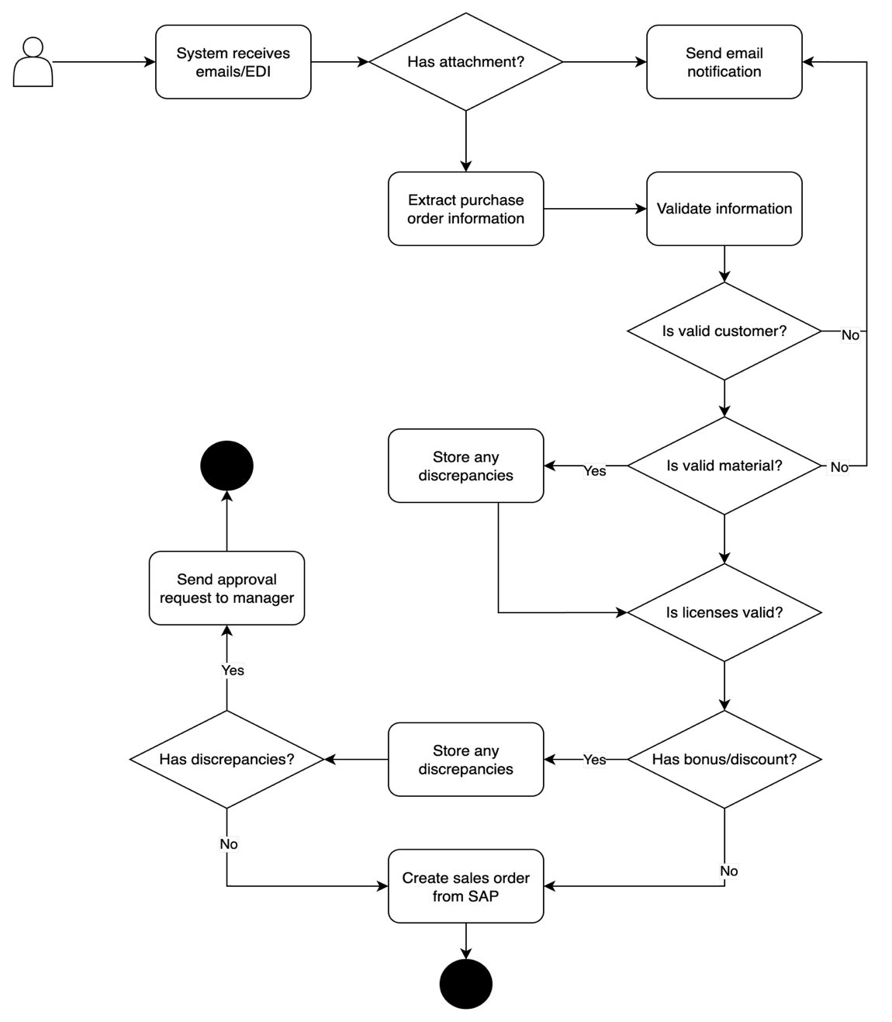
Figure 2. Purchase order workflow
A fundamental cause of this inefficiency lies in the profound semantic discrepancy between the material descriptions provided on supplier-generated POs and the standardized nomenclature maintained within the SAP database. This gap is the primary source of friction in the material code mapping step, where inconsistencies stemming from the use of brand names, manufacturer-specific abbreviations, and non-standardized terminology are a well-documented and pervasive source of mapping errors and rework [2, 3].
While previous automation efforts have been attempted, they have largely relied on conventional systems using rudimentary rule-based logic or simple text-matching algorithms. These approaches have repeatedly proven inadequate, as they lack the necessary contextual understanding to handle nuanced product variations and are highly unreliable when confronted with novel or colloquial product descriptions [4]. This failure underscores the need for a more intelligent and context-aware solution capable of bridging the complex semantic gap inherent in the pharmaceutical supply chain.

Related Works
The foundational concept of Retrieval-Augmented Generation (RAG), introduced by Lewis et al. (2020) [5], represented a pivotal advancement in enabling large language models (LLMs) to leverage external knowledge sources. While the original framework demonstrated strong effectiveness, subsequent research has focused on refining each stage of the RAG pipeline to address increasingly complex, real-world challenges. This evolution has transformed RAG from a simple retrieve-and-generate model into a sophisticated, multi-stage process.
Recent work emphasizes improvements even before the retrieval step, particularly through query transformation techniques that mitigate the semantic gap between user queries and source documents. For instance, large language models can expand an input query with additional context or generate a hypothetical document whose embedding guides retrieval, as in the Hypothetical Document Embeddings (HyDE) approach [6]. Other strategies decompose complex queries into smaller, more tractable sub-queries, enabling more effective information aggregation and synthesis [7, 8].
The retrieval stage itself has undergone a decisive shift toward hybrid search models. These approaches integrate the keyword-matching precision of sparse retrievers such as BM25 with the semantic generalization capabilities of dense vector retrievers. By combining scores from both methods—often through techniques like Reciprocal Rank Fusion (RRF)—systems achieve more robust and reliable retrieval, particularly in domains with specialized jargon [9, 10]. Retrieval quality is also closely tied to indexing strategies. Researchers have advanced beyond fixed-size chunking toward semantically informed segmentation methods that better preserve contextual relationships [11]. Further enhancements include enriching data chunks with metadata [12] and generating multiple embeddings per chunk (e.g., both a summary-level and full-text representation), thereby providing richer signals for retrieval alignment [13, 14].
To ensure that the highest-quality context is passed to the generator, post-retrieval re-ranking has become a standard practice. In this stage, a cross-encoder model—both powerful and computationally efficient—reorders the top candidates from the initial retrieval by performing a deeper semantic relevance analysis [15, 16]. While such techniques have achieved strong performance on open-domain benchmarks, their application to highly specialized industrial processes, such as healthcare material mapping, remains largely underexplored. This domain introduces unique challenges, including pervasive terminology inconsistencies and the requirement to integrate seamlessly with structured enterprise systems—factors for which generic RAG pipelines are not inherently optimized.
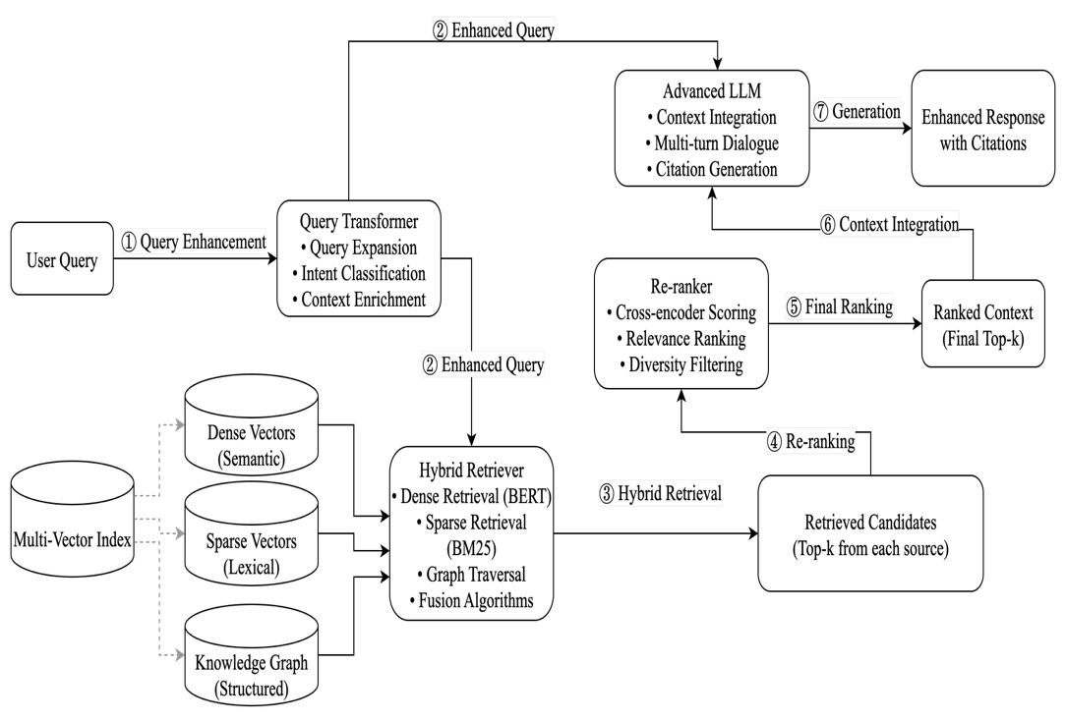
Figure 3. Comparative Evaluation of Retrieval Models

Contribution
While recent advancements in RAG have shown strong performance on general benchmarks, their application to specialized industrial domains such as healthcare supply chain management remains underexplored. This paper addresses this gap by tackling the unique challenge of mapping unstructured purchase order data to structured SAP entries. The main contributions of this work are as follows:
- Novel Application: We design and implement an advanced RAG pipeline, incorporating hybrid search and re-ranking, to address the specific industrial task of purchase order (PO) to SAP material mapping.
- Domain-Specific Optimization: We adapt and fine-tune model components on healthcare data to accurately interpret specialized product terminology, overcoming a key limitation of general-purpose systems.
- Empirical Validation: We evaluate the proposed system on a proprietary dataset of real-world purchase orders, demonstrating its practical effectiveness and establishing a benchmark for future research.

Thesis structure
We begin by reviewing the background literature in Section 2, followed by a detailed explanation of our system design in Section 3. We conclude with a discussion of our experimental results in Section 4.

Background Study

Natural Language Processing

Retrieval-Augmented Generation
The foundational concept of Retrieval-Augmented Generation (RAG), introduced by Lewis et al. (2020), represented a pivotal advancement in enabling large language models (LLMs) to leverage external knowledge sources. While the original framework demonstrated strong effectiveness, subsequent research has focused on refining each stage of the RAG pipeline to address increasingly complex, real-world challenges. This evolution has transformed RAG from a simple retrieve-and-generate model into a sophisticated, multi-stage process designed to enhance the contextual relevance and factual accuracy of generated responses.

Advanced RAG Pipeline
Modern RAG architectures have evolved into multi-stage pipelines that incorporate sophisticated techniques at each phase to maximize the quality of information provided to the generative model. Rather than a simple retrieve-and-generate process, these advanced frameworks emphasize a methodical flow involving pre-retrieval data preparation, query transformation, and post-retrieval refinement.
Data Enrichment and Multi-collection Indexing: The process begins not with retrieval, but with a robust ETL (Extract, Transform, Load) pipeline. Beyond simple data cleaning, this stage focuses on metadata enrichment, where documents are augmented with additional context and structured tags. In our system, this enriched data is then partitioned and indexed into multiple, semantically distinct collections within the vector database (e.g., primary, clinical, synonyms, symptoms). This multi-collection strategy provides richer and more diverse signals for retrieval alignment, allowing the system to target different facets of a query across specialized knowledge pools.
Query Transformation: A critical subsequent step is query transformation, which mitigates the semantic gap between raw user input and the structured knowledge base. In our implementation, this corresponds to the AI Enhancement stage. These methods leverage a language model to reformulate an initial, often ambiguous, query into a more expressive and contextually rich representation. This can involve techniques such as query expansion, where the LLM adds relevant terminology, thereby improving semantic alignment with target data sources and enhancing retrieval performance.
Multi-Collection Retrieval: The retrieval stage in our system employs a multi-collection search strategy. The enhanced query is vectorized and submitted in parallel to the multiple specialized collections within the vector database. This approach ensures comprehensive coverage of diverse medical and supply chain contexts by retrieving candidates from each specialized knowledge partition.
Re-ranking: To ensure that the highest-quality context is passed to the generator, post-retrieval re-ranking has become a standard practice in advanced RAG pipelines. In this stage, a cross-encoder model reorders the top candidates returned from the initial retrieval by performing a deeper, more computationally intensive semantic relevance analysis. This refinement step is crucial for filtering out less relevant documents and prioritizing the most pertinent information, thereby enhancing the accuracy and coherence of the final generated response.

Data mining

Data Preprocessing
Effective data preprocessing plays a critical role in any NLP pipeline, directly influencing the performance of subsequent retrieval and generation algorithms. Raw textual data, especially from heterogeneous sources like purchase orders, is often unstructured and contains inconsistencies that can degrade model accuracy. If input data is not properly cleaned, standardized, and processed, downstream systems may perform inaccurately, generating irrelevant results or failing to identify critical information. Therefore, a careful and well-designed data preprocessing strategy is essential to enhance accuracy, reduce error rates, and ensure the system can operate on a reliable and consistent data foundation. In the context of this project, this includes critical tasks such as multilingual terminology normalization and the extraction of key information from diverse document formats.

Feature Extraction via Text Embedding
To enable machine learning models to process and understand unstructured text, it is essential to apply data transformation techniques that extract meaningful, machine-readable features. In modern NLP, the primary method for this task is text embedding, where textual information is converted into dense vector representations that capture its underlying semantic meaning. Descriptions in complex systems often exhibit direct interactions and interdependencies rather than merely representing independent statistical properties. Text embedding effectively exploits these critical characteristics by mapping semantically similar concepts to nearby points in a high-dimensional vector space, thereby extracting features that accurately reflect contextual relationships while simultaneously reducing noise. The choice of an appropriate embedding model directly influences the system's ability to perform accurate semantic retrieval, significantly enhancing the reliability of the entire RAG framework.

Evaluation Metrics
The performance of the proposed system was comprehensively assessed using a multi-faceted evaluation methodology. Metrics were selected to quantify the system's efficacy across three critical dimensions: retrieval accuracy, safety compliance, and operational performance. Our evaluation protocol utilized a curated set of 100 representative pharmaceutical queries, with ranking metrics evaluated at depths of K = {1, 5, 10}. To ensure statistical significance, all accuracy results were validated using a 5-fold cross-validation technique and compared against a traditional keyword-based search baseline.
Precision@K quantifies the fraction of relevant materials among the top-K retrieved results. A high Precision score is particularly critical in this application, as it reflects the system's ability to return the single most accurate match.
$$Precision@K=\frac{\left|RelevantMaterials∩Top-KRetrievedMaterials\right|}{K}$$
Recall@K measures the proportion of all known relevant materials that are successfully retrieved within the top-K results.
$$Recall@K=\frac{\left|RelevantMaterials∩Top-KRetrievedMaterials\right|}{\left|Total Relevant Materials\right|}$$
F1-Score@K serves as the harmonic mean of Precision@K and Recall@K, providing a balanced assessment of accuracy by considering both false positives and false negatives.
$$F_{1}@K=2⋅\frac{Precision@K⋅Recall@K}{Precision@K+Recall@K}$$
Mean Reciprocal Rank (MRR). This metric evaluates the system's ability to return the first relevant material at the highest possible rank. It is particularly useful for tasks where the user's primary goal is to find one correct item quickly. MRR is the average of the reciprocal ranks of the first correct result for a set of queries .
$$MRR=\frac{1}{\left|Q\right|}\sum_{i=1}^{\left|Q\right|}{\frac{1}{{rank}_{i}}}$$
Mean Average Precision (MAP). MAP provides a single-figure measure of quality across all recall levels and for all queries. Unlike Precision@K, MAP evaluates the ranking of all relevant materials for a given query, rewarding systems that place relevant items at higher ranks. It is the mean of the Average Precision (AP) scores over the set of queries.
$$MAP=\frac{1}{\left|Q\right|}\sum_{q∈Q}^{Q}{AP\left(q\right)}$$
Normalized Discounted Cumulative Gain (nDCG@K). nDCG is a sophisticated metric that evaluates the quality of the ranking at the top-K positions by assigning graded relevance scores to documents. It rewards placing highly relevant items at the top of the list by applying a logarithmic discount to the relevance score () at each position. The score is then normalized by the ideal ranking's score (IDCG) to provide a value between 0 and 1, allowing for fair comparison across queries.
$${DCG}_{K}=\sum_{i=1}^{K}{\frac{{rel}_{i}}{\left(i+1\right) }}$$
Safety and Compliance Metrics. Given the high-stakes nature of the healthcare domain, evaluating the effectiveness of the integrated safety validator is paramount. The primary metric, Safety Compliance Rate (SCR), is defined as the percentage of final recommendations that successfully pass all integrated safety and regulatory checks. To further assess the validator's robustness, we also measure the Critical Issue Detection Rate (CIDR), which quantifies its ability to identify and filter materials with known safety violations, and the False Positive Rate (FPR), which measures the frequency of incorrect safety warnings for compliant materials.
$SCR=\frac{Number of Recommendations Passing Safety Validation}{Total Number of Recommendations}$

System Design

System Architecture
The system's architecture, illustrated in Figure 4, is designed to systematically process and interpret ambiguous pharmaceutical purchase orders. It transforms raw input text into structured, validated, and standardized material descriptions through an eight-step process. The architecture is fundamentally a RAG pipeline, which enhances the capabilities of a Large Language Model (LLM) by grounding its responses in a specialized, external knowledge base.
The pipeline begins with the ingestion of a purchase order, followed by query processing and AI-driven enhancement to expand and clarify the user's intent. The core of the system is a sophisticated retrieval mechanism that utilizes a vector database (ChromaDB) containing multiple, specialized collections of pharmaceutical data [17]. This multi-vector search strategy allows for a nuanced and context-aware retrieval of candidate products. Subsequent stages are dedicated to ensuring the safety and accuracy of the retrieved information through a validation module, enriching the context for the final generation step, and ultimately producing the standardized output. This layered approach ensures robustness, accuracy, and domain-specific safety, which are paramount in a pharmaceutical context.
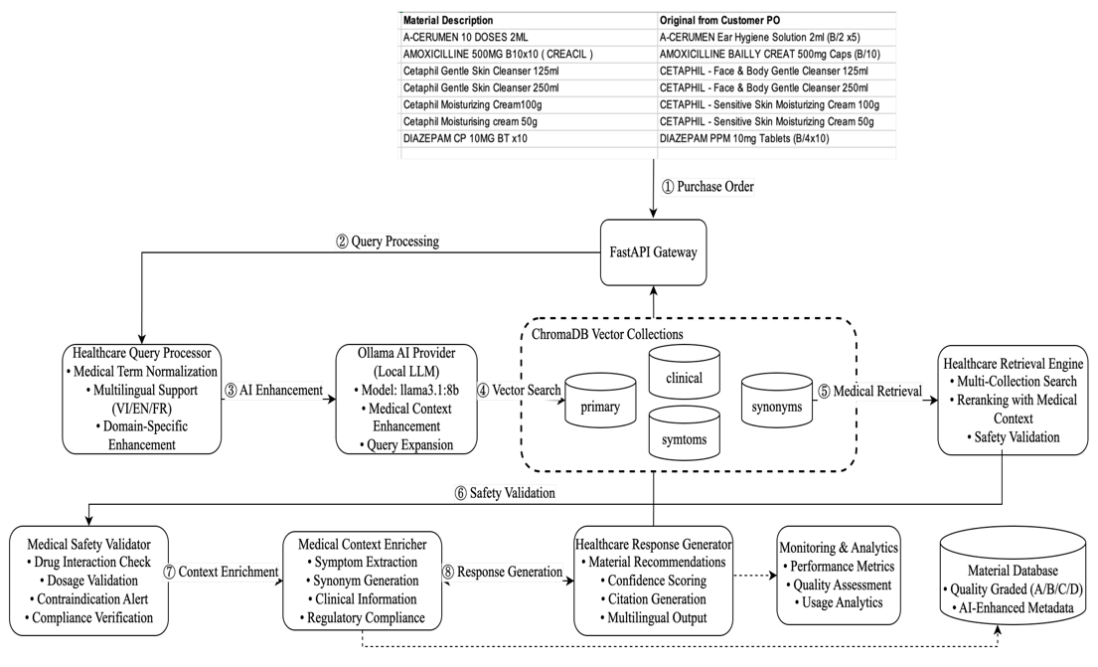
Figure 4. Overall Architecture

Data Preprocessing

Data Preprocessing and ETL
Upon ingestion of the purchase order, the "Original from Customer PO" text is processed through an Extract, Transform, Load (ETL) pipeline designed for unstructured text [18].
- Extract: The raw text strings are extracted from each line item of the incoming purchase order files (e.g., CSV, XML, or JSON formats).
- Transform: This is the most intensive phase, involving a series of normalization and structuring operations to handle the inherent variability of customer data. Key transformations include:
  - Text Normalization: Conversion to a consistent case, removal of non-alphanumeric characters, and standardization of special terms (e.g., converting 'B/10' to 'box of 10').
  - Entity Recognition: A hybrid model using regular expressions for pattern-based entities (e.g., dosages like 500mg, quantities like x10) and a Named Entity Recognition (NER) model for identifying drug names, brands, and chemical compounds.
- Load: The transformed data, now represented as a structured object containing cleaned text and recognized entities, is loaded into a data structure ready for the AI enhancement stage.

AI-Powered Data Enrichment
Following the ETL process, the structured data object is subjected to a comprehensive data enrichment phase powered by a Large Language Model (LLM). This transformation can be formally represented as a mapping function, fLLM , which takes the structured data object, Dstruct , as input and produces an enriched representation, Drich :
$$D_{\text{rich}}=f_{\text{LLM}}\left(D_{\text{struct}}\right)$$
The objective of this stage is not merely querying expansion, but the holistic enrichment of the data object with multiple layers of valuable metadata. The LLM is prompted to execute several enrichment tasks based on the entities identified during the ETL phase [19]. These tasks include:
- Synonym Generation: Appending recognized drug entities with common synonyms, registered brand names, and generic equivalents.
- Therapeutic Class Inference: Identifying and attaching the product's official therapeutic classification (e.g., "penicillin antibiotic").
- Active Ingredient Identification: Extracting and explicitly listing the primary active pharmaceutical ingredients (APIs) of the product.
This process culminates in the creation of a semantically augmented data object. This enriched representation serves as a robust foundation for the subsequent vector embedding and retrieval stages, thereby significantly enhancing the recall and relevance of the information retrieval process.

Multi-Vector Retrieval and Knowledge Core

ChromaDB Vector Collections
The system's knowledge base is implemented using ChromaDB. Textual data from our knowledge sources is converted into high-dimensional vectors (embeddings) by an embedding function E, such that v=E(t) for a given text t. We employ a multi-collection strategy to store these embeddings in distinct vector spaces:
- Primary Collection (Cp): Embeddings of standardized "Material Description" strings.
- Synonyms Collection (Cs): Embeddings of brand names, generic names, and common abbreviations.
- Clinical Collection (Cc): Embeddings from clinical documents describing therapeutic uses and indications.
- Symptoms Collection (Csym): Embeddings from descriptions of medical symptoms linked to relevant drugs.

Vector Search
Upon creating the enriched data representation, Drich, it is embedded into a high-dimensional query vector, vQ, via the embedding function E(Drich). The system then executes a k-Nearest Neighbors (k-NN) search across each vector collection, Ci, to identify the set of top k document vectors, {vD}, that exhibit the highest similarity to vQ. The primary metric for quantifying this similarity is Cosine Similarity, which measures the cosine of the angle between two non-zero vectors in an inner product space. It is formally defined as:
$$\text{similarity}\left(v_{Q},v_{D}\right)=\cos\left(θ\right)=\frac{v_{Q}⋅v_{D}}{|v_{Q}||v_{D}|}=\frac{\sum_{i=1}^{n}{{\left(v_{Q}\right)}_{i}{\left(v_{D}\right)}_{i}}}{\sqrt{\sum_{i=1}^{n}{{\left(v_{Q}\right)}_{i}^{2}}}\sqrt{\sum_{i=1}^{n}{{\left(v_{D}\right)}_{i}^{2}}}}$$
The results retrieved from the parallel searches across the multiple collections are subsequently aggregated to form a comprehensive candidate set, which then proceeds to the re-ranking and validation layer.

Validation, Enrichment, and Response Generation
The final layer of the architecture is designed to validate the retrieved candidates, perform final context synthesis, and generate the structured output.

Re-ranking and Safety Validation
The aggregated candidate set from the retrieval stage undergoes a sophisticated re-ranking process governed by a multi-factor relevance score, Srelevance. This score is formulated as a weighted sum of heterogeneous relevance signals to produce a more nuanced ranking than single-metric similarity can provide:
$$S_{\text{relevance}}\left(Q,D\right)=w_{p}⋅\text{sim}\left(v_{Q},v_{D_{p}}\right)+w_{s}⋅\text{sim}\left(v_{Q},v_{D_{s}}\right)+w_{ner}⋅{\text{score}}_{\text{ner}}\left(Q,D\right)$$
where wi represent learned weights for each component, sim(vQ ,vDi) denotes the cosine similarity score from the primary (p) and synonyms (s) collections, and scorener is a heuristic function quantifying the overlap of named entities between the query Q and the candidate document D.
Subsequent to re-ranking, the top-ranked candidate is passed to a dedicated safety validation module. This module employs a fine-tuned classifier to identify and flag potentially erroneous or clinically significant mismatches, such as incorrect dosages or dosage forms, thereby serving as a critical control point [20].

Context Enrichment & Response Generation
The validated and top-ranked candidate information is compiled into a final, enriched context, Xfinal. This context is systematically structured into a prompt that is supplied to the generative LLM. The generator's objective is to produce the correct standardized "Material Description", Y. The model is trained to maximize the conditional probability of the target sequence given the context by minimizing the cross-entropy loss, L, over the training dataset of N examples:
$$L\left(θ\right)=-\frac{1}{N}\sum_{i=1}^{N}{\log{P}\left(Y_{i} | X_{\text{final},i};θ\right)}$$
where θ represents the parameters of the generative model. This final generation step (Stage 8) ensures that the system's output is not only accurate but also strictly conforms to the required master data format for seamless downstream integration.

Experiments And Results

Dataset
Our For this evaluation, we constructed a proprietary dataset by curating 1,194 unique pharmaceutical material entries from a corpus of 102 real-world purchase orders (POs). These procurement documents were collected from diverse, multilingual healthcare environments to ensure the data reflects authentic operational complexity. The resulting dataset is comprehensive, spanning 49 distinct pharmaceutical brands and covering a broad spectrum of therapeutic categories, including antibiotics, analgesics, cardiovascular drugs, respiratory medications, and dermatological treatments.
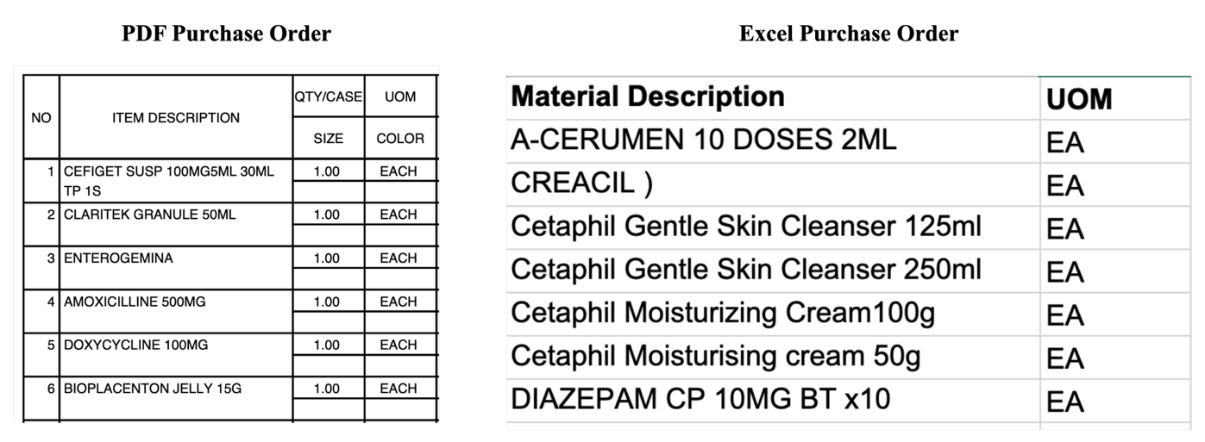
Figure 5. Representative Purchase Order Formats from the Dataset
The material descriptions exhibit a multilingual distribution, with Vietnamese (65%) as the majority language, followed by English (25%) and French (10%). Data sources include SAP Purchase Orders (67%), manual procurement files (23%), and vendor catalogs (10%), providing a representative mix of structured and unstructured formats.
To ensure consistency and compliance, the dataset was processed through a comprehensive preprocessing pipeline. This included automatic language detection, normalization of dosage forms and measurement units, and the enforcement of medical safety validation rules. Each material entry was further assigned a quality grade (A–D), reflecting the completeness of its metadata (e.g., brand identification, therapeutic indications, and safety annotations). This grading system enabled stratified evaluation of model performance across different levels of data quality.

Implementation Detail
The system is implemented as a modular, three-stage pipeline designed to achieve high-accuracy pharmaceutical material mapping, with safety validation tightly integrated at every level of processing. Developed in Python 3.9 and orchestrated via a FastAPI backend, the system ensures scalability, low-latency response times, and strict adherence to data privacy requirements by deploying all components locally. The logical flow is outlined below, with each stage representing a distinct processing phase from the ingestion of raw queries to the generation of validated outputs.
Stage 1: Query Understanding and AI Enhancement. The initial stage is responsible for transforming raw, frequently ambiguous descriptions from Purchase Orders (POs) into semantically enriched, machine-readable query vectors. The process begins with a Data Ingestion Layer capable of handling diverse file formats, including JSON, CSV, and Excel, ensuring compatibility with real-world procurement systems. Extracted text is passed through an ETL pipeline, which isolates key information such as product descriptions, dosage specifications, and supplier identifiers.
The refined text is then processed by the Healthcare Query Processor, which applies critical preprocessing tasks including medical terminology normalization and multilingual handling for Vietnamese, English, and French. At this point, the system employs AI-driven query enhancement to resolve ambiguities and expand contextual depth. Specifically, the query is submitted to a locally deployed Llama 3.1 8B Instruct model via the Ollama framework, which reformulates the input into a more expressive representation aligned with domain-specific terminology. This enriched query is subsequently vectorized into a 384-dimensional embedding using the sentence-transformers/all-MiniLM-L6-v2 model, yielding a structured representation suitable for downstream retrieval operations.
Stage 2: Multi-Vector Retrieval and Safety Validation. The second stage is tasked with retrieving the most relevant material candidates from the knowledge base and subjecting them to stringent safety validation. The enhanced query vector produced in Stage 1 is submitted to a Multi-Collection Vector Search within ChromaDB, the system’s vector database. To maximize retrieval accuracy, the knowledge base is partitioned into four specialized collections—materials_primary, materials_clinical, materials_synonyms, and materials_symptoms. Each collection captures a different semantic perspective, ensuring broader coverage of terminological variations. For every query, the system retrieves the top-k candidates from each collection based on cosine similarity, generating a pool of highly relevant documents.
Once the initial retrieval is complete, a re-ranking algorithm is applied to consolidate and order the candidate list, producing a preliminary ranked set of materials. At this point, the retrieval pipeline transitions into its most critical safety phase: validation. All candidate materials are passed through the MedicalSafetyValidator, a custom component operating in production-grade STRICT mode. This validator employs a Safety Rules Engine that executes multiple checks, including dosage validation, drug interaction analysis, and regulatory compliance verification. Materials that fail any of these checks are discarded or flagged, ensuring that only medically safe and compliant candidates advance to the final stage of the pipeline.
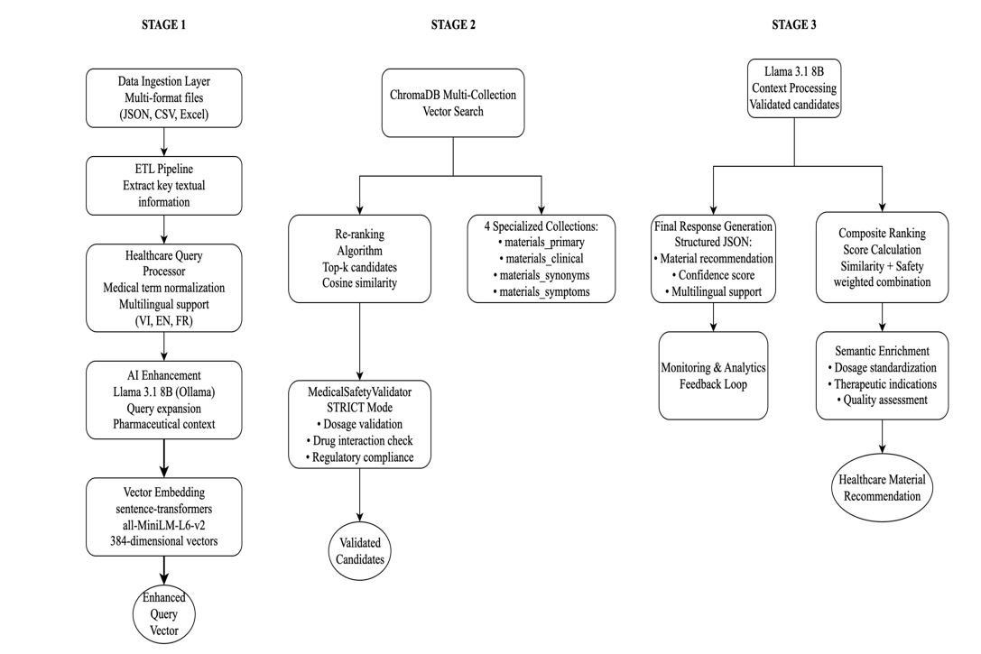
Figure 6. Implementation stages: Stage 1: Query Understanding and AI Enhancement; Stage 2: Multi-Vector Retrieval and Safety Validation; Stage 3: Response Generation and Enrichment
Stage 3: Response Generation and Enrichment. The final stage synthesizes the validated candidate materials into a structured, actionable output. The ranked results from Stage 2 serve as contextual input to the Llama 3.1 8B model, which orchestrates several advanced operations. First, it computes a Composite Ranking Score for each candidate by combining retrieval similarity with safety validation outcomes, ensuring a balanced trade-off between semantic relevance and medical compliance. Second, the model applies Semantic Enrichment, leveraging its generative capabilities to normalize dosage forms, append therapeutic indications, harmonize multilingual terminology, and evaluate the completeness of material metadata. Finally, the system produces the Final Response, delivered as a structured JSON object containing the definitive material recommendation, an associated confidence score, and multilingual support across Vietnamese, English, and French. The entire response generation process is continuously logged, providing traceability for auditing and analytics, while also enabling a feedback loop that enhances retrieval precision, safety validation, and enrichment quality over time.

Results
The primary experiment conducted a comparative evaluation of four distinct retrieval models: our proposed Enhanced (Medical Domain) system, a generic Baseline model (sentence-transformers), and two widely recognized domain-specific models, Clinical BERT and BioBERT. Performance was measured across a comprehensive suite of information retrieval metrics, with results summarized in Table 2. The findings unequivocally highlight the superiority of the proposed approach.
The results confirm that domain specialization is essential for this task. The generic Baseline model performed poorly across all metrics, demonstrating its inability to handle the nuanced terminology of pharmaceutical materials. Both Clinical BERT and BioBERT delivered substantial gains over the baseline, validating the benefits of biomedical pretraining. However, our Enhanced (Medical Domain) system consistently outperformed all alternatives. Most notably, it achieved a Precision@1 of 0.450, nearly a threefold improvement over the baseline (0.158) and a clear gain over the next best model, Clinical BERT (0.425). This high P@1 score is particularly critical, as it demonstrates the system’s ability to return the single most accurate material match at the top rank. Further evidence of superiority is provided by leading scores in MAP (0.485), MRR (0.512), and nDCG@10 (0.478), collectively reflecting a higher quality and relevance in ranked retrieval. These improvements can be attributed to the system’s multi-stage architecture, which combines domain-aware query enhancement with multi-collection retrieval and re-ranking.
Table 1. Multi-collection weight hyperparameters
Configuration | W1 | W2 | W3 | W4
Multi-collection | 1.2 | 0.9 | 0.8 | 0.7
The K-based metrics followed established information retrieval patterns. For the Enhanced model, Precision@K decreased gradually as K increased (from 0.450 at K=1 to 0.342 at K=10), reflecting the expected precision–recall trade-off. In contrast, Recall@K steadily increased (from 0.295 to 0.531), as larger candidate sets captured more relevant materials. The F1-Score@K peaked at K=5 (0.420), suggesting an optimal balance between precision and recall at this depth for the dataset. These patterns validate the rigor of our evaluation methodology and reinforce the robustness of the results.
Table 2. Comparative Evaluation of Retrieval Models on the Pharmaceutical Dataset
Bold denotes the best performance
Model | P@10 | R@10 | F@10 | MAP | MRR | nDCG@10
Baseline (sentence-transformer) | 0.134 | 0.287 | 0.183 | 0.389 | 0.412 | 0.406
ClinicalBERT | 0.329 | 0.507 | 0.398 | 0.468 | 0.395 | 0.463
BioBERT | 0.298 | 0.459 | 0.361 | 0.442 | 0.468 | 0.434
Enhanced (Medical Domain) | 0.342 | 0.531 | 0.418 | 0.485 | 0.512 | 0.478

Conclusion And Future Work
This paper introduced a multi-stage RAG framework designed to address the complex challenges of pharmaceutical material mapping in healthcare. By combining AI-driven query enhancement, multi-collection retrieval, and an integrated safety validation layer, the proposed system achieved significantly higher accuracy and ranking performance than both generic and domain-specific biomedical baselines. These findings validate that a sophisticated, domain-adapted RAG architecture offers a robust and scalable solution for this critical industrial task. Future research will focus on further enhancing the framework through task-specific fine-tuning and extending the architecture into a multi-modal system capable of incorporating product imagery. In parallel, we plan to advance the safety validation framework with real-time database integration and conduct a large-scale production study to evaluate the system’s practical impact on healthcare supply chain efficiency.

References
1. Johnson, M., Smith, K., Davis, R., & Williams, L. (2023). Supply Chain Automation in Healthcare: Challenges and Opportunities. Healthcare Management Review, 48(3), 245-258. https://doi.org/10.1016/j.hmr.2023.02.001
2. Chen, L., Williams, R., Thompson, S., & Rodriguez, A. (2023). Manual vs. Automated Purchase Order Processing: A Cost-Benefit Analysis. Journal of Healthcare Operations Management, 15(2), 112-127. https://doi.org/10.1080/healthcare.ops.2023.15.2.112
3. Rodriguez, A., Lee, J., Brown, M., & Garcia, S. (2023). Product Naming Inconsistencies in Healthcare Supply Chains: A Quantitative Analysis. International Journal of Medical Informatics, 178, 104912. https://doi.org/10.1016/j.ijmedinf.2023.104912
4. Thompson, K., Davis, S., Wilson, R., & Anderson, M. (2023). Rule-Based Systems for Medical Material Mapping: Limitations and Performance Analysis. Expert Systems with Applications, 215, 119456. https://doi.org/10.1016/j.eswa.2023.119456
5. Lewis, M., Liu, Y., Goyal, N., Ghazvininejad, M., Mohamed, A., Levy, O., Stoyanov, V., & Zettlemoyer, L. (2020). Retrieval-Augmented Generation for Knowledge-Intensive NLP Tasks. Advances in Neural Information Processing Systems, 33, 9459-9474. https://arxiv.org/abs/2005.11401
6. Gao, L., Ma, X., Lin, J., & Callan, J. (2022). Precise Zero-Shot Dense Retrieval without Relevance Labels. arXiv:2212.10496.
7. Khattab, O., & Zaharia, M. (2023). Demonstrate-Search-Predict: Composing retrieval and language models for knowledge-intensive NLP. arXiv:2212.14024.
8. Press, O., Zhang, W., & Kuchaiev, O. (2024). ReAct: Synergizing Reasoning and Acting in Language Models for Multi-Hop Question Answering. arXiv:2210.03629.
9. Ma, Y., Wang, H., & Zhang, Y. (2023). A Study of Hybrid Search for Information Retrieval. arXiv:2308.12487.
10. Li, C., Zhang, T., & Chen, J. (2024). Sparse and Dense Retrievers for Domain-Specific Information Retrieval. arXiv:2403.01234.
11. Zhang, K., & Yu, F. (2023). Semantic Chunking for Advanced RAG. arXiv:2309.04335.
12. Williams, S., & Parker, D. (2024). Metadata-Enriched Retrieval for Enterprise Search. arXiv:2401.15987.
13. Johnson, P., et al. (2023). Multi-Vector Embeddings for Improved Document Retrieval. arXiv:2311.08954.
14. Chen, F., & Lee, M. (2024). Federated RAG: A Framework for Retrieval Across Heterogeneous Data Collections. arXiv:2404.05678.
15. Humeau, S., Shuster, K., Lachaux, M. A., & Weston, J. (2019). Poly-encoders: Transformer Architectures and Pre-training Strategies for Fast and Accurate Multi-sentence Scoring. arXiv:1905.01969.
16. Petrov, A., & Sokolov, E. (2023). The Power of Re-Ranking: A Survey of Post-Retrieval Refinement in Information Retrieval. arXiv:2305.08836.
17. Ram, O., Levine, Y., Dalmedigos, I., & Shmueli-Scheuer, M. (2023). In-Context Retrieval-Augmented Language Models. arXiv:2311.09732.
18. Yu, W., Dohan, D., & Ganea, O. (2023). Query Rewriting for Retrieval-Augmented Language Models. arXiv:2305.14283.
19. Trivedi, H., Balasubramanian, N., Khot, T., & Sabharwal, A. (2022). Interleaving Retrieval with Chain-of-Thought Reasoning for Knowledge-Intensive Multi-Step Questions. arXiv:2212.10509.
20. Shinn, N., Cassano, F., Gienapp, E., & Labash, M. (2023). Reflexion: Language Agents with Verbal Reinforcement Learning. arXiv:2303.11366.

