MOBILE PROGRAMMING
LAB REPORT 1
Student name | Tran Khanh Binh
Student ID | 2231200127
GitHub repo link | https://github.com/Binhhere/CSW430

Question 1. GitHub
Step 1 — Create a GitHub account (https://github.com/signup).
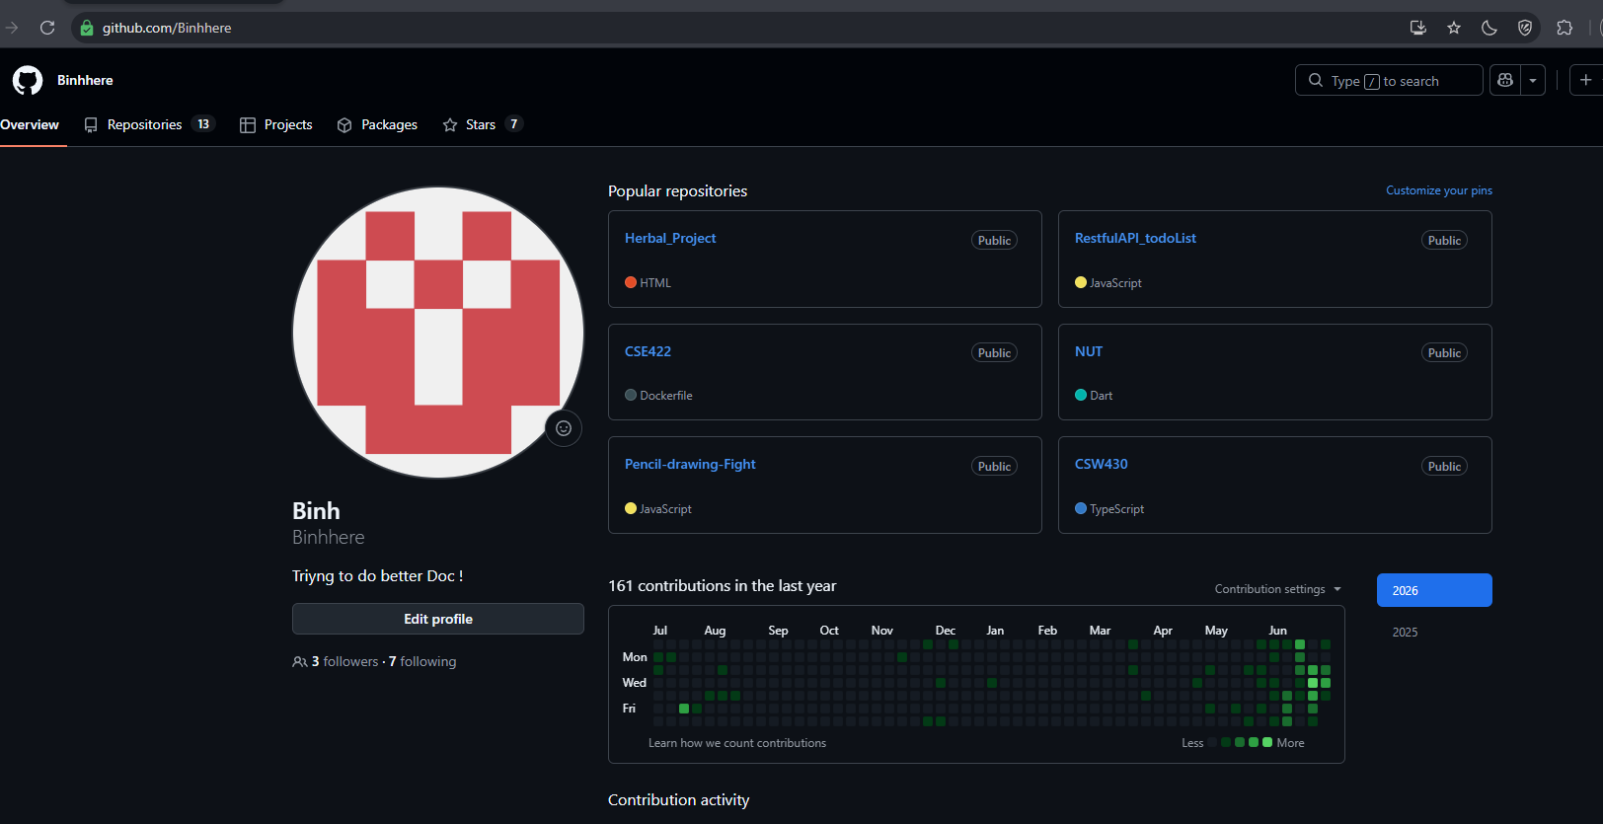
Step 2 — Create a GitHub repository.
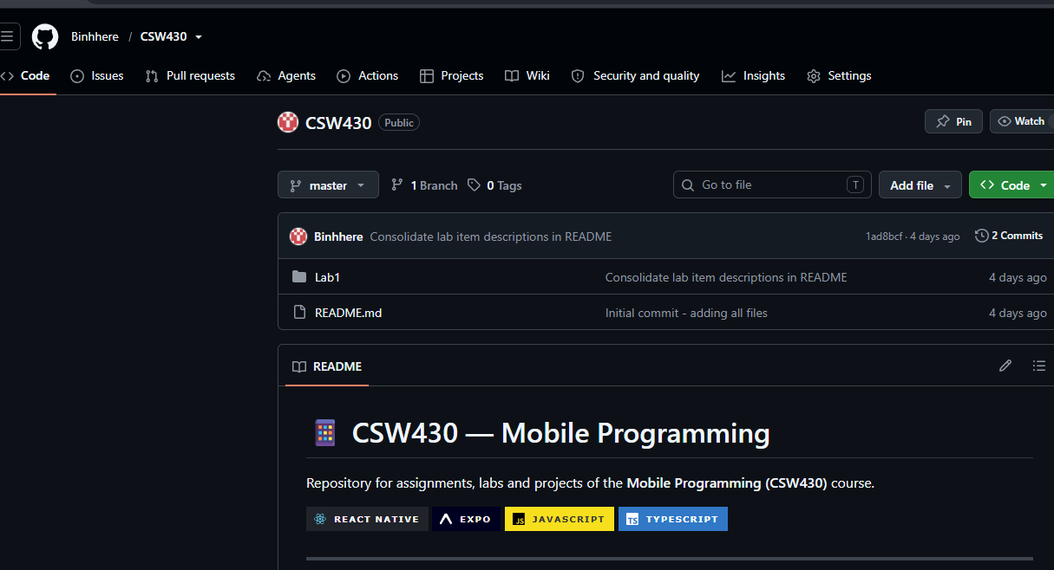
Step 3 — Download and install GitHub Desktop (https://desktop.github.com/).
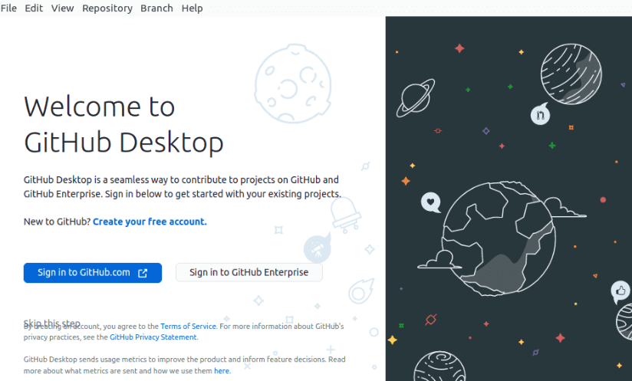
Step 4 — Open GitHub Desktop and sign in with your GitHub account.
Step 5 — Create an empty folder to store the assignment/project.
Step 6 — In GitHub Desktop, select the repository you created on GitHub to clone.
Step 7 — Create the project in that directory and commit it to GitHub.
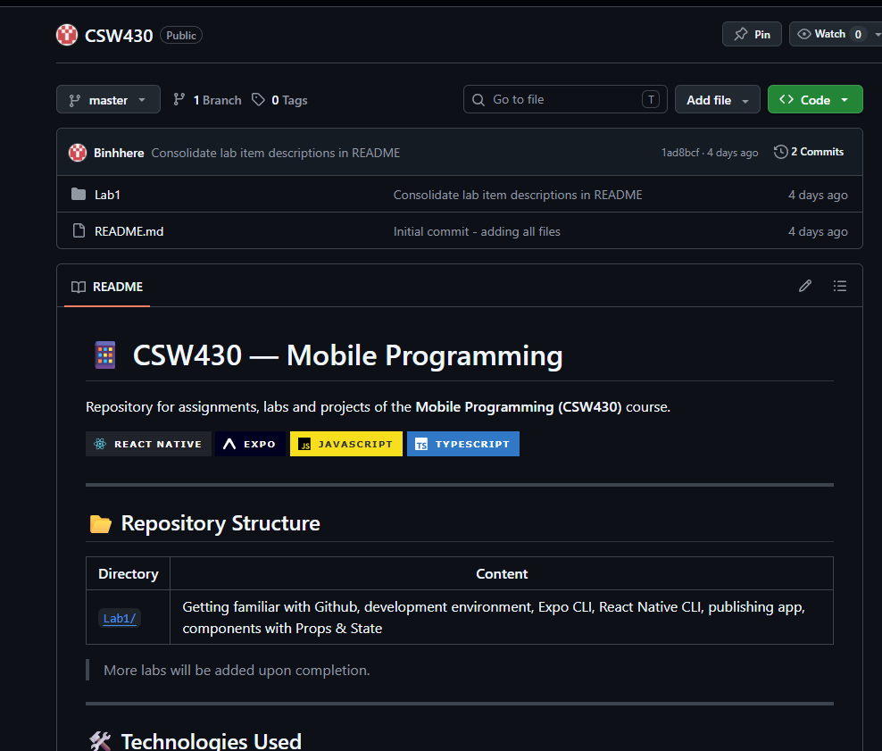

Question 2. Development Environment Settings
- https://docs.expo.dev/get-started/installation/
- or https://reactnative.dev/docs/environment-setup?guide=quickstart

- https://reactnative.dev/docs/environment-setup?guide=native

Question 3. Create Expo CLI Apps
Step 1 — Open Visual Studio Code and open a New Terminal.
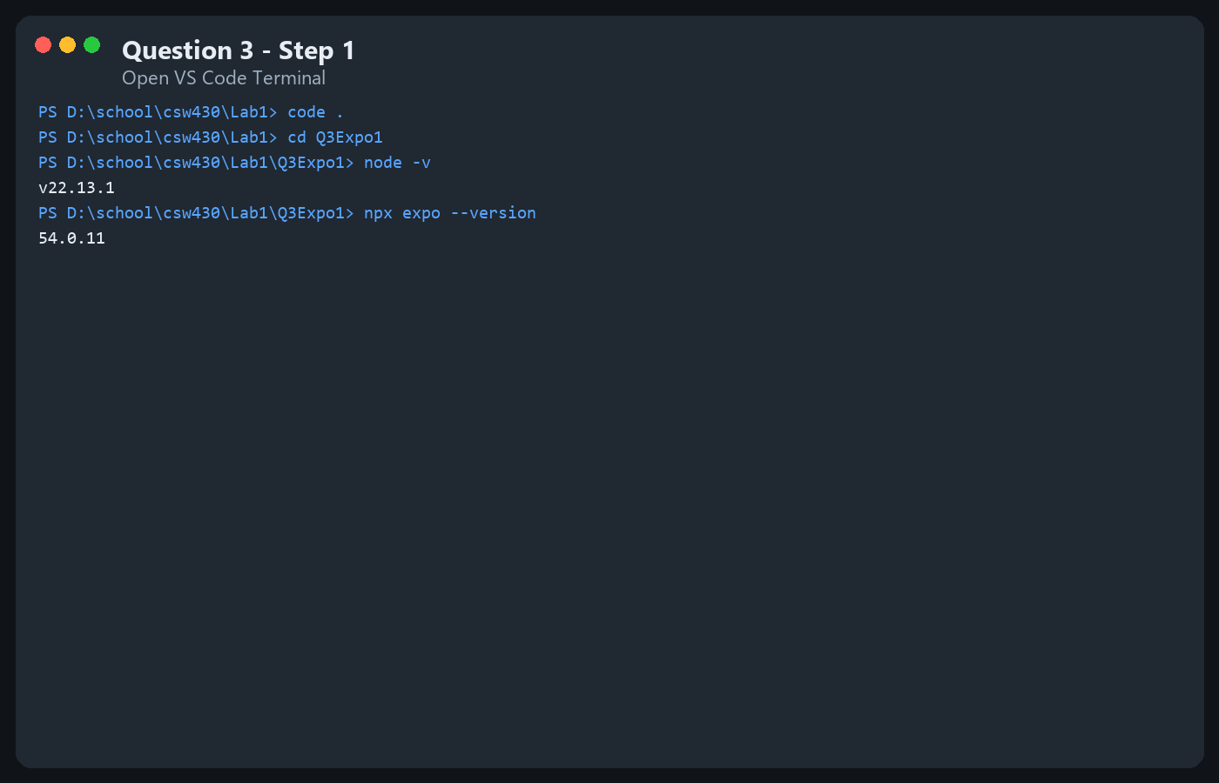
Step 2 — Create the project (e.g. "Q3Expo1").
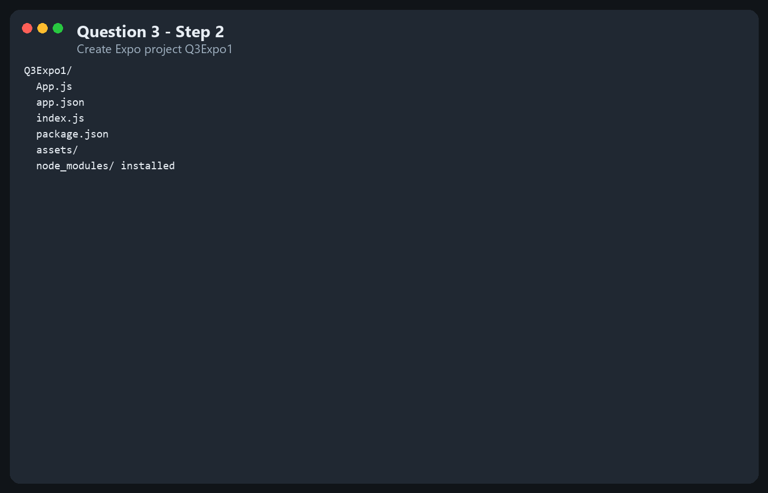
Step 3 — Open project "Q3Expo1" in VS Code (File > Open Folder).
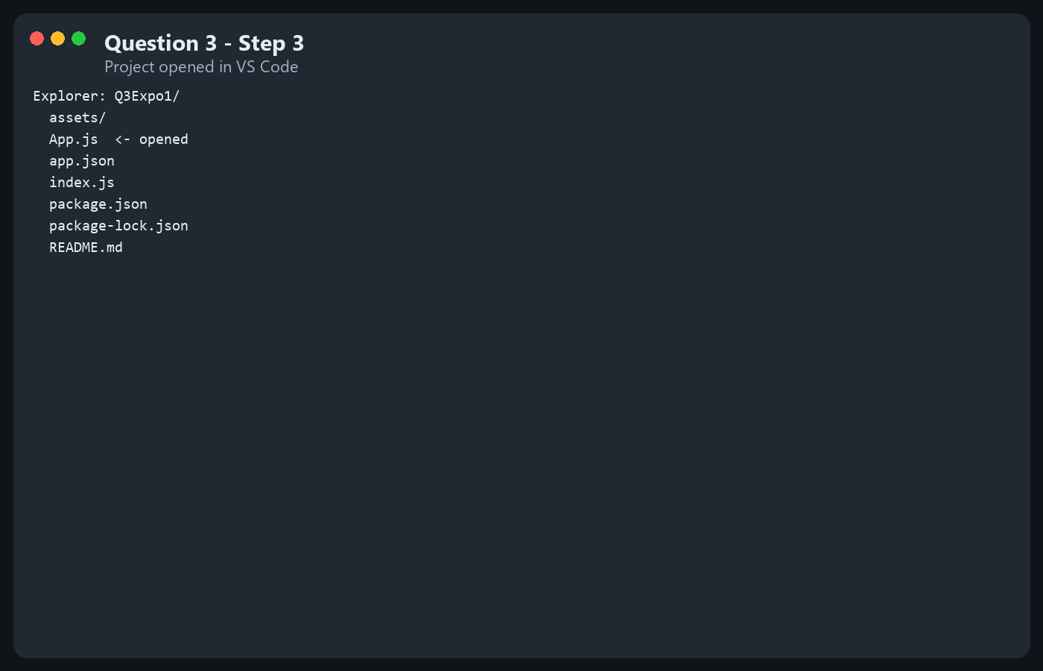
Step 4 — Open file App.js and enter the source code.
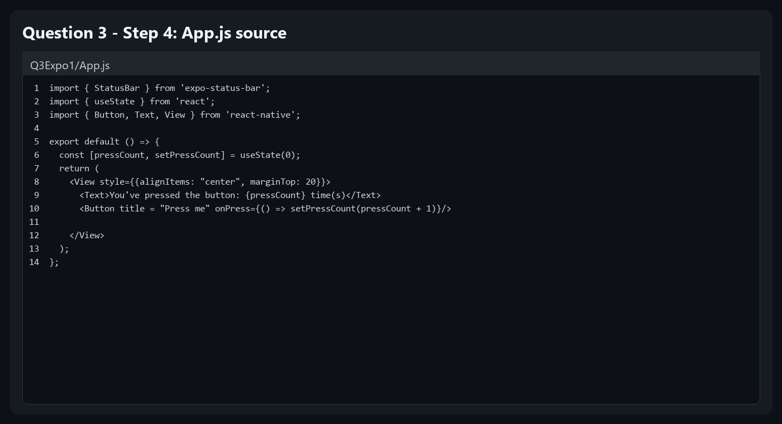
Step 5 — Run the Expo CLI app. Open package.json to view the available run commands.
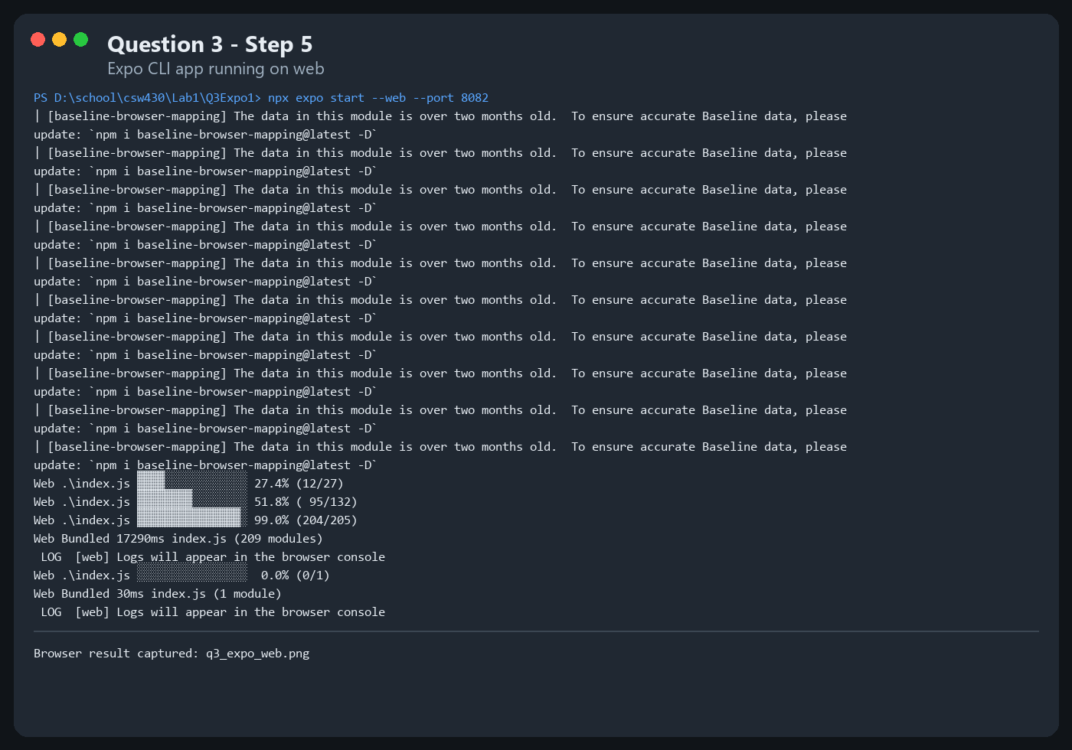
Step 6 — Alternative way to run the Expo app: go to https://snack.expo.dev/ and view results on Web/Android/iOS.

Question 4. Create React Native CLI Apps
Step 1 — Open Visual Studio Code and open a New Terminal.
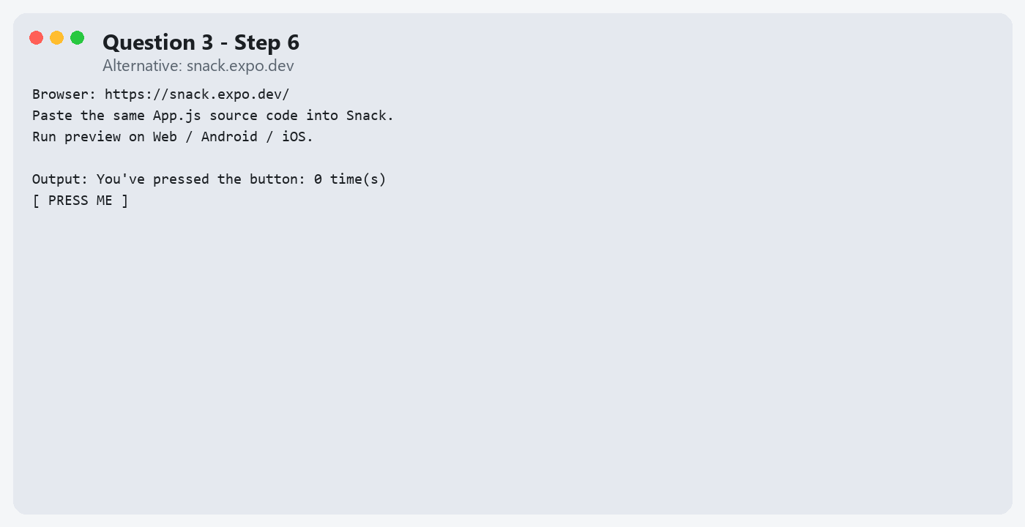
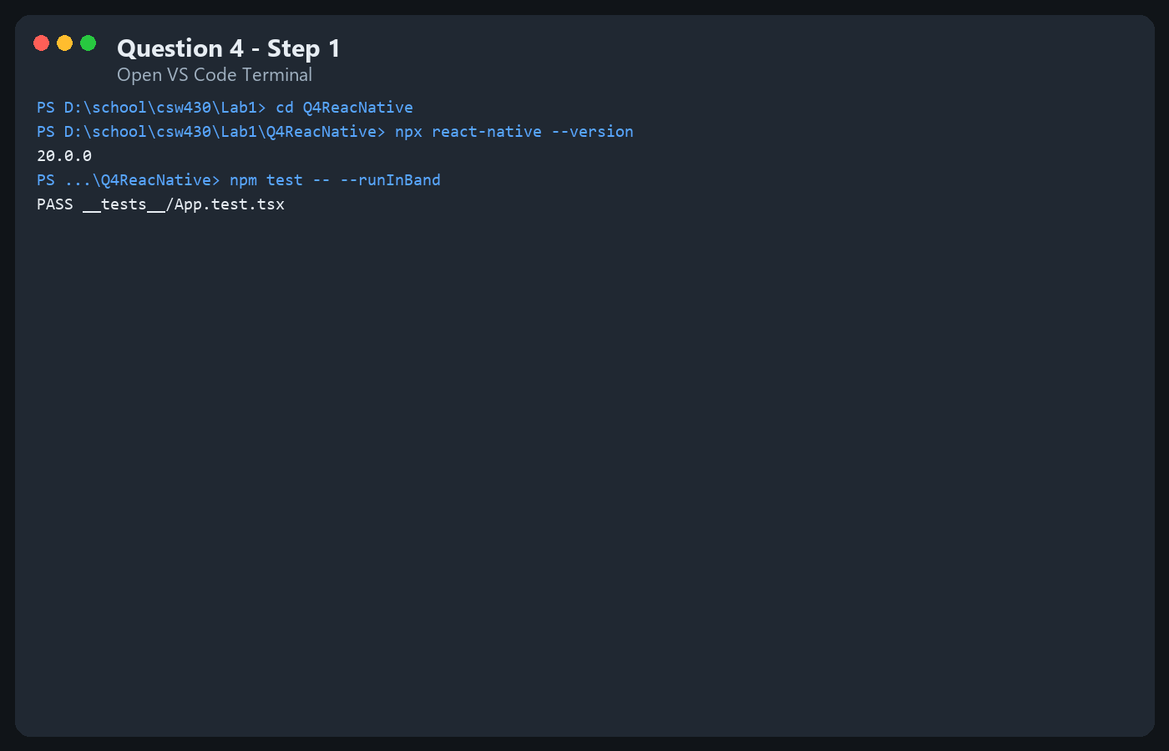
Step 2 — Create the project with React Native CLI (e.g. "Q4reactNative").
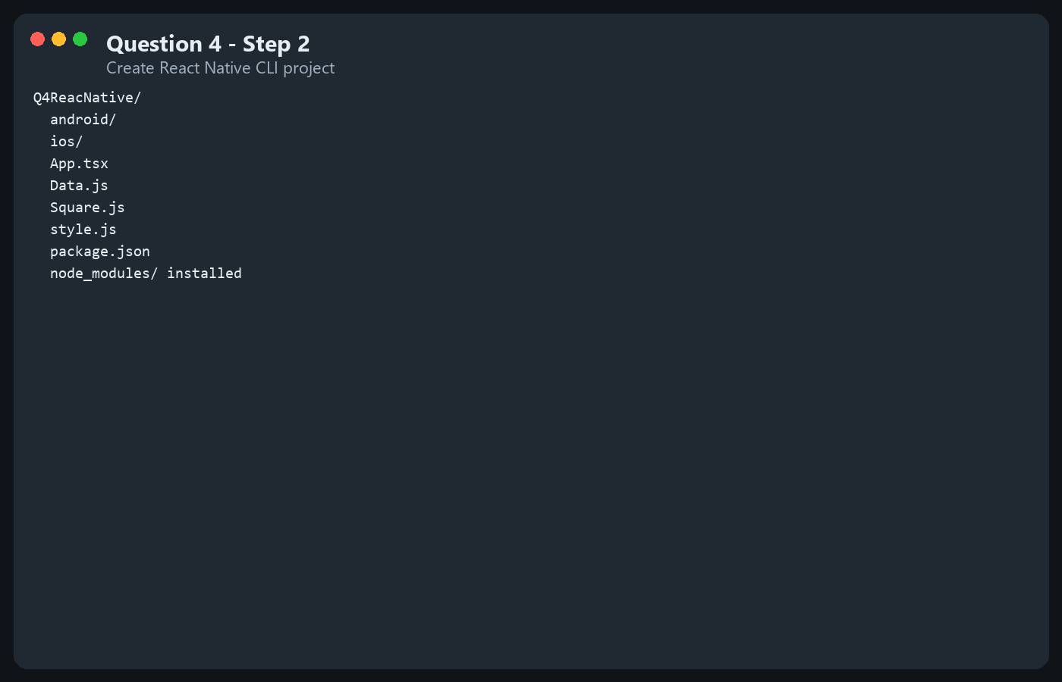
Step 3 — Open project "Q4reactNative" in VS Code (File > Open Folder).
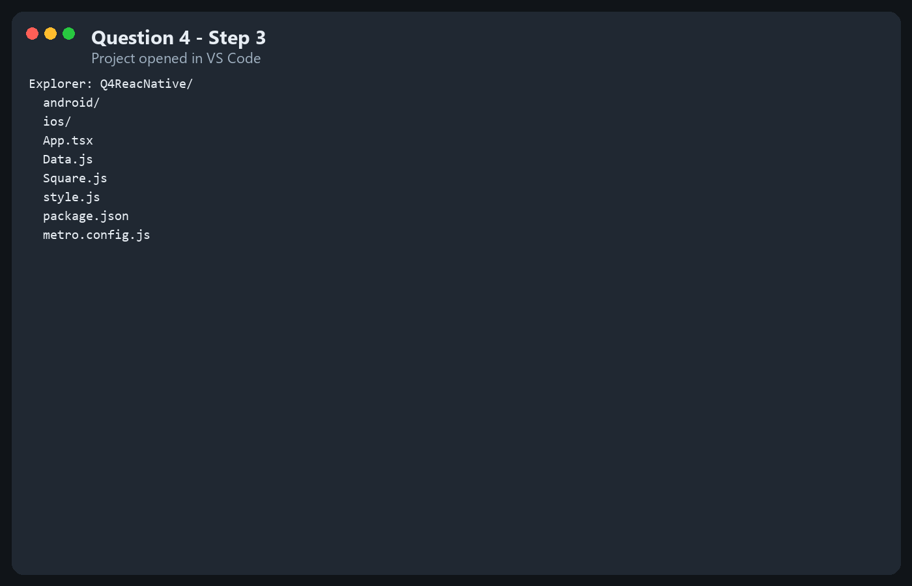
Step 4 — In the Explorer window, create a new file named "style.js".
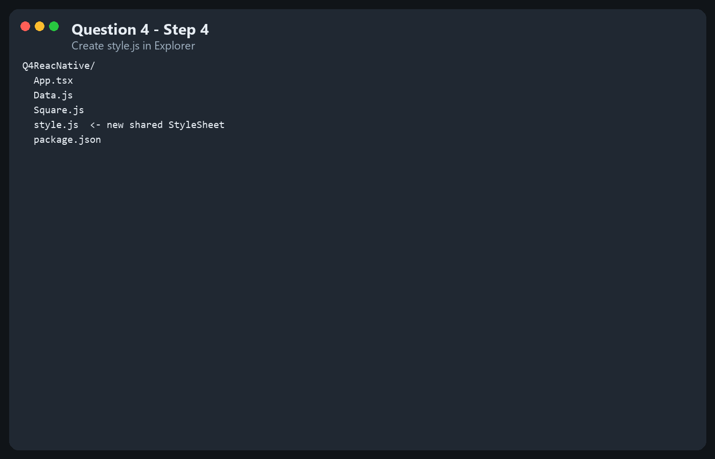
Step 5 — Add the required code to "style.js".
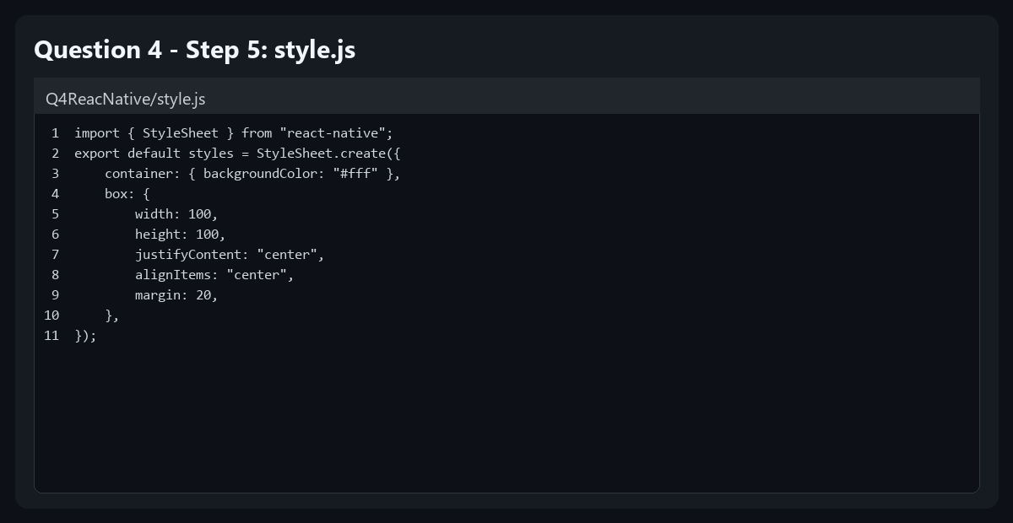
Step 6 — Create a new file named "Data.js" and enter the given code.
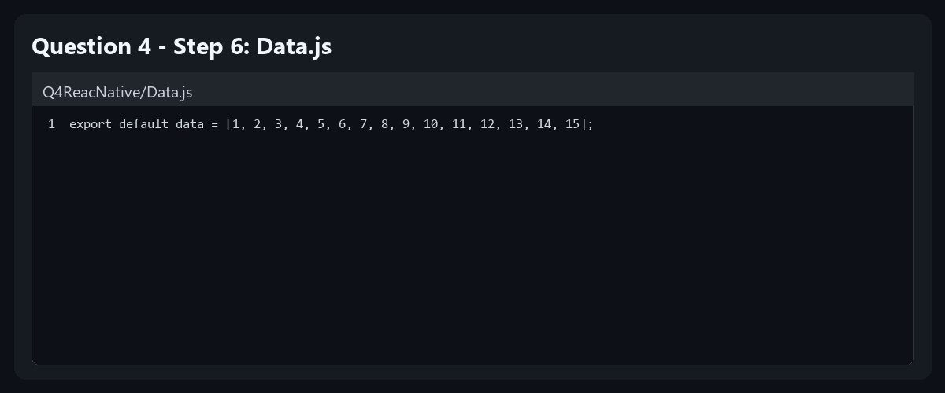
Step 7 — Create a new file named "Square.js" and enter the given code.
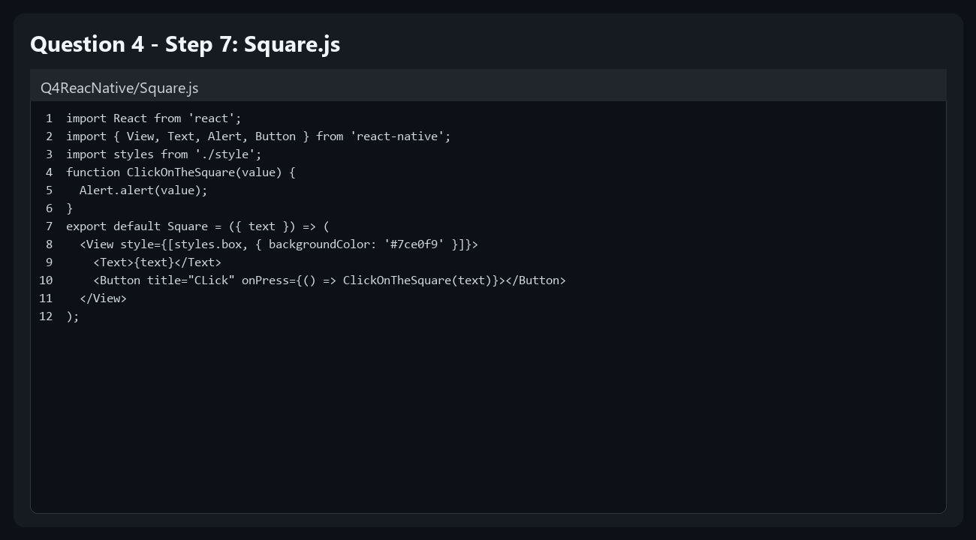
Step 8 — Open the "App.tsx" file and enter the given code.
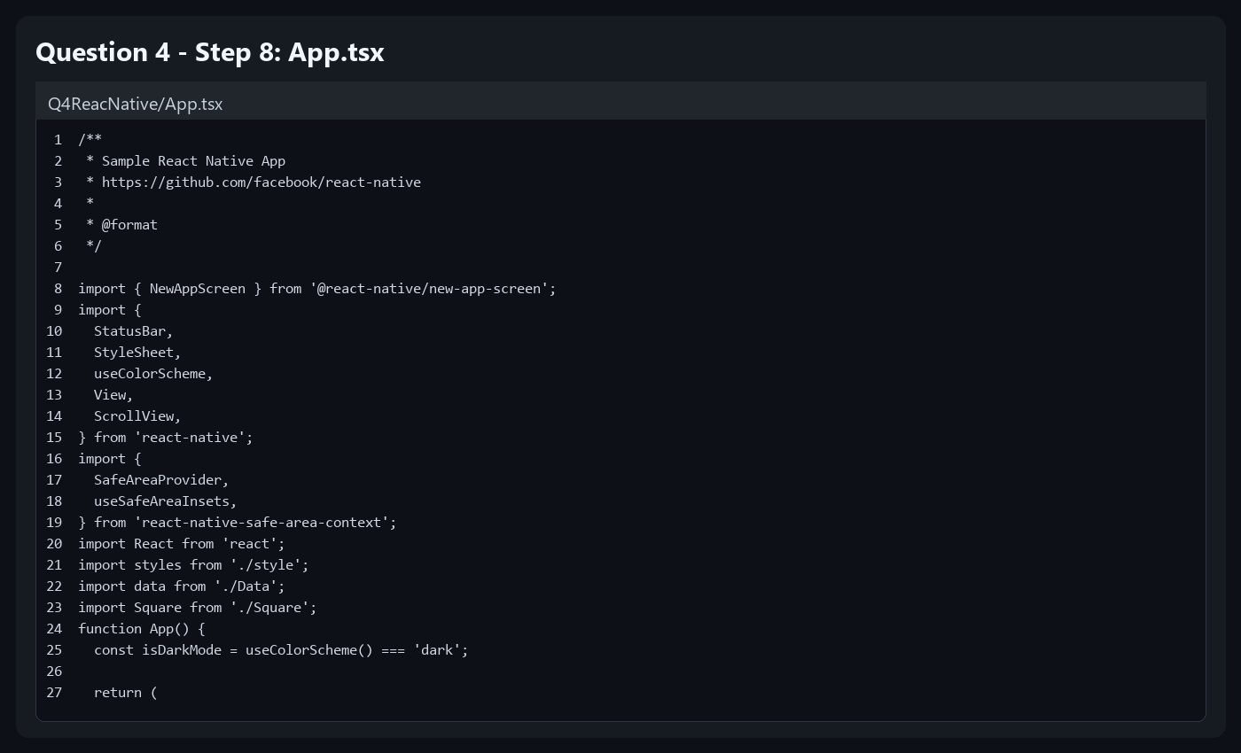
Step 9 — Run the React Native CLI app. Open package.json to view run commands, then run the app.
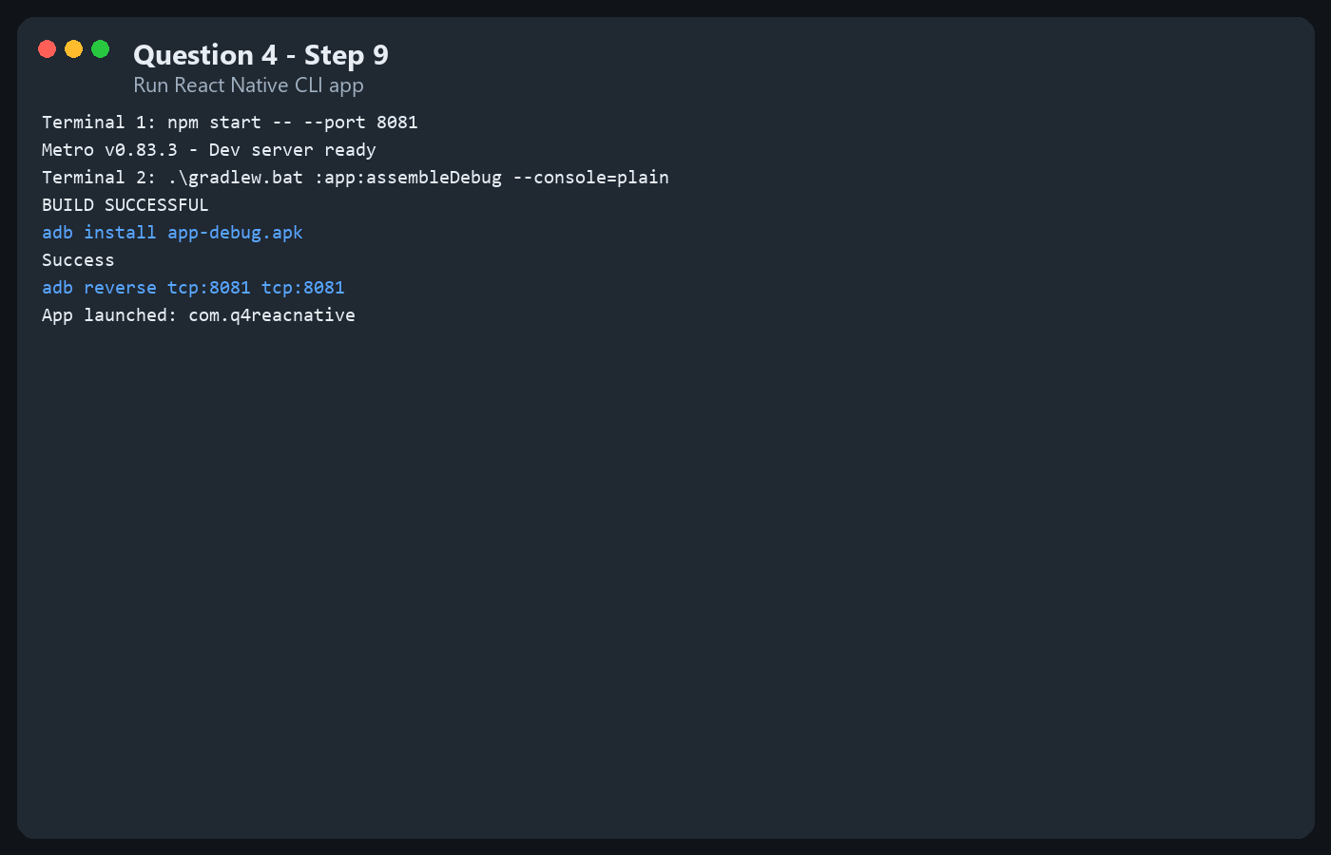
Step 10 — Result (app running on emulator/device).
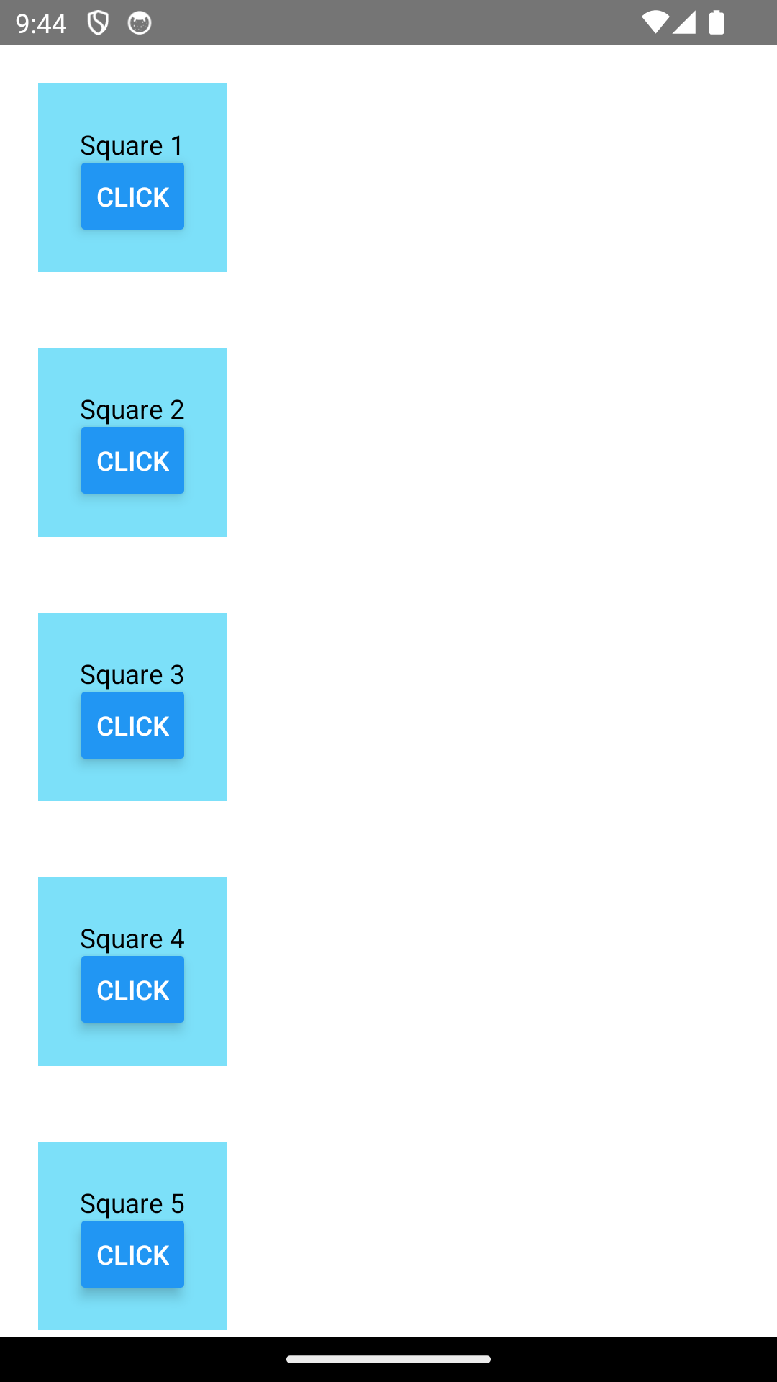

Question 5. Publishing
On Windows, keytool must be run as administrator from C:\Program Files\Java\jdkx.x.x_x\bin. Open PowerShell and run:
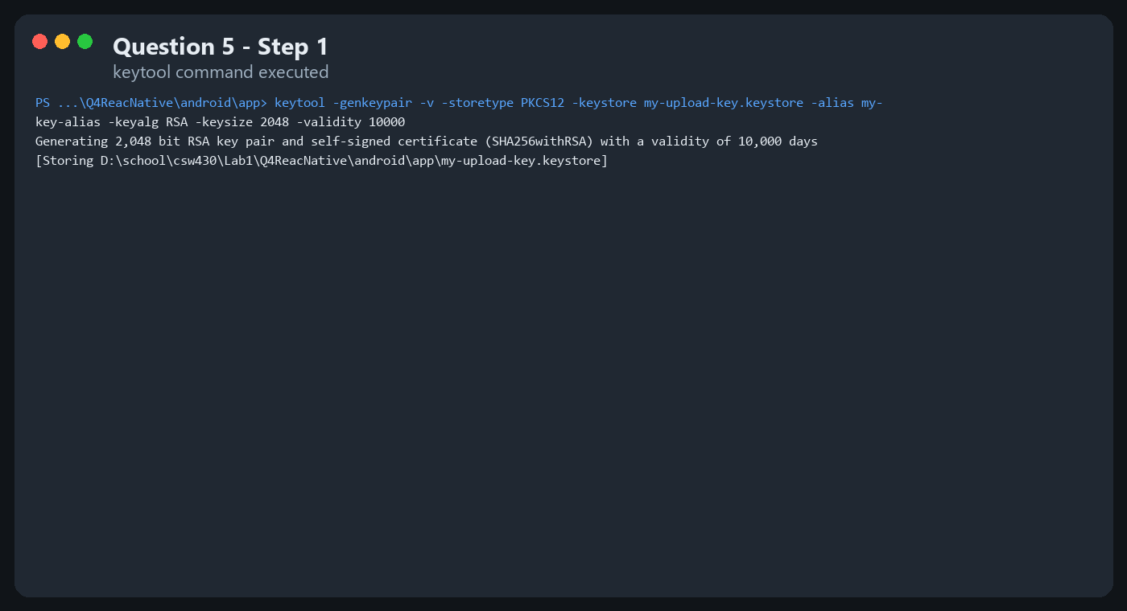
- Place my-upload-key.keystore under the android/app directory of the project.
- Edit ~/.gradle/gradle.properties (or android/gradle.properties) and add the store file, key alias, and passwords.
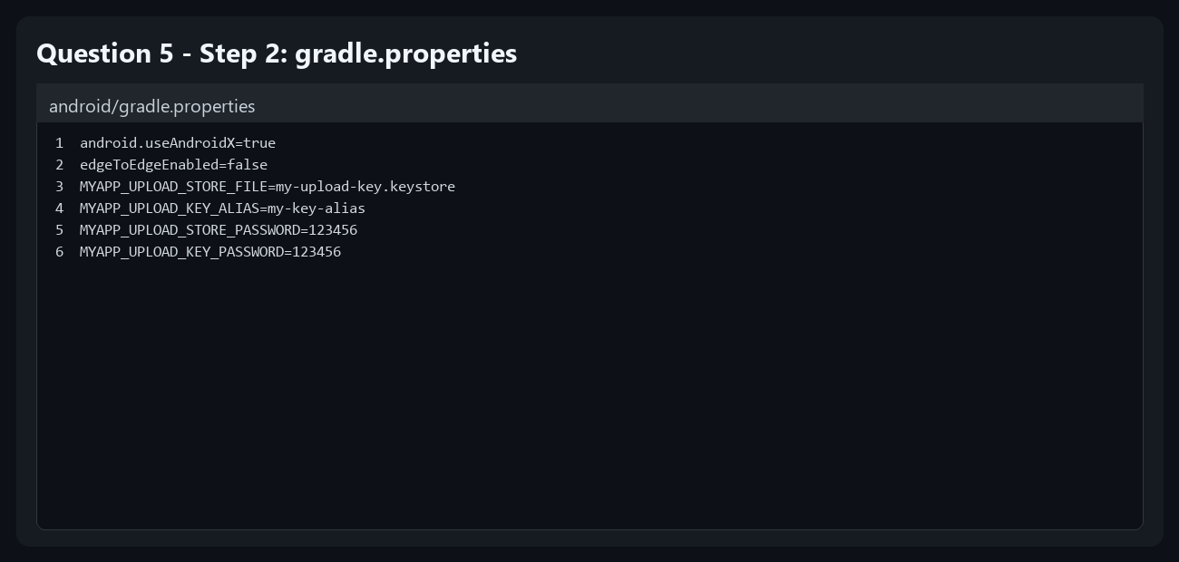
Add the signingConfigs block and reference it in the release buildType.
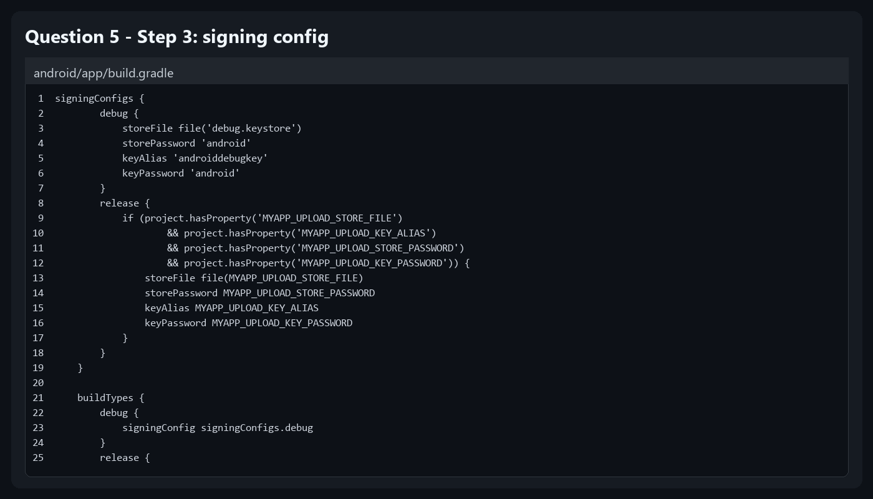
Optional — split by CPU type:
Output file location: ./android/app/build/outputs/bundle/release
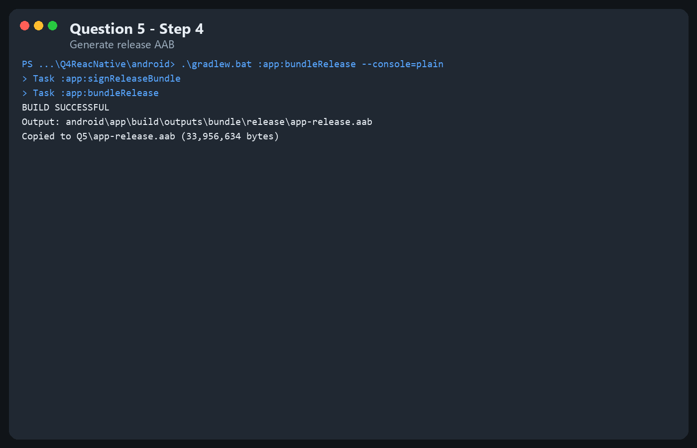
./gradlew assembleRelease
Output file location: ./android/app/build/outputs/apk/release
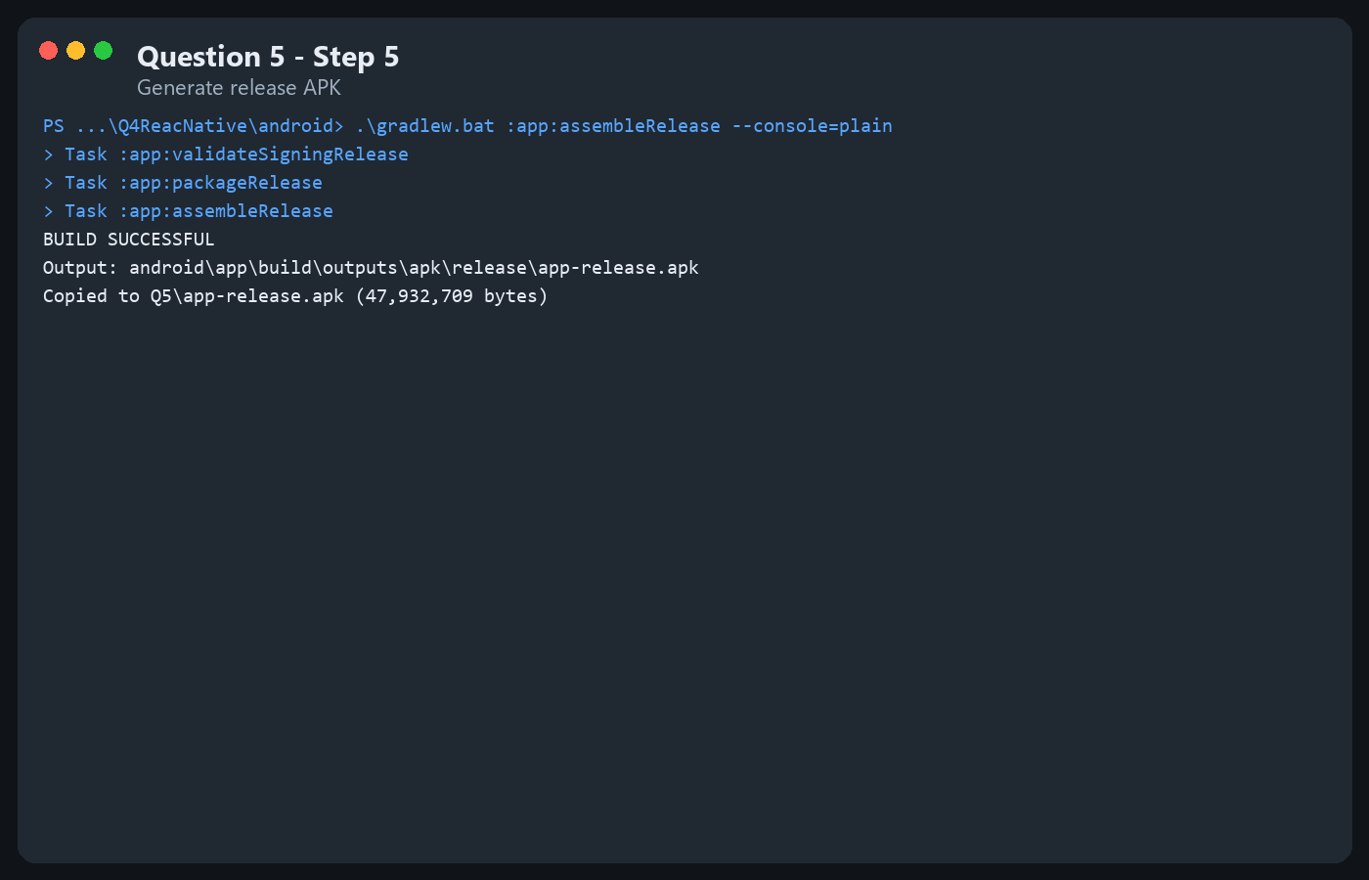

Question 6. Build Apps with Props and State
Build an employee information entry screen with: full name, age, occupation specialized in training, and an Update button that displays a success message. Also write a program to sum the first digit and the last digit of a number.
Source code:
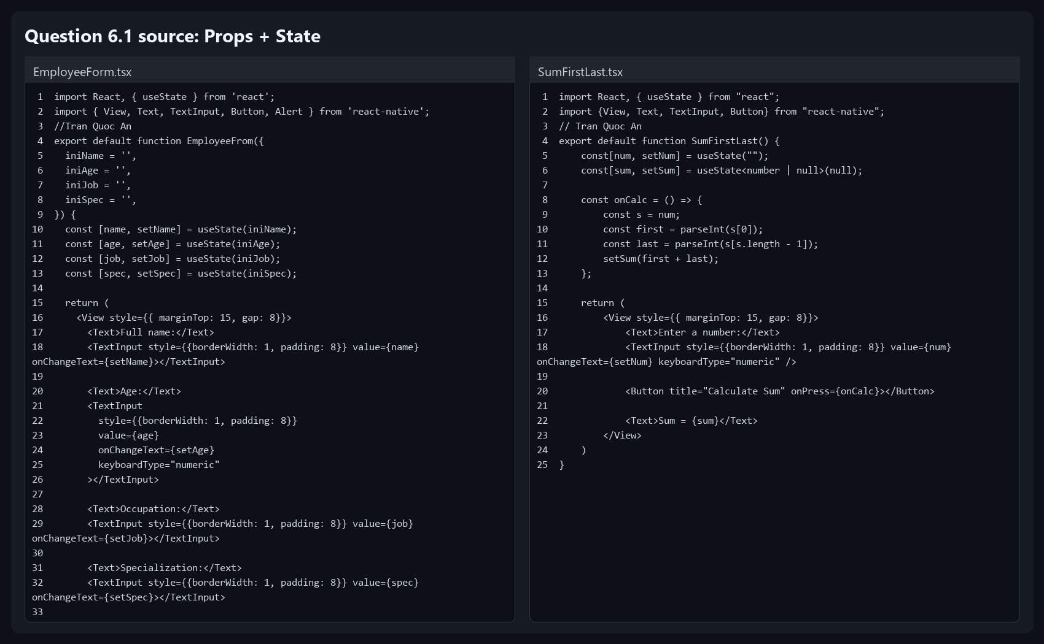
App running / result:
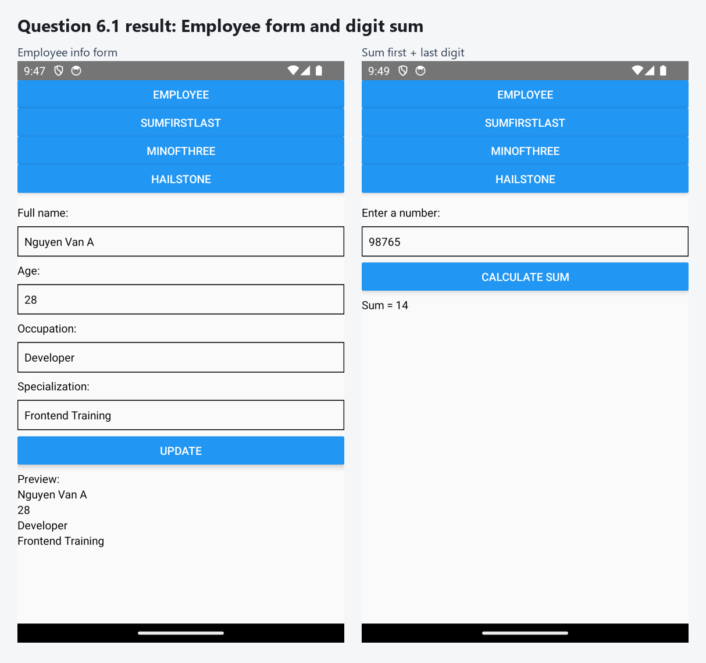
Source code:
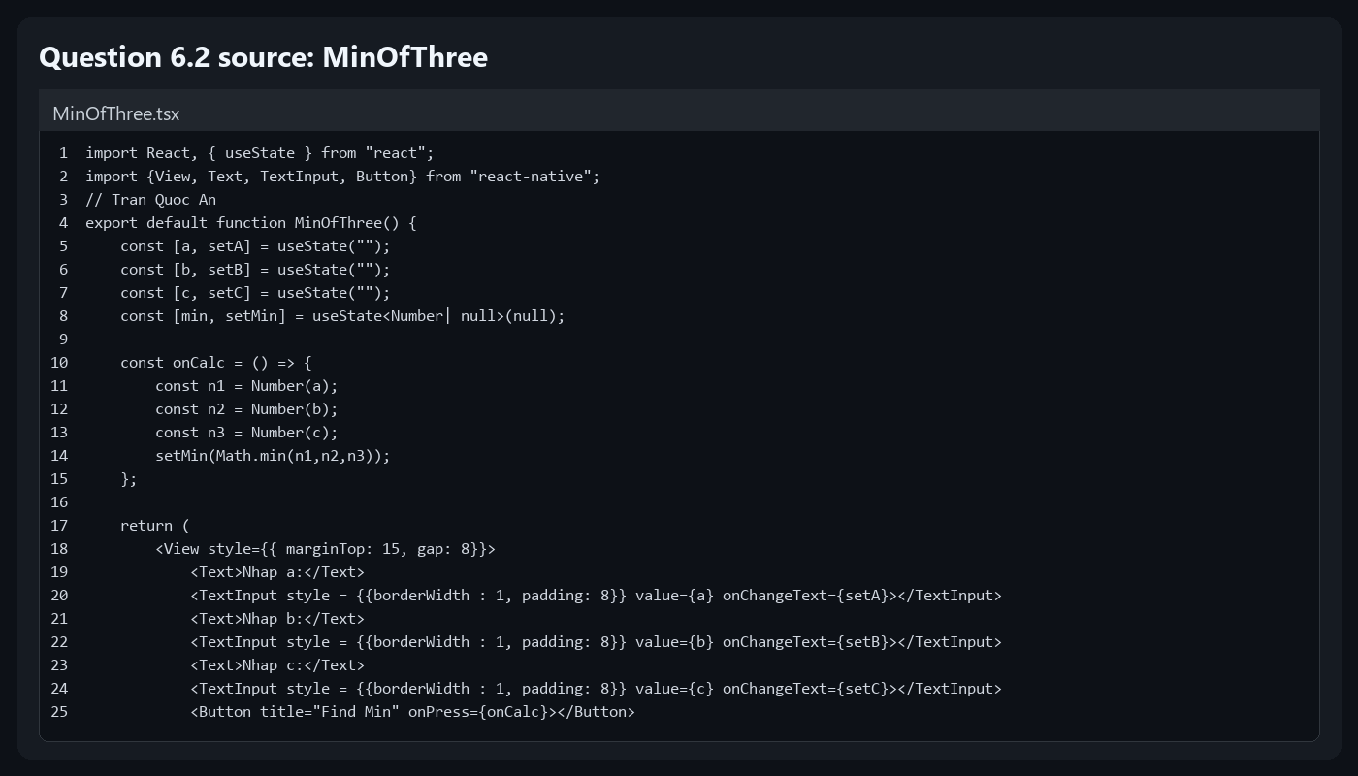
App running / result:
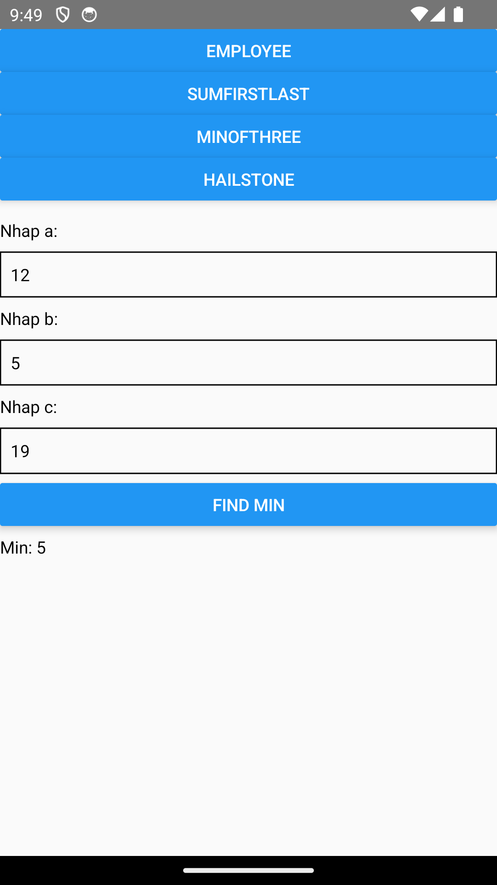
For a positive number n > 0: if n is even, divide by 2; if n is odd, multiply by 3 and add 1. Repeat until n equals 1.
Source code:
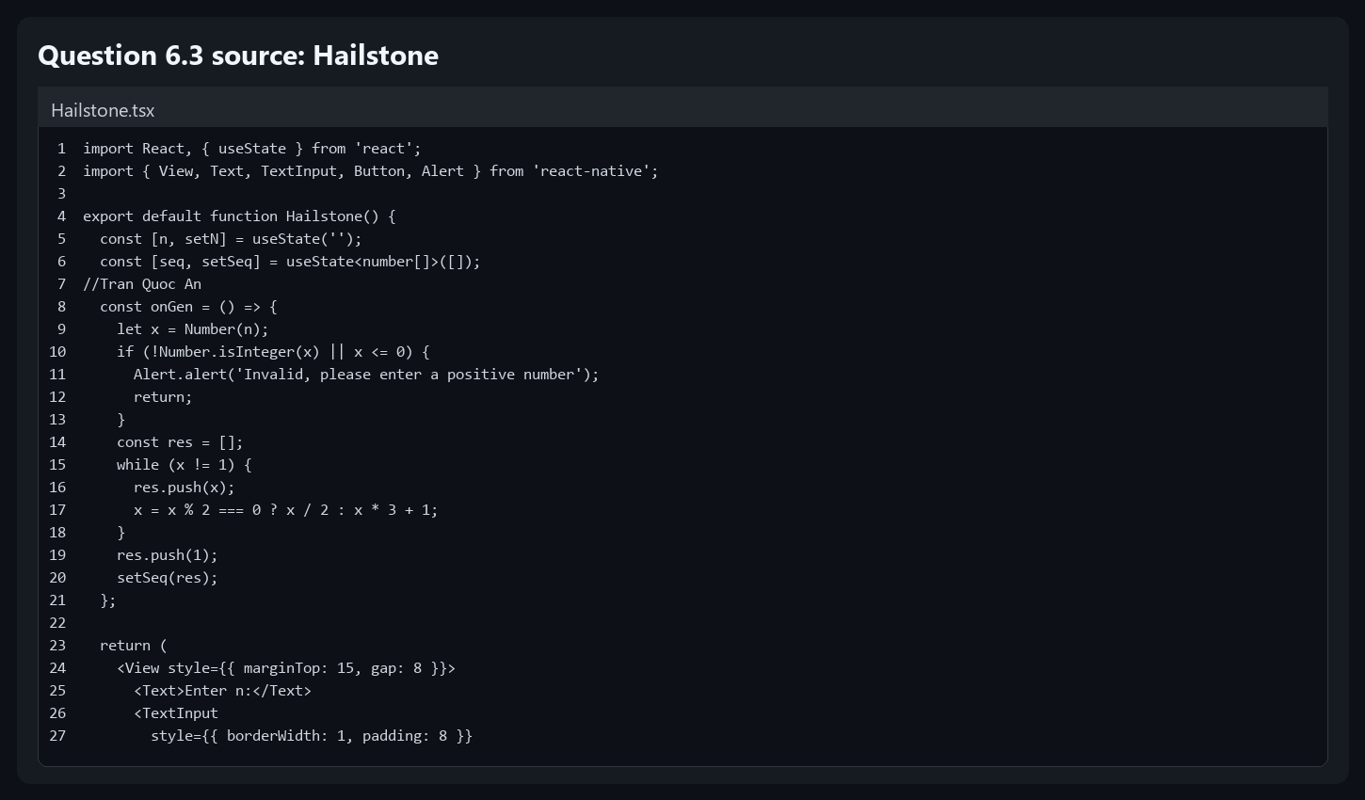
App running / result:
