MOBILE PROGRAMMING
LAB REPORT 2

Question 2. Build APIs Using Node Js
Requirement: Create a Node.js project in Visual Studio Code, create server.js, and configure Express, body-parser, and MySQL.
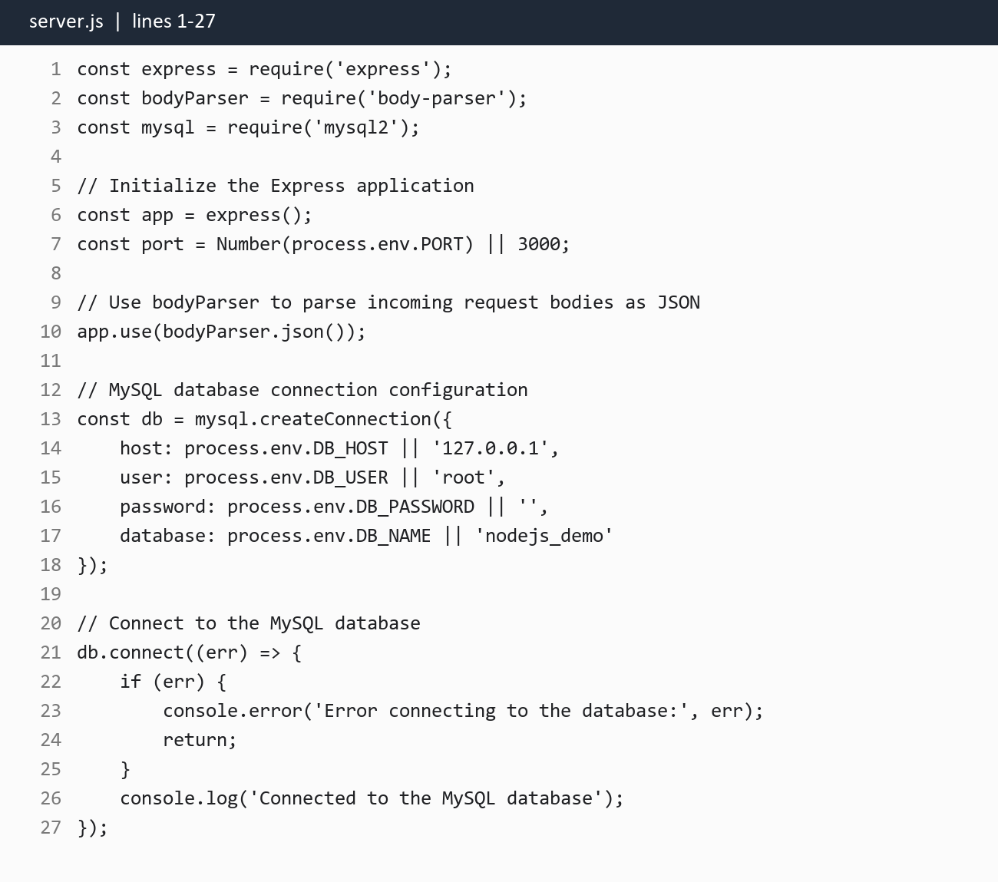
Requirement: Implement the Create, Get All, and Get by ID user API endpoints.
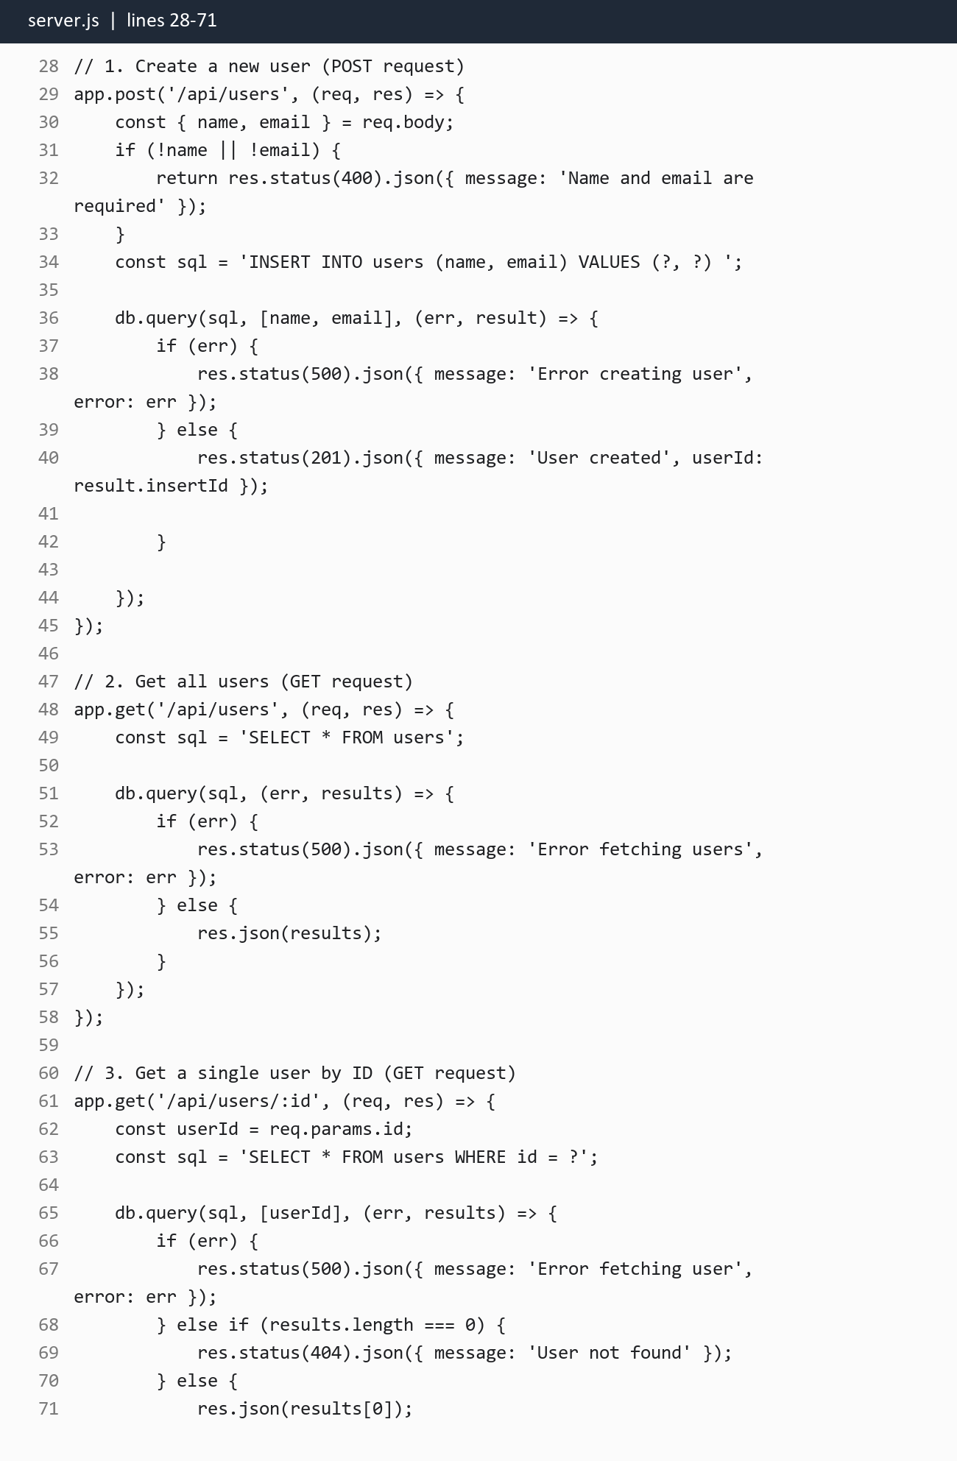
Requirement: Implement the Update and Delete user API endpoints.
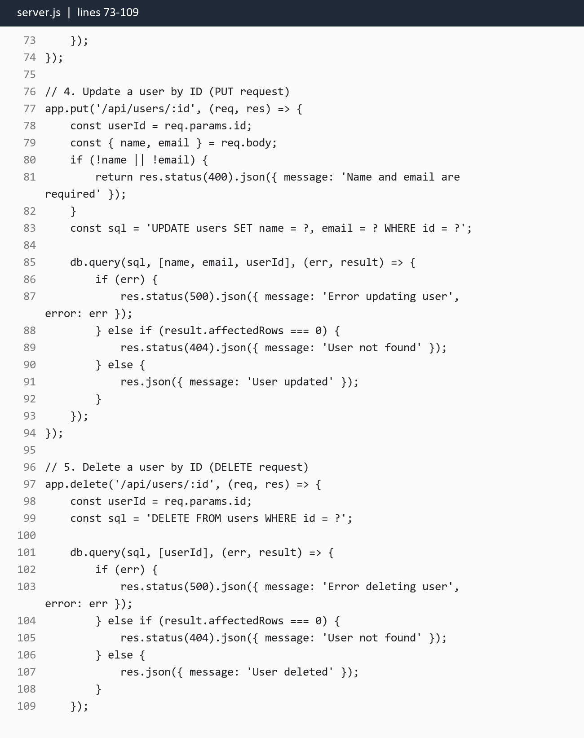
Requirement: Run the project with Node server.js or npm start and verify the CRUD API against the MySQL users table.
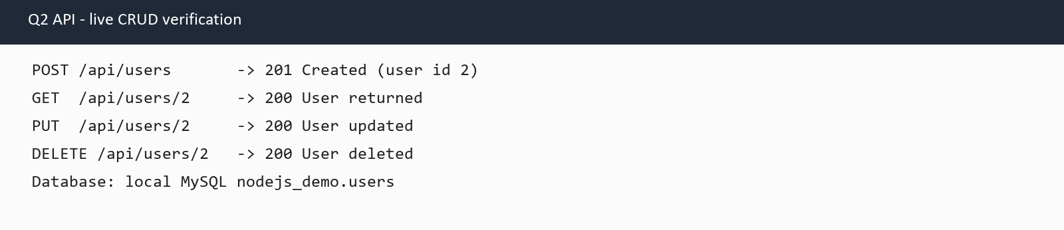

Question 3. Login Screen Interface Design
Requirement: Create the Q2Login project, install @react-navigation/native, create Styles.js and Login.js, and render the Login component from App.tsx.
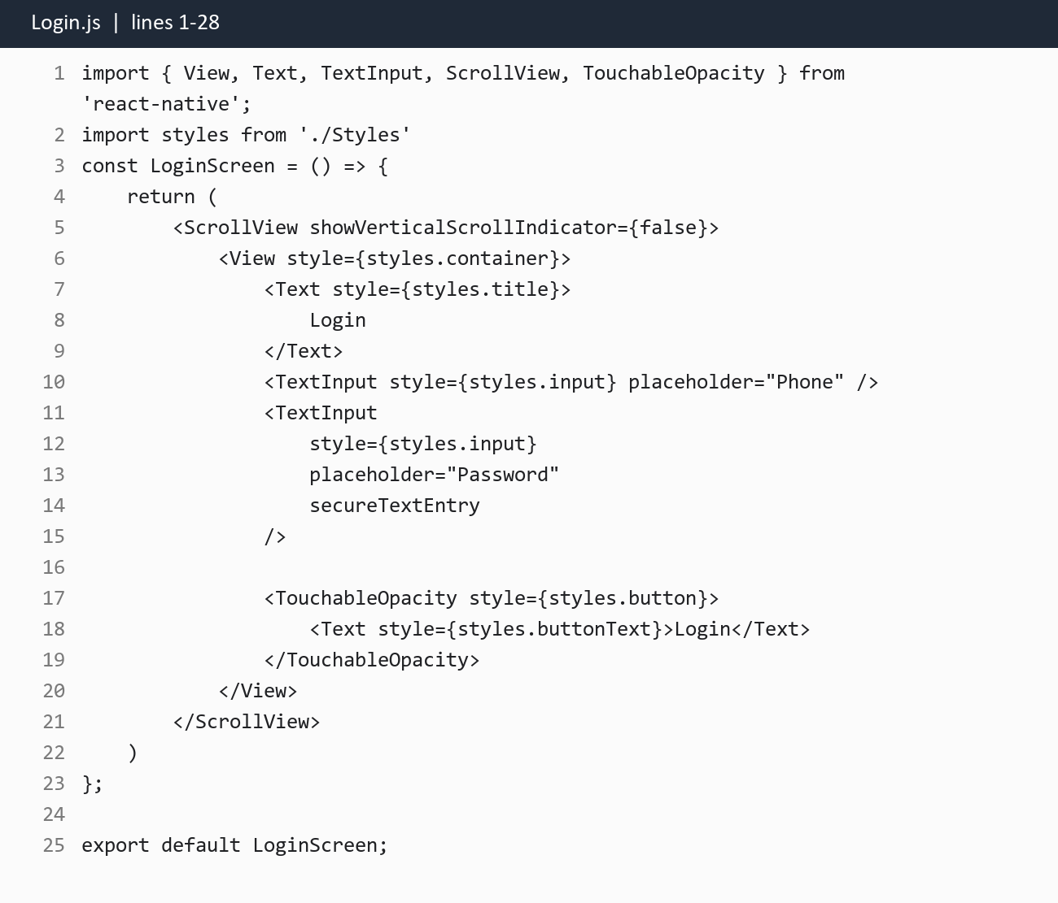
Requirement: Run the React Native app on Android. The login screen provides Phone and Password inputs and a Login button.
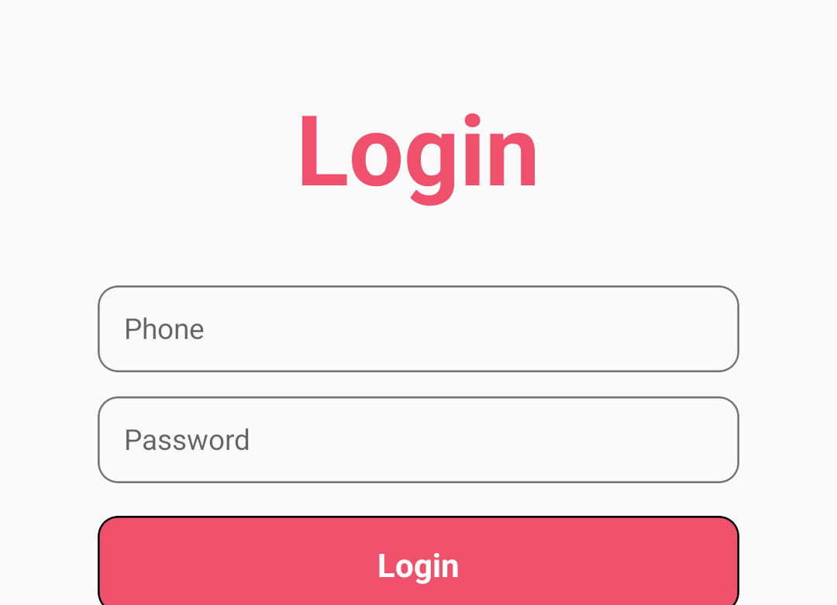

Question 4. Personal Income Tax Calculation
Requirement: Create the Q3IncomeTax project and styles.js, then implement the income-tax calculation in App.tsx using the required 10%, 20%, and 30% brackets.
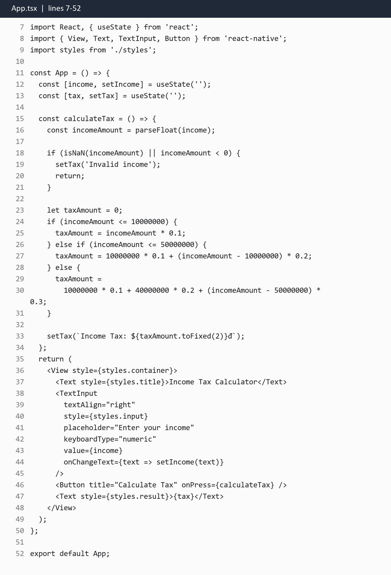
Requirement: Run the application on Android and provide an income input with a Calculate Tax button and result area.
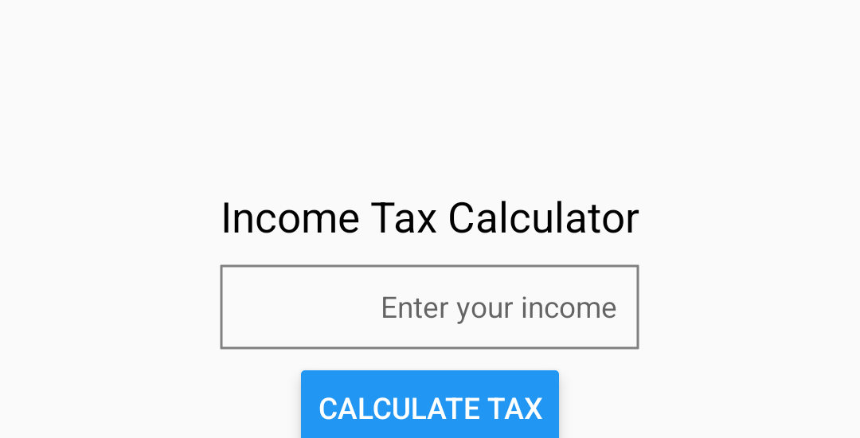

Question 5. Calculator Screen Interface Design
Requirement: Create the Q3Calculator project and style.js. Use state for displayValue, operator, and firstValue, then implement number, operator, equal, and clear handlers.
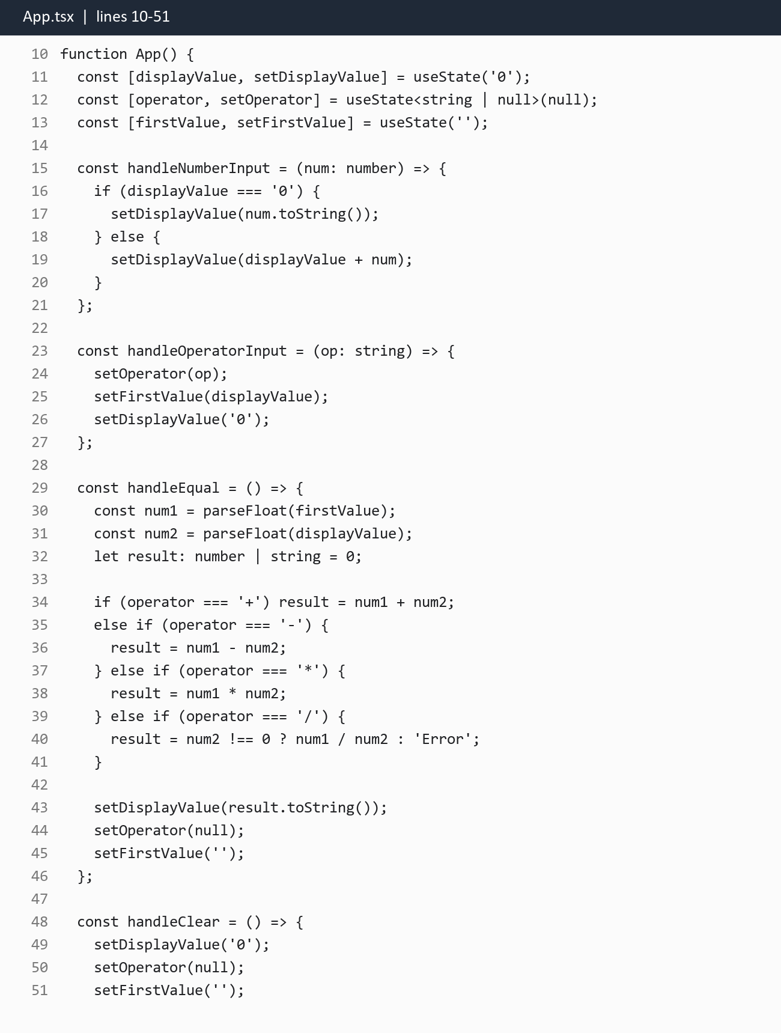
Requirement: Create the calculator interface with number buttons and arithmetic operators connected to the event handlers.
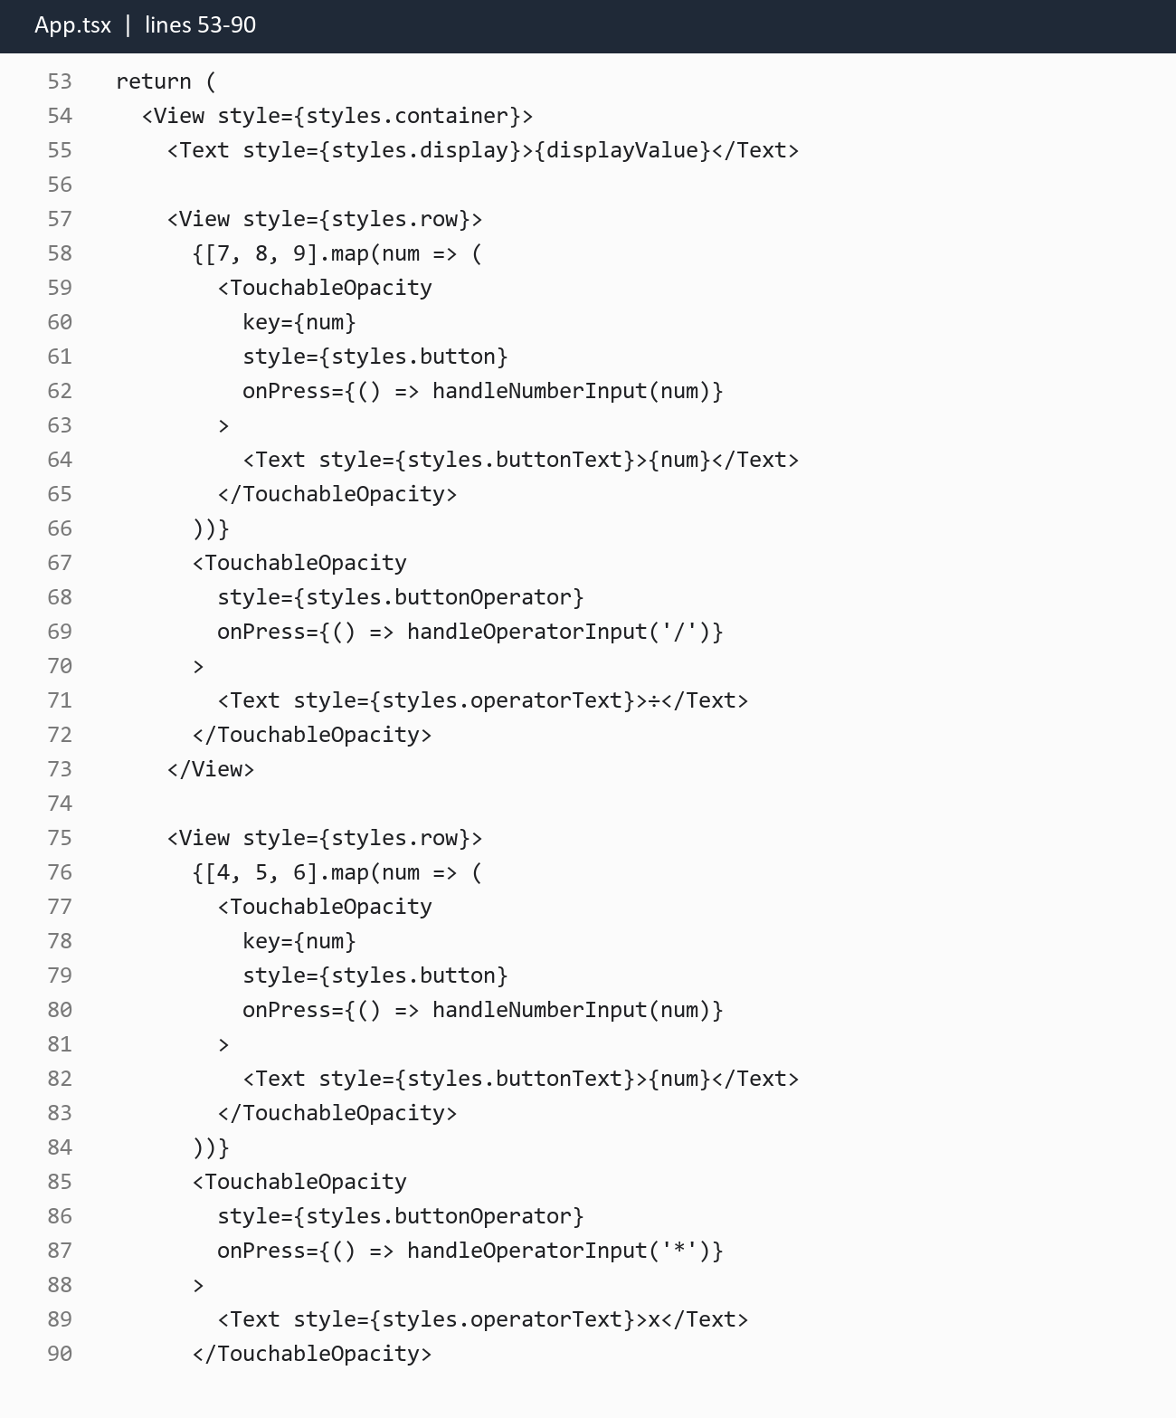
Requirement: Add the final calculator row with 0, +, Equals, and Clear actions.
