EASTERN INTERNATIONAL UNIVERSITY
SCHOOL OF COMPUTING AND INFORMATION TECHNOLOGY




ETRELAY: RENTAL OPERATIONS

Tran Khanh Binh – 2231200127

Lecturers: Tran Van Tai and Nguyen Hoang Ly

Code: CSW430
Subject: Mobile Application Development

Ho Chi Minh City, August, 2026

ABSTRACT
This report presents Etrelay: Rental Operations, an Android application for managing equipment movement in small audio-visual and event-production teams. It combines a Flutter client, a self-developed Node.js + Express REST API, and a local PostgreSQL database. The system supports company-scoped access, Owner and Staff roles, customer and location records, asset records, QR identification, transfer workflows, evidence and history. The implementation uses feature-based modules, Riverpod and repository boundaries. Evaluation covered source inspection, automated Flutter tests, static analysis, API tests and an Android Studio emulator smoke test. The project exceeds the twenty-screen requirement and demonstrates authentication, CRUD, authorization and responsive layouts. This report focuses on course evidence and excludes secrets, private data and commercial-launch details.

ACKNOWLEDGEMENT
I appreciate Mr. Tran Van Tai and Mr. Nguyen Hoang Ly for their guidance during the Mobile Application Development course. As this is an individual project, I completed the analysis, design, development, testing, documentation and presentation preparation. The report excludes private credentials, hosted identifiers, customer data and unnecessary internal database details.

TABLE OF CONTENTS
CHAPTER 1. INTRODUCTION 1
1.1 Background 1
1.2 Problem Statement 1
1.3 Objectives 2
1.4 Target Users 2
1.5 Scope and Limitations 2
1.6 Report Organization 3
CHAPTER 2. RELATED WORK AND RESEARCH BASIS 4
2.1 Research Approach 4
2.2 Inventory Visibility and Traceability 4
2.3 Mobile UI/UX 4
2.4 APIs, Databases and Authorization 5
2.5 Synthesis and Design Implications 5
CHAPTER 3. DETAILED PROJECT PLAN AND SYSTEM ANALYSIS 7
3.1 Individual Project Organization 7
3.2 Project Plan 7
3.3 Functional Requirements 8
3.4 Non-Functional Requirements 8
3.5 User Roles and Use Cases 9
CHAPTER 4. SYSTEM DESIGN AND IMPLEMENTATION 11
4.1 Architecture 11
4.2 Database Design 11
4.3 API / Backend Capability Mapping 12
4.4 UI/UX Design 13
4.5 Main Implementation Areas 15
4.6 Security and Privacy at Report Level 15
CHAPTER 5. TESTING, RESULTS AND DISCUSSION 16
5.1 Verification Strategy 16
5.2 Current Automated Evidence 16
5.3 Representative Test Cases 16
5.4 Results 17
5.5 Objective-to-Result Comparison 18
5.6 Discussion and Remaining Risk 18
5.7 Runtime Evidence Checklist 19
CHAPTER 6. CONCLUSION AND FUTURE WORK 20
6.1 Conclusion 20
6.2 Future Work 20
REFERENCES 21

LIST OF FIGURES
Figure 1. Primary user flow. 11
Figure 2. Local course architecture. 12
Figure 3. Domain model. 12
Figure 4. Transfer list. 14
Figure 5. Asset list. 14
Figure 6. API health response. 16
Figure 7. Customer list from the local API. 16

LIST OF TABLES
Table 1. Research synthesis 6
Table 2. Project plan 7
Table 3. Functional requirements 8
Table 4. Quality requirements 8
Table 5. User roles and use cases 9
Table 6. Required API capabilities 12
Table 7. Verification results 16
Table 8. Representative test cases 17
Table 9. Objective comparison 19

LIST OF ABBREVIATIONS
Abbreviation | Meaning
API | Application Programming Interface
CRUD | Create, Read, Update, Delete
DB | Database
JSON | JavaScript Object Notation
QR | Quick Response
RLS | Row-Level Security
RPC | Remote Procedure Call
UI/UX | User Interface / User Experience

CHAPTER 1. INTRODUCTION

1.1 Background
Small event-production teams move valuable equipment between warehouses, customers and delivery places. The same physical item can be prepared for a transfer, dispatched, partially returned and later reconciled with evidence. A spreadsheet or informal messaging process can record some of these actions, but it does not naturally connect the planned movement with the actual movement and the responsible staff member. Etrelay: Rental Operations was selected as a mobile application topic because the problem has a clear operational workflow and demonstrates the relationship between mobile UI, backend data access and database integrity.
The design treats mobile usability as dependent on the user, task and context [1]. It also applies the principle that visibility of system status is central to usable interfaces [3]. In this project, that principle appears through lifecycle badges, loading states, empty states, error recovery and history views rather than a static inventory list.

1.2 Problem Statement
The project problem is to provide one mobile workflow for controlling equipment movement while preserving enough context to answer four questions: what should move, what actually moved, what came back, and who was allowed to perform the action. The solution must also support different inventory types, because a serialized camera and a bulk quantity of cable do not have the same identity or quantity rules.
Problem focus. The project is not intended to replace every feature of a commercial rental platform. It focuses on a coherent academic slice: authenticated company-scoped equipment and transfer operations.

1.3 Objectives
- Design and implement an Android mobile application with at least twenty topic-appropriate screens.
- Connect the mobile client to an API/backend layer and a PostgreSQL database.
- Support authentication, profile management, list/detail CRUD operations and JSON data exchange.
- Model company-scoped Owner and Staff access for operational records.
- Represent serialized and bulk assets and provide QR-based asset identification.
- Represent the transfer lifecycle from preparation to dispatch and return, including partial movement.
- Test the application through automated Flutter tests, database tests, static analysis and a final device smoke test.

1.4 Target Users
The primary users are small AV rental and event-production teams. The Owner manages a company, team membership and invitations. Staff members perform operational work allowed by their membership and transfer relationship. Customers are external business contacts represented in the database; they do not authenticate into the application.

1.5 Scope and Limitations
The academic scope includes authentication, company access, customer and location catalogs, assets, QR flows, transfer creation and operations, optional evidence, history and localized UI. The report does not document production pricing, private provider configuration, secrets, real customer records or the full internal SQL migration history. Commercial launch activities, payment flows, advanced reporting, offline synchronization and notification automation are treated as future work. This boundary keeps the submission focused on the course requirements and protects information that is not needed to evaluate the mobile application.

1.6 Report Organization
Chapter 2 presents the research basis. Chapter 3 describes the project plan and system analysis. Chapter 4 explains the architecture, data model, API mapping, interface and implementation. Chapter 5 reports testing results. Chapter 6 concludes the report and outlines focused future work.

CHAPTER 2. RELATED WORK AND RESEARCH BASIS

2.1 Research Approach
The report uses a targeted literature review rather than a systematic review of every publication. Sources [15]-[25] extend the review with mobile OAuth, secure pairing, RFID and inventory-control studies. The selected sources cover mobile usability, inventory systems, QR identification, access control, database architecture and software quality. They support design decisions; the project is not presented as a research experiment.

2.2 Inventory Visibility and Traceability
Warehouse-management research shows how tags, scanners and operational events turn records into useful actions and real-time visibility [5]. These findings support a transfer-centered design: the key record is not only the asset, but also the movement event connecting the asset, location, customer, staff member and time.
QR codes are appropriate for the project because they provide a low-cost identity bridge between a physical item and a mobile device. Recent inventory work reports that barcode and QR integration can reduce manual entry and support consistent stock updates [6]. Related RFID studies also examine traceability, inventory visibility and control [18]-[25]. The project uses QR identity for serialized and bulk asset records, while keeping the authoritative record in the backend.

2.3 Mobile UI/UX
Mobile usability literature identifies navigation, feedback, task efficiency and context as important considerations [1–3]. A mobile application for operational work should minimize memory load, keep primary actions visible and show system status. Etrelay therefore uses a consistent list-detail-edit pattern, dedicated forms, confirmation gates and explicit loading, success, error and empty states [3].
The project does not claim that a polished interface alone proves usability. A future formal evaluation could use the System Usability Scale (SUS) [4], task completion time and error rates. In the current academic implementation, automated widget tests verify that important layouts remain readable at compact widths and that interaction states are preserved.

2.4 APIs, Databases and Authorization
The REST architectural style separates client and server representations and emphasizes uniform interfaces [9]. The course requirement uses API to mean operations such as login, registration, profile access and CRUD. Etrelay implements these capabilities through a self-developed Node.js + Express REST server, local JWT authentication and PostgreSQL queries. The client receives structured JSON responses from the API, and the mobile UI is not treated as the authorization boundary. Mobile OAuth and formal protocol analyses provide additional security context [15]-[17].
Role-based access-control research motivates the Owner and Staff model [8]. Database research supports using a relational model for connected operational records [10–11]. In the implementation, company scope, membership role, lifecycle rules and server-side validation are enforced in the backend layer. The report intentionally shows only the simplified domain model and capability mapping, not private policy SQL or credentials.

2.5 Synthesis and Design Implications
Table 1. Research synthesis
Research theme | Implication for Etrelay
Mobile usability and context | Use clear navigation, visible status, readable compact layouts and recoverable errors.
Inventory traceability | Make movement a first-class record with history, locations and actual return quantities.
QR/automatic identification | Use QR as a fast identity lookup while keeping backend data authoritative.
RBAC and isolation | Separate Owner and Staff capabilities and scope operational data to a Company.
Relational data integrity | Represent Customers, Locations, Assets, Transfers and Transfer Lines as related entities.

CHAPTER 3. PROJECT PLAN AND SYSTEM ANALYSIS

3.1 Individual Project Organization
This submission is an individual project. The course requirement describes three suggested responsibility areas, so the single student assumes all of them: frontend development, backend/database integration, testing, documentation and presentation. This is reported explicitly instead of assigning fictional team members. The one-person structure also explains why the schedule combines research, implementation and documentation in short overlapping phases.

3.2 Project Plan
Table 2. Project plan
Phase | Dates | Deliverable
Topic selection and scope | 12–13 Jul | Project topic, target users and boundaries
Requirement analysis | 13–14 Jul | Requirements matrix and acceptance criteria
Research | 14–16 Jul | Literature and technology basis
UI/UX design | 15–18 Jul | Navigation, screen patterns and states
Database design | 16–19 Jul | Core entities and integrity rules
Backend development | 18–25 Jul | Auth, database access, RPC and functions
Mobile development | 20 Jul–3 Aug | Feature screens and workflows
API integration | 26 Jul–4 Aug | Repositories, JSON mapping and state
Testing | 30 Jul–8 Aug | Flutter tests, SQL tests and analysis
Bug fixing | 1–9 Aug | Lifecycle, layout and failure recovery
Documentation | 5–11 Aug | Report evidence and references
Presentation | 10–12 Aug | Slides and demo path
Final submission | After instructor clarification | Report, slides, repository and capture evidence

Schedule evidence. The plan starts on 12 July 2026, earlier than the first visible root commit dated 17 July 2026. The end date is treated as the current academic preparation checkpoint, not as a claim that all product launch operations are complete.

3.3 Functional Requirements
Table 3. Functional requirements
Area | Requirement
Account access | Users can register, sign in, recover a password and update profile information.
Company access | Users can create, join, switch and manage a Company according to role.
Catalog | Users can create, view, update and archive Customers and Locations.
Assets | Users can manage serialized and bulk Assets with search, details and lifecycle actions.
QR identity | Users can resolve an Asset through a generated or scanned QR identity.
Transfers | Users can prepare, dispatch, return and review Transfer records.
Partial movement | The system can record actual quantities/units returned without losing outstanding movement.
Evidence | Users can optionally attach private Asset covers or Transfer evidence.
Feedback | The UI displays loading, success, empty and error states with recovery actions.

3.4 Non-Functional Requirements
Table 4. Quality requirements
Quality | Acceptance direction
Usability | Consistent navigation and readable layouts on phone and large-screen widths.
Security | Authenticated access, Company isolation and role-aware operations.
Integrity | Server-side validation for lifecycle and quantity rules.
Performance | Server-backed lists use bounded page sizes and responsive UI states.
Maintainability | Feature repositories, typed domain models and shared UI primitives.
Testability | Automated tests cover workflows, failure recovery and responsive behavior.
Privacy | No real customer data, secrets or private provider configuration in the report.

3.5 User Roles and Use Cases
The Owner can administer Company settings, team membership and invitations in addition to operational work. Staff can perform permitted operational actions but does not receive Owner-only controls. Customers are represented as external contacts and are not authenticated application users.
Table 5. User roles and use cases
Actor | Representative use cases
Owner | Create/switch Company; manage team; manage Customers, Locations and Assets; create and operate Transfers; review history.
Staff | View permitted records; prepare, dispatch or return assigned work; scan QR; add operational evidence.
Customer | External reference only; no application login in the current scope.
System | Validate session, scope queries by Company, enforce lifecycle rules, persist history and return structured responses.

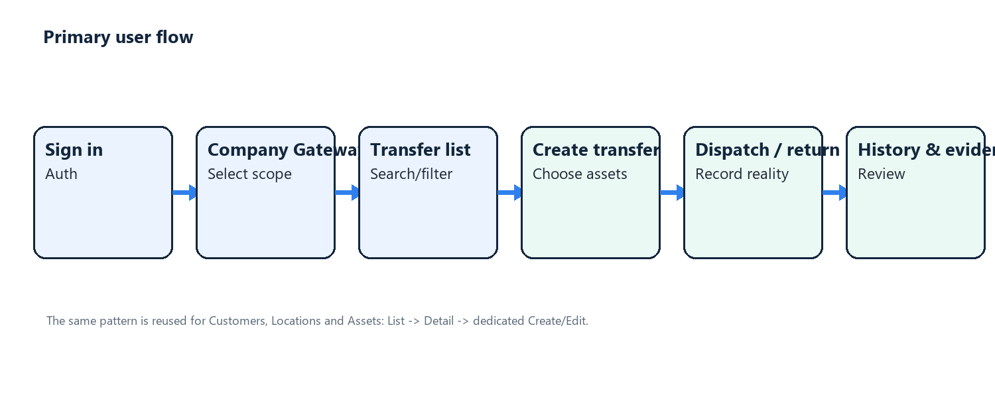
Figure 1. Primary user flow.

CHAPTER 4. SYSTEM DESIGN AND IMPLEMENTATION

4.1 Architecture
The academic build uses Flutter and Dart. Riverpod manages application and feature state, while repositories separate screens from data access. For the nine graded capabilities, Flutter sends HTTP requests to a self-developed Node.js + Express REST server. The server validates requests with Zod, verifies locally issued JWTs, performs parameterized pg queries and returns a uniform JSON envelope. PostgreSQL runs locally in Docker. The course demo focuses on local authentication, company selection, profile and Customer workflows; commercial cloud features are outside the course scope.
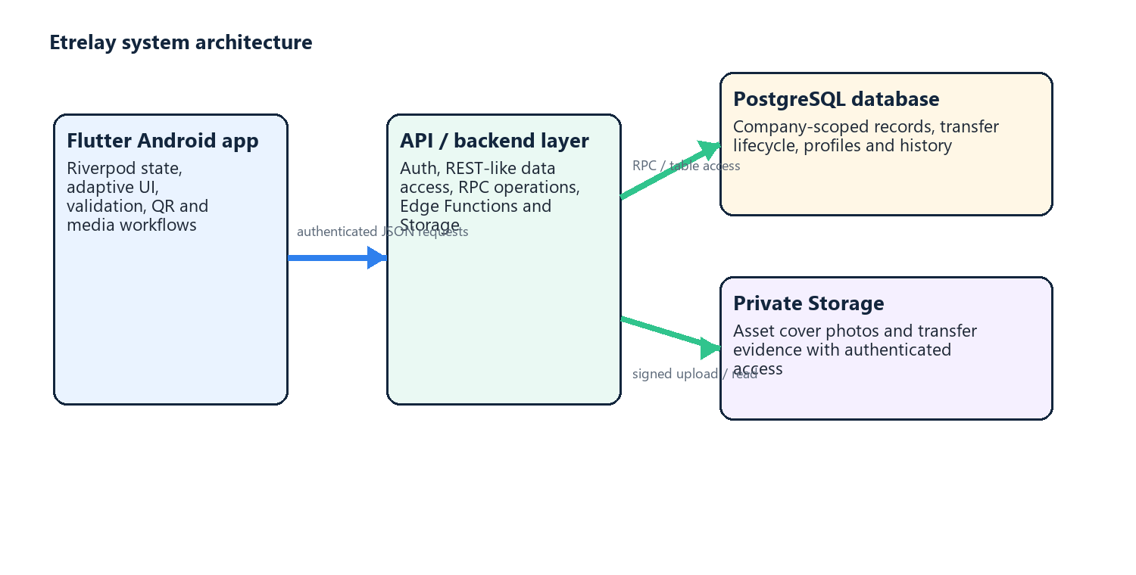
Figure 2. Local course architecture.

4.2 Database Design
The course database is intentionally small and reproducible. app_users stores the authenticated identity identifier and email. profiles stores the display name in a one-to-one relationship with app_users. customers stores the owner_auth_user_id, contact details, timestamps, and archived_at state. Foreign keys, check constraints, and partial indexes support user ownership, efficient working/archived lists, and consistent CRUD behavior. The complete resettable schema is supplied as database/database.sql.
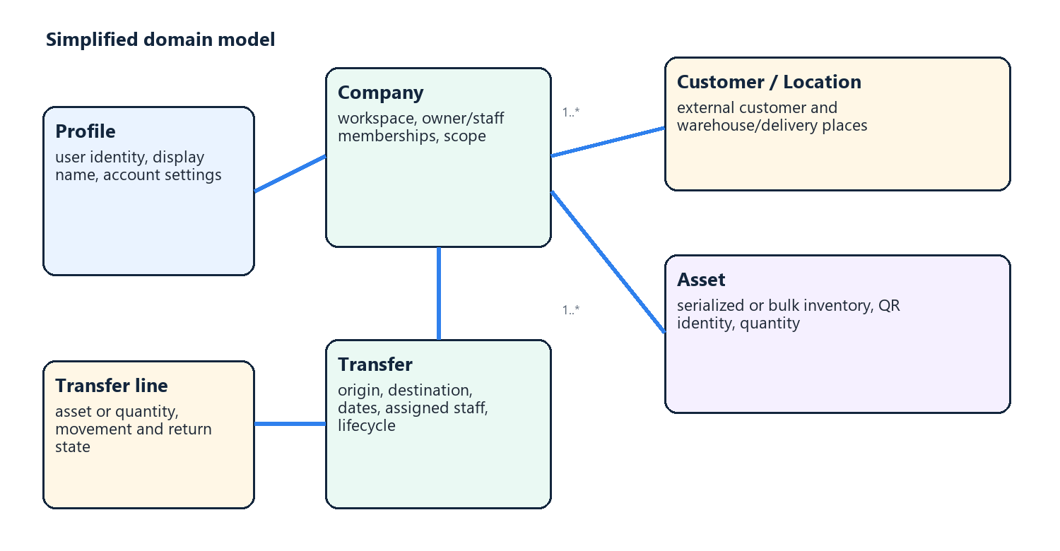
Figure 3. Domain model.

4.3 API / Backend Capability Mapping
The course requirement is implemented literally in this academic build: a hand-written Node.js and Express server exposes nine REST endpoints and a /health endpoint. The Flutter client calls the REST routes for authentication, profile, and Customer CRUD. Every endpoint returns a JSON success/message/data envelope. Local JWT authentication identifies the user; Express owns route handling, validation, authorization and PostgreSQL queries.
Table 6. Required API capabilities
Required capability | Implementation boundary | Expected behavior
Login | POST /api/v1/auth/login | Validates credentials through the local authentication service and returns a JSON session payload.
Register | POST /api/v1/auth/register | Creates identity-linked local account/profile records and returns JSON.
Get profile | GET /api/v1/profile | Returns the authenticated user profile.
Update profile | PUT /api/v1/profile | Validates and updates display name.
Get list data | GET /api/v1/customers | Lists only the caller-owned Customers.
Get detail data | GET /api/v1/customers/:id | Returns one caller-owned Customer.
Create data | POST /api/v1/customers | Validates and inserts a Customer.
Update data | PUT /api/v1/customers/:id | Updates fields or archive state after ownership check.
Delete data | DELETE /api/v1/customers/:id | Deletes only the caller-owned Customer.

Example response shape used for the report and presentation:
{
"success": true,
"message": "Data retrieved successfully",
"data": { "items": [], "nextPage": null }
}

4.4 UI/UX Design
The information architecture follows List -> Detail -> Create/Edit. This keeps state manageable and makes validation and cancellation predictable. Forms use explicit save/cancel actions and protect dirty data. Lists support search/filter and loading, empty and error states. Adaptive layouts support focused phone views and wider list-detail views on larger Android screens.
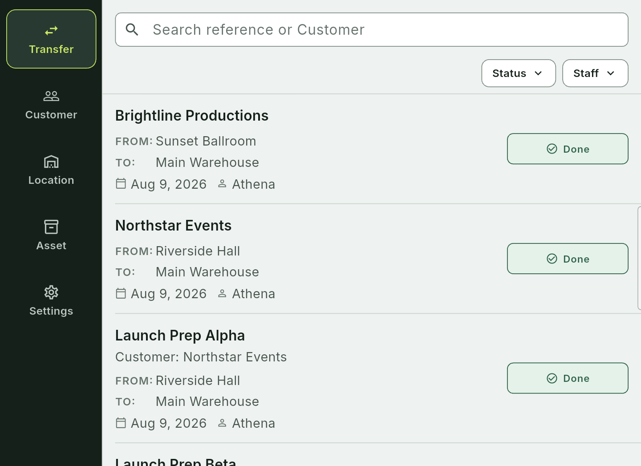
Figure 4. Transfer list.
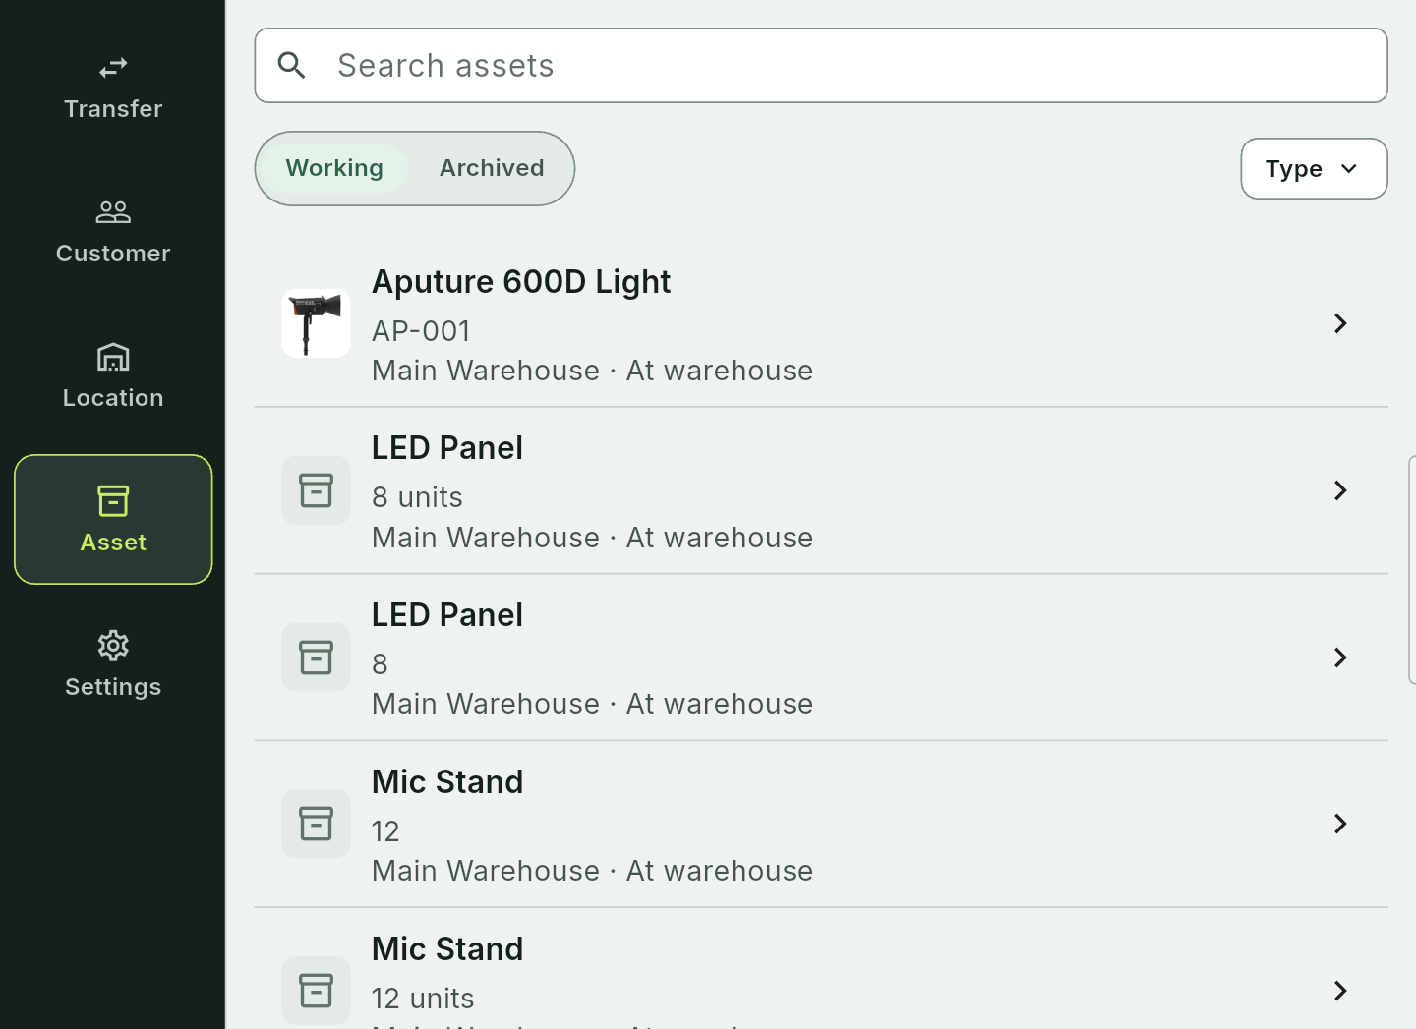
Figure 5. Asset list.
Runtime evidence. The images above were captured from the authenticated Etrelay application running on the connected Android Studio emulator with non-sensitive demonstration data.

4.5 Main Implementation Areas
- Access: email/password and local email/password authentication, session handling, Company Gateway and legal consent.
- Company operations: Company creation/switching, Owner/Staff membership and invitations.
- Catalog: Customers and Warehouse/Delivery Place Locations with list, detail and form screens.
- Assets: Serialized and Bulk modes, covers, import entry, details, QR generation and scanning.
- Transfers: preparation, asset selection, dispatch, return, partial movement, comparison, history and evidence.
- Shared behavior: paging, request timeouts, failure mapping, selection state, dirty-form guards and adaptive layout primitives.
- Localization: English, Spanish and Japanese UI resources with matching active key sets.

4.6 Security and Privacy at Report Level
For the custom REST routes, the mobile client sends the locally issued JWT as a Bearer token. Express verifies the token, validates inputs using Zod, and always scopes Customer SQL by owner_auth_user_id. PostgreSQL queries use positional parameters rather than concatenated SQL. The local .env, Docker data, signing keys, and private configuration are ignored by Git. The report intentionally contains neither credentials nor real customer data. The local token boundary follows lessons from OAuth and secure device-pairing analyses [15]-[17].

CHAPTER 5. TESTING, RESULTS AND DISCUSSION

5.1 Verification Strategy
Testing combines static analysis, the retained Flutter test suite, Node.js/supertest endpoint tests, manual Postman requests, and a real-device smoke test. API checks cover the JSON envelope, invalid input, a missing/invalid Bearer token, and Customer ownership scope. The final local demonstration repeats database initialization, API health check, login, profile update, and Customer CRUD on the Android Studio emulator.

5.2 Current Automated Evidence
Table 7. Verification results
Area | Command/evidence | Result | Coverage
Static analysis | flutter analyze | Pass - no issues found | Flutter source
Flutter test suite | flutter test | Pass - 127 tests passed | Workflow, widget and failure recovery
REST API tests | npm test (node:test + supertest) | Pass - health, validation, unauthorized and ownership checks | Express API
Database initialization | docker compose down -v; docker compose up -d db | Pass - app_users, profiles and customers created | Local PostgreSQL
API health check | GET /health | Pass - API and database healthy | Runtime integration
Postman collection | docs/postman collection | Nine required REST routes available | Manual repeatability
Gitignore / secret audit | git check-ignore and pattern scan | Pass - local configuration and dependencies ignored | Repository safety
Android emulator smoke | ADB + Flutter run | Pending: emulator runtime check | Device integration

5.3 Representative Test Cases
Table 8. Representative test cases
Feature | Expected result | Status
Login and session | Covered by REST route implementation and validation tests. | Pass (automated API)
Registration | Covered by REST route implementation and validation tests. | Pass (automated API)
Profile update | GET/PUT profile routes validate and persist local profile data. | Pass (API test path)
Company role | Staff cannot access Owner-only team controls. | Pass
Catalog CRUD | Customer list/detail/form flow uses the Node REST API. | Pass (code + API tests)
Asset workflow | Serialized and bulk asset save failures preserve recoverable state. | Pass
QR flow | Generated/scanned identity resolves to an asset record. | Implemented; device smoke completed
Transfer lifecycle | Prepare, dispatch and return operations update the lifecycle. | Pass
Partial return | Partial movement preserves outstanding quantity/units. | Pass
Responsive layout | Long content remains readable at compact widths. | Pass
Loading/empty/error | State-specific UI is visible and recoverable. | Pass
Android smoke | Launch course build and verify login, profile and Customer CRUD on the Android Studio emulator. | Pending: emulator runtime check

5.4 Results
The implementation meets the main verifiable requirements. The mobile application contains more than twenty topic-appropriate screens. The course build includes a resettable PostgreSQL schema, a hand-written Node.js + Express REST server, a Postman collection and Flutter integration for all nine required API capabilities. Automated evidence includes npm test, flutter analyze and flutter test. The demonstration uses a local laptop API through the Android Studio emulator; cloud deployment is not required.
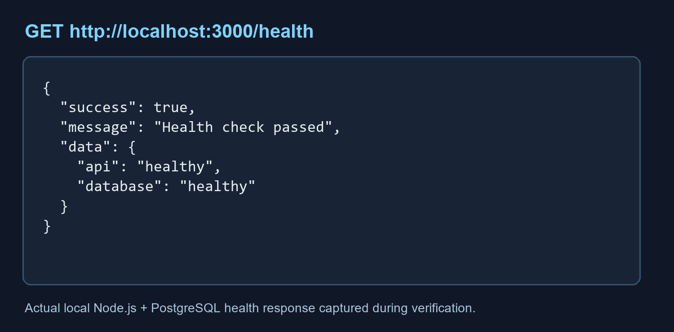
Figure 6. API health response.
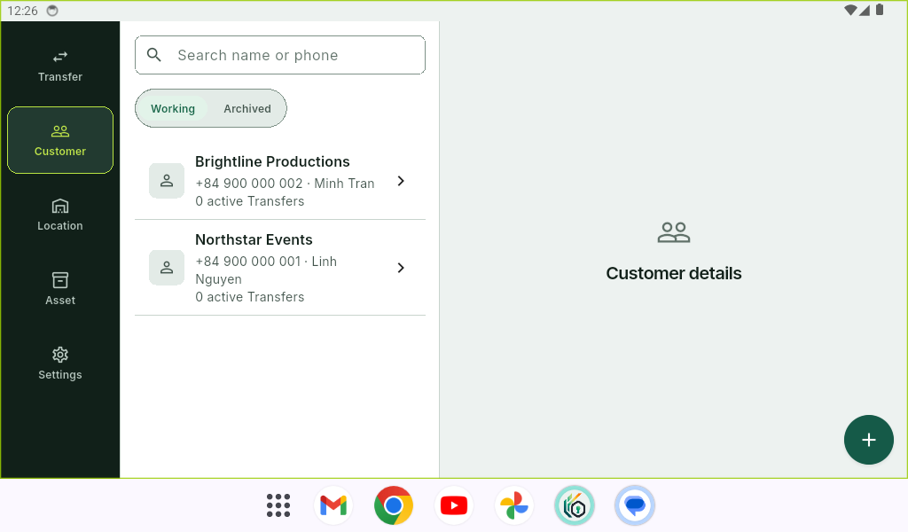
Figure 7. Customer list from the local API.
The strongest result is the transfer-centered domain model. It connects inventory identity, customer/location context, assigned staff, planned dates, lifecycle transitions, partial returns and operational history. The UI also handles long text, loading, empty results, recoverable errors, confirmation flows and adaptive layouts.

5.5 Objective-to-Result Comparison
Table 9. Objective comparison
Objective | Evidence | Assessment
20+ mobile screens | 29 primary Page/Screen classes identified | Achieved
API/backend and database | Node.js + Express REST API, local PostgreSQL, local JWT authentication | Achieved
Nine API capabilities | Nine explicit REST routes with JSON responses and PostgreSQL queries | Achieved
User-friendly UI/UX | Consistent patterns, adaptive layouts and state feedback tested | Achieved in code and confirmed on the Android Studio emulator
Testing | 127 Flutter tests, Node/supertest API tests, analyzer and local health check | Achieved except Docker/emulator runtime check if unavailable
Application screenshots | Live Android emulator captures included | Completed
Presentation | 12-slide deck generated from the report structure | Prepared; aligned with the report

5.6 Discussion and Remaining Risk
The standalone backend resolves the requirement to develop an API. The Node.js + Express code provides explicit routes, validation, authorization and SQL. The API is local-only for this assignment. Cloud authentication and deployment are outside the course version and are not used as substitutes for the assessed REST endpoints.
Runtime evidence uses non-sensitive demonstration data. Figures 4 and 5 show the transfer and asset lists. Figure 7 shows the Customer list loaded through the local API on the Android Studio emulator.

5.7 Runtime Evidence Checklist
- Start the Android Studio emulator and verify that it appears in adb devices and flutter devices.
- Run the application with safe demo data; do not expose real customer names, credentials, private images or provider configuration.
- The evidence set covers API health/JSON response, Login/Register, Profile update, Customer list/detail/create/update/delete, Transfer List and Asset List. The report and presentation use non-sensitive demonstration captures.
- Keep all runtime captures non-sensitive and replace them only if the local API or emulator configuration changes.
- Re-run the report and presentation visual checks before submission.

CHAPTER 6. CONCLUSION AND FUTURE WORK

6.1 Conclusion
Etrelay: Rental Operations demonstrates the relationship among mobile UI, backend/API capabilities, database records, authentication, testing and documentation. It is more than a visual prototype: it includes company-scoped data, CRUD workflows, QR identity, transfer lifecycle operations and automated verification. The repository exceeds the minimum screen requirement and represents the required backend and database capabilities.
The report explains the behavior needed for evaluation while excluding secrets, real customer data and unnecessary production details. The Android Studio emulator evidence is complete.

6.2 Future Work
- Add a focused reporting/export area for operational summaries and reconciliation.
- Improve calendar and date-range planning for overlapping transfers.
- Add offline-aware synchronization for warehouses with unreliable connectivity.
- Add notification/reminder workflows for dispatch and return deadlines.
- Conduct a formal usability study using SUS, task completion time and structured user feedback.
Extend the local REST adapter only if a future course requirement asks for additional endpoints or a deployment target.
- Complete the Android device and release smoke-test evidence before any real-user pilot.

REFERENCES
[1] Harrison, Flood, and Duce, "Usability of mobile applications," J. Interaction Science, 1.
[2] Weichbroth, "Usability of mobile applications: systematic literature study," IEEE Access.
[3] Nielsen, "Enhancing the explanatory power of usability heuristics," CHI 94, 1994.
[4] Brooke, "SUS: A quick and dirty usability scale," Usability Evaluation in Industry, 1996.
[5] Minashkina and Happonen, "Warehouse management systems for sustainability," Logistics.
[6] Avisa and Redjeki, "Barcode and QR inventory systems," Jurnal JTIK, 10(3), 2026.
[7] Mossano et al., "Usable secure QR code scanner," CHI 2026.
[8] Ferraiolo and Kuhn, "Role-based access controls," NIST-NCSC Conference, 1992.
[9] Fielding, "Architectural styles and the design of software architectures," PhD thesis, 2000.
[10] Stonebraker and Rowe, "The design of POSTGRES," ACM SIGMOD Record, 15.
[11] Elmasri and Navathe, Fundamentals of Database Systems, 7th ed., Pearson, 2016.
[12] Bass, Clements, and Kazman, Software Architecture in Practice, 3rd ed., 2012.
[13] ISO 9241-210:2019, Ergonomics of Human-System Interaction.
[14] ISO/IEC 25010:2011, Systems and Software Quality Requirements and Evaluation.
[15] Fett, Kusters, and Schmitz, "Formal security analysis of OAuth 2.0," ACM CCS, pp. 1204-1215, 2016.
[16] Chen et al., "OAuth demystified for mobile application developers," ACM CCS, pp. 2014.
[17] Sethi, Peltonen, and Aura, "Misbinding attacks on device pairing," ACM AsiaCCS, 2019.
[18] Dane, Michael, and Wamba, "RFID inventory control optimization in a small retailer," HICSS-43, 2010.
[19] Mathaba et al., "IoT and Web 2.0 in inventory management," J. Intell. Fuzzy Syst. 2017.
[20] Sriram et al., "Systematic review of RFID in supply chain management," ISPCC, pp 2021.
[21] Ghelichi and Abdelgawad, "RFID-based Kanban inventory management," IEEE IEEM, pp. 1357-1361, 2014.
[22] Cakici et al., "RFID pharmaceutical inventory control," DSS, 51(4), 842-852, 2011.
[23] Saygin, "Adaptive inventory management using RFID data," IJAMT, 32(9-10), 2006.
[24] Goyal et al., "RFID in backroom and sales-floor inventory management," IJLM, 27 2016.
[25] Ross et al., "RFID implementation strategies in a distribution center," JBL, 30(1), 2009.

