Social Media Stat Report

Executive Summary
This report presents a comprehensive analysis of EthioWare's digital performance across LinkedIn, YouTube, and its web traffic, contextualized against educational industry benchmarks. The analysis reveals that while the organization has established a solid foundation with strong organic reach and effective content formats, there are clear opportunities for strategic growth. Key findings indicate a mobile-first audience, a high reliance on Google Search for traffic, and strong performance in specific content types like interviews. However, areas like social media engagement and YouTube subscriber conversion show significant room for improvement. The recommendations outline a clear path to build upon these strengths, address data limitations, and drive a more robust, multi-platform educational content strategy to boost brand recognition and audience loyalty.

1. Introduction
This document serves as a strategic marketing report for the department, translating the raw data into actionable insights. The objective is to evaluate EthioWare's current digital footprint, identify audience engagement trends, and formulate data-driven recommendations to enhance ethioware market position as a premier educational brand.

2. Methodology & Data Quality

2.1 Data Sources
The analysis is based on four primary datasets:
- LinkedIn Analytics
- YouTube Analytics
- Platform & Search Term Analytics
- Web analytics

2.2 Data Limitations & Context
LinkedIn Analytics
- Incomplete Data: The "Impressions (sponsored)", "Clicks (sponsored)", "Reactions (sponsored)", "Comments (sponsored)", and "Reposts (sponsored)" columns all contain zero values. This indicates that either no sponsored content was run during the tracked period, or more likely, that the data for paid campaigns was not properly collected or is missing.
- Missing Contextual Data: The "Comments (organic)" column only provides a numerical count of comments. There is no qualitative data, such as the actual text of the comments, to perform a sentiment analysis or to understand the nature of the conversation.
YouTube Analytics
- Fragmented Data: The data is provided in three separate files: a summary of lifetime performance (YouTube Analytics - Summary.xlsx), top content over the channel's lifetime (YouTube Analytics - Top Content.xlsx), and a 48-hour snapshot (YouTube Analytics - Top Content (Last 48 Hours).xlsx). This fragmentation makes it challenging to track content trends and performance over a continuous timeline.
- Missing Time-Series Data: There is no detailed time-series data for views, watch time, or subscribers. Without this, it's impossible to see a trend line and correlate performance with specific publishing dates or marketing activities.
- Limited Top Content: The "Top Content" files only list a handful of videos, which limits the ability to perform a comprehensive analysis of all content on the channel.
Web Analytics
- Inconsistencies & Discrepancies:
- Inconsistent Geographic Data: The website-cleaned.csv file lists 65 unique countries with a high number of requests from Ireland, while the Visits by Country.xlsx file only lists 5 countries, with Ethiopia as the top country. This suggests a severe incompleteness or a filter applied to one of the datasets.
- Incompleteness & Missing Data:
- Limited Top Paths Data: The Top Paths.xlsx file is severely incomplete, as it only contains two pages, /apply and /EB0107254. This provides a very narrow view of user flow and makes it impossible to conduct a comprehensive analysis of the user journey.

3. Platform-Specific Performance Analysis

3.1 LinkedIn Performance

3.1.1 Key Metrics & Benchmarks
Ethioware LinkedIn performance metrics, when compared to education industry benchmarks, reveal an area for improvement in engagement despite solid visibility.
Metric | Ethioware Value | Industry Benchmark (Education / Nonprofit) | Meaning / Definition | Gap / Notes
Engagement rate (by impressions) | 10% (avg); Peak 28% (Feb 2025); Low 3% (Dec 2024) | 2.2% – 3.0% | % of people who saw a post and engaged (likes, comments, shares). Shows effectiveness of content in driving interaction. | Very high vs benchmark (excellent, but check calculation consistency).
Average impressions per post | 140 (Sunday 177; Friday 98) | 300 – 1,000+ | Average number of times a post is displayed in users’ feeds. Indicates visibility and organic reach. | Below benchmark; indicates limited reach or small follower base.
Reach (% of followers reached per post) | 7% | 4% – 10% | % of followers who see each post. Reflects organic visibility relative to total audience size. | Within benchmark range (healthy reach for follower size).
Impressions ↔ Clicks correlation | 0.77 (strong) | 0.5 – 0.8 (strong) | Measures how strongly impressions (views) drive clicks (traffic). High value means visibility is critical for clicks. | In line with benchmark; boosting impressions will lift clicks.
Comments per post | 0.52 | 1 – 2 | Average number of comments per post. Reflects how conversational and discussion-oriented the content is. | Below benchmark; audience not very conversational.
Reposts (shares) vs clicks | 33 reposts vs 6,908 clicks (corr. 0.08) | Shares 5% – 10% of engagements | Reposts = amplification to others’ networks; clicks = direct consumption. Shows if content is “share-worthy.” | Far below benchmark; content useful but not “share-worthy.”
Reaction-to-Impression ratio | 1.07% | 2% – 3% | % of viewers who reacted (liked, celebrated, etc.). Measures emotional resonance of content. | Below benchmark; content not highly resonant emotionally.
Posting frequency | Varies | 2 – 3 posts per week | Average number of posts published per week. Affects reach, consistency, and algorithm favorability. | Should align with benchmark best practice.
Optimal days/times | Wednesday (best reactions) & Sunday (best impressions) | Mid-week (Tues–Thurs) | Days/times when posts generate the strongest audience response. Useful for scheduling. | Ethioware’s Sunday peak is an audience-specific advantage.
Top performing posts (by impressions) | 2,417 (Feb 4, 2025), 1,906 (Jul 6, 2025), 1,607 (Jul 5, 2025), 1,386 (Jul 23, 2025), 1,194 (Aug 11, 2024) | Top posts often 2–10× avg impressions | Posts that significantly outperform average visibility. Helps identify successful content patterns. | Most of the spikes suggest or align with cohort registration but can be further analyzed.
Quarterly engagement performance | Q1 2025: 18%, Q2: 11%, Q3: 10%, Q4 2024: 5%, Q3 2024: 7% | Seasonal swings (30%–80% variation) | Engagement trend across quarters. Reveals seasonal peaks and lows for campaign planning. | Matches typical seasonality; Q1 should be prioritized for campaigns.
Engagement breakdown | Reactions 76.6%, Comments 19.9%, Reposts 3.4% | Reactions 70–85%, Comments 10–25%, Shares 3–10% | Distribution of engagement types. Shows whether audience is passive (likes), conversational (comments), or amplifying (shares). | Mix aligns with norms; reposts at low end of benchmark.
Correlation matrix highlights | Impr–Clicks 0.77, React–Comm 0.45, ER–Reactions 0.62 | 0.3 – 0.8 (moderate to strong) | Correlation measures show which metrics move together (e.g., more impressions = more clicks). Useful for strategy prioritization. | Within normal ranges; confirms impressions drive clicks.
Top posts by engagement rate | 2.17% (Jun 11, 2025, 6 impr.), 1.36% (Mar 26, 2025, 25 impr.), 0.81% (Feb 15, 2025, 134 impr.) | Top ERs usually >3% | Shows the % of viewers engaging per post. Highlights content that resonates most strongly regardless of reach. | High ER posts had very small impressions; need scale.

3.1.2 Engagement Trends & Top Content
Analysis of ethioware historical data reveals clear audience behavior patterns that provide tactical advantages:
- Highest Reactions: We see the most organic reactions on Wednesday. This suggests a key window for posting high-impact, discussion-driving content.
- Top Performing Days: The top 5 days for total impressions are clustered in February and July. These peaks likely correlate with "cohort registrations," demonstrating the powerful synergy between the marketing content and key institutional events.
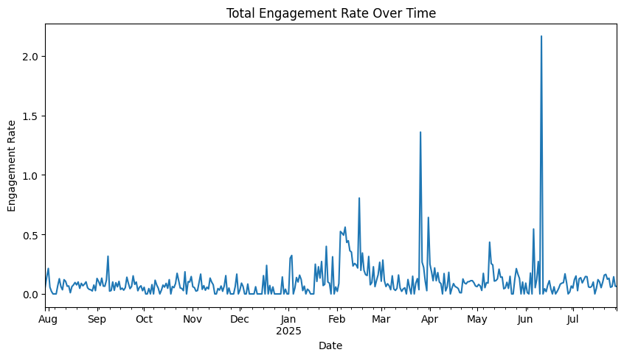
Marketing Department Recommendations for Ethioware
- Boost Reach & Impressions:
- Encourage staff, partners, and students to engage with posts (the algorithm amplifies personal interactions).
- Test multi-format content: carousels, infographics, and short videos (LinkedIn favors these).
- Use relevant educational hashtags (#EdTech, #OnlineLearning, #EthiopiaEducation) to tap into broader audiences.
- Strengthen Thought Leadership:
- Post expert insights from teachers, researchers, and guest contributors.
- Share data-driven posts which perform well in education.
- Repurpose student success stories and case studies to position Ethioware as a trusted leader.
- Increase Engagement (Beyond Clicks):
- End posts with questions or prompts (“What’s your biggest learning challenge?”) to spark comments.
- Run polls (LinkedIn gives them algorithmic boost).
- Highlight user-generated content from students or community.
- Improve Shareability:
- Package content into bite-sized, value-first tips
- Create “ready-to-share” visuals (quotes, stats, infographics).
- Tag partner organizations, universities, or thought leaders to encourage reshares.
- Optimize Posting Strategy:
- Maintain a minimum of 2–3 posts per week (consistency matters more than volume).
- Double down on Wednesdays but continue Sunday experiments (unique audience strength).
- Use LinkedIn analytics to refine best posting times (track engagement per hour).
- Build Community Engagement:
- Respond to every comment (boosts reach + shows active presence).
- Feature student/trainer voices via “Takeover Days” where they share their learning journey.
- Join and post in relevant LinkedIn Groups (education, African edtech, social innovation).
- Leverage Analytics:
- Track reach %, engagement rate, shares vs clicks monthly.
- Run A/B tests (e.g., infographic vs text-only) to see what resonates.
- Identify top-performing content and repurpose it (turn into blog, video, or carousel).

Visualizations: 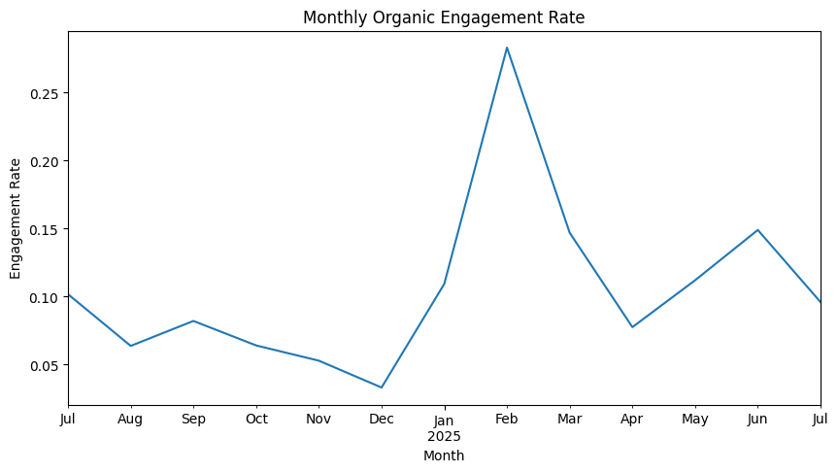
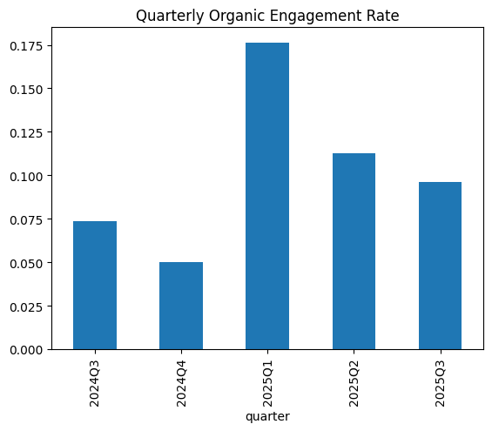

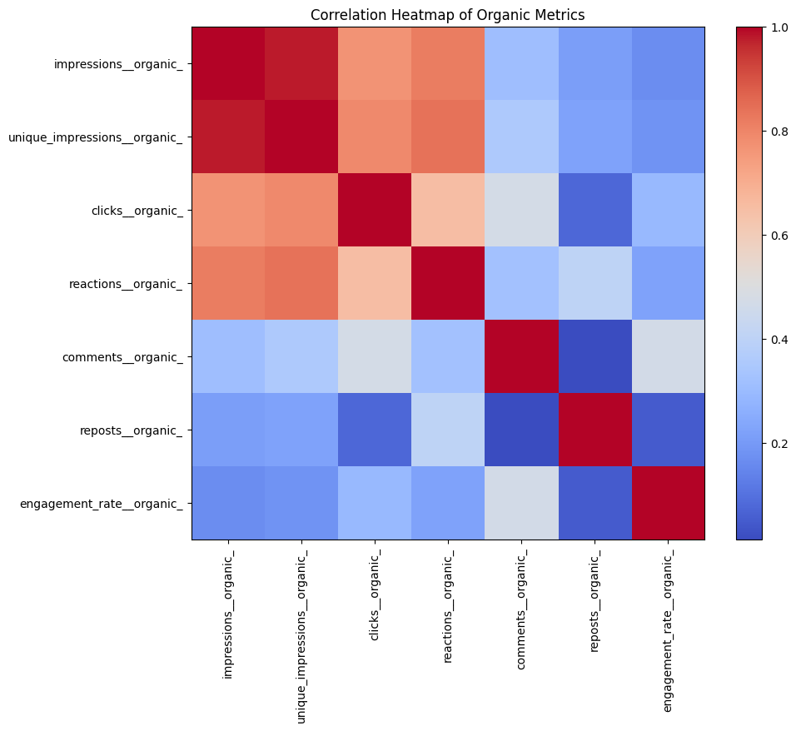
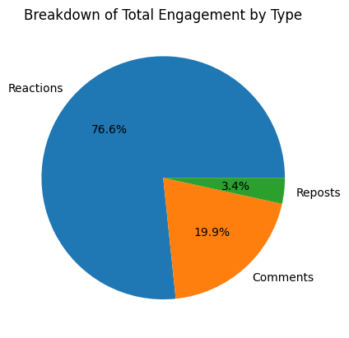

Audience Behavior Insights:
- Prefers low-effort engagement: 77% of total engagement comes from reactions, showing the audience is more likely to “like” than comment or share.
- Not very conversational: Average of 0.52 comments per post vs. industry benchmark 1–2, suggesting posts don’t spark dialogue.
- Rarely shares content: Only 33 reposts vs. 6,908 clicks; users consume content personally but don’t amplify it to their networks.
- High click-through activity: Content generates strong direct clicks, meaning it’s seen as useful/informative to individuals.
- Time-sensitive engagement: Sunday impressions (+27% above average) and Wednesday reactions (+47% above average) show strong behavioral patterns tied to timing.
- Emotional resonance is low: Reaction-to-impression ratio is 1.07% vs. benchmark 2–3%, showing content doesn’t strongly “move” the audience emotionally.
- Seasonal engagement: Q1 has 80% higher engagement than Q4, meaning timing campaigns early in the year yields the best impact.
- Reactions drive engagement rate: Correlation of 0.62 between reactions and engagement rate shows that boosting reactions directly improves overall performance.
- Browsing mindset: Higher Sunday impressions suggest users casually scroll and read content when relaxed, unlike weekdays when they are more transactional.

3.2 YouTube Performance

3.2.1 Total Channel Metrics
Ethioware YouTube channel metrics provide a snapshot of the audience and content quality.
- Total Views: 7,873
- Watch Time: 514.3 hours
- Subscribers: 201
- Average Watch Time per View: 3.92 minutes
This average watch time per view is a strong indicator of content quality, falling within the "Good" educational benchmark (3-5 minutes). It suggests that once viewers click on the videos, they find the content valuable and engaging.

3.2.2 Subscriber-to-View Ratio Analysis
This is a key metric for understanding audience loyalty and brand conversion.
- Current Subscriber Ratio: 2.55%
- Educational Benchmark: Average (2-5%)
Assessment: The performance in this area is average. It indicates a developing audience, but a need to actively convert the substantial number of non-subscriber views (97.4% of total views) into committed followers.
Metric | Ethioware Value | Educational Benchmark | Meaning / Definition | Gap / Notes
Subscriber-to-View Ratio | 2.55% | 1-3% = developing; 3-5% = good; 5-10%+ = strong | % of total views that result in new subscribers. Shows how well viewers are converted into loyal followers. | Ethioware is in “developing” range. Close to “good,” but needs improvement.
Average View Duration (Watch Time ÷ Views) | ~3.9 minutes | 4–6 min typical for educational | Avg time viewers spend watching a video. Reflects retention and content stickiness. | Slightly below ideal; suggests improving hooks and pacing.
Top 10 Videos’ Share of Total Views | 69% | 60-80% common for developing channels | % of total views coming from top performing videos. Shows concentration of interest. | Within benchmark; but signals channel relies heavily on a few videos.
Top Video Dominance | 50.9% of top 10 views | Healthier if <50% | Portion of top video compared to other leading videos. Lower dominance means content diversity. | Slightly over-dominant → channel depends too much on one video.
Recent Performance (48h) | 24 views (3 videos) | Small educational channels often expect higher with consistent uploads | Short-term traction check after posting. Indicates freshness and algorithm pickup. | Weak recent performance; suggests inconsistent uploads or promotion.
Daily Average Views (Recent) | ~12/day | 20–50/day for small growing channels | Measure of daily visibility. Indicates consistency and growth pace. | Below benchmark; growth opportunity with more frequent & promoted content.

3.2.3 Top Content & Insights
An analysis of ethioware top 10 overall videos reveals a strong correlation between views and content format.
- Top Content Dominance: The top video, an "Interview with Jelani Nelson," represents over 50% of the total top 10 views, with 2,766 views. This highlights the immense potential of the interview format for the audience. The top 3 videos alone drive 73.4% of the total top 10 video views, a clear signal that a few key videos are responsible for a significant portion of the historical success.
- Content Formats: Videos like "Safaricom Talent Cloud Navigation" (tutorial/navigation) and "DM 101" also perform well, indicating strong audience interest in practical guides and brand-specific content. The data shows that "Interview" and "Digital Literacy" are the most common content types in the top 10 videos.
- Recent Performance: The recent branded video "Ethioware Pre-Training Graduation" captured 58.3% of recent traffic, indicating strong audience interest in community-focused and milestone-driven content. The average daily view count from the last 48 hours is 12 views per day, which is significantly below the overall average of 543 views per top video. This indicates that a consistent publishing schedule could accelerate channel growth.
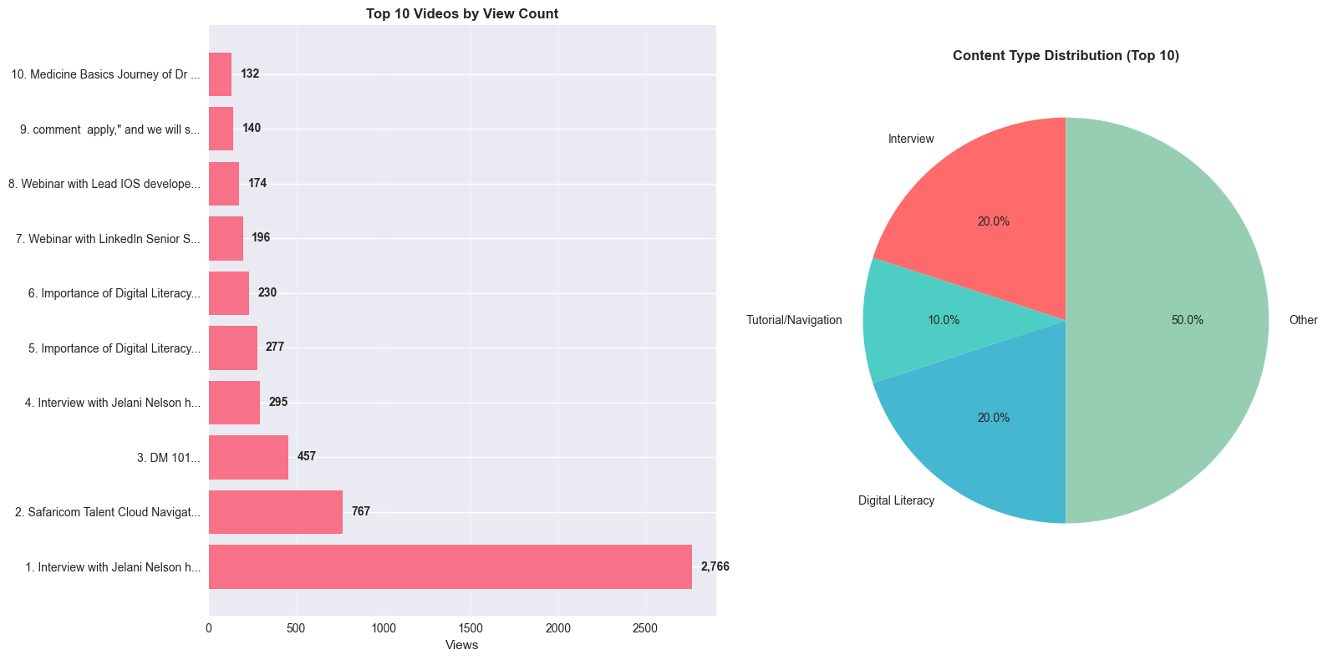
Suggestions for Marketing department
Increase subscriber conversion:
- End each video with a strong, specific CTA asking viewers to subscribe (especially if they like content) to move toward 3-5%.
- Use pinned comments, end screens, and video descriptions to prompt subscribes.
Boost engagement rate:
- Encourage interactions: at least one “like this video if …” or “comment your question” per video.
- Include calls to action early in video (within first 30 seconds) to build engagement.
- Respond quickly to comments to encourage conversation.
Improve retention / watch time:
- Hook viewers in first 15 seconds: preview what’s coming, pose a problem.
- Use chapters/timestamps in videos, especially longer ones.
- Make content concise, avoid fluff; ensure each segment adds value.
Diversify content so channel isn’t reliant on one video:
- Analyze your top video’s title, topic, format, thumbnail; replicate those successful patterns.
- Try producing more content around similar themes but with variations.
Increase frequency and freshness:
- Post videos on a consistent schedule (weekly or biweekly) to build audience expectation.
- Promote new videos through other channels (LinkedIn, email, social media) as they go live to generate early traction.
Track new metrics to measure progress:
- Calculate engagement rate = (likes + comments + shares + new subs) ÷ views(impression) x 100.
- Track average view duration and retention curves.
- Monitor recent performance window (first 48h) vs longer term; track trends.

3.3 Platform & Search Term Analysis

3.3.1 Platform & Device Breakdown
The website traffic data confirms that the audience is primarily mobile and finds us through search.
- Total Views: 837
- Mobile Traffic: An impressive 73.8% of ethioware traffic comes from mobile devices, placing us in the "Excellent" category for an educational institution (benchmark >70%). This confirms ethioware audience is primarily accessing the content on the go.
- Desktop Traffic: 26% of the traffic comes from desktop devices.
- Google Search Traffic: 84.3% of the total traffic originates from Google Search. This is a massive strength that demonstrates the SEO efforts are effectively driving discoverability.
- Google Maps Traffic: Only 16% of the total traffic comes from Google Maps.
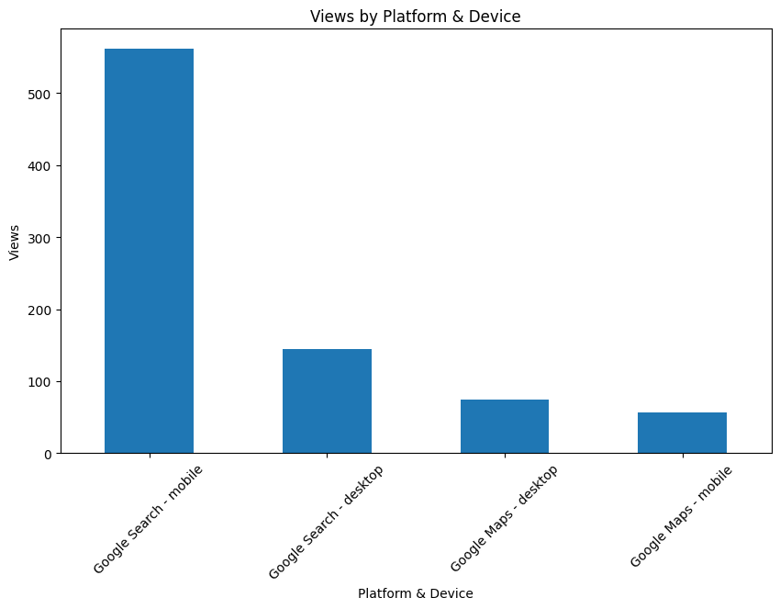
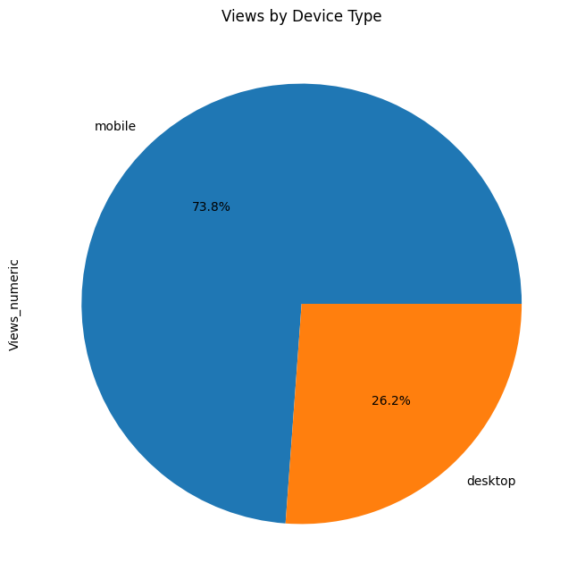

3.3.2 Search Term Analysis
The search term breakdown reveals interesting insights about user behavior and potential content gaps.
- Top Search Term: The term "ethioware" is the top driver, accounting for 23 views and showing strong brand recognition.
- Common Misspellings: The low-volume terms contain misspellings such as "ethioderset" and "etyuoved." These misspellings present a valuable SEO opportunity to create content or metadata that captures this traffic, which may be from a highly motivated but slightly misinformed audience. The presence of related terms like "ethio educti" and "ethioecoders" also highlights audience interest in specific areas of education and technology.

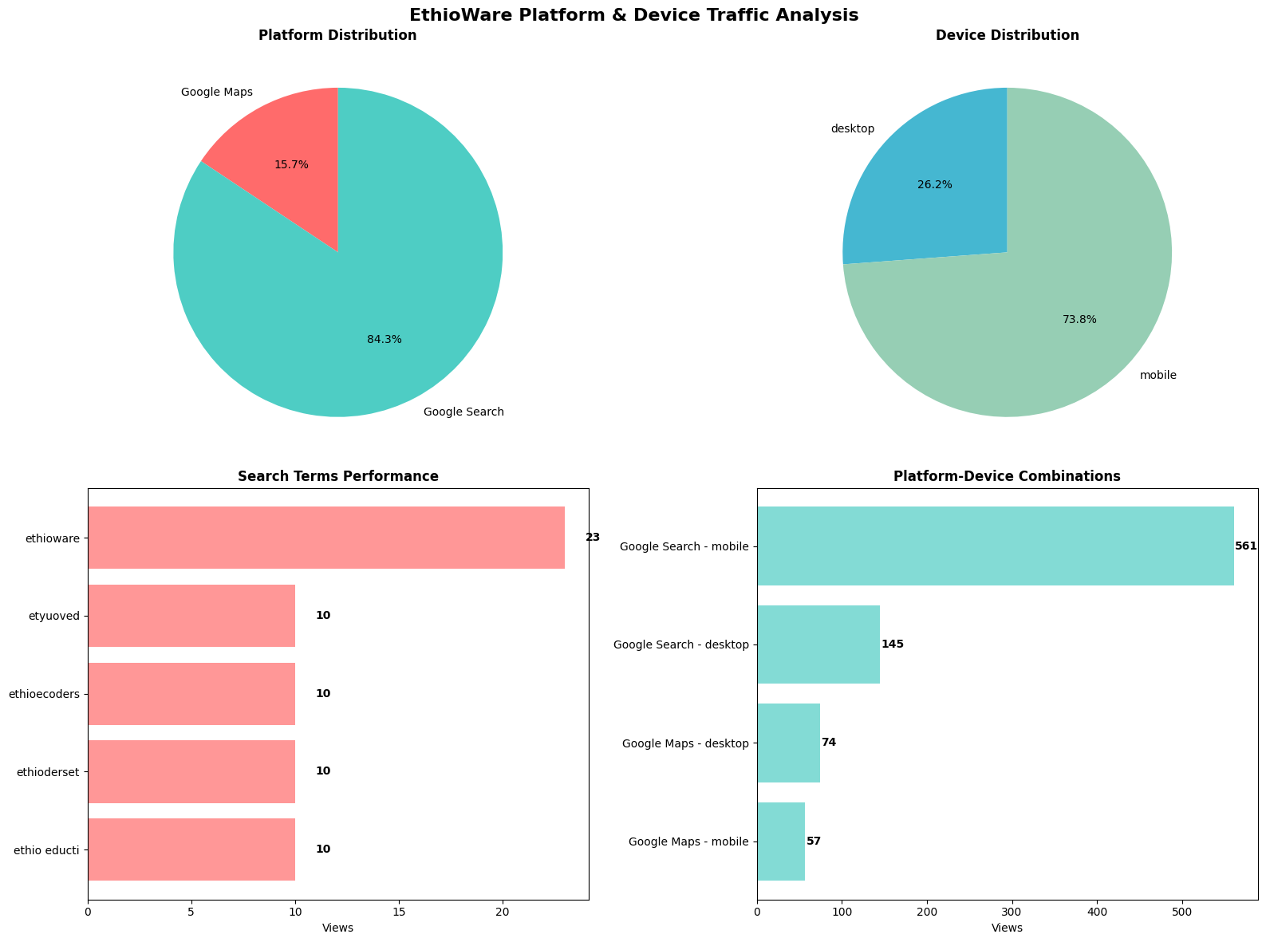
Summary metrics:
Metric | Ethioware Value | Meaning / Definition | Gap / Notes
Mobile Traffic Share | 74% (618/837 views) | % of visits from mobile. Shows device preference and optimization needs. | Strong mobile-first presence.
Desktop Traffic Share | 26% (219 views) | Portion of visits from desktops. Reflects traditional/workplace browsing. | Normal, but far less than mobile.
Google Search Share | 84% (706/837 views) | Portion of traffic from Google Search. Indicates organic search visibility. | Strong SEO performance.
Google Maps Share | 16% (131/837 views) | Portion of traffic from local search (Maps). Reflects discoverability for location-based queries. | Low; local optimization underdeveloped.
Top Search Term Views | “ethioware” – 23 views | Shows brand recognition and direct search intent. | Strong recall; but limited non-brand searches.
Low-Volume Terms (<15 views) | 4 out of 5 search terms | Long-tail or mis-typed queries that show niche interest. | SEO gaps; missed opportunities to capture variations.

Suggestions for Marketing Department
- Optimize Google Maps presence with updated profile, consistent NAP (Name-Address-Phone), posts, reviews, and categories to boost traffic share from Maps (currently under 20%).
- Since 74% of traffic comes from mobile, prioritize fast-loading pages, mobile-friendly video embeds, and vertical-first content formats.
- Current dominance of “ethioware” shows strong brand pull, but related low-volume terms suggest missed opportunities. Create SEO-optimized landing pages and blogs around related educational terms (e.g., “digital literacy programs”).
- Run campaigns/content optimized for problem-solving queries (e.g. “digital education resources”) to grow awareness outside brand recall.
- Encourage desktop-friendly resources (like long PDFs, webinars) to keep workplace searchers engaged, while maintaining short/mobile-first content for casual users.

4. Web Analytics Dataset Report

4.1 Executive Summary
This comprehensive analysis reveals critical insights into user behavior and market opportunities. The data shows that the majority of the visits are from Ethiopia and users prefer Chrome. Key opportunities include optimizing for desktop users and leveraging direct traffic. The data shows clear patterns in user preferences that can drive targeted marketing strategies.

4.2 Key Takeaways
- Geographic concentration suggests a localized marketing focus.
- Chrome optimization is critical for 86% of users (desktop + mobile).
- Desktop-focused design strategy recommended despite mobile growth.
- Direct traffic dominance indicates strong brand awareness.
- Content optimization around high-performing pages like /apply.

4.3 Data Overview
Primary Dataset: Website-Cleaned
- Source: website-cleaned.csv/xlsx
- Total Records: 97,856 requests
- Unique Countries: 65
- Time Period: Not specified in dataset
- Key Metrics: Requests per country, geographic distribution
Secondary Datasets
- Summary.xlsx: Overall visit metrics (360 total visits).
- Top Paths.xlsx: Page-level visit data (/apply: 50 visits, /EB0107254: 10 visits).
- Visit by Browser.xlsx: Browser usage (Chrome: 220 visits, 61% market share).
- Visits by Country.xlsx: Geographic distribution (Ethiopia: 250 visits, 69% of total).
- Visits by Device Type.xlsx: Device preferences (Desktop: 230 visits, 62%).
- Visits by Operating System.xlsx: OS distribution (Windows: 150 visits, Android: 130 visits).
- Visits by Source.xlsx: Traffic sources (Direct: 210 visits, 66%).

4.4 Key Findings
Geographic Insights
- Top Country: Ethiopia dominates with 250 visits (69% of total visits).
- Average Visits per Country: 72.00 visits.
- Median Visits per Country: 30.00 visits.
- Global Reach: Data from 5 countries in Visits by Country dataset.
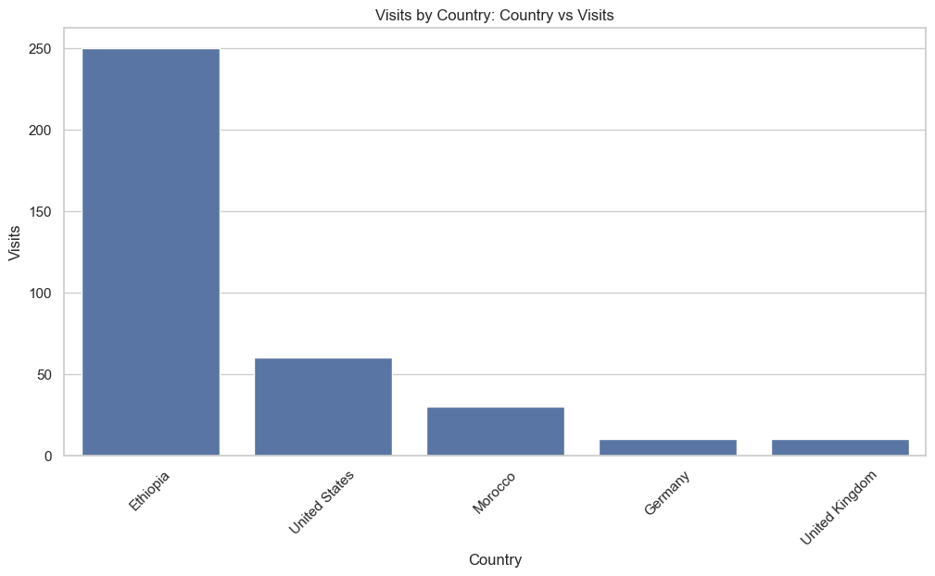
User Behavior Patterns
- Primary Browser: Chrome (61% of visits).
- Device Preference: Desktop (62% of visits).
- Operating System: Windows leads (42% of visits).
- Traffic Source: Direct traffic (66% of visits).

Content Performance
- Top Performing Page: /apply (83% of page visits).
- Page Diversity: Only 2 pages tracked in Top Paths dataset.

4.5 Detailed Analysis
1. Geographic Distribution Analysis
- Website-Cleaned Dataset: Total countries: 65, total requests: 97,856. The top 10 countries account for 97.4% of all requests.
- Visits by Country Dataset: Total visits: 360 across 5 countries. The dominance of a single country indicates a strong local market presence and opportunity for deeper market penetration.
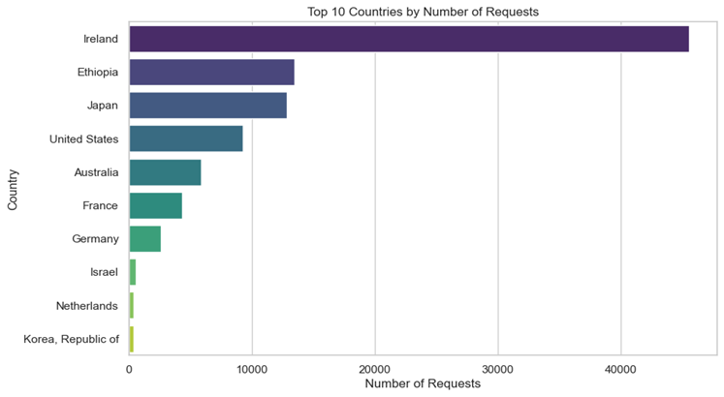
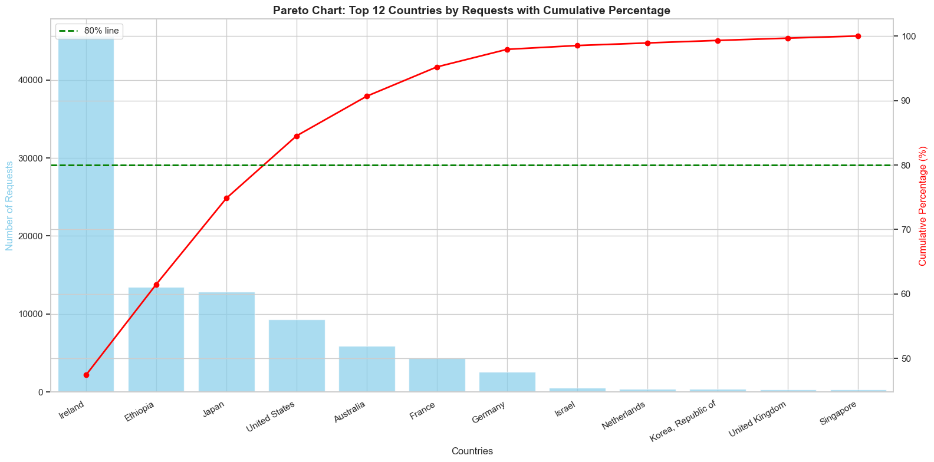
Top 3 countries (out of top 12 shown) account for ~80% of requests. Countries with above-median requests (22): 32 total
2. Browser and Device Analysis
- Browser Usage: Chrome (61.1%) and Chrome Mobile (25.0%) together account for 86% of the traffic, making the Chrome ecosystem the primary focus for development and testing.
- Device Type Distribution: Despite the trend toward mobile-first, desktop traffic (61.8%) is still the dominant preference, suggesting the current user base may be more stationary and professional. Mobile optimization remains a high priority for growth.
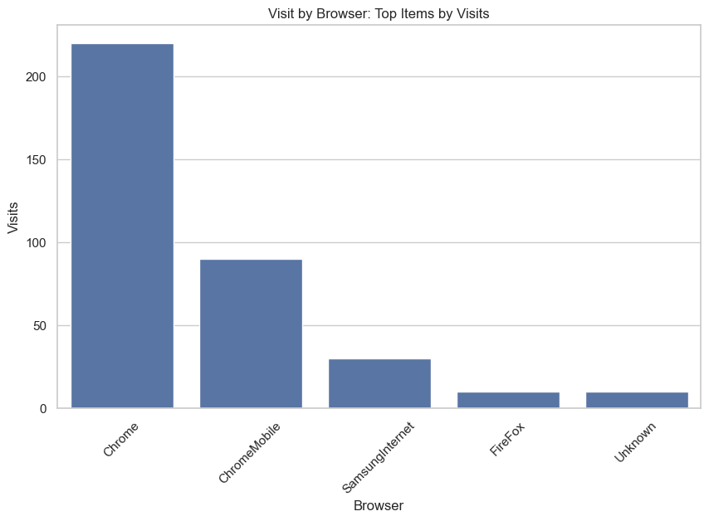
3. Operating System Analysis
- OS Usage Patterns: Windows and Android together account for 78% of users. This indicates that content and technical compatibility must be broad to serve this majority user base effectively.
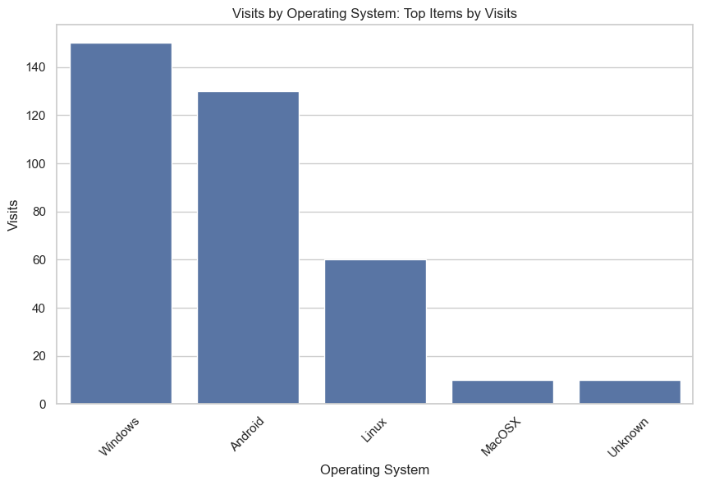
4. Traffic Source Analysis
- Source Distribution: Strong direct traffic (66% of visits) suggests effective branding, word-of-mouth, or repeat visits. Google Search remains a key acquisition channel at 16.7%.
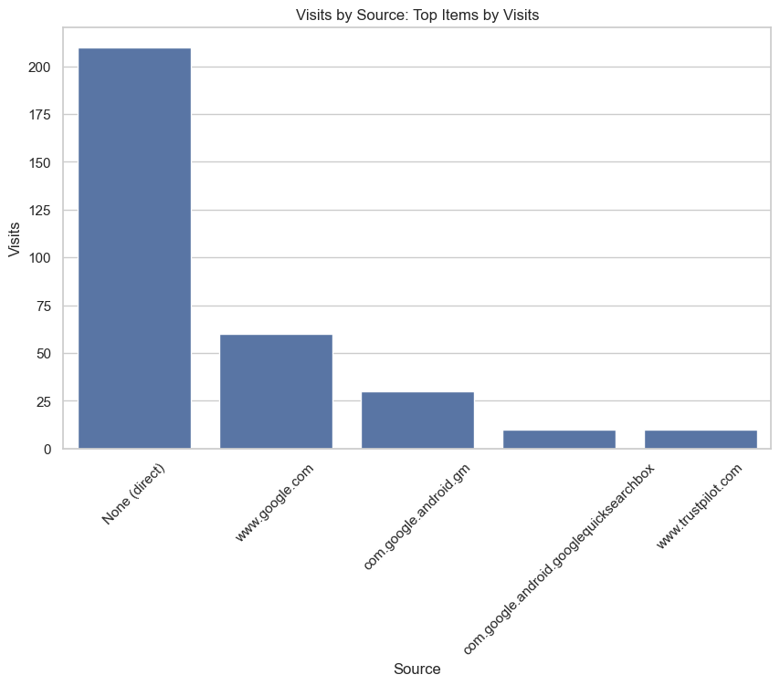
5. Content and Page Analysis
- Top Performing Pages: The /apply page shows exceptional performance, indicating high user intent for application/conversion processes. This is a critical funnel page that should be continuously optimized.
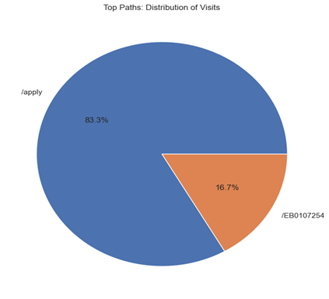
6. Statistical Insights
- Distribution Analysis: The request distribution is highly skewed, with a few top countries driving the majority of traffic. The significant gap between average (72) and median (30) visits per country indicates the presence of outliers and high geographic concentration.
- Comparative Analysis: The top 10 countries in the Website-Cleaned dataset account for requests that are 37.7 times greater than the rest, reinforcing the need for a focused market strategy.
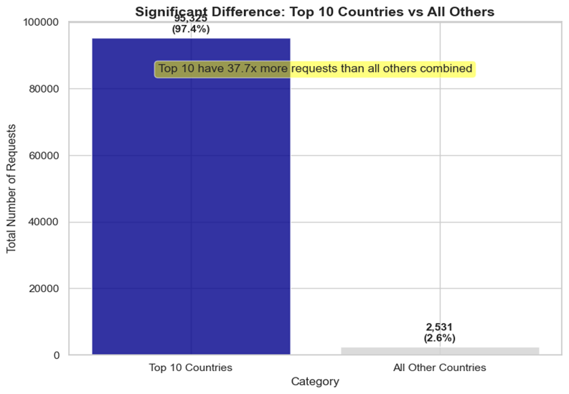
Marketing Suggestions
Local Market Penetration (Ethiopia – 69%):
- Run localized campaigns in Amharic and English.
- Partner with Ethiopian universities, schools, and EdTech communities.
- Create region-specific ads highlighting accessibility and relevance.
Browser & Device Optimization (Chrome 86%, Desktop 62%):
- Prioritize Chrome-first testing to ensure seamless user experience.
- Maintain desktop-friendly layouts while enhancing mobile optimization (for Android growth at 36%).
- Direct Traffic Leverage (66%):
- Launch referral programs (e.g., discounts or recognition for referrals).
- Encourage alumni/learners to share EthioWare’s content directly.
- Use branded short links to amplify direct access tracking.
- Content Strategy (/apply page 83%):
- Streamline the application process (fewer clicks, clear CTAs).
- Repurpose “application success stories” into case studies for social media.
- OS & Platform Diversity (Windows 42%, Android 36%):
- Develop lightweight, Android-friendly pages to capture mobile-first users.
- Ensure compatibility with Linux (16%) for technical/academic users.

