A, Traffic Table
- Monthly total views per month from traffic table(distribution)
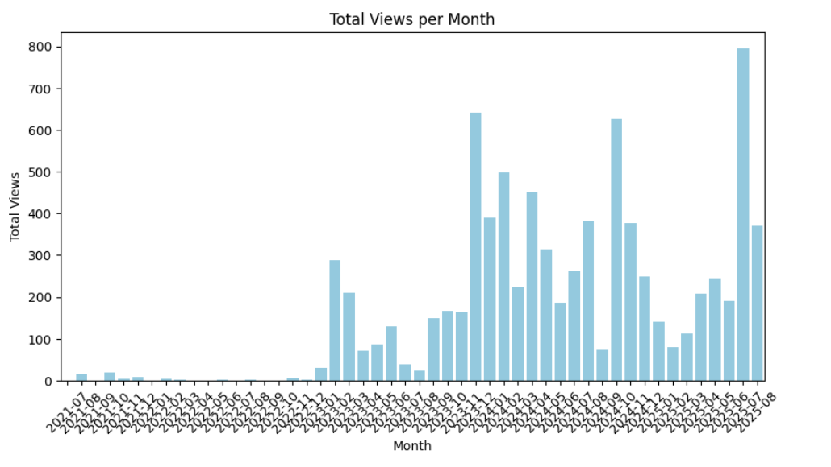

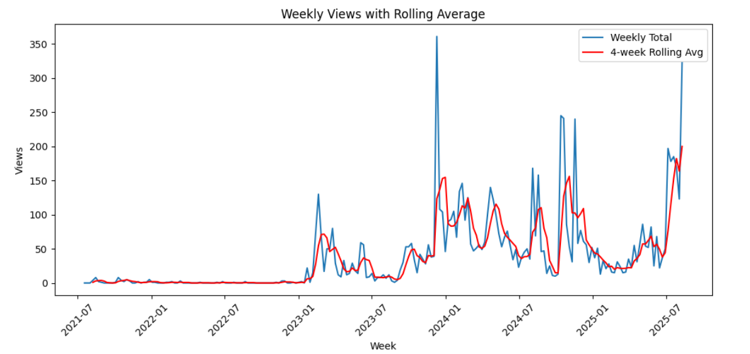
- Weekly views

Summary
- The chart shows weekly views (blue line) and a 4-week rolling average (red line) from mid-2021 to mid-2025.
- From 2021 until late 2022, activity was very low with almost no views.
- Around early 2023, views began to rise significantly with some spikes, showing the start of consistent engagement.
- The peak occurred around early 2024, with the highest weekly views surpassing 350.
- Views remained volatile but generally higher through 2024 and 2025, with repeating cycles of growth and drop.
- The rolling average smooths out the spikes, showing a gradual upward trend overall, even though short-term fluctuations are sharp.

Suggestions
* The spikes suggest occasional bursts of interest, but consistency is lacking..
* Leverage Rolling Trends – Since the 4-week rolling average is increasing, doubling down on recent successful efforts could accelerate sustained growth.
* Reduce Drop-offs – After peaks, views drop sharply. Keeping the audience engaged with follow-up content after major events may help retain momentum.
Overall: The long-term trend is positive, but focusing on consistency and sustaining audience engagement will turn these spikes into steadier growth.

B. Traffic Table
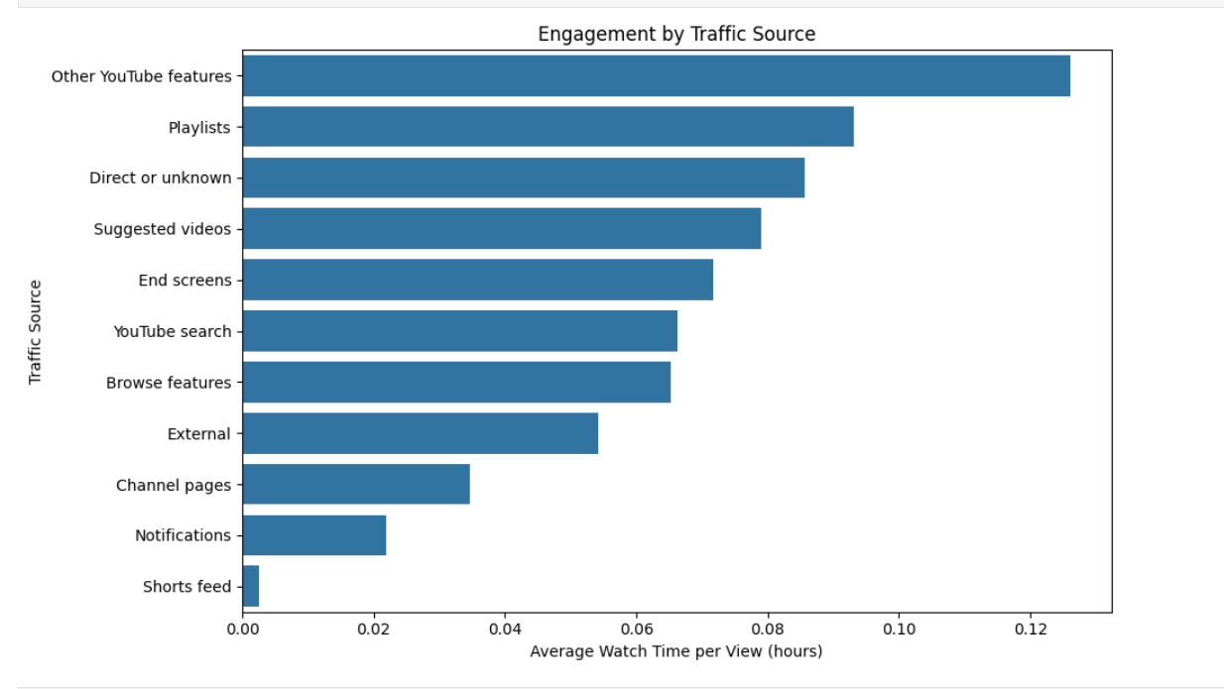
1. Engagement by Traffic source

2 .
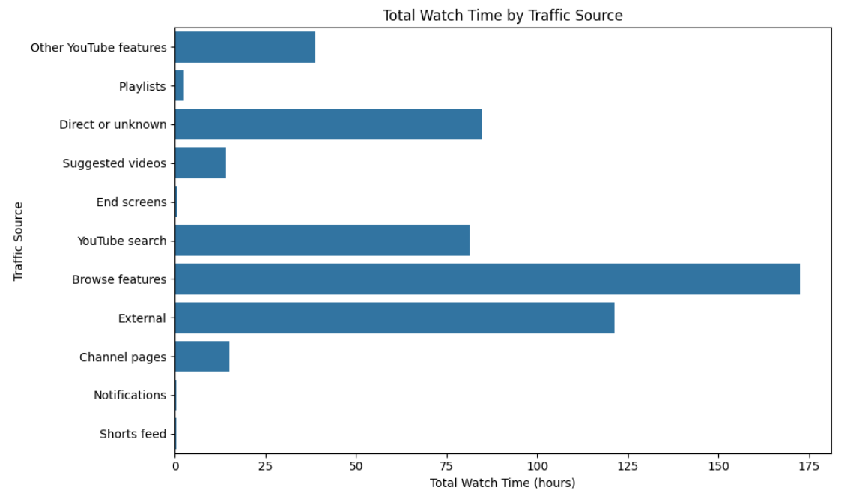

C. Traffic Chart
1.Total views by traffic source
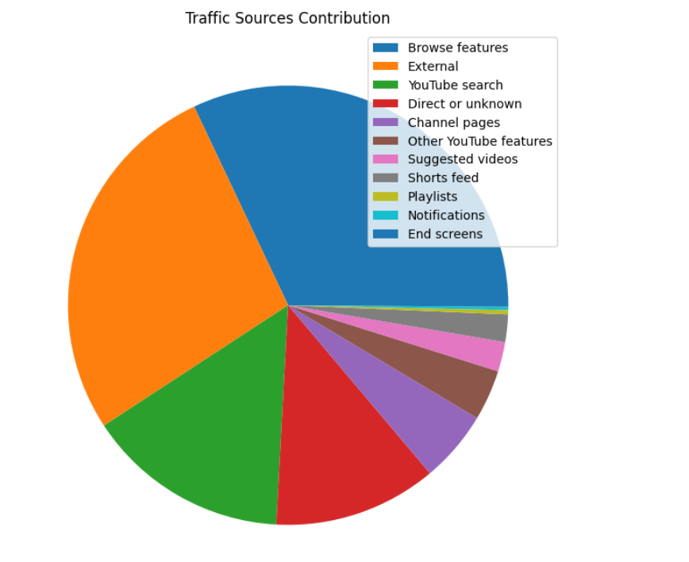
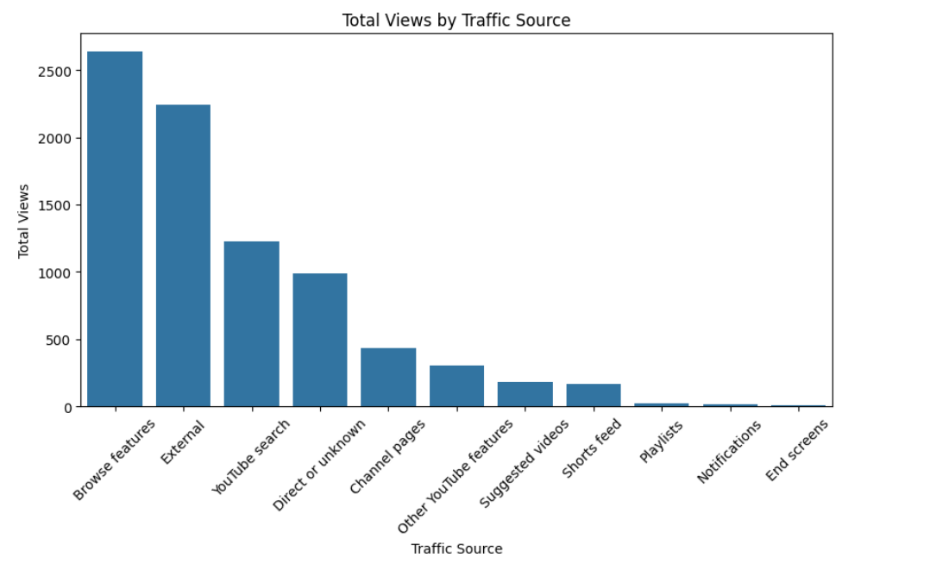

Most of the views are coming from Browse features and External sources, with YouTube search also giving a good amount. People are finding the videos when scrolling or from outside links, not from inside YouTube recommendations.
Suggestion: Making the videos show up in browse and search (good titles, thumbnails, and SEO)
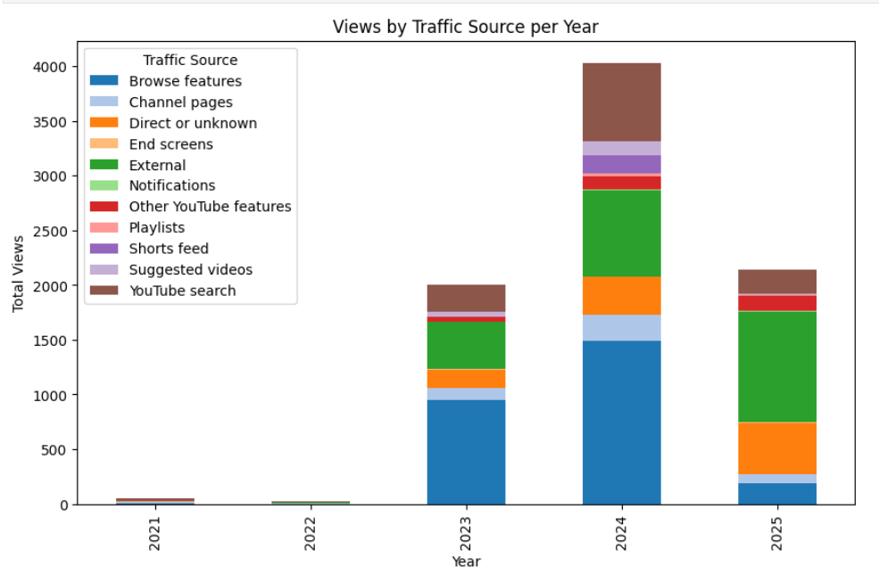
2. Traffic source per year

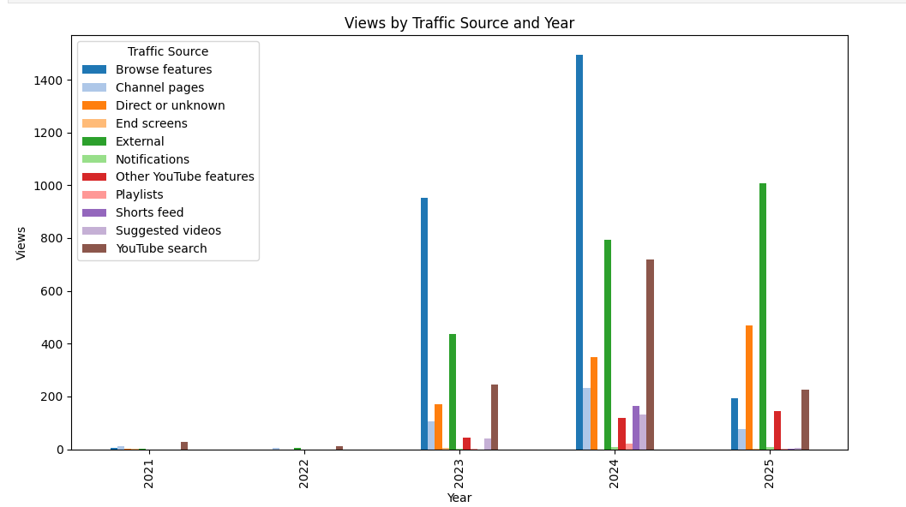

The chart shows that most views came from browse features in 2023–2024, but in 2025 this source dropped sharply while external and direct or unknown views grew stronger. YouTube search and suggested videos also increased steadily.
D. Content Chart
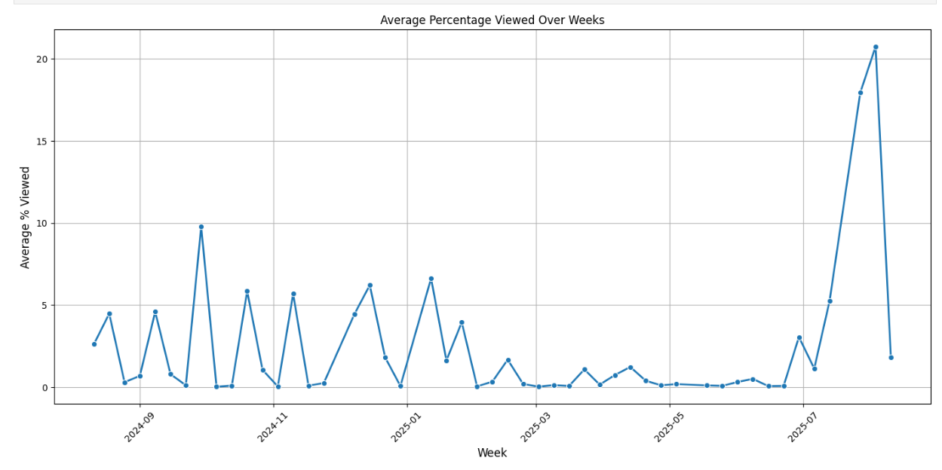
1. Weekly distribution of average views(filtered average % viewed > 0)

2.

E. Content totals
1.Average percentage viewed(daily)
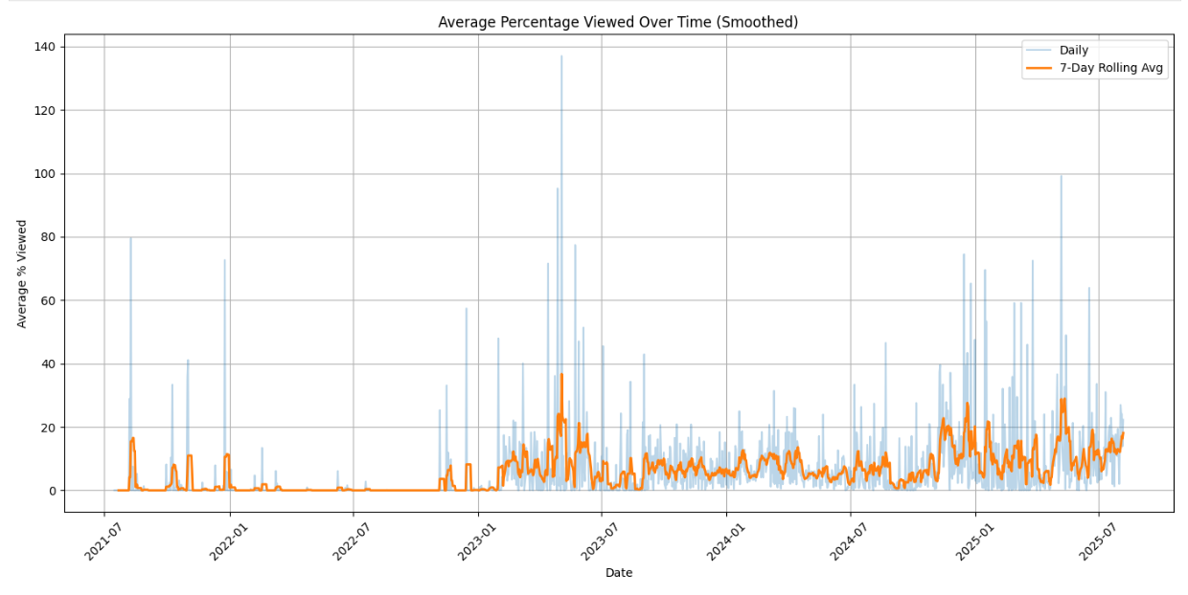

2.Average percentage viewed monthly
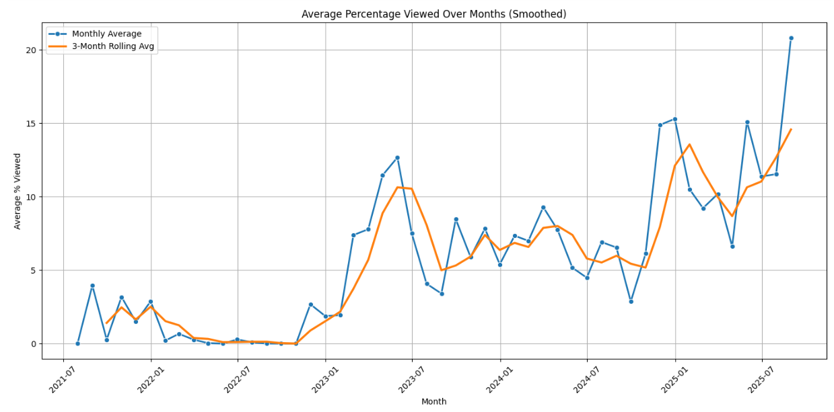

Summary
- Daily View (Chart 1): Engagement is very volatile, with many spikes but generally low average viewing percentages. The 7-day rolling average shows a small but steady improvement from 2023 onwards, though still it is limited.
- Monthly View (Chart 2): The monthly averages show clearer growth, especially from early 2023 onward. There’s a noticeable upward trend, with the last few months peaking, suggesting long-term improvement in viewer engagement.

Suggestion
- The content/production team should focus more on improving consistency and quality of content to reduce daily volatility.
- The marketing team appears to have been effective in increasing engagement steadily (as shown in monthly data), but needs to push further to sustain higher retention levels.

F. Content Table
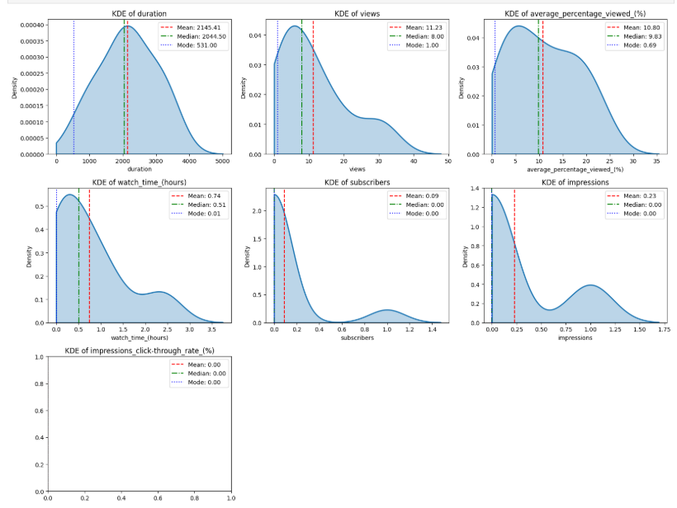

1. Duration
- Mean (average): 2145 sec (36 min)
- Median (middle value): 2045 sec (34 min)
- Mode (most frequent): 531 sec (9 min)
→ Most content is long, but the most common length is short.
✓ Suggestion: Balance long-form with shorter versions to see what keeps people engaged.

2. Views
- Mean (average): 11
- Median (middle value): 8
- Mode (most frequent): 1
→ Most items receive very few views.
✓ Suggestion: Improve visibility — stronger titles, visuals, and descriptions.

3. Average Percentage Viewed
- Mean (average): 10.8%
- Median (middle value): 9.8%
- Mode (most frequent): 0.7%
→ Audience drops off quickly.
✓ Suggestion: Use strong openings, clear value upfront, and faster pacing.

4. Watch Time (Hours)
- Mean (average): 0.74 hrs (44 min total)
- Median (middle value): 0.51 hrs (31 min total)
- Mode (most frequent): 0.01 hrs (1 min total)
→ Some watch time exists, but most sessions are short.
✓ Suggestion: Keep viewers engaged beyond the introduction.

5. Subscribers / Followers
- Mean (average): 0.09
- Median (middle value): 0
- Mode (most frequent): 0
→ Very little growth in followers.

6. Impressions (times content was shown)
- Mean (average): 0.23k
- Median (middle value): 0
- Mode (most frequent): 0
→ Content is not being shown widely.
✓ Suggestion: Improve covers (thumbnails) and titles to increase exposure.

7. Impressions Click-Through Rate (CTR - Click Through Rate)
- No clear data (mostly 0).
→ without clicks, impressions do not turn into views.
✓ Suggestion: Redesign titles and covers to improve click-through rate.

Key Insights
-Content is longer than what most people are consuming.
- Visibility is low (few impressions) and engagement is weak (only ~10% viewed on average).
- Follower growth is almost zero, meaning little conversion from viewers.
• Marketing teams → to identify campaign weaknesses.
• Educators / trainers → to improve lesson engagement.

Main Suggestions
- Shorten content (5–10 minutes works better for attention).
- Use strong hooks at the start.
- Improve covers and titles for visibility.
- Double down on high-performing topics or formats.

